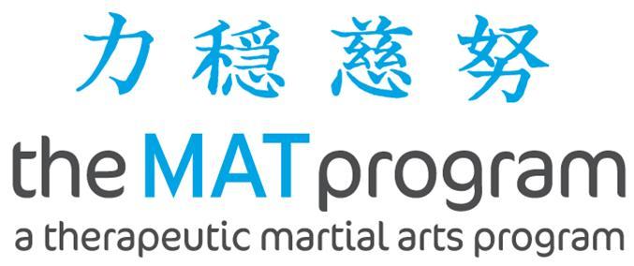

CHAMPS MAT LIFE SKILLS PROGRAM

INFORMATION FOR PARENTS AND GUARDIANS

What is Champs?

CHAMPS is a peer support program for children who have a parent (or other family member – siblings, grandparents etc) with mental health concerns. The CHAMPS programs are for children aged between 8 and 12.

CHAMPS programs are based on the belief that children, parents and families do well when they have a shared understanding of mental health and wellbeing - and having a range of resources and supports can help when things are challenging. Children can benefit from spending time with other trusted adults and with children who may be having similar experiences. Eastern Health FaPMI (Families and Parents where there is a Mental Illness) program run a number of different CHAMPS programs including Peer Support Programs, Kids Club and a family fun day. The MAT Life Skills program is one of these programs.

What is the MAT Life Skills Program?
The MAT Life skills program is a physically active therapeutic program that combines the basics of behaviour management with the principles of traditional martial arts. It provides students with a structured opportunity to develop self-control and self esteem and it has been found it to be equally effective with both boys and girls, particularly those who display a lack of impulse control. It is our aim to teach students skills that they will transfer from the martial arts classes to other classes as well as to their behaviour in the schoolyard, at home, and in community contexts.
It is an eight-week program that focuses on teaching:
- How to identify various feelings
- Appropriate ways to respond to these feelings
- How to self-invest to achieve a positive future
The program does not teach children how to fight. There is no instruction in street fighting, throwing or weapons techniques. It does teach basic self-defence techniques such as palm blocks and evasions. It aims to provide participants with opportunities to experience success.
The program works around four basic teachings:
- Be Strong
- Be Calm
- Be Kind
- Try Hard

Who runs the group?

The group will be facilitated by staff from the MAT Life Skills program and Eastern Health
FaPMI (Families where a Parent has a Mental Illness) program. FaPMI coordinates referrals for the group and someone will speak to you by phone before the group commences to find out more about your situation and to check if the group is suitable for your child.

Is there a cost to attend?

There is no cost for children to attend the group. If assistance with transport is required we may be able to help depending on the area. Give us a call to discuss.

We welcome opportunities to catch up with you either at the beginning or the end of group time or, over the phone. Please let us know if your child is unable to attend for a week. We welcome your feedback and will be distributing evaluation forms at the end of the program.

Please contact the staff member with your group if you have any questions or concerns.

The group runs for 8 weeks each term

You must register to attend - please call Laurel Gorman on 0435 384 531
Or email: fapmi@easternhealth.org.au
