POSITION DESCRIPTION

Position Title: | Talent Acquisition Specialist – Medical Workforce
Award Classification: | HS4
Award / Agreement Name: | Victorian Public Health Sector (Health and Allied Services, Managers and Administrative Workers) Single Interest Enterprise Agreement 2021 – 2025
Position Reports to: | Talent Acquisition Lead

EASTERN HEALTH – HEALTHIER TOGETHER
Eastern Health is one of Melbourne’s largest metropolitan public health services. We provide a comprehensive range of high quality acute, sub-acute, palliative care, mental health, drug and alcohol, residential care, community health and statewide services to people and communities that are diverse in culture, age and socio- economic status, population and healthcare needs. ‘Being part of Eastern Health is being part of a welcoming team of healthcare experts’ is achieved through Eastern Health’s strategic goal of HEALTHIER TOGETHER.

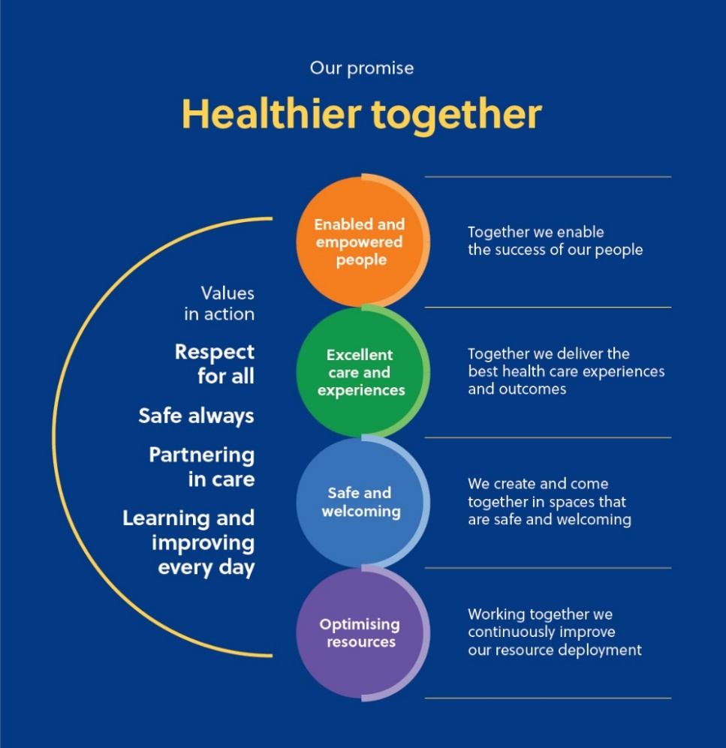

POSITION PURPOSE

The Medical Workforce Talent Acquisition Specialist (MWTAS) works collaboratively with the Medical Workforce Unit, Talent Acquisition, People Managers, candidates and other stakeholders to deliver a recruitment program that supports Eastern Health to meet workforce optimisation and sustainability requirements aligned with the Strategic Plan. The MWTAS is responsible for the generation and implementation of Talent Acquisition strategies responsive to local and national workforce trends to ensure Eastern Health are an employer of choice for medical workforce.
The MWTAS operates strategically to provide a supported recruitment service for those engaged with the Medical Workforce Unit through the provision of specialist advice, creative sourcing and attraction solutions. The role ensures best practice recruitment standards and a positive candidate experience are maintained.

MAJOR DUTIES AND/OR RESPONSIBILITIES

- Collaborate to embed best practice recruitment across the Directorates maintaining alignment of quality candidates with Eastern Health Values.
- Establish and maintain relationships with relevant internal and external stakeholders to support effective talent acquisition.
- Analyse and apply data and workforce trends to inform medical recruitment strategies.
- Develop and implement a recruitment strategy for medical workforce roles, including a sourcing strategy and working with preferred suppliers.
- Report on emerging trends in the employment market and target talent segments.
- Actively participate in workforce planning initiatives to support identification of key roles and positions.
- Support and coach the Medical Workforce Unit (MWU) and stakeholders to deliver efficient recruitment practices and processes using the electronic recruitment system.
- Develop resources and provide coaching for hiring managers in recruitment and talent selection.
- Effectively articulate and communicate information about employment at Eastern Health
- Manage and continue to grow a quality talent pool and candidate pipeline.
- Partner with MWU to advertise or directly source candidates using various creative mediums; this may include electronic recruitment systems and Careers website aligned with Eastern Health brand guidelines.
- Host and/or support public information forums that promote Eastern Health to prospective candidates (as required).
- Support MWU to deliver bulk recruitment initiatives.
- Monitor medical advertisements within the electronic recruitment system to ensure timely workflow approval processes and candidate management practices in collaboration with the MWU.
- Source internal candidates where appropriate and liaise with Organisational Development to identify talent succession plans.
- Provide shortlist of quality candidates for interview in collaboration with the respective Craft Group MWU representative as required.
- Where required, participate in interviewing and assist with selection decisions.
- Develop a suite of behavioural interview questions for specific roles.
- Assist in the coordination, interpretation and recording of candidate psychometric testing (as required).
- Update and notify candidates on the progress of their applications including confirmation of recruitment outcomes and appropriate feedback to unsuccessful candidates.
- Collaborate with the Credentialing and Compliance team and the Immigration Officer to ensure candidates meet the requirements of the position.
- Provide detailed reports to the Talent Acquisition Lead and the Director Interprofessional Workforce (or delegates) on recruitment metrics and workforce trends.
- Maintain a working knowledge of employment law/process, immigration and profession registration requirements and utilise as required.
- Support processes and initiatives related to the Australian Council on Health Care Standards Accreditation including the National Safety and Quality Health Service Standards and other related requirements.
- Manage the Pre-Employment Screening process.
- Provide recruitment administrative support as required.
- Attend meetings / professional development sessions as required.
- Other reasonable duties within the scope of the role.

SAFE PRACTICE AND ENVIRONMENT

Eastern Health is a child safe organisation, committed to promoting the wellbeing and cultural safety of Aboriginal children, children with disabilities and all children in their diversity. More information here.

Occupational Health and Safety

Eastern Health is committed to provide and maintain a working environment for all staff that is safe and without risk to health. All staff are to take care of their own health and safety and the health and safety of any other person who may be affected by your acts or omissions at the workplace. Understand responsibilities and accountabilities to yourself and others in accordance with OH&S legislation and Eastern Health policies and promote a working environment that is congruent with these guidelines. This includes staff reporting of all clinical and OHS incidents and near misses, in particular those related to Occupational Violence, Manual Handling and Slips, trips and falls.

Staff are required to comply with all state legislative requirements in respect to the Occupational Health and Safety Act 2004 and the Workplace Injury Rehabilitation and Compensations (WIRC) Act 2013.

TRAINING AND DEVELOPMENT

Relevant, practical and timely education should direct, facilitate, enhance and support the professional growth and practice of employees in a health environment characterised by change. All programs should endeavour to promote evidence-based practice, a problem solving approach and to be competency based.
You are expected to participate in the personal development process on an annual basis.

QUALITY

As a staff member of Eastern Health staff are required to comply with Eastern Health performance standards and participate in continuous monitoring and improvement as part of your role. You are also required to comply with legislation, professional standards and accreditation standards.
As a staff member employed by Eastern Health services you must have and maintain the appropriate skills and knowledge required to fulfil your role and responsibilities within the organisation. In addition, you must ensure that you practice within the specifications of this position description, and where applicable within the agreed scope of practice.
You are responsible for ensuring safe high quality care in your work. This will include complying with best practice standards, identifying and reporting any variance to expected standards and minimising the risk of adverse outcomes and patient harm. In addition, you will ensure that service and care is consistent with the EH approach to patient and family centered care.

6. CONFIDENTIALITY

Any information obtained in the course of employment is confidential and should not be used for any purpose other than the performance of the duties for which the person was employed. Staff are bound by the Information Privacy Act 2000 and the Health Records Act 2001.

7. EQUAL EMPLOYMENT OPPORTUNITY

You agree to adhere to the Equal Employment Opportunity policies and practices of the Health Service. Discriminatory practices, including sexual harassment, are unlawful. The Health Service will not tolerate discriminatory behaviour, and any such conduct may lead to the invoking of the Disciplinary Policy and Procedure, which may result in termination of employment.
Our commitment to Diversity, Equity & Inclusion
Eastern Health is committed to creating a diverse and inclusive environment that welcomes and values all people. We recognise that diversity is essential in ensuring Eastern Health provides the best service to its consumers.
Aboriginal and/or Torres Strait Islander peoples, people from the LGBTIQA+ community, people living with disability and those from a culturally and linguistically diverse background, are strongly encouraged to apply.
For more information, please click here.

8. PERFORMANCE DEVELOPMENT

A Performance Review, that includes agreed targets, will occur three (3) months from commencement and then annually on the basis of the duties and responsibilities outlined in this position description. This is an opportunity to review personal and the allocated work unit’s service performance, facilitated by the setting of objectives/goals and ongoing evaluation of performance and achievement. Objectives will be developed annually, documented, discussed and agreed with the immediate line manager, who will act as the assessor. The incumbent is expected to demonstrate and show evidence annually of on-going self and allocated work unit’s service development.

9. EASTERN HEALTH’S PROMISE
Our promise to our communities, patients, consumers and staff is that we will be HEALTHIER TOGETHER. Bolder than a vision for the future, our promise calls us to action. We know that working together is the only way we can achieve what is necessary for a healthier future.
Our values are ones in action and are the behaviours that matter most.
- Respect for all
- Safe always
- Partnering in care
- Learning and improving everyday
Learning from the challenges of the past and looking to the future, we understand that we are building towards a more engaged, more reliable, always safe health service in partnership with our people to improve every day.

10. ATTACHMENTS

- Attachment 1 Key Selection Criteria

11. NOTE

Statements included in this position description are intended to reflect in general the duties and responsibilities of this position and are not to be interpreted as being all-inclusive.
Prior to accepting any offer of employment, prospective employees will be required to read and commit to the Eastern Health Code of Conduct, including (but not limited to) issues of Occupational Health and Safety, Equal Opportunity and Confidentiality.
Healthcare workers are strongly recommended to follow COVID vaccination recommendations provided in the Australian Immunisation handbook (based on ATAGI advice). Seasonal vaccination against influenza is a mandatory requirement of this role and employment is conditional on this being up to date prior to employment.

Signed: _______________________________________ Date: ____/____/____
Manager
INCUMBENT STATEMENT
I _____________________________________(Incumbent Name) have read, understood and accepted the above Position Description and associated Attachments.

Signed: _______________________________________ Date: ____/____/____

ATTACHMENT 1

KEY SELECTION CRITERIA

Position Title: | Talent Acquisition Specialist – Medical Workforce
Award Classification: | HS4
Award / Agreement Name: | Victorian Public Health Sector (Health and Allied Services, Managers and Administrative Workers) Single Interest Enterprise Agreement 2021 – 2025
Position Reports to: | Talent Acquisition Lead

Qualifications
Tertiary qualification in a Human Resources discipline
Experience
- Demonstrated experience in:
  - Recruitment and candidate management
  - High volume recruitment (local, interstate, international candidates)
  - Development and implementation of targeted recruitment campaigns
  - Implementation and application of CRM technology
  - Generation of reports and public speaking (presentations)
  - The application of strategic sourcing and talent pipelining methods
- Previous experience in a similar role
Knowledge + Skills
- Demonstrated knowledge and skills related to:
  - The health labour market and responding to recruitment challenges
  - Recruitment systems and advanced user capability with LinkedIn, Social Media platforms and online job boards.
  - Digital literacy and embracing of health technologies and informatics
  - Use of applications in the Microsoft Office suite
  - Stakeholder engagement, building relationships and customer service
  - Process improvement, problem solving and creating a positive candidate experience

Position Requirements
- Ability to travel and work across Eastern Health campuses as required to meet the MWTAS position duties/responsibilities
- High level communication, both written and verbal, demonstrated high level of interpersonal skills with candidates and health care professionals.

Personal Attributes
- Exhibits behaviour which reflects the Eastern Health values.
- Promotes and contributes to a supportive and engaged team environment.
- Commits to providing a safe environment for all.
- Respectful, collaborative and kind.

Aboriginal & Torres Strait Islander Candidates
Eastern Health’s Aboriginal Workforce Plan 2023 – 2026 was released in February 2023. With a strong focus on cultural safety and belonging, actions included in the Workforce Plan provide practical supports for all Aboriginal and/or Torres Strait Islander staff.
An Aboriginal Employment Coordinator is available to ensure each person has culturally safe and positive employee experiences which foster belonging and access to diverse experiences and career pathways. Should you require further information regarding this position or support to complete an application, please contact the Recruitment Manager for this position or Eastern Health’s Aboriginal Employment Coordinator at Aboriginal.Workforce@easternhealth.org.au

