Welcome to ECASA: What to expect when accessing our service

Acknowledgement of country
We acknowledge the sovereign custodians and owners of the lands upon which we are meeting today. I’m currently on the Wurundjeri and the Bunurong people of the Kulin Nation who's land we are gathered on today.
We honour their ongoing connection to land and waters, as the oldest continuous living culture on Earth. We pay respects to Elders past and present and acknowledge Aboriginal and Torres Strait Islander Peoples as the First Peoples. Sovereignty has never been ceded.
We acknowledge the sobering reality that Aboriginal & Torres Strait Islander Peoples are at a significantly higher risk of experiencing gender-based violence

Acknowledgement
ECASA currently does not have wheelchair access. We are working towards making our facility accessible for all.
We work with other Eastern Health facilities to ensure that people who require wheelchair access can see us in-person.
Should you require this, please do not hesitate to contact us.

Introduction
Starting counselling with a new service can feel a bit scary.
That’s why ECASA made this booklet – to help you understand what counselling might be like.
Our staff will always explain things clearly. You don’t have to do anything you don’t feel comfortable with.
You can use this booklet in a way that works best for you. It might help you get ready for counselling, or it might help a support person explain things to you.

Booking First Appointment
- After your intake call, you will be placed on our waiting list.
- Once a counsellor is available, they will call you to make a booking.
- People who have experienced recent sexual assault will get an appointment sooner. Recent sexual assault means the assault happened within the last 2 weeks.
- You will receive a text from ECASA to confirm your appointment
- You will receive another text with a link to fill out a form. You can contact us if you have troubles filling in this form.
- You will receive a text from ECASA the day before your appointment to remind you.
- If you want, your carer can be with you at your appointment. The choice is yours!

Coming to ECASA

Where to park
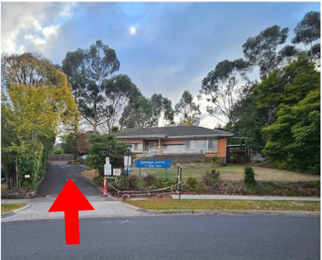 Turn into the driveway for parking. The arrow in the picture points to the driveway
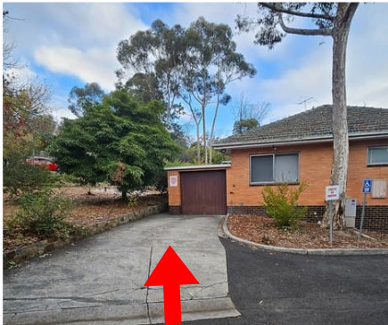 There is a disability parking spot in the driveway. The arrow in the picture points to the spot.
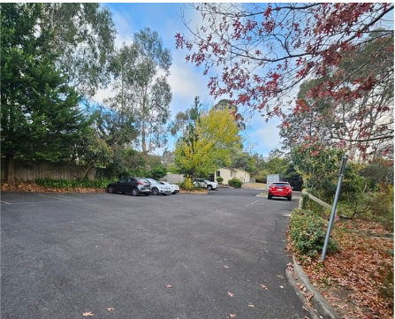 For more parking spots, keep driving through and pick any spot you would like. Any of the spots in the picture can be picked.

Getting to reception
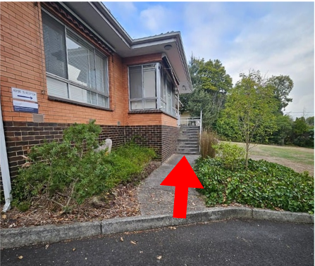Walk around the side of the building and up the stairs. The arrow in the picture points to the stairs.
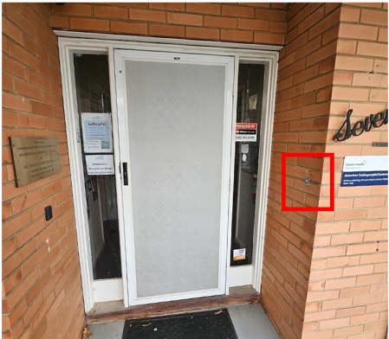Ring the doorbell on the right-hand side for reception to let you in. The doorbell is in the red square in the picture. When you hear a click, the door is unlocked.
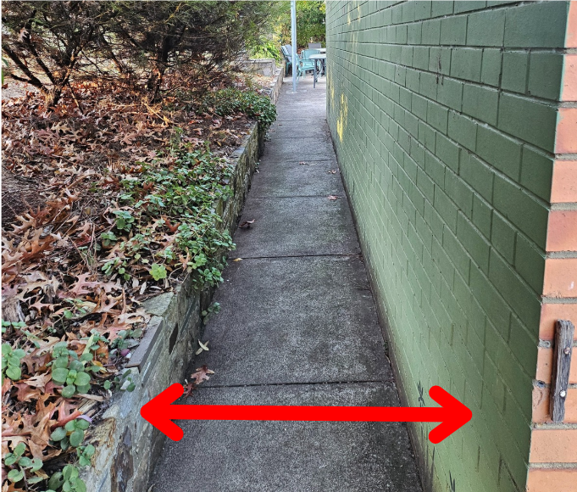If you have a disability, you can come in from the back through path in front of the disabled parking spot. The width of the pathway is 34.5cm. The line in the picture shows the width of the pathway.
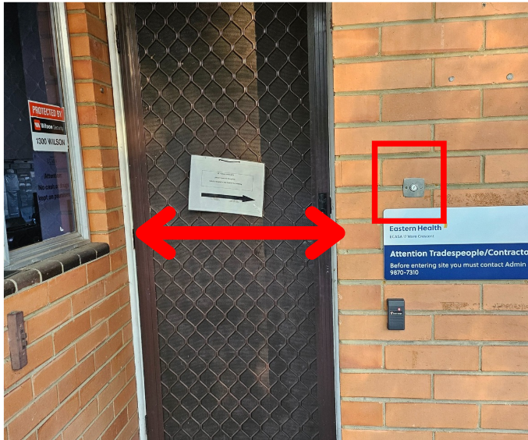Press the doorbell for reception to let you in. The doorbell is in the red square in the picture. The width of the door is 30cm. The line in the picture shows the width of the door.

Getting a parking permit
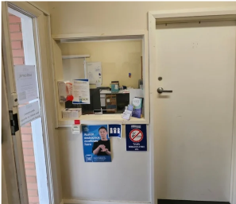Reception will ask for your name and if you need a parking permit.
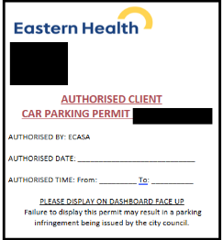You must get a parking permit from the reception.
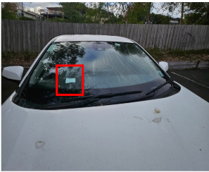If you need a parking permit, place it on your car dashboard. The red square in the picture shows you where to put it.

Waiting for your counsellor
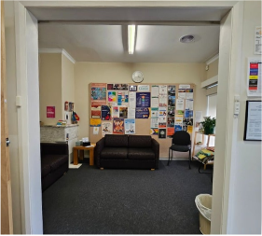While you wait for your counsellor, you can sit in the waiting room.
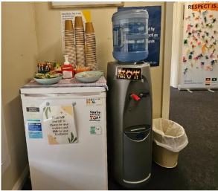
We have snacks, hot beverages, and water for you. There’s cheese in the fridge. Please help yourself!
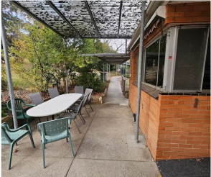
Your counsellor will greet you in the waiting room and bring you to the counselling room. This can be in the other building too.

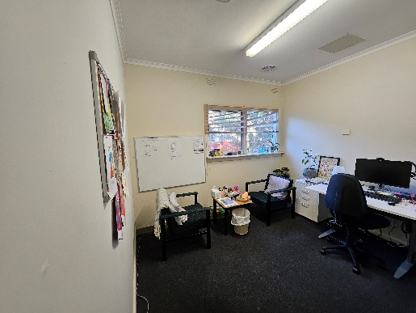 Our counselling room has things like sensory toys to help you. Each counselling room can look a little bit different than the one in the picture.

If you need anything like turning off the lights, please let your counsellor know!

Getting back to your car
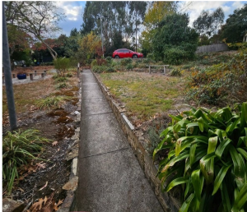After your session, you can get to your car from the pathway. Your counsellor will show it to you.
You did it! You will know exactly what to do next time. If you don’t remember that’s okay- you can always use this booklet again!

Basic questions counsellors may ask
- In your first session, your counsellor will introduce themselves. They will let you know how they work and what training they have done.
- Counsellors will get then get to know you. They will let you set the pace of your entire time with us.
- Counsellors will ask you questions like what happened to you, how that has made you feel, and how it has changed or affected you.
- They will ask you what you want to focus on during your time here. They will make sure that the counsellor and you work towards it.

There may be other questions. Your counsellors will explain them to you. If you need the counsellor to explain things further let them know. Remember the counsellors will work at your pace!

