# Artist Brief for Eastern Centre Against Sexual Assault front entrance reception April 2025

Eastern Health is seeking to engage an Aboriginal artist to commission a mural at the ECASA front entrance. This artwork is being funded through the Eastern Health Foundation and ECASA and is recognised as a key step towards ensuring the ECASA front entrance is welcoming for Aboriginal and/or Torres Strait Islander patients. The importance of a welcoming environment is vital for members of our community who have experienced significant trauma.

This year, ECASA celebrates 30 years as the specialised service provider of support for community members who have experienced sexual assault in the eastern region. First Nations community members are over-represented as victim survivors of sexual assault and family violence, however, referrals to the service have not to date reflected this. This represents an opportunity to ensure a welcoming environment as we target efforts to strongly engage with, and increase access by, our First Nations community to our service and to mark the 30-year achievement. The themes for ECASA are Recovery and Empowerment, and these align very closely with the strength demonstrated by our First Nations people in their resilience and determination to prevail as the longest living continual culture in the world, despite the devastating impact of colonisation.

The art needs to support a safe, calm and welcoming entrance to ECASA, providing visibility to the partnership that Eastern Health has with the Aboriginal and Torres Strait Islander Communities of the eastern region.

It is recommended that the artist assess the space and recommend an overall design that can bring a sense of warmth, welcoming and safety and represent recovery and empowerment. The budget for this project is $2,500. The project is required to be completed by 30th July 2025.

Artists interested in this commissioning appointment are requested to write a brief expression of interest email addressing the key selection criteria addressed to Nikki Harris-Allan, Acting Manager, ECASA, nikki.harris-allan@easternhealth.org.au and provide a link to a portfolio of their past works. For more information on the project please contact Nikki on 0400 428 572.

## Background Information

To guide the artist, the following features of ECASA front reception are highlighted for consideration:

1. ECASA is located at 17 Ware Cres, Ringwood East.
2. The ECASA reception is a small area with a door leading to the main hallway. Attending community members see the main hallway wall on entering the main door.

**Mural Art location**

On the wall visible in front entrance to ECASA (dimensions, up to 1.2m W x up to 1.5m H). There is currently a large wall-hanging with a tree, as in picture below. Given the age of the building, mural to be on a canvas/board to allow relocation.

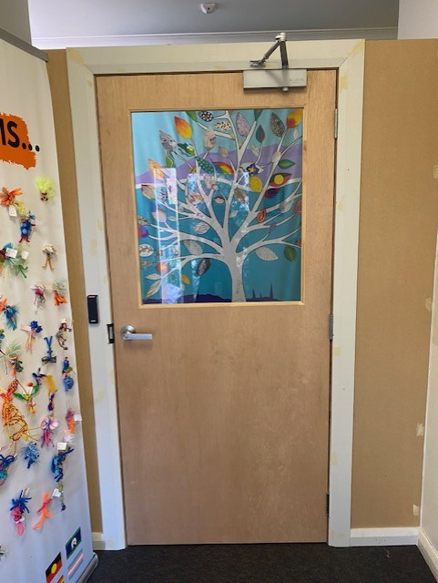

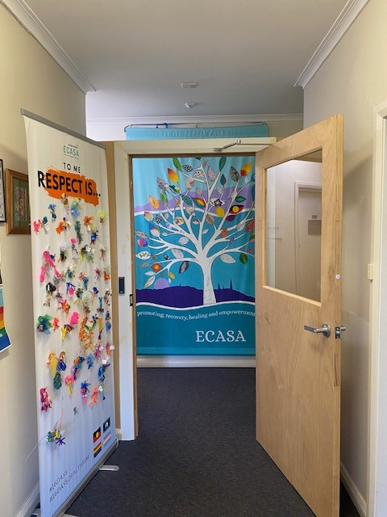

**Key Selection Criteria**

The artist is required to meet the following key selection criteria:

1. A member of the Aboriginal and/or Torres Strait Islander Community.
2. Express/illustrate a vision for healing, culture, country and partnership in support of the care of Aboriginal and Torres Strait Islander peoples at Eastern Health.
3. Demonstrate a connection to Eastern Health and /or the delivery of health care and/or community support.
4. Demonstrate capability to work with clients in a positive and consultative manner.
5. Must be able to meet the commissioning artwork timeline, for all completed art by the end of July 2025.
6. It would be desirable for the artist to feel a connection to the service and the support of all community members impacted by sexual assault.

**Application Process**

Artists are invited to express their interest by submitting:

* A brief email responding to the selection criteria above to Nikki Harris-Allan, Acting Manager, ECASA, nikki.harris-allan@easternhealth.org.au Include a link or examples of previous work.
* Artists are welcome to contact Nikki to discuss the proposal on 0400 428 572.
* All applications must be received by: Friday May 23rd 2025.

The applications will be shortlisted and reviewed by a panel at Eastern Health.