EMHSCA 2017
  - Annual Report
“Creating opportunities to work strategically across the region with Multi- Sectoral partners”
Provided by Bronwyn Williams – EMHSCA Project Officer

Contents
Acronyms 3
Definitions 4
From the Chairs 5
Our Vision 6
Our Values 6
Communications and Reporting 7
Accomplishments in 2017 8
Analysis of the work 9
Future Directions 10
EMHSCA Workforce Development Budget 11
Acknowledgements 12
EMHSCA Partners 13
Appendices 13
Appendix A: Collaborative Pathways Subcommittee 14
Membership 14
Background 14
Activities for 2017 14
Future Plans 15
Appendix B: Strategic Planning Subcommittee 17
Membership 17
Our aims 18
2017 Highlights 18
Future Plans 19
Appendix C: Workforce development Subcommittee 20
Membership 20
Background 21
Activities 21
Event summaries 22
Collaborative Care planning Workshop 22
EMR Orientation 22
The Peer Perspectives Forum 23
NDIS, Mental Health & Partnerships – Making it work together in the east! 23
Bridging the Divide - Mental Health and Co-occurring Issues Explored 24
Evaluating the Workshops 25
What has worked? 25
Areas for improvement 26
Future Work 27
Conclusion 27

Acronyms
AOD – Alcohol and Other Drug
CCAC – Consumer and Carer Advisory Council
DD – Dual Diagnosis
DHHS –Department of Health and Human Services
DHS – Department of Human Services
ECLC – Eastern Community Legal Centre
EDVOS – Eastern Domestic Violence Service
EMHSCA – Eastern Mental Health Service Coordination Alliance
EMR – Eastern Metropolitan Region
EPSN – Eastern Peer Support Network
IMHA – Independent Mental Health Advocacy
MH – Mental Health
MHCSS – Mental Health Community Support Services
NDIS - National Disability Insurance Scheme
SC – Sub-committee
WG – Working Group

Definitions
Carer: family members or friends of a consumer who provide care to the consumer within their relationship as defined by the Carers Recognition Act 2012. Carers may not necessarily live with the person for whom they care. Children can be carers too.
Clinical: Pertaining to treatment focussed services.
Collaborative: A care planning situation where all parties to the plan participate as equals in all processes of coordinated shared care required. This includes all EMHSCA agencies/programs, non-EMHSCA agencies/programs and practitioners, consumers, carers and others deemed relevant to the planning process. *Consent must be sought from the consumer.
Consumer: a person, who has been diagnosed with a mental illness, has direct experience of Mental Health Services or identifies as a consumer [VMIAC’s definition]. The term “consumer” refers to people who directly or indirectly make use of mental health services.
Peer: A person with a lived experience of mental ill-health and/or substance use who offers support to others and/or advice to service providers based on their experience.
Recovery: An ongoing holistic process of personal growth, healing and self-determination as defined by the person (Slade 2009).
Shared Care: Cooperative arrangements made to provide a holistic approach to health and community service provision and involve the consent of the consumer and the participation of the consumer and their carer, family and children where appropriate.

From the Chairs
As we celebrate the end of the first decade of the Eastern Mental Health Service Coordination Alliance we acknowledge the active and productive partnership that this alliance provides for twenty –seven health and community services in the Eastern Metro Region of Melbourne.
We are learning the new language of NDIS and alternative ways of operating as we embrace significant sector reform and work together to ensure people who experience mental ill-health and co-occurring issues continue to experience responsive, appropriate and collaborative services to assist with the multiple facets of their individual recovery journey.
The fourth EMHSCA Shared Care audit, conducted across 6 organisations between February and May 2017 revealed the need to re-commit our focus on collaborative practice across mental health, alcohol and other drug and community services to ensure best outcomes for consumers.
EMHSCA continues to grow and the commitment to the alliance appears strong as evidenced in the members’ survey results in December. Although some services will experience new limitations with regard to subcommittee work, workforce development and linkage participation, the intention to continue to collaborate remains. We are committed to our principles of client-centred care and collaboration, and look forward to working flexibly and creatively in the coming months and years.
The Eastern Mental Health and AOD Planning Council have released their action plan which involves the EMSHCA partnership as an important platform for implementation of screening and capacity building in relation to Family Violence, service users with dependent children, and Aboriginal and Torres Strait Islander people, with the central theme of mental health and substance use. The Eastern Melbourne Primary Health Network is also working to improve collaborative practice via the Eastern Melbourne Primary Health Care Collaborative (EMPHCC) which will include a focus on mental health. EMHSCA continues to support collaborative arrangements and strengthen the local workforce to enable the work.
As 2017 draws to a close and we prepare for continuing collaboration in 2018 we encourage our partners to take this time to consider the importance of our collective work as a vehicle for improving collaborative service provision. Your continued participation is vital to ensure that the experience for the people we serve is as seamless as possible. We look forward to reviewing the goals of our work together and renewing the direction and focus of our Alliance in 2018.
Brad Wynne Dr Tamsin Short
Associate Program Director Senior Manager: Mental Health & AOD Services
Adult Mental Health Community & Rehabilitation Access Health and Community
Eastern Health

Our Vision
To ensure that people who experience mental ill-health and co-occurring concerns have access to responsive, appropriate and collaborative services to assist with the multiple facets of their individual recovery journey.

Our Values
At EMHSCA we value:
• A Strategic approach by encouraging the expansion of organisational thinking and planning into a broader regional context.
• A Respectful approach by treating everyone with courtesy, acknowledging all viewpoints, respecting diversity, and considering everyone with fairness and ensuring constructive honesty.
• Participation from a diverse network of services, consumers and carers who commit to being actively involved in the sharing of information, practice wisdom, resources, and innovation.
• Working collaboratively to support each other to achieve common goals and enhance integrated practice across the region.
• Capacity Building to assist with continuous improvement of the services provided in this region, enhancing collaboration and coordinated care.

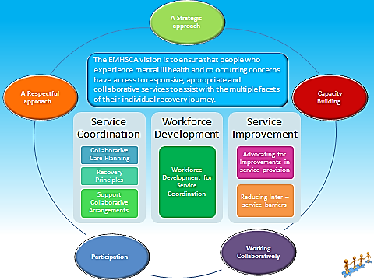
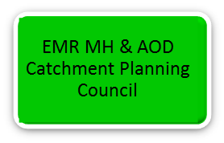
Communications and Reporting 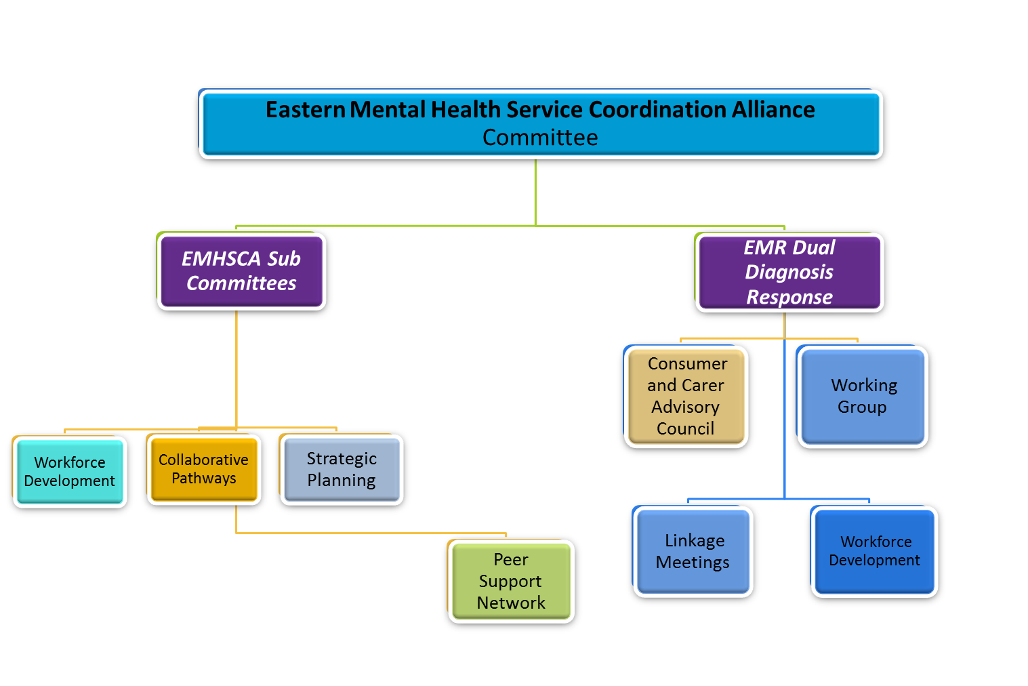
The EMHSCA committee consists of senior managers across inner and outer eastern regional services. They collaboratively strategise and implement significant improvements to service delivery. There are three EMHSCA subcommittees who are actively addressing the elements of the EMHSCA Strategic Plan. Information about their work can be found at http://www.easternhealth.org.au/services/mentalhealth/emhsca.aspx .
To ensure sustainability of the various Dual Diagnosis initiatives in the EMR, a communication relationship has been created with the EMHSCA committee encouraging this common co-occurring issue to be viewed as central to mental health service coordination. The Dual Diagnosis Consumer and Carer Advisory Council is the key peer advisory to EMHSCA. Dual Diagnosis Linkages are the front line staff level network to support service coordination in this region.
EMHSCA works alongside the Mental Health and AOD Regional Planning Council to support and inform the implementation of priority activities for the region.
The Eastern Peer Support Network is a monthly linkage for peer workers across the EMR. A standing agenda item exists for this group to report back to the EMHSCA committee and the Strategic planning sub-committee.

Accomplishments in 2017
- Recognition of the 10 year anniversary of EMHSCA occurred at the EMR Orientation which catered for 220 health and community service providers from 17 health and community service sectors.
- The 4th review of the Shared Care Protocol commenced with the lens of NDIS and other EMHSCA strategic priorities. Consultation included DHS Centrelink, ECLC and Bolton Clarke.
- The Collaborative Pathways subcommittee have developed a colocation guide and provided this to EMHSCA in June.
- A Shared care planning proforma was developed to accompany the Shared Care Protocol and was presented to EMHSCA members in June.
- The Collaborative Care planning Workshop was held in March and involved 70 participants from 15 organisations/ services.
- The Peer Perspectives Forum was held at the Box Hill Town Hall in May and saw around 120 people attend to connect and to learn about how people can make their lived experience count.
- The EMHSCA NDIS forum was provided to 250 staff on 31st August at the Box Hill Town Hall.
- A leadership forum which focussed on the impact of NDIS for EMHSCA was held during the broader EMSHCA NDIS forum and a report was provided.
- The 4th Annual Shared Care Audit report was delivered prior to the August EMHSCA committee meeting and showed the first decline in shared care practices since commencement of the audit process in February 2014.
- The Mental Health and Co-occurring Issues Explored workshop provided to 70 participants in November.
- Consultation regarding effective engagement of peer advisors with EMHSCA took place with the DDCCAC from May 2017.
- Mapping of EMHSCA services and partnerships in relation to NDIS and service change was completed in August.
- EMHSCA presentations were provided at the VAADA conference in February and the VAADA forum in November.
- EMHSCA was presented as a case study at the DHHS Mental Health Innovations forum in September and this case study is now on the DHHS website.
- The EMR Planning Council action plan was delivered by the catchment planning team and is supported by EMHSCA.
- EMHSCA Membership expanded to include Yarra Valley Psychology and Campbell Page.
- A membership survey was conducted to assess the needs of the alliance in 2018 and the potential effects of the NDIS on the EMHSCA strategy.
Analysis of the work

Future Directions
- Strategise to improve the sustainability of the EMHSCA model in an ever-changing environment.
- Articulate EMHSCA’s role in supporting referral pathways.
- Commence some qualitative evaluation of the EMHSCA model in partnership with Deakin University.
- A Physical Health and Mental Health project is to be headed up by Jacky Close and co-designed with Dual Diagnosis Peer advisors.
- Develop and provide a workshop that addresses the need for greater recognition of diversity in the provision of health and community services.
- Conduct Shared Care Audit in the second half of 2018 as a potential measure of the effectiveness of shared care and service coordination initiatives employed in the past year.
- Continue support for Service Coordination leaders in all EMHSCA member services.
- Develop relationships and pathways with Aboriginal Services.
- Improve awareness of Family Violence issues and pathways.
- Strengthen peer participation across the EMR.
- Strategise to improve service responses to vulnerable families.
- Continue to map current and existing partnerships and collaborative initiatives of EMHSCA member organisations.

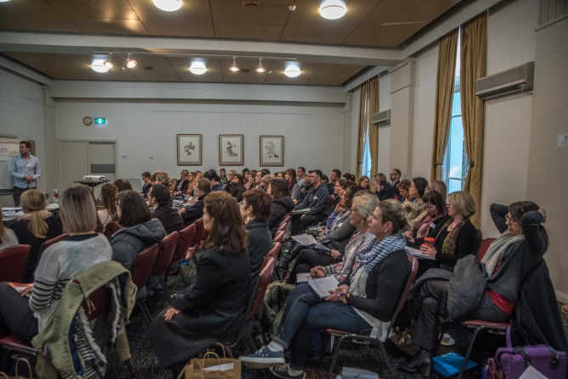
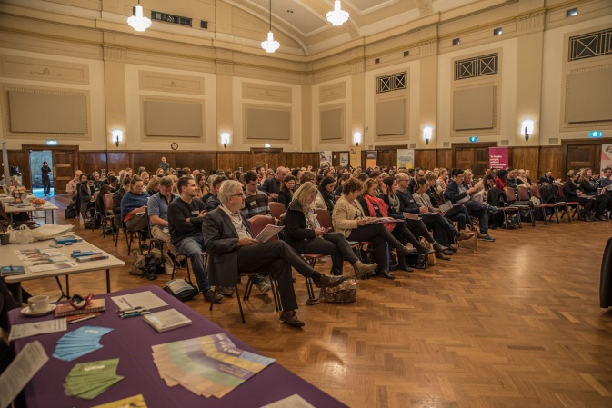

EMHSCA Workforce Development Budget
In March 2017 EMHSCA member services contributed $478 each towards the workforce Development activities for the year.
The four events provided cost $13,056 and catered for 810 staff from our partner services. This is an average cost of $16.10 per participant.
The EMHSCA NDIS forum was provided in August and the Eastern Melbourne Primary Health Network substantially contributed to ensure its success, given that the extent of this event was not initially planned for.
Costs for 2017 are outlined in the table below.
As there are significant changes to the ability of MHCSS partners to contribute to the Workforce Development fund in 2018, the EMHSCA workforce development subcommittee are currently considering how best to fund these events in the future.
Jan-Dec 2017 | CCPW | Orientation | NDIS | MHACIE | Totals
No. participants | 70 | 220 | 250 | 70 | 810
Venue costs | 414 | 1650 | 1,635 | 444 | 4,143
Catering costs | 1291 | 3,600 | 2,859 | 1,163 | 8,913
Total costs | 1,705 | 5,250 | 4,494 | 1,607 | 13,056

Total costs: $13,056 minus $3,676.50 (NDIS event catering and half of venue hire paid by EMphn).
Picture from Mental Health & Co-occurring Issues Explored Workshop 24th August 2016
Total EMHSCA fund expenditure: $9379.50. The 2017 budget allowed for $9556.50 for events.

Acknowledgements
As the EMHSCA Project officer I am grateful to all those who provide their time, energy and expertise in order to improve service coordination for people who experience mental ill-health and co-occurring issues.
I am grateful to all of our chairs.
EMHSCA committee: Brad Wynne and Tamsin Short
Strategic Planning subcommittee: Michelle Clark
Collaborative Pathways subcommittee: Damian Medley
Workforce Development: Jose Abalo and Anna Makris
A huge thank you to all the EMHSCA committee and sub-committee members who attend meetings, support and host events, strategise, decide on and disseminate the work of EMHSCA. Your enthusiasm and involvement is very much appreciated. The ongoing partnership and continuing collaboration across this region are a result of the contribution of many committed people.
I acknowledge the work of Annie Rawson in engaging the local peer workforce and promoting consumer and carer participation in this region.
I would like to thank the Department of Health & Human Services for providing ongoing leadership and support for this project role. Special thanks go to Cathy Keenan and Michelle Clark for their ongoing over-sight and support for the project.
I acknowledge Eastern Health for auspicing the EMHSCA project role and to Brad Wynne and Gavin Foster for their supervision and guidance. I am grateful to Julie Craw and Belinda Tenace at Eastern Health for their assistance with the administration of the EMHSCA work force development funds.
Thank you to all who have contributed financially and physically to the EMHSCA workforce development events in 2017. These events are significant undertakings and the overwhelmingly positive feedback received from participants is testament to all you have achieved. Special thanks are in order for the administration and financial support provided by the staff of the Eastern Melbourne phn.
And finally, I want to express my gratitude to all the consumers and carers who have provided their advice and support to EMHSCA activities. Your contributions keep the work of EMHSCA real!
It is a privilege to work with you all and I look forward to further collaboration in 2018.
Bronwyn Williams - EMHSCA Project officer

EMHSCA Partners
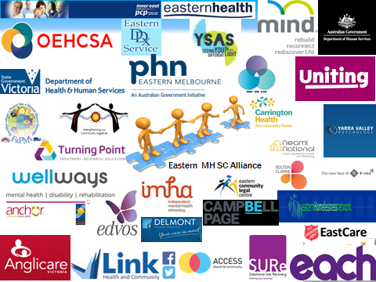

Appendices
Appendix A – Collaborative Pathways Sub Committee Annual report 2017
Appendix B – Strategic Planning Sub Committee Annual report 2017
Appendix C - Workforce Development Sub Committee Annual report 2017
Appendix E – Eastern Peer Support Network annual project report August 201

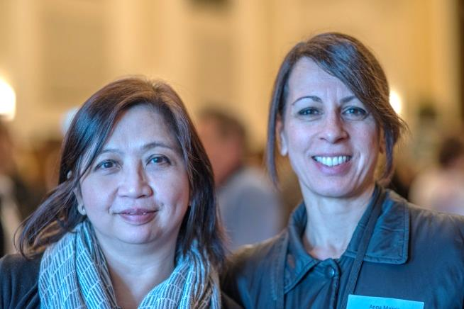
Maria Yap (EMPHN) & Anna Makris (DHS Centrelink)

Appendix A: Collaborative Pathways Subcommittee

Membership
The Eastern Mental Health Service Coordination Alliance (EMHSCA) Collaborative Pathways committee consists of the following representatives:
Agency | Member
Access health & community/Connect4Health | Beth Locke
Anglicare AOD | Rob Watson
Australian Govt. DHS Centrelink | Ann Fraser
EACH MHCSS | Debbie Stanley
Eastern Community Legal Centre | Suresh Ramachandraiah
Eastern Health MH Program | Lisa Gill, Bronwyn Williams (Project officer)
Eastern Melbourne PHN | Rachel Pritchard
EMR Planning Council /EACH | Kim Johnson
Wellways PIR | Rowan Arahia
Mind East MHCSS | Martine Moor (resigned October)
Neami National MHCSS | Ed Marrinan
Bolton Clarke (RDNS) | Tracey Easte
Uniting Prahran MHCSS | Emma Gallardo

Background
The EMHSCA Collaborative Pathways Subcommittee (CPSC) was formed in November 2012. The overarching aims of the subcommittee include:
- Supporting organisational change that enables improvements in Service Coordination in the Eastern Region.
- Creating a sustainable Service Coordination Model.
- Put in place mechanisms to enable improved collaboration between services in the Eastern Metropolitan region in relation to care for people who present to services with mental health concerns and co-occurring issues.
The EMHSCA Shared Care Protocol was developed and reviewed by this subcommittee of EMHSCA and endorsed for use across the Eastern Metropolitan Region of Melbourne in February 2016. An implementation strategy was developed and endorsed by EMHSCA in 2014 to support the embedding of the Shared Care Protocol principles in practice at all EMHSCA member services. This strategy is to be reviewed in 2018.

Activities for 2017
- Monitoring regional shared care practices
- The Annual EMHSCA Shared Care Audit was provided in a flexible format over 3 months this year. The files of 1589 consumers across 6 organisations were audited by EMHSCA member service staff to examine shared care practices across the region. This de- identified data collection aims to highlight areas of need in relation to shared care practices. After 3 years of demonstrated improvement, this year’s results showed a decrease in most domains of the audit. Potential causes of this decline are sector reforms and staff role instability.
- Audit results showed improvement in the involvement of carers in planning processes and there was an increase of service organisations reporting a reduction of all participant exclusion from the shared care plans.
- Redevelopment of the Consumer Shared Care Survey to support the Annual Shared Care audit. This required consultation with EMR consumer and carer advisors from a variety of services.
- A survey was provided to EMHSCA members to ask for suggestions regarding future Shared Care audits. Members considered the value and feasibility of the audit going forwards and decided to continue in the latter half of 2018.

- Shared Care Protocol Implementation Plan

- The EMHSCA shared care protocol review commenced with the inclusion of non-health sector representatives.
- A narrative regarding shared care from a consumer perspective is in development.
- A shared care proforma and guide were developed and endorsed for use across the region to simplify complex collaborative care arrangements for service providers, consumers and carers.
- A review of the implementation strategy is planned for 2018.

- Service Coordination Champion role and Linkages

- CP SC members agreed to rework the model and decided that the CP SC and Workforce Development SC members would become the Service Coordination Champions.
- Rob Watson of Anglicare and Kim Johnson of Each were the 2017 recipients of the Service Coordination Champion awards for their significant contributions to EMHSCA and collaborative practices in this region.

- Colocation

- Mapping of colocation arrangements including barriers and enablers to colocation was completed.
- The EMHSCA colocation guide was developed and endorsed.

Future Plans
- Service Coordination Champions

- Ensure membership of the Collaborative Pathways subcommittee and the Workforce Development subcommittee is representative of all EMHSCA member services.
- Encourage all Service Coordination Champions to attend the Annual Collaborative Care Planning Workshops at least once and attend the Annual EMR Orientation at least once.
- Collect and collate bi-annual feedback from Service Coordination Champions and Linkages.

- Audit of Shared Care Practices

- A 5th service audit of Shared Care Practices is planned for October 2018.
- EMHSCA services are encouraged to embed the elements of the Shared Care Audit in local practices.
- Conduct EMHSCA Consumer care planning survey.

- Consumer and Carer Involvement

- The CP SC has considered its level of consumer and carer participation in subcommittee activities and consulted with the Eastern Dual Diagnosis Consumer & Carer Advisory Council (DD CCAC) regarding suitable ways to ensure consumers and carers are represented in EMHSCA developments.
- DD CCAC members will be invited to join the CP SC in 2018.
- Consumer and carer representatives are members of the EMHSCA committee which regularly oversees the work of the CP SC.

- Supporting shared care practices

- Articulate EMHSCA’s role in facilitation of referral pathways.
- Complete review of the EMHSCA shared care protocol including updates regarding consent and information sharing.
- Review Shared care protocol implementation strategy.

Pictures from EMR Dual Diagnosis Linkages 10 Year Anniversary Celebration
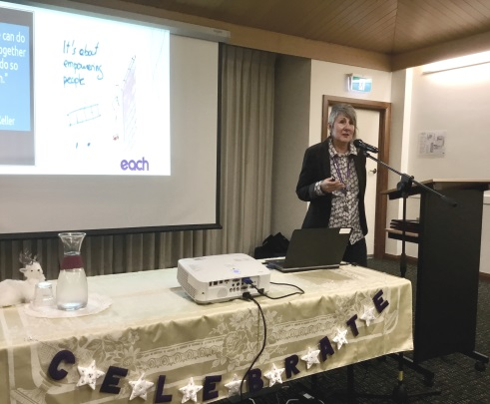
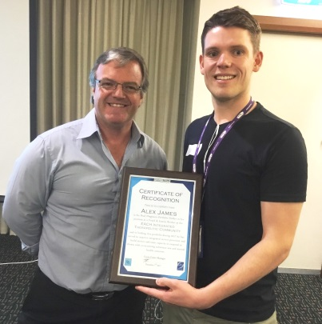
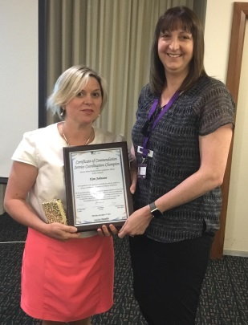

EMHSCA Project officer Bronwyn Williams presenting the EMHSCA Service coordination champion award to Kim Johnson of EACH
Keynote speaker Jenni Thompson of EACH and a founding member of the Dual Diagnosis Linkages network.

Dual Diagnosis Service Manager Gavin Foster presenting Youth & Family Worker Alex James of EACH with the 2017 Dual Diagnosis Champion award

Appendix B: Strategic Planning Subcommittee
In late 2013 the Visionary sub-committee of EMHSCA was formed from current EMHSCA committee membership and was representative of the various sectors of EMHSCA. This sub-committee was set up with the initial aim of developing the first EMHSCA Strategic Plan. The committee was soon renamed to reflect their purpose and became the Strategic Planning sub-committee.

Membership
Member | Title
Anne Dooley (resigned November 2017) | Service manager, MIND Maroondah PARC
Bronwyn Williams | EMHSCA Project Officer /Recovery Framework Implementation Project Officer
Ed Marrinan | Service Manager, Neami Ringwood
Hang Vo | General Manager, Planning, Strategy & Development/EACH
Jacky Close | Executive officer, Outer East Health and Community Support Alliance
Jodie Pappas | Team Leader, Uniting Prahran Kew
Emma Newton | Manager System Redesign & Service Transition (Mental Health/AOD) EMPHN
Michelle Clark (Chair) | Senior Program Adviser, Health Integration & Partnerships, Outer Eastern Melbourne Area, East Division, Department of Health & Human Services
Sally Missing (retired June 2017)/Tracey Blythe | Executive Officer, Inner East PCP
Tamsin Short | Senior Manager Mental Health and AOD, Access Health &Community/Connect 4 Health
Tim Brewster | Service Manager, Outer East Continuing Care Teams, Adult Mental Health Program, Eastern Health
Tom Stylli | Team Leader, SURe AOD services

Our aims
The key objectives of this sub-committee are to
- Contemporise and support implementation of the EMHSCA Strategic Plan.
- Measure EMHSCA member satisfaction with EMHSCA activities.
- Strengthen the Peer (Consumer and Carer) workforce in the EMR.
- Ensure measurement of EMHSCA activities is consistent with the EMHSCA Strategic Plan.
- Review the EMHSCA MOU in line with the EMHSA Strategic Plan.

2017 Highlights
- A clear strategy was developed to support EMHSCA in the transition to NDIS.

- A Leaders’ forum was provided as part of the August event “NDIS, MH and partnerships making it work together in the east!” Fifteen leaders attended and recommendations were provided to the EMHSCA committee for consideration.

- An EMHSCA focussed NDIS information page was delivered via the Eastern Health website.

- EMHSCA partnerships and service provision was mapped with particular reference to NDIS.
- Clarification of the role of EMHSCA in relation to the regional Planning Council for AOD and MHCSS progressed –Catchment planners are represented on the EMHSCA committee, EMHSCA Strategic Planning subcommittee, and the Collaborative Pathways Sub-committee.
- The membership guide was updated to better support new members to EMHSCA.
- Commissioning of a project to support better understanding of the physical health needs of people who experience mental ill health in this region via the OE PCP and the DDCCAC.
- EMHSCA project officer met with DHHS Manager Engagement and Outcomes regarding the Aboriginal engagement strategy for EMHSCA.
- EMHSCA project officer met with Kelly Hinton (Principle Strategic Advisor RFVP) and the chair of the Eastern Regional Family Violence Partnership (RFVP) regarding their engagement with EMHSCA.
- The SP SC collaborated with the Dual Diagnosis Consumer and Carer Advisory Council regarding how we can improve our communication co-design and peer endorsement processes for the EMHSCA work. A tip sheet on engaging with peer advisors was created and endorsed.

Future Plans

- Clarify outputs and outcomes for the EMHSCA strategy.
- Support EMHSCA Workforce development subcommittee to provide the NDIS unpacked forum in May 2018.
- Seek support for the coordination role of the Eastern Peer Support Network.
- Continue to collaborate with the Eastern MH & AOD Planning Council and support a sustainable approach to catchment planning work.
- Continue to ensure EMHSCA membership is appropriate and strategic.
- Continue to facilitate the EMHSCA strategy to maintain linkages and collaboration during the roll-out of NDIS in this region and adjust as required.
- Continue to consider useful links and improvements to the EMHSCA structure to promote collaborative work with Aboriginal Services.
- Collaborate with EDVOS and the MH/AOD catchment planning team to develop strategy to strengthen screening and pathways to support for people experiencing Family Violence.
- Consider ways to support the developing peer workforce in the region.
- Monitor EMHSCA membership and support strategic expansion.

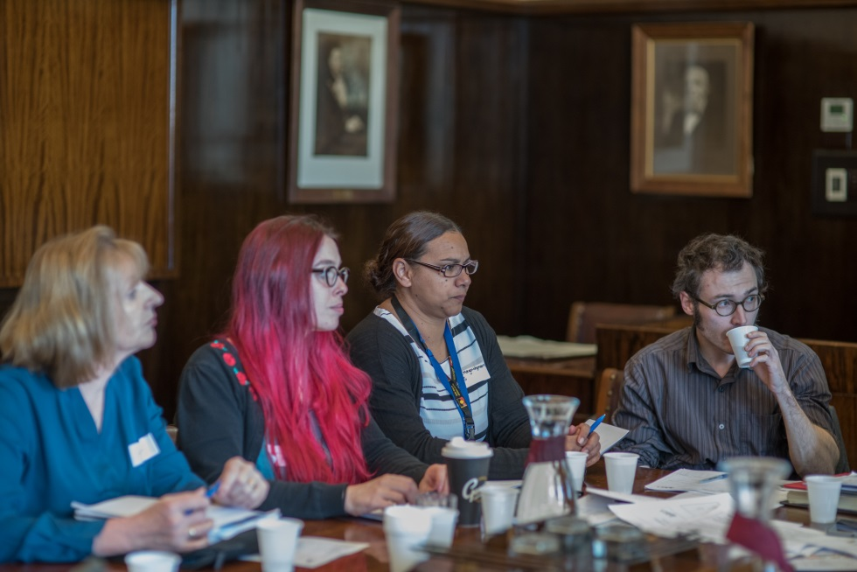

Appendix C: Workforce development Subcommittee

Membership
Name | Organisation
Aaron Jones | Neami National
Anna Makris (Co-chair) | Federal Dept. Human Services
Bronwyn Williams (Project Officer) | Eastern Health
Sandro Madrigale  Catherine Hudgson | Older persons services representative
Sarah Kinstler  Sue Lee Ng | Wellways
Pembrooke Werden | Uniting Prahran
Corey Eastwood | MIND PARC programs
Jose Abalo (Co-chair) | Federal Dept. Human Services
Kim Moreland | EHMH PDT
Maria Yap | EM PHN
Stephanie Bortignon  Nell Dickinson | Anglicare

The EMHSCA Workforce Development Committee develops, provides, and evaluates Mental Health Service Coordination Capability Training for all services involved with EMHSCA. All events include peer workforce participation as a priority. The focus of these events is Recovery oriented and person centred Service Coordination with reference to the EMHSCA shared care protocol and its key principles of collaboration.

Background
In 2008 the Eastern Health Mental Health Alliance Education & Training (EMHA E&T) Committee was convened as a sub-committee of the Eastern Mental Health Alliance Group in order to develop and provide training that would enhance the collaboration between Mental Health services in the Eastern Metropolitan Region (EMR) who were engaged in working with people recovering from severe and enduring mental health concerns.
Over the past 8 years the focus of the committee has been refined to provide workforce development to EMR services involved in service provision to people who experience mental ill-health and aims to enhance service coordination in the region.

Activities
In 2017 we have provided five events as follows:
- Collaborative Care Planning Workshop – for staff to explore the principles of collaborative care planning and familiarise themselves with the elements of the EMHSCA Shared Care Protocol.
- A Region-wide orientation - for new staff to learn about the various services provided referral pathways, intake processes and an opportunity to network.
- The Dual Diagnosis Consumer & Carer Advisory Council and Working group in collaboration with the Eastern Peer Support Network provided the annual peer workforce forum.
- NDIS, Mental Health and Partnerships – Making it work together in the east! forum – A new event as part of the EMHSCA strategy for supporting services through system change and preserving partnerships in a changing environment.
- “Bridging the Divide” Mental Health & Co-occurring Issues Explored (MHACIE) Workshop – An opportunity for participants to consider how to approach complexity in the system as they work with people with multiple concerns.
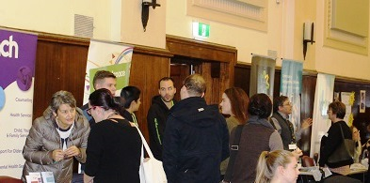

Event summaries
Collaborative Care planning Workshop
The Annual Eastern Metropolitan Region (EMR) Collaborative Care Planning Workshop (CCPW) was held on Thursday the 30th March 2017 in the Matsudo Room at the Box Hill Town Hall and catered for 65 attendees in total. This event is provided annually by the EMHSCA Workforce Development sub-committee which consists of 10 staff from a variety of EMHSCA services. A number of additional staff also assist the committee on the day of the event.
The purpose of this event is to orient staff from health & community services across the EMR to the EMHSCA Shared Care Protocol and provide opportunity to explore the challenges of collaborative practices with an emphasis on generating solutions.
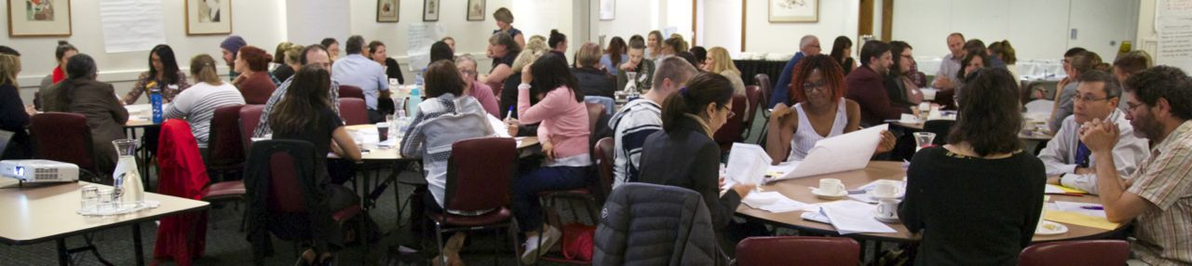
EMR Orientation
The 10th Annual Eastern Metropolitan Region (EMR) Orientation event was held on the 18th May 2017 in the Ballroom at the Box Hill Town Hall and attracted 216 attendees in total (7% increase on 2016 attendance). This event is provided annually by the EMHSCA Workforce Development subcommittee which consists of 12 staff from a variety of EMHSCA services. A number of additional staff also assist the committee on the day of the event.
The purpose of this event is to provide a forum for new and interested staff from the EMR to learn about a range of health and community support services and meet other local staff.
A range of sectors were represented on the day including Mental Health (community and clinical), Alcohol and Other Drugs (AOD), Homelessness/Housing, Aged care services, Youth services, DHHS, DHS Centrelink, Primary Health Network, Family services, Specialist Family Violence services, Carer and Consumer groups, Partners in Recovery, education services and legal services. Almost 40% of the participants were new to the sector and 60% were not. 51% were new to their organisation and indicates that this event provides benefits to staff who are not necessarily unfamiliar with the Eastern region as well as to those who are new.
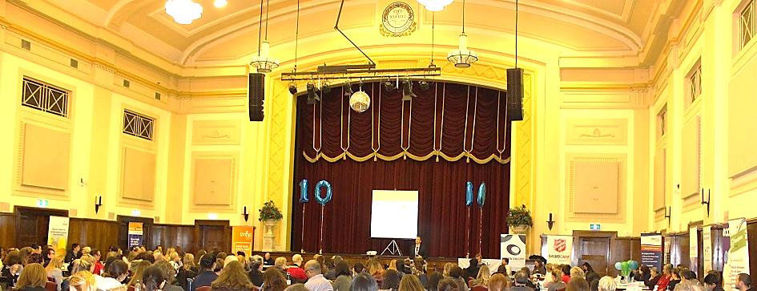

The Peer Perspectives Forum
This event was held on the 29th May 2017 in the Lower Town Hall Box Hill. With approximately 120 attendees, 64% peer workers; 16% service providers; 20% interested in peer work. There was representation from 9 services and 4 peak bodies. Morning speakers were from the peak bodies which included an NDIS focussed presentation by VMIAC. The afternoon included a series of elective workshops for participants. Overall this event was very well received. A marketplace of peer workforce focussed stalls supported improved service awareness and opportunities for connections. 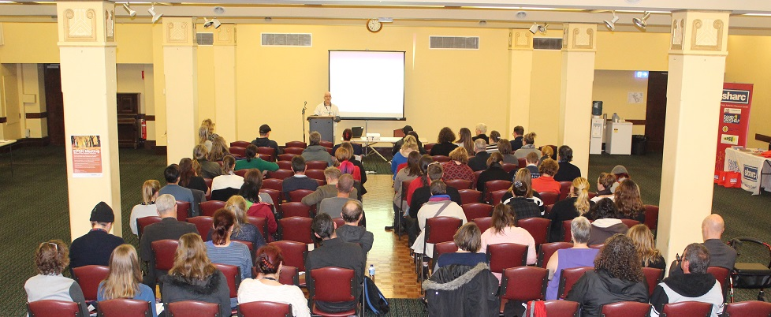
NDIS, Mental Health & Partnerships – Making it work together in the east! 30th August 2017
The EMHSCA Workforce development and Strategic Planning subcommittees identified the need to prepare the Eastern Metro Region Health and Community services for the roll-out of the National Disability Insurance Scheme (NDIS) that is planned to commence in November 2017. Held at the Box Hill Town Hall, the event catered for 250 staff from more than 40 services.
The aim was to provide a mental health focussed NDIS forum tailored to the needs of a range of health and community service sectors who are often involved in working with people experiencing mental ill-health and psychosocial disability and are EMHSCA partners. The key objectives were to 1. provide clarity regarding the various roles of staff, and 2. explore the issues around maintaining the EMHSCA partnerships. The event was provided in 3 parts: Mental health focussed overview presentations; Marketplace of services; Afternoon tailored, sector focussed break-out sessions. The event also included a Leader’s forum to discuss a strategy to manage the potential impacts of NDIS on partnerships.
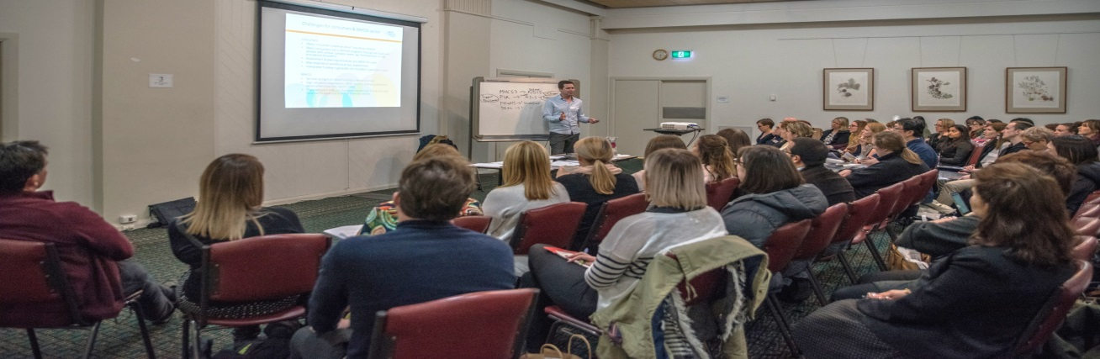

Bridging the Divide - Mental Health and Co-occurring Issues Explored
The Annual Eastern Metropolitan Region (EMR) Mental Health and Co-occurring Issues Explored (MHACIE) Workshop was held on Thursday the 30th November 2017 in the Matsudo Room at the Box Hill Town Hall and catered for 70 attendees in total. This event is provided annually by the EMHSCA Workforce Development subcommittee which consists of 10 staff from a variety of EMHSCA services. A number of additional staff also assist the committee on the day of the event.
The purpose of this event is to provide increased understanding of a variety of issues that may co-occur with mental ill health. Originally entitled “Complex Issues Explored”, it was renamed to more specifically address particular co-occurring issues. The event aims to highlight the fact that it is the system that is complex and not the people we work with.
This year the following co-occurring issues were explored: Physical Health; Substance use; Intellectual Disability; Acquired Brain Injury; Aboriginal health & well-being; Family Violence.
Presenters included staff from Eastern Health, Neami, Victorian Dual Disability Service, CBDATS, Eastern Dual Diagnosis Service, Safe Futures, and EACH.
The consumer perspective on approaching complexity was provided by Elinor Jack. There was a focus on creating safe environments, privacy and the importance of a collaborative approach. The event concluded with a presentation from Aaron Jones (NEAMI) spoke to the issues around approaching complexity.
Table facilitators were utilised to ensure workshop exercises were well utlilised, even with large numbers of attendees. These facilitators were briefed and provided with a guide to support their role.
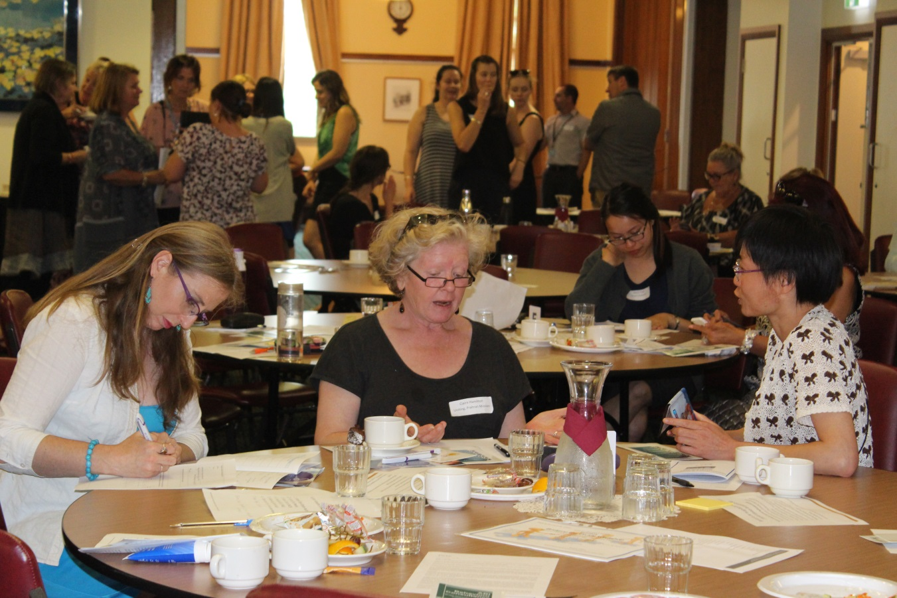

Evaluating the Workshops
Participants were encouraged to offer their feedback at the conclusion of each event. These were collected and data entered into Survey Monkey. Feedback results were circulated to presenters and to committee members and discussed at monthly meetings. Currently the collated feedback is being evaluated for consideration in the development of workshops for 2018.

What has worked?
CCPW (March)
- A confident and engaging peer presenter who workshopped her story with participants.
- Dr. Louise Alexander providing a presentation on collaboration with G.Ps.
- The peer workforce presentation raised awareness of this important partner in the work.
- The standard program for this event is tested over years.
- Cross-sectoral table groups were mentioned by participants as valuable for broad discussion.
EMR Orientation (May)
- This event is very well organised and received.
- Relevant and engaging presentations.
- Marketplace around perimeter of morning sessions.
- Plenty of choice.
Peer Perspectives Forum (May)
- Breakout rooms were a useful development.
- A quiet room with creative activities was welcomed by many.
- Marketplace stalls supported networking and service knowledge.
NDIS Forum (August)
- Practical information provided re NDIS for a variety of sectors.
- Knowledgeable presenters from North East services.
- Overt intention to collaborate during system change.
- Good format to event.
- Tailored break-out sessions for various sectors.
- Real case examples.
MHACIE (November)
- The range of presentations was well received.
- All presenters provided high quality workshops.
- Breaking down complexity into systemic issues improved participants sense of competence in managing issues that involve multiple and complex needs.
- The event attracted almost 100 applications for attendance.

Areas for improvement

CCPW (March)
- More care planning tools to be provided for discussion in table groups.
- Table groups to be encouraged to find quieter spaces for discussions.
EMR Orientation (May)
- Sectoral overviews to be longer session with more breaks.
- Afternoon sessions to be fewer and longer.
- Include short descriptions of workshop choices in event booklet.
- Encourage case discussions in break-out sessions.
- Catering may need to change for this large event.
Peer Forum (May)
- Extend invitation to more service providers.
- Include more info on NDIS as it rolls out in the east.
NDIS Forum (August)
- Further explore impacts on services.
- Focus on support for consumers not phased in with MHCSS.
- More specific info for non-MH service providers.
MHACIE (November)
- Continue to strive for a good blend of case based presentations and specialist information.
- Encourage application of knowledge and skills to cases in workshop.
- Improve focus on how to work together for people.

Future Work
- NDIS unpacked forum planned for 17th May 2018 to continue the partnership conversations and knowledge development regarding this significant system reform.
- Consideration of need to move to user pays model with funding changes.
- Managing Transitions between age groups and sectors.
- Provision of a Diversity focussed workshop.
The EMHSCA members’ survey conducted in late 2017 revealed a potential decline in organisational capacity to support staff participation in the EMHSCA Workforce Development subcommittee, provision of marketplace stalls, funds for events, and attendance at events. The decline could be as much as 50%, and is most likely a result of MHCSS partners becoming NDIS providers with reduced time for collaborative activities and reduced funding. Creative solutions need to be considered if EMHSCA Workforce Development activities are to continue beyond June 2018. Potential solutions are currently being considered by EMHSCA partners and there is tangible good will and intention to support the work going forwards.
Changes to membership are occurring across the various EMHSCA committees and the Workforce Development subcommittee is experiencing some of the most significant ones. Both Aaron Jones and Jose Abalo, who joined the committee in 2013, have resigned in December 2017. Aaron Jones has served the committee as chair for 2015 and has contributed substantially to events and planning. His creativity and clear thinking has been a significant asset to the work and he will be missed. Jose Abalo has served as co-chair for the committee from 2016-2017 alongside Anna Makris and has championed the integration of Centrelink into the EMHSCA work. His good humour and decisive leadership have been most beneficial to the committee and his departure is regrettable. New members are continually sought as the work of this committee is substantial and requires energy and commitment.

Conclusion
The reputation of the EMHSCA events is well established and has become a standard aspect of orientation for new staff at a number of EMHSCA partner services. The overwhelmingly positive feedback received for each event provides the mandate for us to advocate for the continuation of the Workforce Development subcommittee, and to seek finances to support the ongoing provision of these high quality service coordination activities. Creativity will be required to survive the changes to health and community services as NDIS approaches full-scheme over the coming years. In spite of the perceived and experienced challenges, EMHSCA partners continue to support this important initiative and their commitment to explore solutions has not waned. The EMHSCA Workforce Development subcommittee looks forward with curiosity and expectation to 2018 as we navigate the new world ahead, and aim to continue to provide flexible and adaptive service coordination Workforce development events.

