Box Hill Mobile Support & Treatment Service

The Box Hill Mobile Support & Treatment Service (MSTS) is situated on Level 1, 43 Carrington Road Box Hill and is auspiced by Eastern Health Adult Mental Health Service and is part of a network of psychiatric services in the Eastern metropolitan region of Melbourne.

Who comes to BH MSTS?
The BH MSTS provides community rehabilitation for consumers between the ages of 18 and 64.
The primary role is to provide treatment and support to consumers and their carers and families, who are likely to benefit from a period of intensive rehabilitation to increase their level of functioning within the community and who live in the Municipalities of Whitehorse, (west of Springvale Road) Manningham and Monash.
The MSTS is a Smoke Free environment in line with the Eastern Health ‘Tobacco Free Policy’
What services do we provide?
- Assertive outreach and intensive support, treatment and rehabilitation to consumers in their own environment.
- A responsive service over seven days per week between the hours of 8.30a.m. And 5.00p.m.
- Intensive community support and develop relapse prevention strategies in order to reduce the likelihood of relapse, the need for inpatient treatment and deterioration in psychosocial functioning.
- Psychosocial rehabilitation to develop a consumers daily living skills and enhance their capacity for independent community living.
- Support to reduce the consumer’s length of an inpatient stay, when appropriate.
- Support the consumer in maintaining safe, secure and affordable accommodation.
- Education to the consumer, family and carers about mental illness and provide support as required

Interpreters will be arranged for people from non-English speaking backgrounds.

Who works at BH MSTS?
- Administration
- Registered Psychiatric Nurses
- Occupational Therapists
- Psychiatrists
- Clinical psychologists
- Neuropsychologists
- Social Workers
- Medical Officers

How to contact us...
The MSTS is not a front line service and referrals will usually be current consumers of the area mental health service. Referrals will generally be made via the consumer’s case manager.

We can also provide information about, and referral to, other counselling agencies when this would be more appropriate.

Who can refer?
Consumers, families and carers, other agencies and private practitioners are all welcome to discuss a referral to MSTS with the consumer’s case manager.

EASTERN HEALTH ADULT MENTAL HEALTH SERVICE

The Eastern Health AMHS is comprised of many mental health teams. Teams include the Continuing Care Team (CCT), Mobile Support & Treatment Service (MSTS), Young Adult Mental Health Service (YAMHS), Crisis Assessment and Treatment Team (CATT), Upton House psychiatric in-patient unit, Community Care Units (CCU) and Linwood PARC which all form a comprehensive area adult mental health service.

The Carrington Consulting Suites, co-located with the Koonung Clinic, provide services by private practitioners and are operated independently.

SMOKING POLICY

Eastern Health is a totally tobacco-free environment. In the interests of the health and safety of our consumers, staff and visitors, smoking is not permitted in the hospital or in the hospital grounds, including entrances, walkways and car parks. This also includes all buildings, grounds, walkways and car parks.

If you are currently a smoker, whilst you are on hospital premises, you are not permitted to smoke.

As a healthcare provider, we are committed to the health and safety of our patients and staff and ask for your support in this initiative.

How to find us

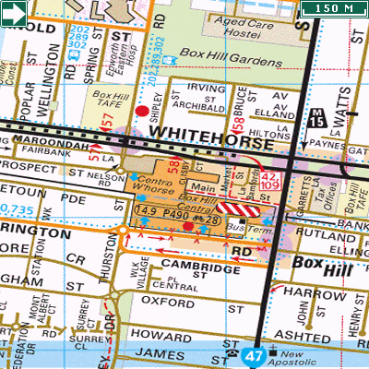

Koonung
KOONUNG CLINIC
1st Floor, 43 Carrington Road, Box Hill, 3128
Box Hill Mobile Support & Treatment Service
Level 1, 43 Carrington Road
BOX HILL 3128

Weekdays 9.00am-5.00pm
Phone: 9843 5800
Fax: 9843 5808
Weekends 9.00am-5.00pm
Phone: 0408 319 082
After hours
Phone: 1300 721 927
Ask for Triage Worker

Protecting Your Privacy

Our staff are committed to respecting your confidentiality and preserving your privacy. We will keep your personal information secure and protected from unauthorised access or improper use, and we will only disclose information about you if it is authorised by you or mandated by law.
All our services comply with the relevant information and privacy legislation.
If you would like a copy of our Privacy Policy please ask a member of staff or visit our website on www.easternhealth.org.au

Eastern Health is accredited by the independent Australian Council of Healthcare Standards in recognition of the achievement of acknowledged standards, and the commitment to continuous improvement in the provision of health care services.



Clive Ward Centre, 16 Arnold Street,
Box Hill, Victoria, 3128, Australia
Tel: (03) 9895 4888 Fax: (03) 9895 4844
Email: info@easternhealth.org.au
Website: www.easternhealth.org.au

© Eastern Health 2008
Authorised by Eastern Health ?????????



Box Hill Mobile Support & Treatment Service

BH MSTS
-----------------------------------------------------------

Eastern Health
Adult Mental Health Service
Level 1, 43 Carrington Road
BOX HILL 3128

Phone (03) 9843 5800

Fax (03) 9843 5808

