WOMEN LEADING CHANGE – FORUM SUMMARY 2018
Wednesday July 18th 2018 Norwood Football Club

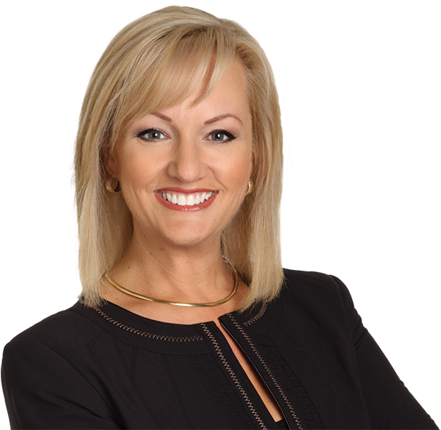
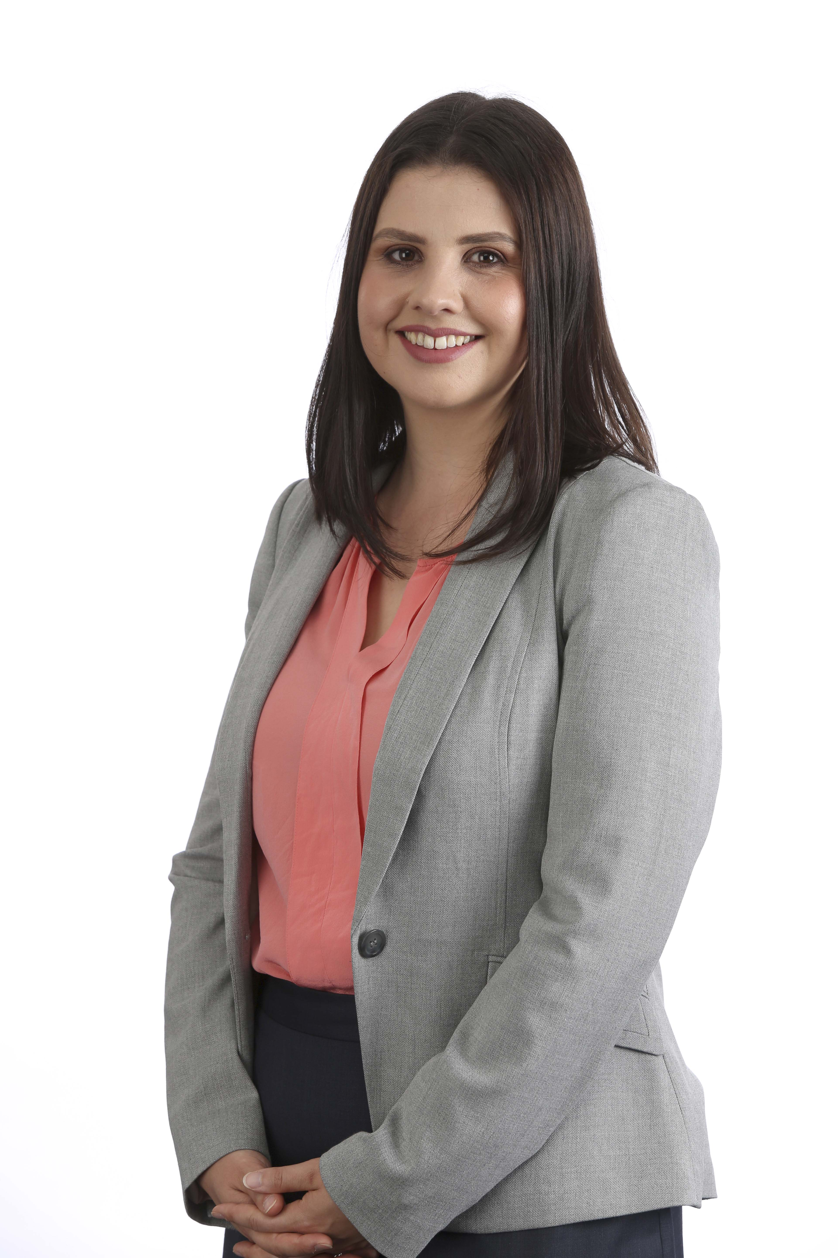
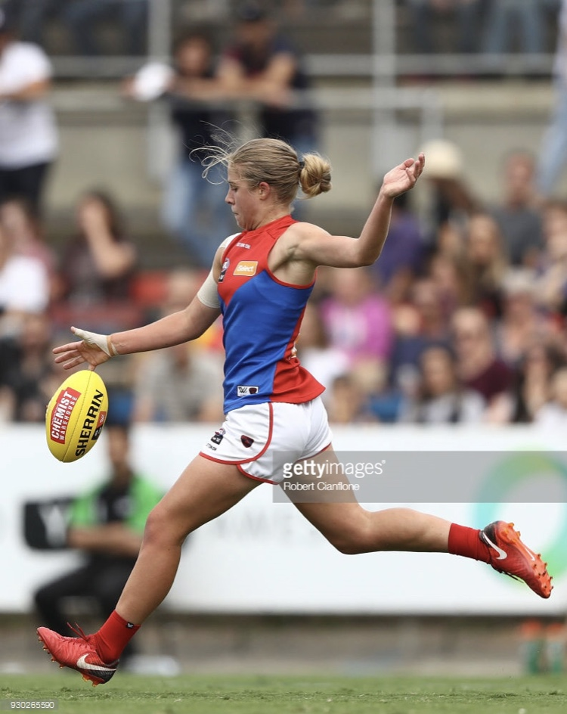

The Hon MLA Heidi Smith Cr Marijke Graham Katherine Smith (AFLW) Lauren Wood (Herald Sun)

Interesting facts!
185 people registered to attend the forum.
22 sporting clubs were represented including a range of senior/junior/football and netball clubs.
6 Councillors attended from Eastern Region councils.
23 representatives from Health Services and Local Government attended from the Eastern Metropolitan Region.

Feedback on the night
88 feedback surveys were received on the night.
73 respondents said that they had learned something new about gender equality that they did not know before.
52 participants expressed interest in further involvement with the Women of the EFL or Women of the AFL Yarra Ranges.
12 respondents were interested in finding out more about running for local government
61 respondents were interested to know more about opportunities for women and leadership.

Taking action on gender equality
98% of respondents to the feedback survey said they were inspired by the forum to take action on gender equality.

What stood out for participants about the guest speakers?
“We need to create a culture of women supporting other women”.
“We can have a go! Don’t be afraid to bite off more than you can chew! “
“We were inspired by young women, their leadership and encouragement to "smash through glass ceilings".
“We need to believe in ourselves, take risks and not be afraid to fail”.

WOMEN IN THE EASTERN METRO REGION

Girls and Women in sport – What are the priorities to support participation?
“Sporting environments need to be inclusive, welcoming and respectful of diversity”.
“The participation of girls and women is increasing and progressing well in our region”.
“We need to continue to improve and expand on facilities for girls and women in sporting clubs”.
“It is important for men to be allies”.
“Male privilege needs to be challenged - from conversations in club rooms, scheduling of games and the visibility of women's achievements in club rooms and the media.”

Women in Leadership – What is working well in our region?
“Opportunities exist to promote women in leadership such as business networks, in some sporting clubs, community groups and associations such as the Australian Local Government Women's Association (ALGWA)”.
“The visibility of female leaders still needs to be increased - even though women continue to take on leadership roles it is not always visible”.
“Sport is a key field in which women's participation in leadership needs ongoing promotion - in coaching, umpiring and in committee roles”.
“Create new forums for young women to focus on leadership pathways”.

Women in Leadership – What are the priorities for our region?
“There is a need for more networking opportunities, mentoring and role models”.
“Support is needed - such as child care, training, sponsorship and employee support”.
“The environment needs to be adapted to enable women to have equal opportunities – ensuring workplaces are flexible and the roles are meaningful”.
“Continue advocacy for women's affairs, to challenge “boys club” culture and ensure roles are rotated so that they are accessible”.

What are the priorities for young women in our region?
“Positive culture and support, focused on choice, empowerment, education and mentoring”.
“Promotion of gender equality in the home and challenging gender stereotypes”.
“Encouraging community involvement to build confidence”.

For more information contact josette.o’donnell@easternhealth.org.au

