HEALTHY MASCULINITIES AND THE PREVENTION
OF VIOLENCE AGAINST WOMEN- AN EASTERN REGION DISCUSSION

On February 7th representatives from sporting, local government and education settings in the Eastern Metro Region came together to discuss healthy masculinity and preventing violence against women. 26 different organisations were represented at the event. Dr Michael Flood from Queensland University of technology (QUT) and Michael Fendel from Jesuit Social Services both delivered passionate presentations on men, gender and masculinity.
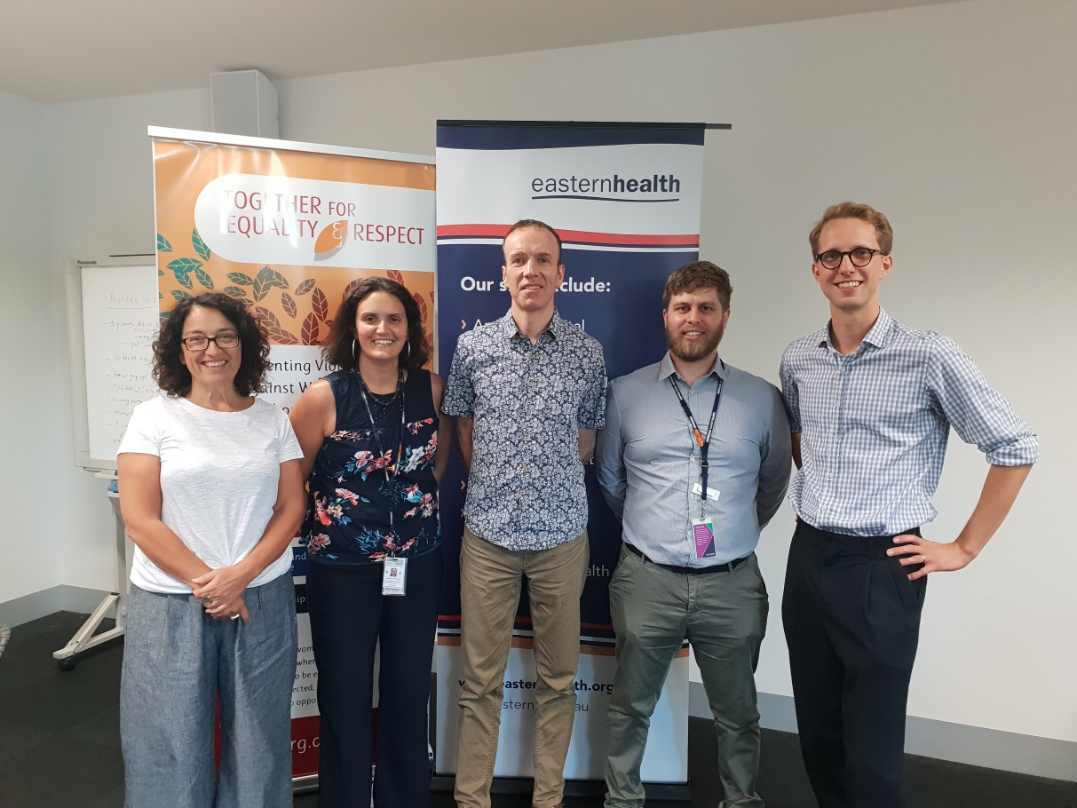
Kristine Olaris (Womens Health East), Josette O'Donnell (Eastern Health), Dr Michael Flood (QUT), Benjamin Brewin (Eastern Health) & Michael Fendel (Jesuit Social Services)
Key results
81% of attendees noted an increase in their awareness of the importance of promoting healthy masculinities to prevent violence against women.
84% of attendees noted an increase in their support for gender equality and the role of healthy masculinities in preventing violence against women.
94% of attendees found the event useful for their organisation.
Feedback from attendees:
“Awesome collaboration of people discussing an important topic."
"The cross section of attendees representing different organisations from government, not for profit and community was a highlight.

Where to next?
Priorities in the Eastern Region
Promote discussions about masculinity.
Work with young people 'where they are at'.
Engage with existing male dominated spaces.
Showcase positive role models.
Explore internal organisation work. Increase women's participation across the board.
Ensure that work with women is not displaced and that woman are part of the masculinities work.
Educate local leaders and people of influence.
Engage with the private sector.
Deliver bystander training: how we can call out everyday sexism.
Work with Women’s Health East and the Together for Equality and Respect (TFER) strategy.

Focus points for collaboration
Share knowledge and resources with each other.
Utilise leverage of accountable organisations.
Encourage councils to work together at different points along the journey.
Use a collective impact approach. Implement workplace audit tools and procedures.
Incorporate respectful relationships.
Engage with small business and private enterprise.
Engage with the trades sector.
Look at the intersection of alcohol and other drugs and mental health and wellbeing with healthy masculinities. Incorporate men's health as part of the message.
Determine how we measure the difference we are making.

Save the dates for the first steering group meeting will be sent out soon. The steering group will aim to seed and stimulate new partnership and project opportunities regarding healthy masculinity and the prevention of violence against women.

For more information contact Benjamin via Benjamin.Brewin@easternhealth.org.au or 0419 810 387

