Why Choose Eastern Health as a HMO?
Eastern Health is Victoria’s second largest health service serving a community of 850,000 people across 2,816 sq. kms at 65 sites/21 locations and a yearly budget in excess of $800m.

2021 saw the opening of the Turning Point Addiction Medicine Unit(TPAMU), increased mental health services with the opening of 9 additional inpatient beds, commencement of construction on the Wantirna public sector 120 bed residential aged care facility.
Network wide, we provided 1.36 million episodes of care, 158,040 patients admitted, 153,839 ED presentations, 35,137 operations, 86,792 people screened at our COVID-19 screening clinic and processed over 120,868 COVID-19 tests.

Eastern Health will continue to focus on delivering our values-based care and seek out opportunities for innovation.

We deliver clinical services through seven clinical programs:
- Emergency and General Medicine
- Women and Children’s Services
- Specialty Medicine
- Surgery
- Continuing Care
- Mental Health, Turning Point, Alcohol and Drugs
- Ambulatory and Community Health

Eastern Health has been fortunate to have a large capital works program across the health service:
- A new Box Hill Hospital (Building A) alongside an extensively renovated old Box Hill Hospital (Building B)
- Critical Care Services now sited on the 4th floor of the Angliss Hospital
- A new Eastern Health Breast and Cancer Centre created at Maroondah Hospital
- An Award winning, Volunteer Falls Prevention and Wellbeing Program (Yale University) in use at Peter James Centre

Electronic Medical Record (EMR) is used at Box Hill Hospital, and variably across other Eastern Health sites designed to provide a comprehensive electronic patient record from pre-admission to discharge, the EMR allows healthcare teams to have fast, easy and real-time access to critical patient information at the point of care, using mobile and fixed computing devices. Transitioning from paper-based clinical systems to an electronic workflow, enables more efficient work practices and better support for clinical decision-making, resulting in improved safety and care for patients.

As an HMO at Eastern Health you will have the advantage of a large network of hospitals to work in, a broad case mix of patients and clinical services available to assist your ongoing training. We have an active education and research focus and strong affiliations with some of Australia’s top universities and educational institutions and a dedicated Postgraduate Medical Education Unit with Supervisors of Junior Doctor training and Medical Education Officers.

Eastern Health is interested in you and your career and your satisfaction is important to us. Our HMO 2 and HMO3 rotations allow you to stream your career into Physician, Surgical, Critical Care or General training streams. The General stream is very suitable for training in a range of specialties including Critical Care, Emergency Medicine, Paediatrics, Obstetrics & Gynaecology, Psychiatry and General Practice. General stream rotations are across a range of acute, sub-acute and mental health programs and a variety of specialties.
Strategic Plan 2017-2022

Our Vision for the future – Great care everywhere, every time

Our mission – Together we care, learn, discover and innovate

Our values – kindness, respect, excellence, agility and humility

Strategic initiatives and priority goals – healthcare excellence, leading in learning, leading in research and innovation and a values-based safe workplace

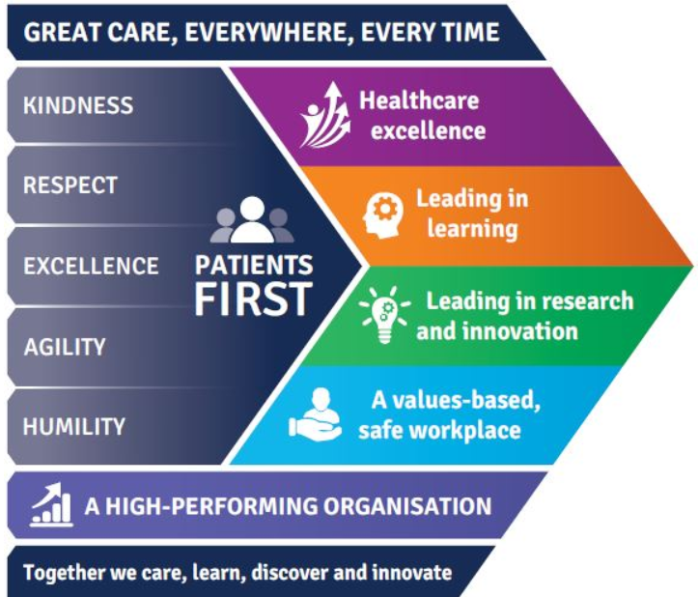

Eastern Health Annual report

