Strengthening Women in Melbourne’s
Outer East 2018-20
Health Promotion

Healesville Hospital and Yarra Valley Health

Executive Summary
Promoting women’s independence and decision making in public life and private life has been identified as a vital strategy for preventing violence against women. It is one of the four key actions of Our Watch’s National Framework for the primary prevention of violence against women and their children in Australia. This involves equalising access to power and resources between women and men, and strengthening women’s economic security, independence and social, political and economic participation and decision-making in public life (Our Watch 2017). Victoria’s Gender Equality Strategy – Safe and Strong also identified the need to strengthen and connect women to advance gender equality (State of Victoria, 2017).

Yarra Ranges Local Government Area had 1,580 family violence incidents reported to police in 2016. This number has increased by 34% over the past four years (Yarra Ranges Health and Wellbeing Profile 2017).Yarra Ranges LGA currently has the highest number of referrals to Eastern Domestic Violence Outreach Service within the Eastern Metropolitan Region (EDVOS, personal communication, 2019). This data reflects an urgent need to address the incidence of family violence within Yarra Ranges LGA to reduce family violence.

Eastern Health, Health Promotion has facilitated and supported strengthening women initiatives across Melbourne’s Outer Eastern Metropolitan area. Some initiatives have been localised while others have had a regional focus. The evaluation of these interventions has shown that the multipronged approach is significantly strengthening women’s independence and decision making in private and public life in our region. Health Promotion has identified leverage points where we think we may have significant local impact – including women’s participation in local government, local leadership, building new women’s networks and providing additional support & role models to young girls and young women to enhance their opportunities to experience empowerment.

Health Promotion has focused on five clear strategies:
- Promote Women’s independence and Decision Making in Public Life.
- Promote Women’s independence and Decision Making in Private Life.
- Empower girls and young women through schools to enhance their capacity for independence.
- Enable environments that support women’s gathering and peer based support.
- Enhance and promote women’s health and wellbeing.

The following report summarises the interventions achieved under each strategy and their evaluation results. More detailed info graphics and reports on the projects can be found on the Eastern Health – Health Promotion website: https://www.easternhealth.org.au/a-z-service-directory/health-promotion-in-the-outer-east/item/267

- Promoting Women’s Independence and Decision Making in Public Life
“Empower women through leadership development and increased participation in decision making in the home and workplace.” Our Watch-Putting prevention of violence against women into practice (2017).

Local Democracy in Action & the Journey Begins with Voices of Women
The Yarra Ranges Council is one of 13 local governments in Victoria that has only one woman councillor (McGowan, 2018). The necessity to achieve gender equality for female representation is clearly supported by the Victorian State Government to prevent family violence and improve the representation, voice and quality of life of girls and women across Victoria (State of Victoria, 2016). Health Promotion supported Voices of Women and partner organisations – CIRE Community services and Yarra Ranges Council to deliver two years of capacity building support to women in the Yarra Ranges through the Promoting Women in Local Government Partnership. Health Promotion held two main objectives for The Journey Begins Program of 2019:
- To increase women’s understanding of Local Government and the process of running for Local Government in the Yarra Ranges.
- To increase women’s confidence in their ability to run for election to Local Government in the Yarra Ranges in 2020.
The program was delivered over eight sessions from February to November 2019, with an average of 10 participants per session. Session topics included the business of Local Government, the role of the local councillor, communicating with confidence, dealing with aggression and backlash and preparing for your campaign. At the end of the second year of support, 3 women expressed an intention to run for local council in the 2020 election. The final program evaluation survey showed that 71% of participants agreed with the statement that “I know enough about local government to run for local government election”. A Facebook page supports this initiative. VoW LDA Facebook

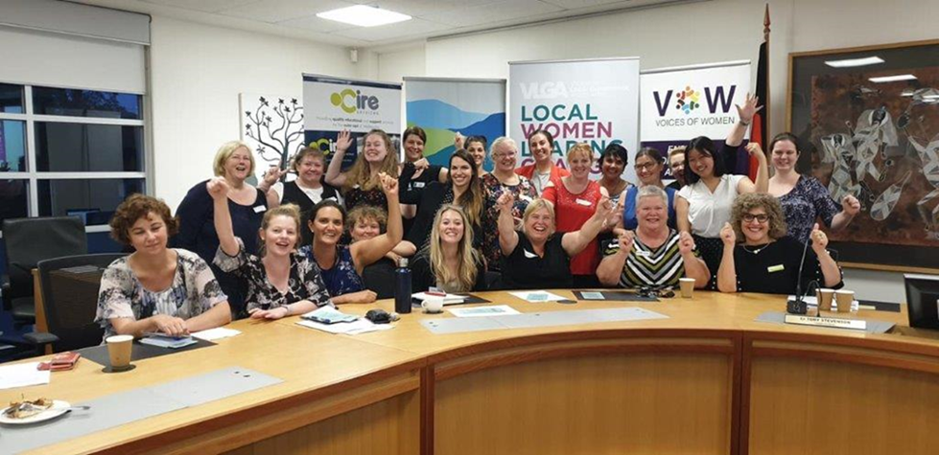
Women involved in the VoW Local Democracy Initiative

Getting Girls In – Increasing Participation in Female Football
Health Promotion has supported increasing women’s participation in football since 2016 with the Be the Change Forum, Women Leading Change Forum (2018) and the Leading the Change Program (2018 – present). In 2019, Health Promotion began a focused approach to working at the club level to promote and encourage girls’ and women’s participation in football. Interest in female football has exponentially increased in the Eastern Region over the last 5 years with the onset of AFLW. Female football at both the junior and senior level is a demonstration of girls’ and women’s capacity to show agency, aggression and strength – a full range of behaviours, attitudes and values not previously attributed to women in traditional understandings of gender stereotypes. The girls and women who choose to participate in this sport often face uncertain levels of support from family and friends and have to demonstrate great resilience and commitment to continue to play. Supporting female football is hence a strategy that promotes girls’ and women’s visibility and access to demonstrate a broad range of personal and character strengths.
Twenty-five people from 13 clubs attended the first Getting Girls In workshop with the AFL Outer East in May 2019. 40% of participants completed the feedback survey with 100% reporting an increase in awareness and confidence to create environments that encourage girls’ and women’s participation. 100% also reported an increased knowledge of ways to increase girls and women’s participation and enable participation in their sporting environment.
Following the success of this model, the Eastern Football Netball League (EFNL) requested support resulting in 2 Getting Girls In workshops delivered across the AFL Outer East and 1 across the EFNL. In November 2019, 50 participants from 29 clubs attended the EFNL Getting Girls In workshop. 56% participants completed the feedback survey, with 96% reporting an increase in awareness and confidence to create environments that encourage girls and women’s participation.
The second AFL Outer East Getting Girls In workshop had 19 participants from 10 clubs attend in February 2020. 37% completed the feedback survey. 100% reported an increase in awareness and confidence to create environments that encourage girls and women’s participation. AFL Outer East has continued their partnership with Health Promotion to promote women’s leadership in 2020 and 2021 due to the success of this initiative. A number or clubs are planning to establish their first senior women’s football team – including Woori Yallock FNC, Yarra Glen FNC and Seville FNC.

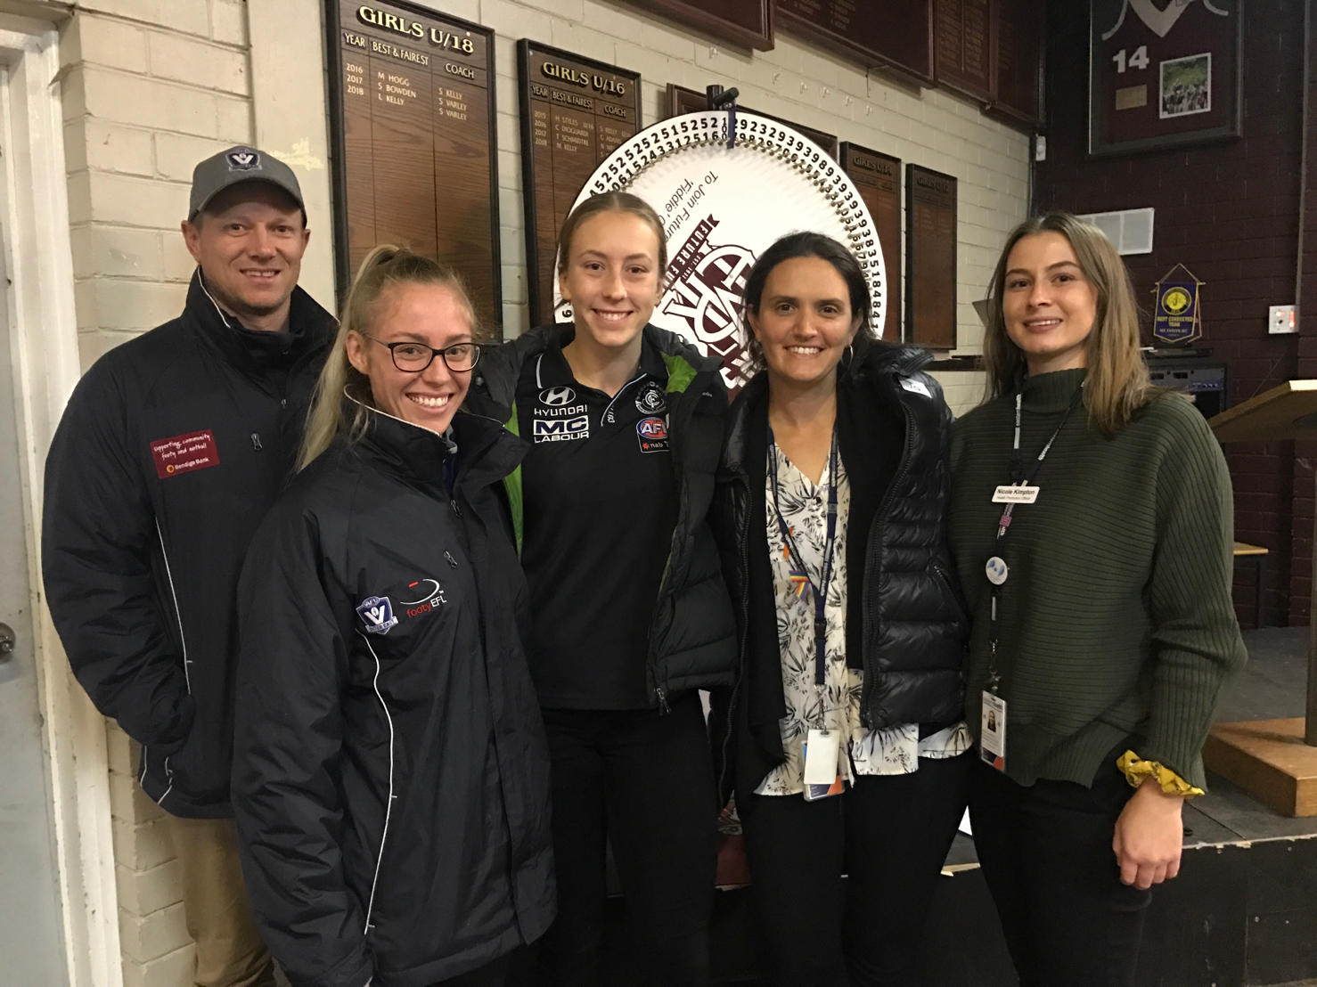
Getting Girls in Workshop 2019

- Promoting Women’s Independence and Decision Making in Private Life
“The ultimate aim of all programs should be to achieve gender equality through the empowerment of women.” Our Watch - Putting prevention of violence against women into practice (2017)

Taking it Step by Step Mentoring Women Program in Yarra Ranges
In 2018, Eastern Health partnered with Voices of Women (VoW) and CIRE Services to develop and deliver a pilot mentoring women program, ‘Taking it Step by Step’ for women living or working in Yarra Ranges. Mentoring provides opportunities for people to gain access to further knowledge and skills through a relationship with someone who has those skills. Mentoring women is a key strategy of VoW’s vision for women of the Yarra Valley to live lives that are empowered, in a community where their voices are heard, represented and sought on for input into the decisions that affect them (VoW 2017). The program matched women with the skills, capacities and wisdom to provide mentoring to other women in the community with a keenness to learn, engage and self-develop. Ten mentors and 10 mentees were recruited to the six month program. Training and support was provided to participants via group gatherings and on-going email and phone support. Eastern Health engaged Deakin University to assist with evaluation of the program through provision of a Master’s student to conduct semi structured interviews with mentees and an evidenced based survey tool Personal Progress Scale-Revised (PPS-R) (Johnson et al 2005) used to conduct pre and post empowerment evaluation with all participants.

The program ran from April to November2019 and 16 participants fully completed it. 100% of these participants reported qualitative increases in empowerment through achieving a personal/professional goal with the support of a well matched mentor. The participant goals achieved included pathways to employment, building the confidence to change careers and better management of work/life balance. Three women have also since been elected to the Voices of Women Committee. The pilot program was up scaled in 2020 with plans to deliver it to up to 25 women in Yarra Ranges. A Facebook page https://www.facebook.com/WISE.YR was developed to provide inspiration, support and empowerment education to facilitate recruitment into the 2020 program.
Leading the Change – Women’s Education Sessions on Crossing the Line
The Leading the Change Program is delivered to the sporting clubs of the AFL Outer East, in partnership with SALT (Sport and Life Training) and Yarra Valley Water. Leading the Change is focused on increasing clubs commitment to respectful relationships, gender equality, challenging condoning of violence against, encouraging active bystander behaviour in the face of every day sexism and women, encouraging help seeking and reducing stigma of mental health illness.
In 2019, the Leading the Change program held 10 sessions with women from 11 different sporting clubs. The program’s evaluation found it to successfully increase women’s understanding of family violence and awareness of abusive relationships behaviours.
122 women responded to the mobile quiz used in the sessions to encourage confidential disclosure of experiences of family violence. 36 % of these women reported that they had experienced an abusive relationship in the past and 51% reported that they knew someone that had experienced an abusive relationship. The Leading the Change Program also included strategies to increase club capacity for female participation (Getting Girls In) and the #Expect Respect social media campaign on the AFL Outer East Facebook. More information can be found on in the Leading the Change Program info graphic for 2018 and 2019 available on the Eastern Health website.

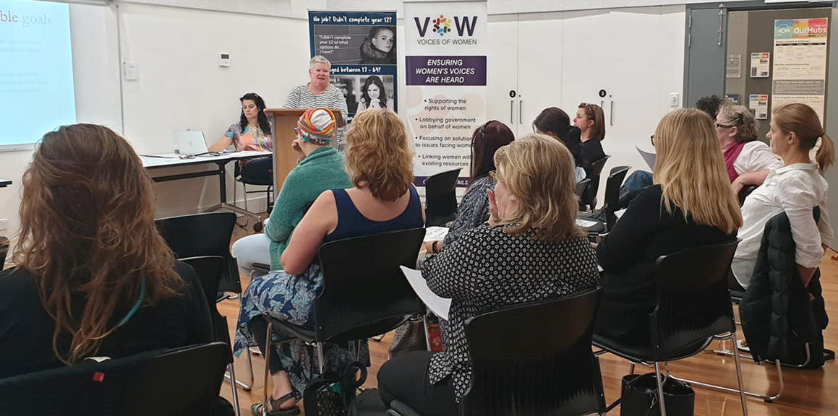
Taking it Step by Step Mentoring Women Gathering

- Empowering Girls in Schools to Enhance Their Capacity for Independence
Unstoppable
“Challenge unrealistic and unhealthy female beauty standards and promote healthy body image.” Gender Equality Strategy - Safe and Strong

The Unstoppable pilot was developed in 2019 in response to an identified need by the Health Promotion team to support girls at Grade 5 and 6 to have access to empowered role models that could increase their sense of agency to meet the challenges ahead in the transition to Secondary school. Engagement in this priority group was identified by several schools and a local secondary school (Upper Yarra SC) as the transition period is known for being a key time when mental health and wellbeing concerns arise for young people (YRC, Child and youth report #REF). Health Promotion identified a local school – Yarra Glen Primary school that was keen to trial the unstoppable program. Yarra Ranges Council Youth Focused Services were also keen to support increasing resilience at these ages. The school requested a program that engaged young men in promoting health masculinity as well. Health Promotion recommended the use of two external education providers – Free form Martial Arts and SALT (Sport and Life Training) to deliver the sessions. Four sessions were held with additional support from the YRC youth ambassadors. During the Freeform and SALT workshops, the girls:
- Learned to re-think what they identify as strong (e.g. girls are as strong as boys) and learned exercises that showed core strength in their bodies.
- Learned about personal space and boundaries, posture and carrying a personal sense of empowerment through self acceptance.
- Practiced basic self defence postures and reflected on power dynamics in relationships.
- Learned about the struggles that teenage women face regarding body image and pressures placed on young women via marketing and social media.
- Identified character strengths that included a range of healthy behaviours that they could call on to navigate the years ahead.

Health Promotion received positive feedback from the school’s teachers about the impacts of the Freeform Martial Arts sessions and the girls identified a range of positive learnings from the session.

Secondary school support
Teenage women find themselves experiencing a barrage of more intense pressures with the experience of secondary school, social media and their first intimate relationships. For three years Health Promotion has supported Healesville High School to deliver a program called This Girl Can, tailored to their Year 9 students in Term 2 and 3 of each year. This program involved a health education/ women’s empowerment focus and instruction in self defence with a range of female presenters that could model and demonstrate women’s capacity for independence and decision making. The program achieved positive results each year, with some participants requesting to attend the program a second time. In 2019, the program trialled a modified form of the Personal Progress Scale (Johnson et al, 2005) to assess changes in the experience of empowerment. The tool showed mixed results, indicating the large variability in the felt experience of empowerment experienced by the teenage women in this group.

Health Promotion was also asked to support and provide education sessions to young women at Upper Yarra Secondary School and Our Lady of Mercy College (Heidelberg). There is a consistent appetite for work with young women that is focused on women’s agency and independence and an urgent need to continue to provide opportunities for women to access role models that demonstrate agency and independence in both their public and private life.
- Enhancing and promoting women’s health and wellbeing.
“Partner with and listen to women and girls on their health care and service provision.” Gender Equality Strategy - Safe and Strong

Prevention activity focused on women’s physical health is an important strategy for women’s empowerment. Women’s physical health is influenced by a wide range of social determinants. Health Promotion aims to support women’s access to health information and work with our settings and environments to ensure that they enable women’s participation. Vic Health has provided clear research into the barriers women face to participate in physical activity, exercise and recreation. The This Girl Can campaign aims to address these barriers. Community Health at Healesville Hospital & Yarra Valley Health has supported access to women’s health information through providing Women’s health education sessions during Women’s Health Week (at the Healesville Library and at a craft business), women’s health sessions during Healesville Women 4 Women gatherings at International Women’s Day events, through the delivery of My Body My Way sessions (that encourage intuitive eating and a positive relationship to our bodies and food) and support for the Body Image Network of the Upper Yarra.

Supporting women to be physically active in Recreation Facilities – This Girl Can
In 2018 and 2019 Eastern Health Health Promotion partnered with the Yarra Centre to deliver a 6 week This Girl Can campaign with the following aims:

- Provide a safe and non-judgemental environment for women to exercise
- Decrease the barriers for women participating in physical activity
- Promote the use of Eastern Health Community Health Services
- Increase participants’ involvement in physical activity each week

In 2019 16 women aged 16 - 81 years participated in the pilot physical activity program with the Yarra Centre – This Girl Can. 50% of participants that completed the pre and post survey doubled the number of physical activity sessions they undertook per week.
In 2020, 10 women participated each week in the second Yarra Centre This Girl Can program. However the program finished early and evaluation could not be completed due to the COVID-19 restrictions. The Yarra Ranges Council was successful in attaining the This Girl Can - Victoria Local Area Marketing grant. 10 events were planned across the Yarra Ranges during This Girl Can week. Health Promotion provided advice on the planning and evaluation, however all events were postponed due to COVID-19.

- Connecting Women to facilitate Peer Based Support
“Foster networks of support and connectivity for women and girls.” Gender Equality Strategy - Safe and Strong

Health Promotion continues to support building capacity in the local community for women to connect in peer settings and gain support. Women’s gatherings share a specific purpose in that women can support each other through identifying with the lived experience of our gender, as well as advocating for each other as we continue to demand an increase in our own sense of public safety, wellbeing and a reduction in intimate partner violence. Health Promotion has supported the development of several strategic groups in the Yarra Valley and Yarra Ranges that have now become part of the infrastructure of women’s ongoing empowerment in these communities.

Healesville Women 4 Women
The Healesville Women 4 Women network developed from the Change the Story partnership in the Healesville community outlined in the Strengthening Women in the Yarra Valley Report 2016 – 2017 (Eastern Health, 2017). This group has been supported by the Eastern Community Legal Centre and the Healesville Living and Learning Centre. The group initially delivered a significant event to the Healesville community, celebrating International Women’s Day in 2017. This celebration focused on women’s strength and diversity and featured women in local leadership as well as a range of nurturing workshops. From this day a smaller network of women agreed to continue to facilitate quarterly gatherings of women in Healesville for connection and empowerment. Health Promotion continues to support this group to hold events, including women’s health events that will provide opportunities for women to connect, gather and learn about local supports and services. During the Corona virus pandemic, the Healesville Women 4 Women group delivered a consistent online social media campaign that saw the group numbers increase. They are planning a significant event for International Women’s Day in 2021 and have attracted a diverse and skilled group of women to organise the event for the local community.

Voices of Women
Voices of Women formed from a series of consultations that occurred in 2016 as outlined in the Strengthening Women of the Yarra Valley Report (Eastern Health, 2017). Voices of Women have developed a clear mission to:
- Promoting women’s leadership capacity and education through targeted programs
- Advocating for policies and practices that promote gender equity in local government, business and community sectors
- Promoting a human rights and gender equity approach amongst community stakeholders for the prevention and reduction of domestic violence in our community.
- https://voicesofwomen.org.au/about-vow/

This group has focused on three priorities in the Yarra Ranges:
- Supporting and promoting women to run for Local Government in the 2020 election, through the Local Democracy in Action & The Journey Begins Initiatives (website).
- Enabling women to access clothes that are suitable for professional interviews and work at a local shop front in Moorolbark.
- Empowering women through the Taking it Step by Step Mentoring program.
Voices of Women has become a significant and influential advocate for women in the Yarra Ranges and is a key testament to the need to support women’s activation through the establishment of new structures that can enhance their visibility in public life and ensure that they are considered in future decision making.

Women of Warburton
Women of Warburton are a newly formed women’s support network in the Upper Yarra after the conclusion of Warburton’s Women of Interest group. The Upper Yarra Services Network identified a need for women in the Upper Yarra to establish better connection and gain easier access to local information and support. The Women of Warburton hope to establish a similar model to Healesville Women 4 Women tailored to women across the Upper Yarra seeking connection. The network is lead by local service providers and community members.

- Discussion
It is essential that Health Promotion continue to focus on promoting women’s independence and decision making in the communities of the Yarra Ranges to prevent violence against women. This clear strategy is complemented by a focus on increasing and enhancing women’s peer based support networks and increasing the visibility of girls and women in physical activity and recreation. An intersectional lens should be also applied to this work to facilitate women’s independence and decision making in more vulnerable groups, including the LGPTIQ+ community, women living with disabilities and Aboriginal and Torres Strait Islander women. The main strategies employed have included awareness raising, face to face education workshops, support for new structures and organisations and face to face program support for primary and secondary schools. The prevalence of violence against women in the community points to an urgent needs to educate and build the resilience and capability of women at the same time as engaging boys and men in our region to increase their commitment to gender equality and the practice of respectful relationships. Health Promotion should continue to focus on both genders, as well as broadenings its approach to focus on priority and diverse communities within the Yarra Ranges in our next 4 year plan.

- Recommendations
- That Health Promotion continue to invest in priority initiatives that promote women’s independence and decision making, with a clear focus on:
  - The primary school setting
  - The secondary school setting
  - Engagement with young women in sports with female participation including netball in partnership with the AFL Outer East.
  - Women’s civic participation in Local Government.
  - Women’s participation in leadership in sporting settings.
- That Health Promotion investigate the existing supports for women in workplaces and the capacity for Health Promotion and our partners to support workplaces to implement the Our Watch Gender Equality Standards.
- That Health Promotion investigate alternative tools and use qualitative methods to ensure that the impact of our programs is understood.
- That Health Promotion use an intersectional lens to invest in promoting women’s independence and decision making in more vulnerable groups, including the LGPTIQ+ community, women living with disabilities and Aboriginal and Torres Strait Islander women.

- References

- Johnson, D. M., J. Worell, and R. K. Chandler. 2005. Assessing psychological health and empowerment in women: The personal progress scale revised. Women & Health 41 (1):109–29. doi:10.1300/J013v41n01_07.
- McGowan, Ruth. Gender Equity in Local Government – Research Companion (2018). <https://www.localgovernment.vic.gov.au/__data/assets/pdf_file/0029/329285/Gender-Equity-in-Local-Government-Research-Companion.pdf>
- State of Victoria (2016). Safe and Strong – A Victorian Gender Equality Strategy. file:///C:/Users/jo337/AppData/Local/Packages/Microsoft.MicrosoftEdge_8wekyb3d8bbwe/TempState/Downloads/Safe-and-Strong-Victorian_Gender_Equality_Strategy.pdf.
- Vic Health (2017), Helping girls and women get active – This Girl Can. https://www.vichealth.vic.gov.au/-/media/ResourceCentre/PublicationsandResources/Physical-activity/TGC-Getting-Women-Active-Guide.pdf?la=en&hash=83C66E81B0DA3FAC2E6CF8A29EA5C24A8256A451.
- Our Watch, Australia’s National Research Organisation for Women’s Safety (ANROWS) and VicHealth (2015) Change the story: A shared framework for the primary prevention of violence against women and their children in Australia, Our Watch, Melbourne, Australia.

© Eastern Health 2017

