NDIS Pathway Timelines
Response times and guidance on follow up action for clinical mental health services

To receive this publication in an accessible format phone 03 9096 7147, using the National Relay Service 13 36 77 if required, or email julie.skilbeck@dhhs.vic.gov.au
This product was produced by the Specialist Clinical Mental Health and NDIS Collaboration Project, funded by the Department of Health and Human Services through the Commonwealth Government Sector Development Fund.
This resource will be reviewed and updated to reflect practice changes and developments as the NDIS transitions to full Scheme.
Authorised and published by the Victorian Government, 1 Treasury Place, Melbourne.
© State of Victoria, Department of Health and Human Services, June 2018
Except where otherwise indicated, the images in this publication show models and illustrative settings only, and do not necessarily depict actual services, facilities or recipients of services. This publication may contain images of deceased Aboriginal and Torres Strait Islander peoples.
Where the term ‘Aboriginal’ is used it refers to both Aboriginal and Torres Strait Islander people. Indigenous is retained when it is part of the title of a report, program or quotation.
ISBN/ISSN <number>
Available at <web page address>
Printed by Department of Health and Human Services

Purpose
To provide an overview of key points in the NDIS pathway, expected response time and follow up
Tip: Flag expected response times in your electronic calendar or diary.

Key follow up timelines

If a consumer would like your support to follow up any NDIS queries they must provide consent to the National Disability Insurance Agency (NDIA) and, once they have a plan, their NDIS funded Service Providers. You can register this consent with the NDIA by -
- calling the 1800 number with the consumer and getting their verbal consent to have your contact details added to their NDIS file, or
- submitting a signed consumer consent form to the NDIA
Tip: Calling before 10.00 am and after 6.00 pm can reduce call wait times.

For NDIS funded Service Providers, particularly Support Coordinators, you can do this by -
- ensuring your contact details are listed on the consumer’s NDIS Plan at the Planning Meeting, or
- submitting a signed consumer consent form to the Service Provider which includes your contact details.

Key contact details
Access progress queries: direct to NAT@ndis.gov.au
Complaints: direct to feedback@ndis.gov.au (be assertive to get action)
Telephone: 1800 800 110 (for both access progress queries and complaints)

Local escalation and advice process (delete as appropriate)
- Discuss with NDIS Local Lead on your team.  - Feedback to Local service NDIS Working Group  - Escalate to NDIS Program Lead within mental health service | - NDIS Program Lead who will collate and feedback to  - Local Area Mental Health NDIS Interface Group  - State-wide Mental Health NDIS Interface Group

The table on the following two pages outlines the key steps in the NDIS pathway, expected response time frames and any related follow up actions.

NDIS pathway process | Expected response time | Follow up action
Getting an Access Request Form (ARF) after calling NDIS | Seven days via post | If consumer does not receive ARF via post after two weeks call 1800 800 110 or email the National Access Team (NAT) NAT@ndis.gov.au and document in file.  Consumer has four weeks to send completed ARF and supporting evidence back. Call 1800 800 110 or email NAT if more time needed.
NAT may request further information after submitting valid ARF | NAT will make request within 21 days of receiving valid ARF | Clinicians must provide additional information within 4 weeks of receiving request from NAT otherwise the access request is considered to have been withdrawn.  Call 1800 800 110 or email NAT@ndis.gov.au if more time needed.
Eligibility decision after submitting valid ARF | 21 days via post  Where additional information has been requested, within 14 days of receiving the final piece of information | If no decision after five weeks, call 1800 800 110 or email NAT@ndis.gov.auand document in file.
Priority Planning meeting | Immediate priority for NDIS participants who are at risk of harm, or whose stability of accommodation or care arrangements have broken down;  Within two weeks of eligibility decision for NDIS participants whose stability of accommodation or care arrangements are unsustainable, fragile or at risk of breakdown;  Within six weeks of eligibility decision for NDIS participants in, or returning to, a community setting who:  have no, or very few, supports in place where delay is likely to result in higher scheme costs, poorer longer term outcomes or a further reduction in functioning; or  need to have appropriate support arrangements in place to be able to return to the community, for example participants returning home after an admission for acute mental health treatment or participants being released from prison or custody. | Identify consumer as needing a priority planning meeting and provide supporting evidence as requested to NAT via email NAT@ndis.gov.au or call 1800 800 110. Follow local escalation process within the mental health service when clinically indicated.
Phone call from an NDIS Business Administration Support Officer (BSO) to the consumer or their nominee to arrange a meeting time and place to meet with Planner | Shortly after receiving letter confirming eligibility – no specific time frame. | If no contact after one week call 1800 800 110 or email enquiries@ndis.gov.au and document in file.  Request contact name, number and email of BSO for any liaison prior to meeting to ensure:  planner has all information prior to meeting  planner is aware of how meeting should be conducted to support consumer e.g. multiple shorter meetings, location/environment
Planning Discussion meeting with NDIA Planner or Local Area Coordinator (LAC) | Six weeks after acceptance into NDIS.  Note: If Planner approves Support Coordination they will ask participant to choose a provider in this meeting. | Request contact name, number and email of Planner for any additional documents or information you may want to send or follow up later
Plan approval, copy of Plan and activation code | 10 days after last Planning Discussion meeting via post.  Consumer’s Plan will be available on the NDIS Myplace portal about 24 hours after it has been approved. | If Plan not received after two weeks contact Planner, or call 1800 800 110 and document in file.  LAC or the NDIA will provide the consumer with an activation code needed to access Myplace for the first time. Activation code will also be included with mailed approved Plan and will expire within approximately 10 days. Another code can be given by calling the NDIA on 1800 800 110 or contacting LAC.
Phone call from Support Coordinator provider to arrange meeting | Within 2 days of plan handover between planner and support coordinator | If no contact within one week of plan being approved, contact Planner to address delay and document in file.
Meeting with Support Coordinator | Within 5 days of plan handover between planner and support coordinator | If meeting has not occurred within two weeks of plan being approved, call Provider to address delay and document in file.
(if required) Request Internal Review because participant is dissatisfied with approved plan.  Note: participant must request an Internal Review within three months of receiving plan | Within 14 days of receiving the request for an Internal Review, the NDIA must decide whether or not to conduct the review and will notify participant in writing | If no contact after three weeks call 1800 800 110 or email enquiries@ndis.gov.au to address delay and document in file.
Request for Plan Review due to change in circumstance | Within 14 days of receiving the request the NDIA must decide whether or not to conduct the review and will notify participant in writing | If no response after three weeks call 1800 800 110 or email  enquiries@ndis.gov.au to address delay and document in file.
Unscheduled Plan Review Meeting | Within 14 days of deciding to conduct the review the NDIA must commence reviewing the participant’s plan | If no response after three weeks call 1800 800 110 or email enquiries@ndis.gov.au and document in file.
Scheduled Plan Review | Three months prior to plan expiring participant will be contacted by NDIA to arrange a Plan Review meeting | If no contact two months prior to plan expiring call 1800 800 110 or email enquiries@ndis.gov.au and document in file.

Appendices Summary
- Basic consent form
- NDIS Complaint form
If a consumer is not satisfied with the way the NDIA carried out its decision-making, or how the NDIA dealt with them during the review process, they can make a complaint.
https://www.ndis.gov.au/about/contact-us/feedback-complaints/complaint-form.html

- Application for a review of a Reviewable Decision
Many decisions made by the NDIA are reviewable. They include, for example:
- NDIS access decision
- The funding and provision of reasonable and necessary supports i.e. the appropriateness of the Plan
When a consumer is told about an NDIA decision (e.g. eligibility or an approved NDIS plan), they will be told how to request an internal review. If a consumer thinks a decision made by the NDIA about them is wrong, they can submit an application for internal review of a decision. If they disagree with a decision about the supports in their plan, use the review of a decision form to request an internal review. The request for review must be made within three months of receiving the reviewable decision notice.
When asking for a review, they need to explain why they think the decision is incorrect.
You don’t have to use this Application for review of a reviewable decision form, but it can help describe why an internal review of the decision is needed.
https://www.ndis.gov.au/participants/reasonable-and-necessary-supports/decision-review/application-review-reviewable-decision

- NDIS Change in circumstance form
If a consumer requires increased or new psychosocial disability supports due to a significant change or life event (e.g. becoming homeless, a recent trauma, loss of informal supports, acquisition of co-morbid other disability e.g. ABI) and requires a plan review this can be initiated via a change in circumstance form.
https://www.ndis.gov.au/participants/understanding-your-plan-and-supports/change-circumstances

- NDIS Plan Review Request form
A Plan Review is a process in which the NDIA performs a re-assessment of a participant’s support needs and prepares a new plan on behalf of the participant.
A Plan Review can take place:
- as part of the planning cycle (a Scheduled Plan Review); or
- at any time, on the initiative of the NDIA (an Unscheduled Plan Review); or
- at any time, where a participant requests a review and the NDIA decides to conduct a review of the participant’s plan (an Unscheduled Plan Review).
https://www.ndis.gov.au/medias/documents/plan-review-form-pdf/Plan-Review-Request-Form.pdf
A consumer can request an Unscheduled Plan Review at any time by filling out this form and returning it to: NDIA, GPO Box 700, Canberra, ACT 2601. An Internal Review is a separate process by which an NDIA staff member, known as an internal reviewer, reviews a decision made by another NDIA staff member.
If a consumer disagrees with a decision about the supports in their plan, use the review of a decision form to request an internal review within three months of the decision date. If they are still not happy after the internal review of the decision, they can apply for a review by the Administrative Appeals Tribunal (AAT), a tribunal that exists outside the NDIA. Please note: The AAT cannot review a decision by the NDIA until the decision has been internally reviewed by the NDIA.
For information about applying for a review by the AAT, see the AAT website http://www.aat.gov.au/applying-for-a-review/national-disability-insurance-scheme-applicants

Contact permission letter
To the NDIA,
I……………………...(full name) give consent for ………………………….. from …………………………. to communicate with you regarding the following matters on my behalf:

You have permission to communicate with this person on all these matters.
Thank you and kind regards,

Name:
Date:
Name of person
Signature:
Date:

Name of nominated person (if relevant)
Signature:
Date:

Complaint Form

Part A – About you

Fill in this box if you are complaining on behalf of someone else
Name of person: Click here to enter text.

What is your relationship to that person? Click here to enter text.

Does the person know you are making this complaint? Choose an item.

Does the person consent to the complaint being made? Choose an item.

Fill in this box if someone is assisting you with the complaint – for example a family member, your nominee or representative.
Name of representative: Click here to enter text.
Organisation: Click here to enter text.
Postal Address: Click here to enter text.

Contact Numbers
Business: Click here to enter text.
Mobile: Click here to enter text.
Fax: Click here to enter text.
TTY: Click here to enter text.
Email: Click here to enter text.

My preferred contact is: Choose an item.

Part B – Your complaint

What is your complaint about?

Provide some details to help us understand your concerns. You can include what happened, where it happened and who was involved or the decision made by the Agency that you are unhappy about.

Click here to enter text.

Part C – Who is your complaint about?
Name of the person, or service about whom you are complaining (the respondent or the Agency person who made the decision)
Name/organisation: Click here to enter text.
Address: Click here to enter text.
Post Code: Click here to enter text.

Contact numbers
Home: Click here to enter text.
Business: Click here to enter text.
Fax: Click here to enter text.
Mobile: Click here to enter text.
TTY: Click here to enter text.
Email: Click here to enter text.

What is this person’s/organisation’s relationship to you? Click here to enter text.

What outcomes are you seeking?
Click here to enter text.

NOTE: If you want to complain about more than one person or organisation, please provide this additional information on an extra page.

Part D – Further Information

Supporting Information

Please attach copies of any documents that may help us investigate your complaint (for example letters, references, emails). If you cannot do this, please tell us what you think we should obtain.

Click here to enter text.

Have you made a complaint about this to another agency?

(For example: a disability service or equal opportunity agency, Health Care Complaints Commission, Ombudsman.)

If so, please provide details of the agency to which you made your complaint and any outcome. Please also attach copies of any letters you have received from that agency.
Click here to enter text.

☐Please check this box to consent to the National Disability Insurance Agency providing information to a third party (e.g. a Provider or another jurisdiction) to resolve your issue.
Email your form to: feedback@ndis.gov.au,
or
National Disability Insurance Agency, GPO Box 700, Canberra ACT 2601,
or
Drop your form off at any National Disability Insurance Scheme office.
Office locations

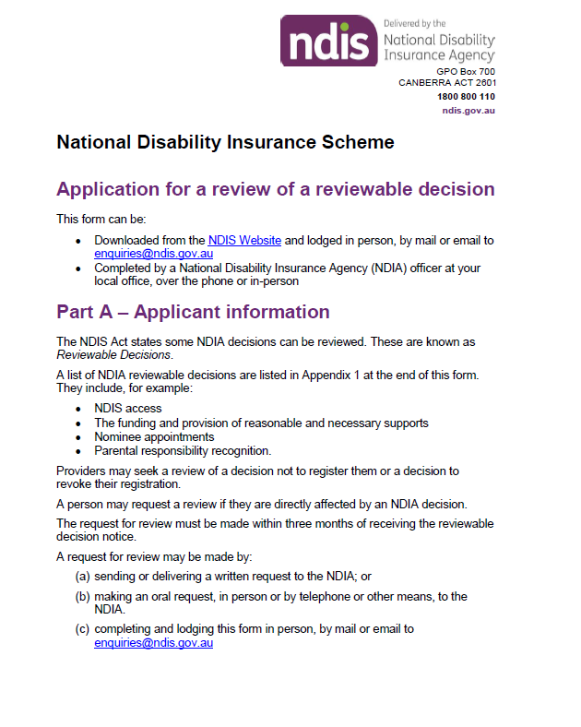

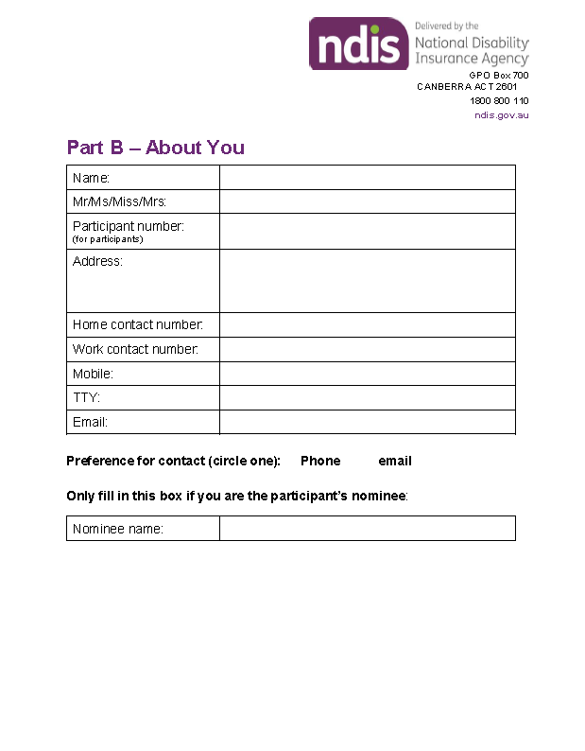

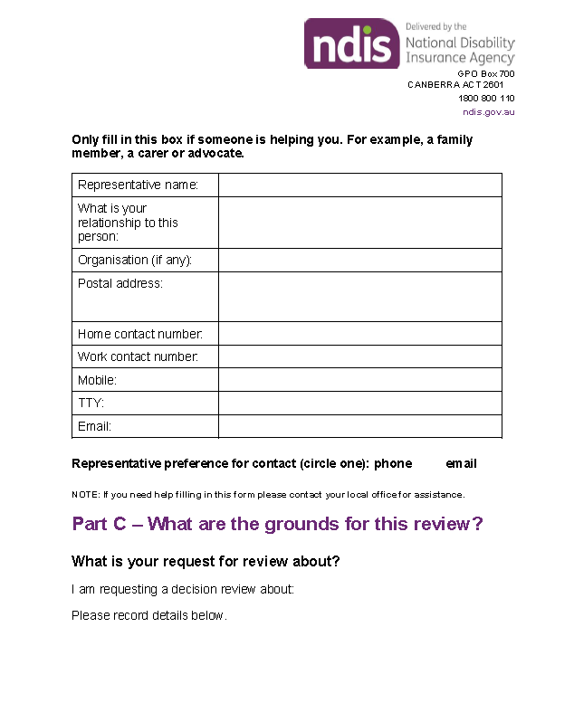

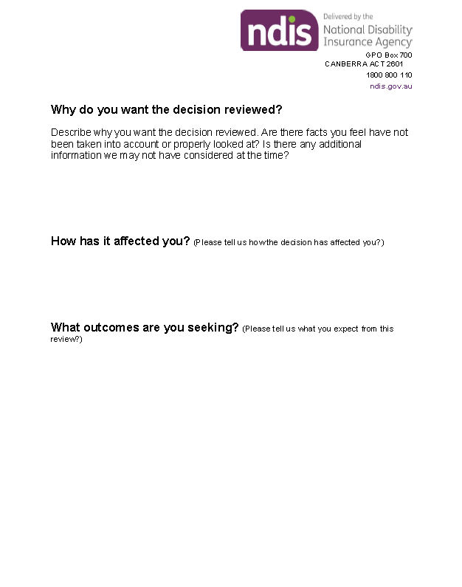

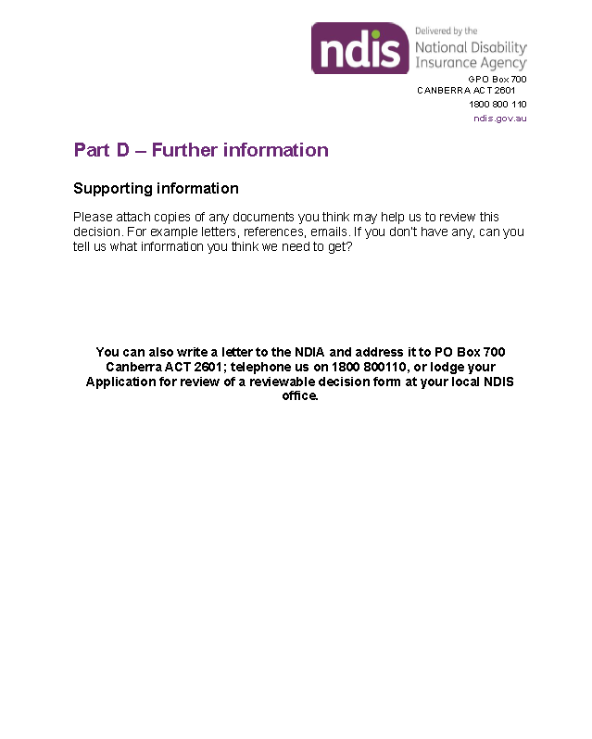

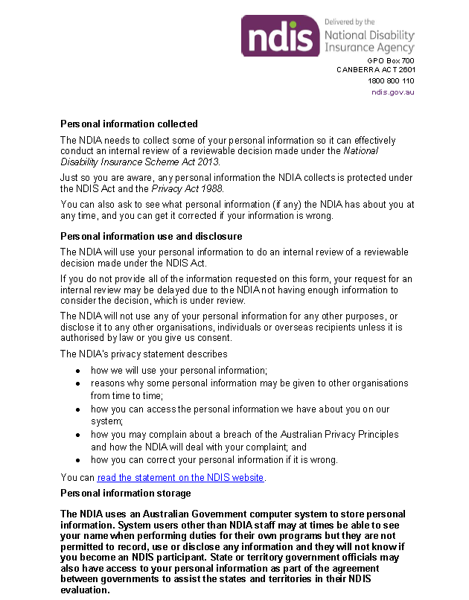

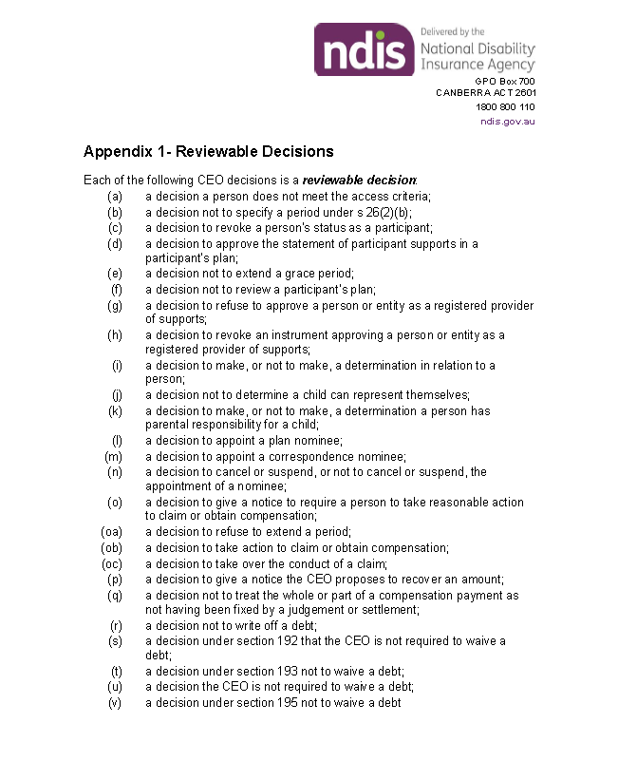

Change of circumstances form
NDIS participants, and people awaiting access decisions, can provide change of circumstance details using this form.

What is a change of circumstance?
A change of circumstance is a significant event or change in your life. You must tell the NDIA if you experience significant changes to your:
disability support needs
informal support arrangements
compensation status (for example, you apply for, receive, or are entitled to compensation for injury)
living arrangements (for example you plan on moving, or have moved, house, overseas or permanently into aged care residential accommodation).
Note: A change of circumstances does not necessarily mean a plan review.

How do I let the NDIA know?
There are three ways you can let the NDIA know about your change of circumstances:

In writing
You can tell us about changes in writing using:
myplace (participant portal)
Email: enquiries@ndis.gov.au or
Mail: NDIA, GPO Box 700, Canberra ACT 2601

By phone
You can tell us about changes over the phone by calling:
1800 800 110
TTY: Ph. 1800 555 677 and ask for 1800 800 110 or your local office
Speak and listen (speech to speech relay): Ph. 1800 555 727 and ask for 1800 800 110 or your local office.

In person
You can tell us about changes in person by visiting:
Your local NDIA office

Part A: Person’s current details
If the participant or person requesting access is completing this form, record the current details you gave the NDIA in Part A.
When you have completed Part A, proceed to Part C to let us know when your change of circumstances happened, or is likely to happen.
If you are completing this form on behalf of a person under 18 years, for whom you have parental responsibility, or a person from whom you are a legal guardian or representative, complete Part A then proceed to Part B.
Note: If you are requesting a plan review please complete the Request for plan review form.
Requested current details | Provided current details
Name
NDIS number or customer number
Date of birth
Current postal or residential address
Current phone (Home)
Current phone (TTY)
Current phone (Mobile)
Current email
Current local NDIS site

Part B: Parent, legal guardian or representative
Only complete Part B if you are completing this form on behalf of a person under 18 years, for whom you have parental responsibility, or a person from whom you are a legal guardian or representative. You may need to provide information to confirm you are authorised to represent the person with disability.
Requested representative details | Provided representative details
Name
Relationship to the person in Part A
Postal or residential address
Phone (Home)
Phone (TTY)
Phone (Mobile)
Email

Part C: When did (or will) the change happen?
Complete Part C to let the NDIA know the date the change happened, or is likely to happen, and whether it is a permanent or temporary change. If the change is temporary also record the date when the change will, or is likely to, end.
Requested change details | Provided change details
Permanent or temporary change
Start date
End date (temporary changes only)
Don’t know

Part D: Change to contact details
Complete Part D to let the NDIA know your new contact details. You do not need to record any details already recorded in Part A.
Requested new contact details | Provided new contact details
New postal or residential address (Include number, street, suburb, state, postcode and country)
New phone (Home)
New phone (TTY)
New phone (Mobile)
New email

Part E: Other changes
Complete Part E to let the NDIA know about the following changes in your circumstances. These changes may affect your NDIS plan and supports.
Requested other change details | Provided other change details
My informal supports and/or living arrangements have changed. | For example, a family member who has provided informal support has a new job and you need to replace this support.
My employment has changed. | For example, you are moving from part-time to full-time work.
My financial arrangements have changed. | For example, another person or organisation has started managing your money or you have become bankrupt.
My disability support needs have changed. | For example, you have experienced and increase or decrease in your support needs.
My health and wellbeing have changed. | For example, you have been diagnosed with a health condition which may impact on your disability
Other (please tell us)
Note: If you are requesting a plan review please complete the Request for plan review form.

Part F: Signature
In signing this form, I certify the information provided in this form is true and correct.
Requested participant or representative signed authority | Provided authority
Signature
Name
Date

Version change control
Version No | Amended by | Brief Description of Change: | Status | Date
0.01 | BL0012  JS0109 | Supersedes existing Form – Change of circumstances – Feb 2015 (no version control on published document). | DRAFT | 12/5/2017
0.02 | JL0048 | Comms edits | DRAFT | 22/05/2017
0.03 | HM002 | Legal review | DRAFT | 23/05/2017
1 | HNL757 | Approved by LFWG | APPROVED | 25/05/2017

