ALLIED HEALTH RESEARCH NEWS

ISSUE 46 MARCH 2019
Allied Health Research News

The 3rd Victorian Allied Health Research Conference was held on the 22nd March at Melbourne Convention and Exhibition Centre. This has become a major event on the Allied Health calendar. The event was sold out and the
Eastern Health Oral Presentations:
Casey Peiris: A group lifestyle intervention program reduced emergency department presentations for people with metabolic syndrome: a retrospective case control study
Katherine Harding: The STAT model improves access to sub-acute rehabilitation and outpatient services: A stepped wedge randomised controlled trial
David Snowdon: Clinical Supervision as an Evidence Translation Strategy
Swapna Gokhale: Improving efficiency of referral triage for ambulatory pain management service for improved patient access and flow
Rebecca Sullivan: Post stroke communication disability: A risk factor for falls in inpatient rehabilitation
Ella Ottrey: Interprofessional collaboration at mealtimes in hospital: The need for cultural change
Nick Taylor: Evaluation of a ward-based risk assessment manual handling program on workplace practice
standard of the presentations
was very high.

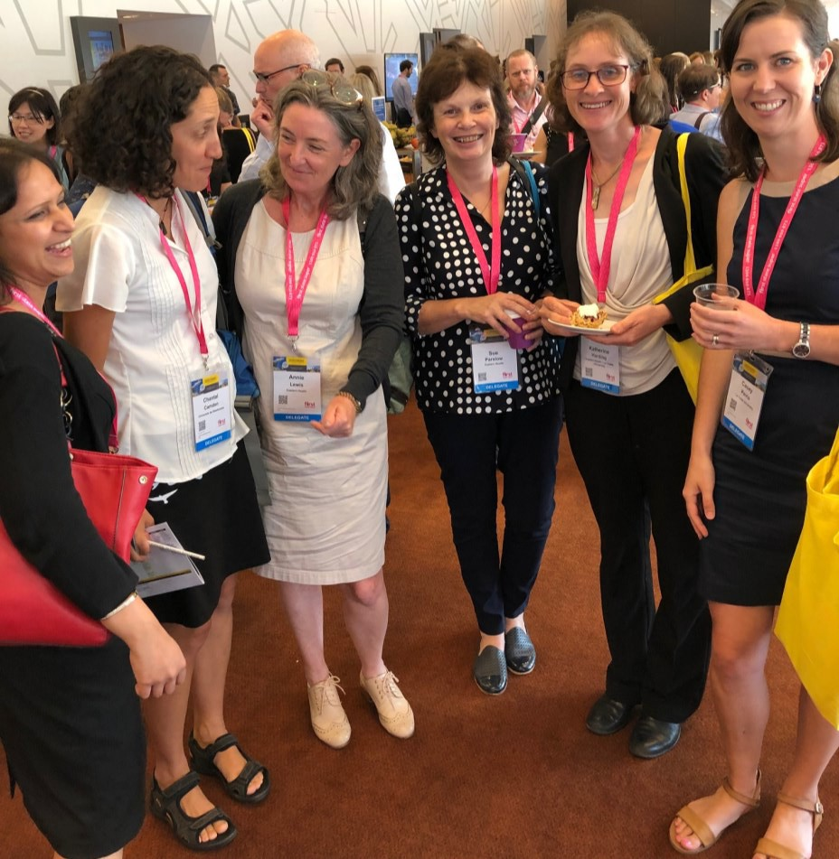A Research Newsletter for Allied Health Clinicians
Inside this issue:
Allied Health was very well represented, with 8 oral presentations from Eastern Health staff or projects conducted at Eastern Health. There were also several eposters from Eastern Health, including
one by David Snowdon (“Cost effectiveness of a model to Improve access to community outpatient services”) that took out the best poster award.
2019 Allied Health Research Forum-May 9th | 2
Stepping into Research Training Scheme: 2019 applications now open! | 3
Welcome to Amy Dennett | 3
ComeBack trial: Coaching and exercise for better walking | 4
New PhD students | 4
STAT trial a finalist in  La Trobe University Awards | 5
MiHIP trial: Opportunities for EH clinicians | 5
50 publications! EH Allied Health Research Report launched | 6
Allied Health Research Achievements | 7

The event was also a fantastic opportunity for networking with a representation from a wide range of health services across Victoria. Key note speakers Donna Markham (Chief Allied Health Officer for Victoria), Professor Sally Green (Cochrane Australia) and Kerryn Harvey (START Foundation) also gave the
audience plenty to think about.
The Victorian Allied Health Research Conference continues to pack a huge amount of value into a one day event at a very reasonable price. If you didn’t make it this year, start thinking now about what you might be ready to submit for 2021!

Eastern Health staff in deep discussion
about research matters!
From left: Swapna Gokahel, Chantal Camden (visiting scholar from Canada),
Annie Lewis, Sue Parslow, Katherine Harding, Casey Peiris

ALLIED HEALTH RESEARCH NEWS MARCH 2019
Page 2

2019 Allied Health Research Forum

Thursday 9th May, 1.30 - 4.30pm

Wantirna Health Lecture Theatre
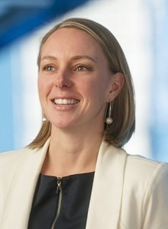3 Minute Presentation

Guest Speaker:
Donna Markham

Chief Allied Health Officer,
Safer Care Victoria

Donna Markham is the Chief Allied Health
Officer for Victoria and the Chief Allied Health Officer for the State-wide Equipment Program. As a qualified Occupational Therapist, she has worked in the healthcare sector for approximately 15 years.
Donna is recognised as one of Victoria's leaders in allied health and has led many significant allied health reforms, workforce development changes and research projects and publications. Donna also led the implementation of the Allied Health Credentialing, Competency and Capability Framework.

Donna was formerly the Chief Allied Health Officer at Monash Health. She has worked in both public and private health in a variety of senior management and leadership roles and was honoured to become a finalist for the Telstra Victorian Young Business Women's Award in 2014.
Donna is a graduate of the Leadership Victoria Williamson Community Leadership Program and the Australia Institute of Company Directors.
competition
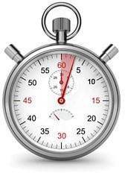
3MP competition entrants are asked to present a project (proposed or completed) in strictly 3 minutes, with no props and a single power point slide.
Allied Health clinicians at Eastern Health are eligible to enter the competition.
Our esteemed panel of judges will be awarding a prize for the best presentation, and the audience will also be voting for a “People’s Choice” award.

Still not sure? Search for “3 minute thesis” on YouTube and you’ll find plenty of examples of three minute presentations to get an idea of what the format looks like.
Entry forms are available either from allied health managers, or by contacting Katherine Harding or Nick Taylor in the Allied Health Clinical Research Office. Entries close 26th April, 2019.

Poster Display

Have you presented a printed poster at a conference in the last 12 months?
Why not give it another airing?
We are inviting allied health clinicians who have pre- sented posters in printed format at conferences over the last year to display them for their colleagues at the Allied Health Research Forum.
If you have a poster that you would like to display, please:
- Send an email to: katherine.harding@easternhealth.org.au to let us know of your intention, and so that we can ensure that space is made available for you
- Bring your poster anytime from 1.00pm on the day of the forum.

Refreshments will be served, so please RSVP by 30th April to annie.lewis@easternhealth.org.au

Page 3

ALLIED HEALTH RESEARCH NEWS MARCH 2019

“Stepping into Research”
Allied Health Research Training Scheme
Applications now open for 2019!

What is “Stepping into Research?”
This program introduces allied health clinicians to the process of conducting and writing up a sys- tematic review of the literature. No previous research experience is required, just basic computer literacy and a demonstrated interest and enthusiasm for finding the answers to an important
clinical question.
Participants will have the opportunity to present at an appropriate Eastern Health Forum, and are expected to work towards the goal of submitting their work to a peer reviewed journal.

What’s Involved?
Successful applicants will be supported by their manager to spend one half day per week for twelve weeks to learn to conduct and write up a systematic review on a topic relevant to their work place. The program includes:
- 4 x 3 hr group training sessions (Thursday afternoons: 11th July, 1st August, 29th August, 19th September at Box Hill)
- A series of 1:1 meetings with an allocated mentor
(time and site negotiable)
- Private study time
- An additional presentation afternoon at Box Hill for participants and mentors on Thursday 17th October.

Expectations
At the conclusion of the program, participants are expected to have written a systematic review of the evidence for a clinical intervention of relevance to their workplace to a standard suitable for submission to a peer reviewed journal.
Participants are also expected to be available to present their
findings at an appropriate Eastern Health forum, such as the annual Allied Health Research Forum.

To obtain an application form, contact Katherine Harding at the Allied Health Clinical Research Office or talk to your manager. Further information is available from Nick Taylor
(9091 8874) or Katherine Harding (9091 8880).
Applications close Friday 31st May. Places will be limited.

Welcome Amy Dennett, Allied Health Research and Translation Fellow

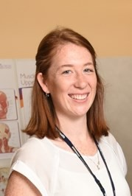
The Allied Health Clinical Research Office team is excited to welcome Dr Amy Dennett into the role of Allied Health Research and Translation Fellow. This
position is one of 10 newly created Grade 4 positions across Victoria that aim to support research and evidence based practice in allied health through building research capacity. The purpose of the role is to support, promote and complete
research relevant to Allied Health that will improve patient outcomes, and has a particular responsibility of supporting and promoting research for health professionals from the Allied Health sciences.
Amy is well known to Eastern Health through previous physiotherapy roles, initially in a variety of community and rehabilitation settings, and specialis- ing in oncology rehabilitation in recent years. Amy is also an accomplished researcher, having completed her PhD last year examining the role of oncology rehab-ilitation for increasing physical activity levels of cancer survivors. She has published multiple
papers in peer-reviewed journals, presented her research widely at national and international events, and is rapidly developing a reputation as a research leader in her field.
Amy will be working within the Allied Health Clinical Research Office, based at Box Hill Hospital, but will also be working collaboratively with colleagues in the allied health sciences and will regularly be seen out and about across Eastern Health. She will continue to work one day per week in a clinical role with the
oncology rehabilitation service.

ALLIED HEALTH RESEARCH NEWS MARCH 2019
Page 4

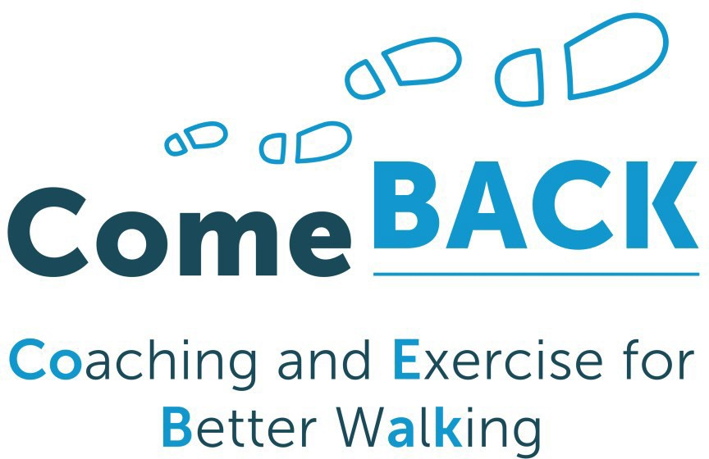Achieving physical activity goals is challenging when people have difficulty walking. But we know that exercise is the single most important thing we can do to improve walking ability and daily activities.
The Allied Health Clinical Research Office has partnered with the University of Sydney and the Institute for Musculoskeletal Health in a multi-state, NHMRC-funded randomised controlled trial called ComeBACK: Coaching and Exercise for Better Walking. The trial will test physical activity coaching for adults with mobility limitations. Easter Health is one of a number of sites around the country recruiting participants for this trial.
Clients from our four Community Rehabilitation Programs with mobility limitations who are ready for diacharge from CRP have the opportunity to participate in this trial. Those who sign up to the trial will be randomised to one of the following interventions:
- A 6 month phone based health coaching program together with access to technology to track activity levels;
- A single phone session with tailored advice and 6 months of text messaging support;
- No intervention for 6 months, followed by the text messaging support program.
Thank you to the CRP therapists who are involved in assisting in recruitment. We will be keeping you informed of the trial’s progress and trust that the participating clients benefit from the intervention.

Clients are eligible for this trial if they are:
- Attending one of our Community Rehabilitation Programs
- Living in the community
- Have difficulty walking 800m but are not wheelchair dependent
- Not currently doing 150 minutes of exercise per week
- Able to participate in phone based coaching delivered in English

For further information contact: Annie Lewis

ComeBack Trial Project Officer Annie.lewis@easternhealth.org.au

Congratulations to our new PhD Students

Congratulations to two of our allied health clinicians have started their journey towards a PhD this year.
Occupational Therapist Anna Joy has enrolled at La Trobe University. Her PhD studies will investigate the efficacy of technological solutions to
facilitate translation of research evidence into practice in the field of sensory rehabilitation for stroke survivors.
Speech Pathologist Rebecca Sullivan is embarking on her PhD journey with the University of Technology, Sydney. Rebecca is keen to use her PhD studies to build on her recent
work (see p.7) investigating the relationship between falls and communication disorders in inpatient settings.

ALLIED HEALTH RESEARCH NEWS MARCH 2019
Page 5

Eastern Health Project a finalist in the inaugural
Excellence in Research and Translation Awards

An Eastern Health based team from the Allied Health Clinical Research Office were very excited to have a projct selected as one of six finalists in the inaugural Allied Health Research and Translation awards at La Trobe University.
The project, title “Reducing waiting time for Sub-Acute and Ambulatory Care” is also known as the STAT project at Eastern Health as it
tested the effectiveness of the “Specific Timely Appointments for Triage” model for access and triage to reduce waiting time for patients referred to a range of ambulatory and community health services.
This award was designed to showcase work done in health research and translation by La Trobe university researchers. The awards night, held on 20th March, at the Glasshouse was an opportunity to celebrate the achievements of all the nominees. The event was hosted by Norman Swan, and a short
To see the STAT project award video (and play “spot the Eastern Health extras!”) go to:
http://arch.latrobe.edu.au/News/arch-members
-nominated-for-award
video about each
of the projects was screened.
Unfortunately the STAT project didn’t take out the title. This honour went to the COSMOS randomised controlled trial, that has shown that caseload
midwifery model reduces the rate of caesarean births.

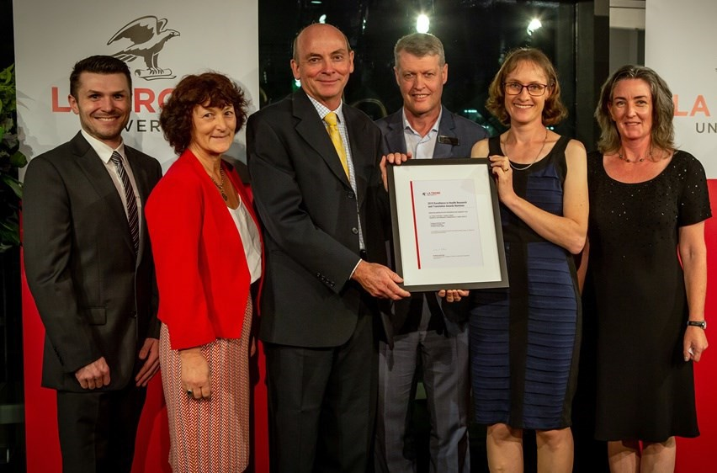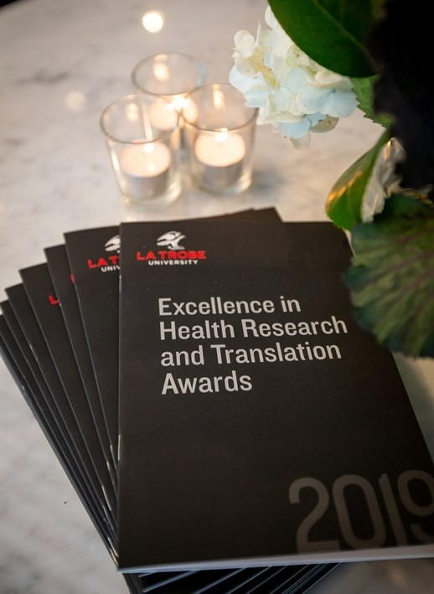

MiHIP Project
In the last edition of Allied Health Research News we reported on a new randomised controlled trial evaluating motivational
interviewing to increase mobility in patients recovering from hip fracture that will be getting underway this year. The project has been funded for the next 4 years by the National Health and Medical Research Council.
The project is bringing a number of opportunities for clinicians who might be interested in getting involved.
For more information please contact:
Nick Taylor nicholas.taylor@easternhealth.org.au Phone: 9091 8874

Members of the STAT research team with University Pro Vice Chancellor Robert Pike. From left : David Snowdon, Jenny Watts, Nick Taylor, Robert Pike, Katherine Harding and Annie Lewis)
Upcoming opportunities for interested clinicians
Project manager/trial coordinator: This will be a part time (0.6 to 0.8 EFT), fixed term role, expected to be advertised in May. We will be seeking someone with excellent project management skills and an understanding of the health service context.
Casual staff (employed through La Trobe University) will be needed to provide three distinct services. These roles are ideally suited to people interested in working additional casual hours on top of their usual role:
- Motivational Interviewers: 6-10 clinicians will be recruited to conduct weekly telephone based motivational interviewing with the intervention group participants. High level interpersonal skills required. Training in motivational interviewing will be provided.
- Outcome assessors: Several casual staff will be needed to conduct home-based outcome assessments, blinded to group allocation
- Dietitians: The control group will receive a telephone based dietetics intervention, equivalent in time/attention to the motivational interviewing intervention. Dietitians will be recruited to provide this service.
PhD student: There may be a scholarship opportunity for a clinician who is qualified for direct entry to PhD (eg with demonstrated research experience or post graduate research qualifications) to join this project team. Please be in contact as soon as possible if this interests you.

ALLIED HEALTH RESEARCH NEWS MARCH 2019
Page 6
Allied Health hit 50 publications in a calendar year
Launch of the 2018 Allied Health Research Report

Every year the Allied Health Clinical Research Office compiles a report of Allied Health research activity. The report for the 2018 calendar year is now available for download from Allied health research page of the Eastern Health website. Once again our report shows an ongoing increase in research activity. In the 2018 calendar year we had:
  - 46 projects either in progress or completed
  - 50 publications in peer-reviewed journals
  - 46 presentations at local, national or international conferences
  - 15 students enrolled in PhDs or clinical doctorates, with 5 completing their studies during the calendar year.

The number of publications from Allied Health at Eastern Health annually since 2006

60
50
40
30
20
10
0
The number of publications in academic, peer reviewed journals is a commonly used metric for research activity. While this does not capture all research activity it is an indicator of high quality research being completed and reported beyond our health service.
It is therefore encouraging to see that the annual rate of publications with authors from our allied health professional workforce at Eastern Health continues to increase steadily, and this year we hit the milestone of 50 publications in a calendar year!
The number of presentations at conferences was less than in 2017, but this is most likely explained by the events held in any given year. The National Allied Health Conference and the Victorian Allied Health Research Conference are both major biennial events on the allied health calendar, and are held in the odd numbered years. So we are expecting big things on the conference front from our Allied
Health workforce in 2019!
Many thanks to everyone who contributed to the 2017 Allied Health Research Report.
Need some advice on a research idea?
Come and have a chat to an experienced researcher at one of our allied health research clinics.

Site | Date | Contact
Maroondah Hospital | April 4th, 8.30-10.30 | Katherine.Harding@easternhealth.org.au
Wantirna Health | May 2nd, 9.30-11.30 | Katherine.Harding@easternhealth.org.au
Yarra Ranges Health | 6th June, 9.30-11.30 | Judi.porter@easternhealth.org.au
Peter James Centre | 20th June 8.30-10.00 | Katherine.Harding@easternhealth.org.au
Box Hill Hospital | Make an appointment any time | Katherine.Harding@easternhealth.org.au or  Nicholas.taylor@easternhealth.org.au
Angliss Hospital |  | Judi.porter@easternhealth.org.au

Page 7
Allied Health Research Committee
Nick Taylor Katherine Harding Anne Thompson Jason Wallis (PT) Alison Wilby (Psych)
Sarah Dallimore (Pod) Judi Porter (Dietetics) Rebecca Nicks (OT) Lauren Lynch (SP) Glenda Kerridge (SW) Judy Bottrell (PT)
Peter Brann (Mental Health)

Allied Health Clinical Research Office Telephone: 9091 8880 or 9091 8874 nicholas.taylor@easternhealth.org.au katherine.harding@easternhealth.org.au

ALLIED HEALTH RESEARCH NEWS MARCH 2019

Allied Health Research Achievements
Publications

Alex Robinson (Physiotherapy)
Robinson A, Snowdon D. Treadmill training may be an effective form of task-specific training for improving mobility in people with Parkinson's disease and multiple sclerosis: A systematic review and meta-analysis. Physiotherapy. (In press).

Deenika Benjamin (PhD Student, Physiotherapy)
Benjamin D, Shields N, Frawley H, Taylor NF, van de Water AM. 2019. Relationship between diastasis recti of the abdominal muscles (DRAM) and musculoskeletal dysfunctions, pain and quality of life: a systematic review and meta-analysis. Physiotherapy. 105:24-34.

Stephanie Clarke (Physiotherapy)
Clarke S, Munro PE, Lee AL. 2019. The Role of Manual Therapy in Patients with COPD. Healthcare. 7(1): E21.

Katherine Harding (Allied Health Clinical Research Office)
Fradgley EA, Karnon J, Roach D, Harding K, Wilkinson-Meyers L, Chojenta C, et al. 2019. Taking the pulse of the health services research community: a cross-sectional survey of research impact, barriers and support. Australian Health Review. [Early online]

David Snowdon (PhD, Allied Health Clinical Research Office)
Snowdon D, Leggat SG, Harding KE, Boyd J, Scroggie G, Taylor NF. 2019. The association between effectiveness of clinical supervision of allied health professionals and improvement in patient function in an inpatient rehabilitation setting. Disability and Rehabilitation. [Early online]

Rebecca Sullivan (Speech Pathology)
Sullivan R, Harding KE. 2019. Do patients with severe post stroke communication difficulties have a higher incidence of falls during inpatient rehabilitation? A retrospective cohort study. Topics in Stroke Rehabilitation. [Early online]

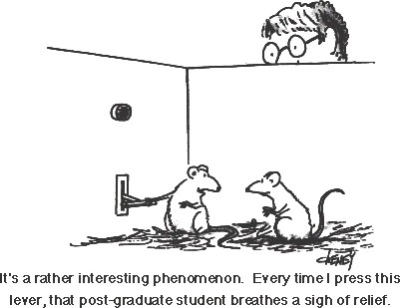

Follow us on Twitter!
@EH_Research

Multi-disciplinary conference opportunities
in 2019

