ALLIED HEALTH RESEARCH NEWS

ISSUE 44 SEPTEMBER
2018

A Research Newsletter for
Allied Health

Inside this issue:

The STAT Project | 2
Social work are Reaching for the Stars! | 3
Upper limb assessment and intervention framework | 4
Occupational Therapy Vic- Tas Regional conference | 5
Euan’s Musings | 6
Allied Health research achievements | 7
Allied Health Research News

Congratulations Box Hill Hospital and Eastern Health!!

Exciting news for research at Eastern Health—The latest global rankings indicate Box Hill Hospital is ranked at Number 2 in Australia and number 36 in the world for research excellence.
This global ranking is undertaken by Times Higher Education for non-University and non-commercial research organisations. To see Eastern Health rated number 2 in Australia based on field-weighted citation impact (FWCI) is remarkable.
What is Field Weighted Citation Impact (FWCI)?
FWCI measures research impact, accounting for differences in citation levels across different fields, article types and publication age. Organisations were ranked using field-weighed citation impact for the period 2013-2017. Organisations with less than 500 publications in this period were excluded.
Research from Allied Health, Medicine and Nursing within Eastern Health contributed to this great outcome.

Research leaders in Allied Health, Nursing and
Medicine at Eastern Health
—Prof Nick Taylor , Dr Maryann Street (representing Prof Julie
Considine), Prof Ian Davis and Prof David Taylor (EH Director of Research).

Times Higher Education Research Excellence Table

Here is the link to the 2017 Eastern Health research report, which
gives you some insight into the fabulous work being done!
https://www.easter
nhealth.org.au/abo
ut-
us/publications/cat
egory-items/3-
publications/11-
research-reports-
2014

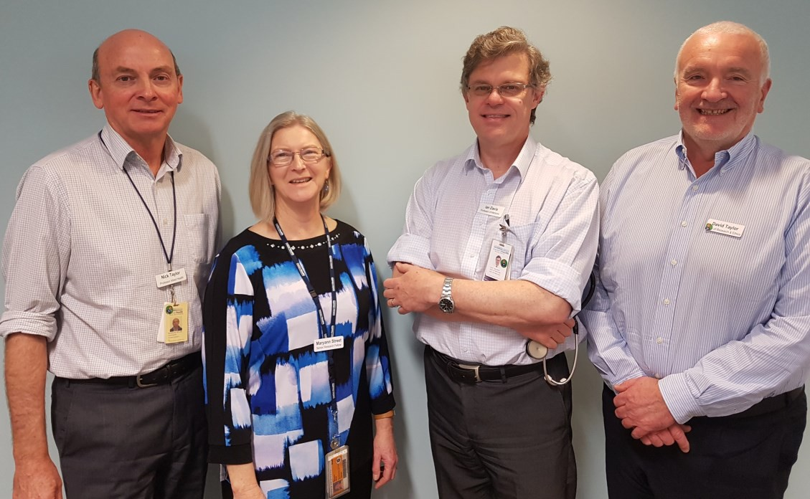
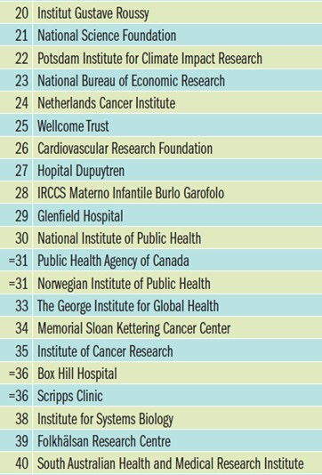
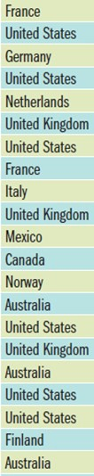
https://www.timeshighereducation.com/feature
s/are-research-institutes-islands-excellence

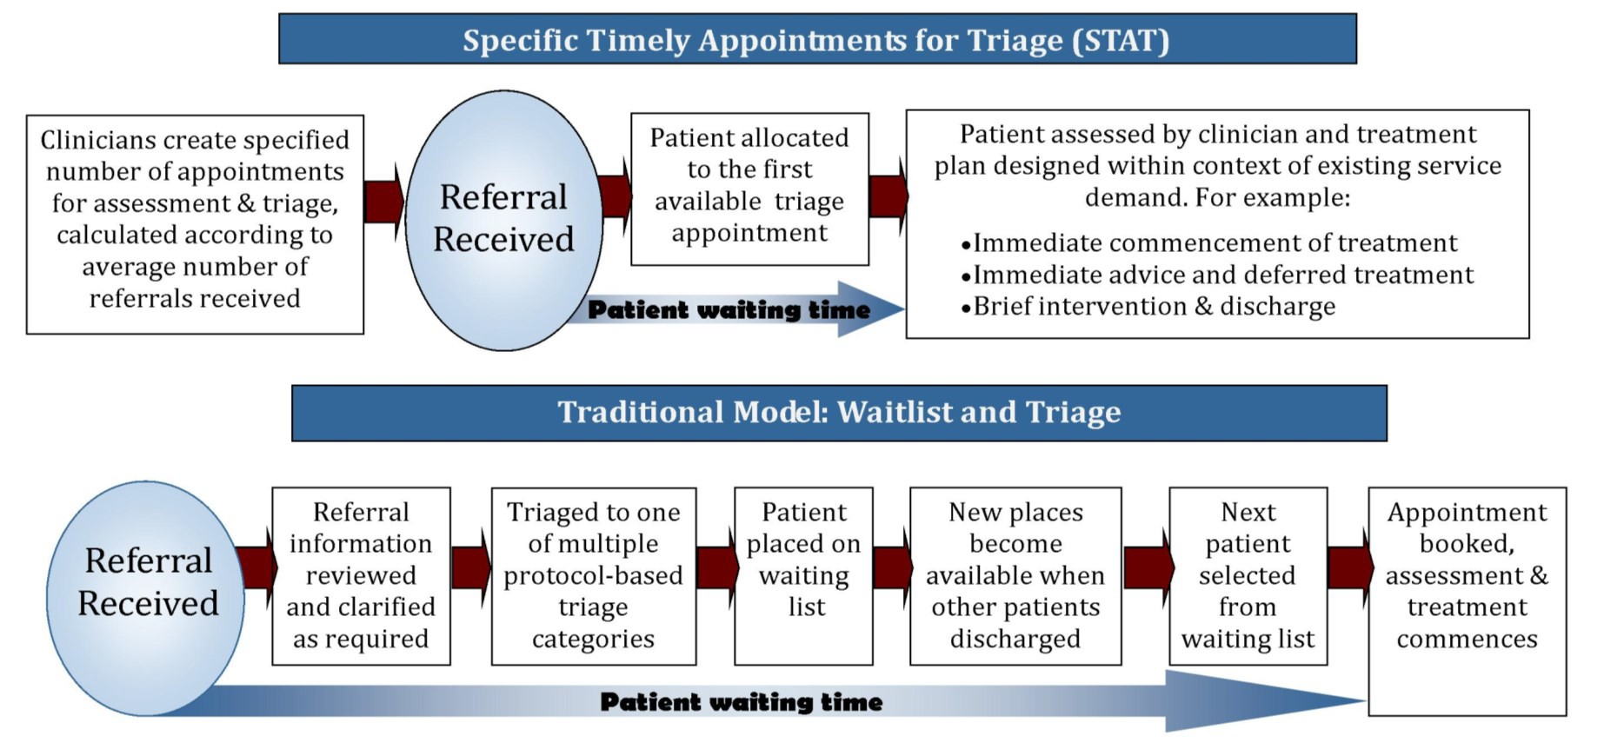
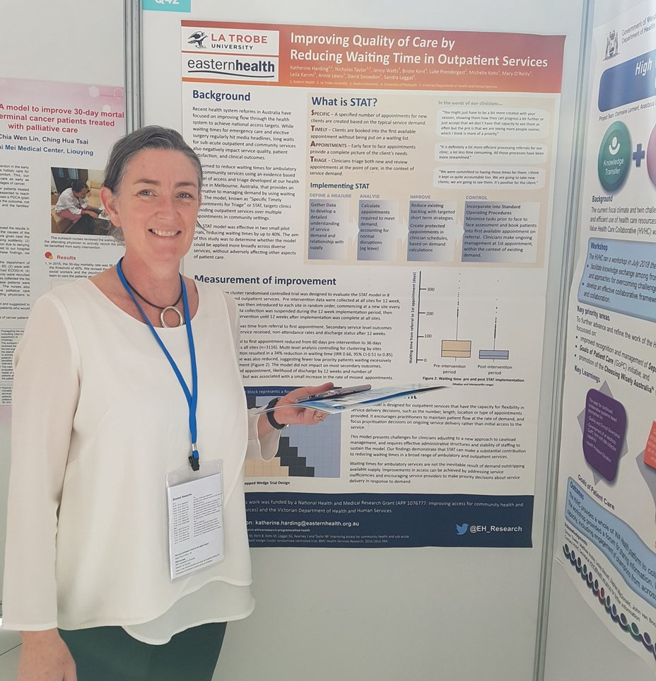
Improving access for community health and sub-acute outpatient services – the STAT project
Harding KE, Leggat SG, Watts JJ, Kent B, Prendergast L, Kotis M, O'Reilly M, Karimi L, Snowdon DA, Lewis AK, Taylor NF. (in press). A model of access combining triage with initial management reduced waiting time for community outpatient services: a stepped wedge cluster random- ised controlled trial. BMC Medicine (accepted 10 September 2018, impact factor 9.088).

Waiting lists have been described as “the scourge of modern medicine”. Recent health system reforms in Australia have focused on improving access to hospital services with greater understanding of the need to ensure efficient patient flow through all health system components to achieve national access targets. While waiting times for emergency care and elective surgery regularly hit media headlines, patients also frequently face long waits for a broad range of sub-acute outpatient and community based services with significant health and economic costs.

Mean time from referral to first appointment
reduced from 60 days pre-intervention to 36 days post
-intervention across all sites, a 34% reduction in waiting time (IRR 0.66, 95% CI 0.63 t 0.70). Variation in waiting time was also reduced, suggesting fewer low priority patients waiting excessively long
periods for assessment.
Earlier access to healthcare has the potential to prevent deterioration of a condition, improve quality of life and reduce anxiety associated with waiting for care. Reducing waiting time can also improve service efficiency, by reducing the need for resources to manage the waiting list. STAT encourages practitioners to maintain patient flow at the rate of demand, and focus prioritisation decisions on ongoing service delivery rather than initial access to the service. Our findings demonstrate that STAT can make a substantial contribution to reducing waiting times in a broad range of ambulatory and outpatient services.
Waiting lists for these services are not always inevitable, but can be addressed with alternative approaches to access and triage that improve patient flow. We have developed an innovative model for access and triage, known as STAT (Specific and Timely Appointments for Triage). The STAT model has been effective in two pilot trials at Eastern Health, reducing waiting times by up to 40%. A successful application for a grant from the National Health and medical Research Council has now enabled a larger trial, led by Katherine Harding and Nick Taylor, to be conducted here at Eastern Health. The aim of this study was to determine whether the model could be applied more broadly across diverse services, without adversely affecting other aspects of patient care.
The key elements of the STAT model are (1) careful analysis of supply and demand; (2) a
one-off intervention to reduce the existing waiting list;
(3) creation of specific, protected appointments for new patients in clinician schedules; (4) simplification of booking processes to facilitate immediate access to an initial appointment; (5) training clinicians to shift priority decision-making related to access, to priority decision-making related to the need for ongoing
service provision. The project was implemented in 8 community
health and outpatient services for 3116 patients.
The primary
outcome was time from referral to first appointment.

Reaching for the Stars – a Social Work leadership and research initiative

The Reaching for the Stars (R4TS) program is a successful initiative of the
Health Social Work Director’s group – a Practice Group of the
Victorian Branch of the Australian Association of Social Workers. R4TS was established in 2014 to develop leadership capabilities amongst the hospital social work workforce. Over time, the group reported anecdotally that recruitment to senior positions could be difficult and additionally that the transition to senior positions often posed significant challenges.

R4TS aims to develop Grade 2 social workers by attendance at monthly seminars, and to expose them to the range of skills they will need to move into a senior role, including leadership, project management and a broader understanding of the health system. Participants are carefully selected via an application process, and are also required to undertake a research project within their health service and are subject to the rigours of the ethics application process and management of their project. They are expected to complete a poster presentation to the HSWDG Research Symposium in the following year. In 2017, EH social workers Carmen Mohanu and Sophie Hatzipashalis completed the R4TS program and undertook research projects within Eastern Health. A summary of their projects has been provided below:

Social Workers Sophie Hatzipashalis
(L) and Carmen Mohanu

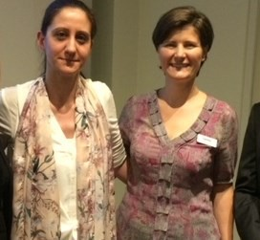
Addressing Hoarding and Squalor in a Health Care Setting Project
Sophie Hatzipashalis, Social Worker, Wantirna Health / PJC
As a hospital social worker on a sub acute ward, I was starting to notice a pattern. When patients were identified with behaviours
relating to hoarding and squalor, there appeared to be a lack of knowledge by staff across all disciplines on the resources and
treatments available. There was also confusion around staff’s responsibility and processes to follow. Hoarding and squalor related behaviours present serious safety
issues to the individual and the general public. These concerns led me to focussing my research project on ‘Addressing Hoarding and Squalor in a Health Care Setting’. My aim is
to increase staff’s awareness in this area and to provide them with information about how to respond more effectively. This qualitative project has been approved by Eastern Health’s Ethics Committee and includes four objectives (see table). This project has allowed me to strengthen my research skills, increase my confidence and network with a range of
internal and external workers. I would recommend all social workers interested in research to give it a go!
An interdisciplinary approach to identifying and referring those at risk of complicated grief
Carmen Mohanu, Social Worker, Wantirna Health
Last year the Eastern Health Inpatient Supportive and Palliative Care unit at Wantirna Health identi- fied there were no clear guidelines around identifi- cation of families at risk of potential complicated grief. Complicated grief is “a reaction to loss that can have long-term effects. Individuals may expe- rience severe and prolonged grief symptoms.” To determine the level of competencies and confi- dence of staff in
assessing and referring appropriately families at risk of potential complicated grief, a survey was carried out. The results indicated that 96% of the staff wanted further education in this area and 86% felt that an assessment tool would be beneficial to guide their assessment. As a result an education package was developed and delivered, followed by a second survey to determine the impact of this education session. The results of this survey are currently being collected.
As part of the next step in this project, a working group was formed to develop or determine which complicated grief risk assessment tool can be
implemented on the ward to support the staff in
their assessments. It is anticipated that as a result of the staff’s education and use of an assessment tool, the families at risk of potential complicated grief will have better outcomes in the long run.

ALLIED HEALTH RESEARCH NEWS SEPTEMBER 2018 Page 4

Introduction and Evaluation of Upper Limb Assessment and Intervention Framework

Project lead: Anuschka Toal
This project, which is a collaboration between Eastern Health and VSCN established an integrated Upper Limb Framework of upper limb rehabilitation post stroke that is strongly grounded in evidence, and is responsive to contemporary health management methods including:
inter-disciplinary practice; individual versus group therapy delivery; Allied Health Assistant workforce delegation. The framework provided an assessment and treatment protocol based on clinical severity.
To determine effectiveness of the framework, a pre and post documentation audit was completed. The pre-audit consisted of 57 medical histories of stroke admissions. Results indicated that physiotherapists predominantly completed the upper limb assessment on admission (96%) and 68% of patients admitted received an upper limb
assessment by an occupational therapist. Assessment of the required domains of upper limb function by both occupational therapists and physiotherapists was poor with < 1% assessments having all domains completed.
Improvements in the quantity and quality of assessment were noted following framework implementation with 75% of patients admitted receiving an OT upper limb assessment. Of these, 96% had all domains covered within the assessment. Similarly, 75% of patients admitted received a Physiotherapy upper limb assessment. Of these, 67% had all domains covered within the assessment, with most assessments completed collaboratively.
Focus groups during development and trial phases of the assessment forms and process were used to encourage both active involvement and education throughout the project by key stakeholders. Identification and use of site based champions were also nominated to facilitate ongoing education and training for new and rotating clinicians. The framework (including forms and resources) is accessible to all clinicians through the Sharepoint. Education sessions were un- dertaken and in addition, wider clinical knowledge gaps were targeted through the use of practical workshops focused on intervention practices.
In conclusion, the upper limb framework has provided a consistent and streamlined assessment protocol for stroke clinicians to work within. Further work is ongoing to embed this framework into clinical practice with the hope that all stroke survivors where indicated receive appropriate and timely standardised assessments with follow on of evidence based intervention practices.

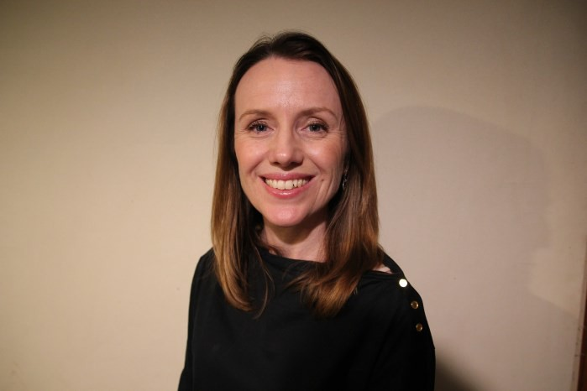
Welcome to Gr 4 Occupational Therapist for Acute Services, Rebecca Nicks!
Rebecca has worked as an occupational therapist in rehabilitation and acute neurosciences for over 20 years and has completed a Masters in Health Sciences (Occupational Therapy). She has held many roles across Melbourne and the United Kingdom in the public health sector and brings a wealth of experience in evidence based practice. She enjoys supporting and mentoring
clinicians with their research projects and is committed to ensuring that research exists within a clinical setting to strengthen both the clinician and the service they provide. Her recent research has involved home modifications, goal setting for stroke and ABI clients, and longitudinal outcomes for people with an ABI. She has presented her work both locally and internationally and published outcomes of her work in peer reviewed journals. Bec will be a fabulous addition to the OT dept at Eastern Health!

Eastern Health shines at the Occupational Therapy Vic-Tas Regional Conference
Occupational Therapy Australia held their Vic-Tas regional conference in Melbourne on 29th June. It was terrific to see Eastern Health so well represented. 8 staff presented their work against the key themes of Engage, Enrich and Enable. Keynote speakers included: Professor Lorimer Moseley, Professor Iona Novak, Dr Dinesh Palipana and Dr Elisa Yule.
Congratulations to the following staff
Jessica Tuck – “Family caregiver intervention improves outcomes for patients with delirium.”
Jude Boyd – “Defining advanced practice roles for occupational
therapy – A competency-based framework to work with”
Sara Whittaker and Meagan Rennison – “Improving timely, efficient and meaningful clinical handover for occupational therapy within a large health network”
Sara Whittaker – “Evaluation of occupational therapy practices for continuity of care in rehabilitation from bed based services to ambulatory and community models of care”
Jennifer White – “Does cognitive retraining after stroke result in
better everyday living? A systematic review and meta-analysis”
Sara Whittaker, Catherine Green, Stephanie Tawse and Annette Leong – “Evaluation of the use of an electronic daily handover tool by occupational therapy to support clinical service
provision”

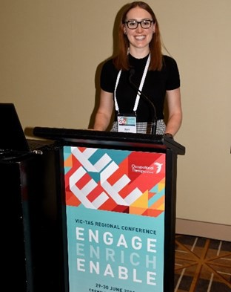
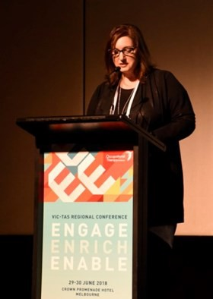
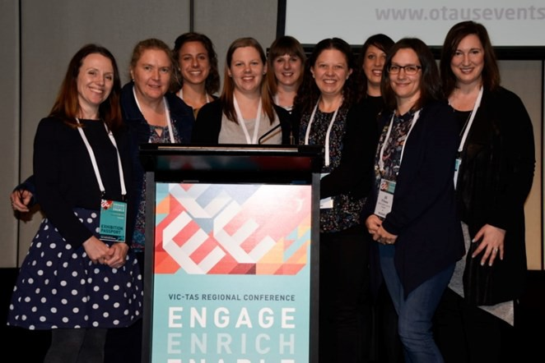
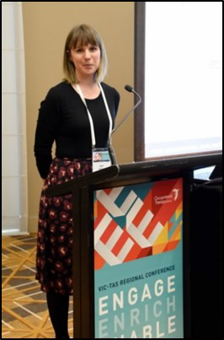

From left ; Rebecca Nicks, Catherine Green, Amber Knight, Lisa Collins, Jenn White, Nichola Terrington, Sara Whittaker, Jill d’Souza & Jude Boyd

From Top: Jess Tuck, Jude Boyd and Jennifer White

Euan’s Musings
Dr Euan Donley works in mental health and likes to analyse people for the purposes of simplifying who they are to keep to his word limit.

MANAGING THE EXPECTATIONS OF OTHERS
There are two types of people; those who like to categorise, and those who don’t. The more astute of you have just noticed I am the former. Thus, I now propose there are two types of researchers; experienced and less
so. You, dear reader, are one of those. As a researcher of diverse experience, you may be asked to do some research.
I have spoken in the past about managing our own expectations on research and what it may mean for us and the world. But what about the expectations of others?
Some years ago a private company asked me to do a study on a tool they developed for training staff. They had hired three people and wanted me to help validate their tool. If I could just pop over for a month, use the tool to test three staff, and prove their tool was effective. Now, I was much more courteous than in this article, but needless to say they were advised that the best outcome with a sample size of three on an invalidated tool is a self-funded publication in the International Journal of Who Cares.
So with this in mind, I have some tips in managing the expectations of others who want you to do some research;
Research takes time: having a week off to research something is akin to baking a cake for 30 seconds. It will be sloppy, unfinished, and only appreciated by 4 year-olds.
Research takes headspace: Doing it sporadically for two hours at a communal desk in between clinical duties is like asking someone to read Jane Austin while watching Avengers at the cinema (I am moving my
pop-culture references away from Star Wars just for today).

Have a basic concept of what they want: Do they have a research question that is more sophisticated that, “Can you publish something?”
Be prepared for disappointment: Much like when reading this article, the outcome may not reflect what was hoped
Keep them informed: Milestones such as ethics approval, preliminary data, and initial findings are generally exciting to hear.
Sell the positives: Good research generally gets good exposure and longevity. It’s important to remind people that your ROD (Research Obsessive Disorder) is a good thing for them in the long-term.
I usually like to end on a great little summary of things which is hopefully both witty and educational. But I’m fresh out. Now there are two types of readers; those that expect this, and those that don’t care how I end it as long as there is a full stop.

Do you need some assistance with a research question?
No further formal research clinics are scheduled for 2018. Howev- er any allied health clinicians wanting research advice are welcome to contact:
Nick Taylor (BHH) Nicholas.taylor@easternhealth.org.au Judi Porter (Angliss) Judi.porter@easternhealth.org.au

Are you interested in finding out what’s happening in the world of research at Eastern Health? You’ll find Allied Health Clinical Research Office news
@EH_Research
Join the twitter conversation—we are hoping to reach 200 followers! Will you be the 200th for a chocolate surprise?

Allied Health Research Achievements
Publications
Baldwin C, Harry AJ, Power L, Pope K, Harding K. (2018). Modified constraint-induced movement therapy is a feasible and potentially useful addition to the Community Rehabilitation tool kit after stroke: A pilot randomised control trial. Australian Occupational Therapy
Journal, epub (ahead of print).
Benjamin D, Shields N, Frawley H, Taylor NF, van de Water AM. (in press). Relationship between diastasis recti of the abdominal muscles (DRAM) and musculo- skeletal dysfunctions, pain and quality of life: a systematic review and meta-analysis. Physiotherapy (accepted 20 July 2018)
Coker F, Williams CM, Taylor NF, Caspers K, McAlinden F, Wilton A, Shields N, Haines TP. (2018). Allied Health IMPACT study: Investigating the impact of Mod- els of Practice for Allied health Care in subacute settings. A protocol for a quasi-experimental mixed methods study of cost effectiveness and outcomes for patients exposed to different models of Allied Health care. BMJ Open 2018;8:e020361. doi:10.1136/bmjopen-2017-020361
Dennett AM, Peiris CL, Taylor NF, Reed MS, Shields N. (in press). 'A good stepping stone to normality': A qualitative study of cancer survivors' experiences of an exercise-based rehabilitation program. Supportive Care in Cancer (accepted 16 August, 2018)
Dennett AM, Shields N, Peiris CL, Prendergast LA O’Halloran PD, Parente P, Taylor NF. (in press). Motivational interviewing added to oncology rehabilitation did not improve moderate-intensity physical activity in cancer survivors: a randomised trial. Journal of Physiotherapy (accepted 10 August 2018)
Emmerson K, Harding K, Lockwood K, Taylor N (2018). Home exercise programs supported by video and automated reminders for patients with stroke: A qualitative analysis. Australian Occupational Therapy Journal, 65(3), 187-197.
Harding KE, Leggat SG, Watts JJ, Kent B, Prendergast L, Kotis M, O'Reilly M, Karimi L, Snowdon DA, Lewis AK, Taylor NF. (in press). A model of access combining triage with initial management reduced waiting time for community outpatient services: a stepped wedge cluster randomised controlled trial. BMC Medicine (accepted 10 September 2018, impact factor 9.088).
Nicks RJ and Letts L (2018). CAP of Functional assessments used by occupational therapists with older adults at risk of activity and participation limitations: A systematic review. Australian Occupational Therapy Journal. Epub (ahead of print) doi: 10.1111/1440-1630.12532
Ottrey E, Jong J, Porter J. Ethnography in nutrition and dietetics research: A systematic review. Journal of the Academy of Nutrition & Dietetics.
Porter J, Wilton A. Professional identity of allied health staff. Journal of Allied Health (in press).
Sansonetti D, Nicks RJ, Unsworth C (2018). Barriers and enablers to aligning rehabilitation goals to patient life roles following acquired brain injury. Australian Occupational Therapy Journal, epub (ahead of print).
Snowdon DA, Leggat SG, Harding KE, Scroggie G, Boyd J, Taylor NF. (in press). The association between effectiveness of clinical supervision of allied health professionals and improvement in patient function in an inpatient rehabilitation setting. Disability and Rehabilitation (accepted 28 August 2018)
Summers BE, Laver KE, Nicks RJ, Lannin NA (2018). What factors influence time-use of occupational therapists in the workplace? A systematic review. Australian Occupational Therapy Journal, 65(3), 225-227
Conference Presentations:
Boyd, J. Defining advanced practice roles for occupational therapy – A competency-based framework to work with. Occupational Therapy Australia Vic-Tas regional conference, Melbourne, 29th June.
Donley, E. Putting technology into practice: Bringing tele-psychiatry to the ED. 2018 Victorian Healthcare Association Annual Conference, Melbourne, 17 August 2018.
Haley, M. Delirium Management: Let’s get physical. 2018: Delirium Clinical and Research Days, Melbourne, 6-7th September 2018. (Winner best poster!)
Tuck, J. Family caregiver intervention improves outcomes for patients with delirium. Occupational Therapy Australia Vic-Tas regional conference, Melbourne, 29th June.
Tuck, J. Family intervention improves outcomes for patients with delirium. DECLARED 2018: Delirium Clinical and Research Days. Melbourne, 6-7th September 2018. (Winner best presentation!)
Whittaker, S & Rennison, M. Improving timely, efficient and meaningful clinical handover for occupational therapy within a large health network. Occupational Therapy Australia Vic-Tas regional conference, Melbourne, 29th June.
Whittaker, S. Evaluation of occupational therapy practices for continuity of care in rehabilitation from bed based services to ambulatory and community models of care. Occupational Therapy Australia Vic-Tas regional conference, Melbourne, 29th June.
White, J. Does cognitive retraining after stroke result in better everyday living? A systematic review and meta-analysis. Occupational Therapy Australia Vic- Tas regional conference, Melbourne, 29th June.
van Veenendaal, N, Breik, L. Nutrition practices in general medicine results from Australian Nutrition Day participation. 40th ESPEN Congress on Clinical Nutrition and Metabolism, Madrid. September 2018.

Ukovic BM, Breik L. End Unnecessary Fasting (ENUF): An Australian Nutrition Day experience. 40th ESPEN Congress on Clinical Nutrition and Metabolism, Madrid.September 2018 .
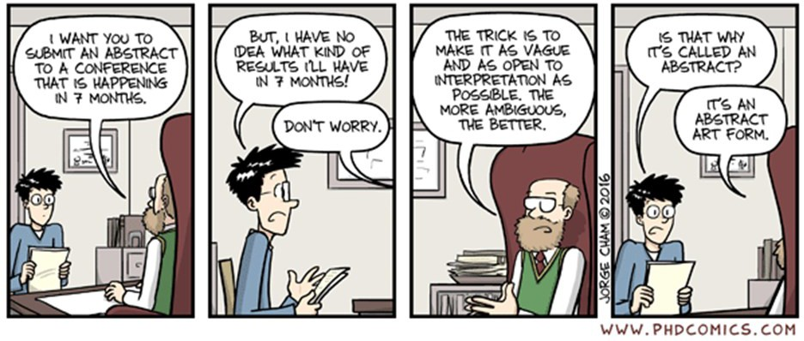
Allied Health Research Committee
Nick Taylor Katherine Harding
Judy Bottrell (PT) Peter Brann (mental health) Sarah Dallimore (Pod) Euan Donley (Triage and CATT) Glenda Kerridge (SW) Lauren Lynch (SP)
Rebecca Nicks (OT) Judi Porter (Dietetics) Anne Thompson (AHCRO) Jason Wallis (PT) Alison Wilby (Psych)

