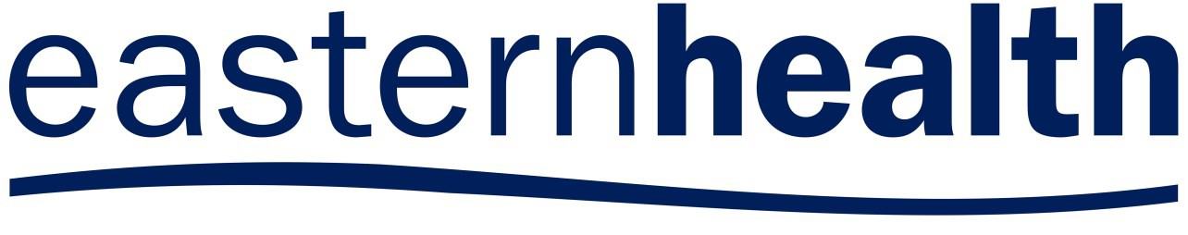

ALLIED HEALTH RESEARCH NEWS

ISSUE 42 MARCH 2018

A Research Newsletter _{for} Allied Health Clinicians
Inside this issue:

Stepping into Research Training Scheme—2018 applications now open! | 2
2018 Allied Health Research Forum-May 10th | 3
Early Supported Discharge after stroke | 4
Euan’s musings | 4
Research employment opportunities | 5
Allied Health Research Achievements | 6

Allied Health Research News
Launch of the 2017 Allied Health Research Report

Annually the Allied Health Clinical Re- search Office compiles a report of Allied Health research activity. The report for the 2017 calendar year has just been released and is available for download from Allied health research page of the Eastern Health website.
This year’s report demonstrates that allied health research continues to flourish at Eastern Health. In the 2017 calendar year we had:
- 48 projects either in progress or completed
- 41 publications in peer-reviewed journals
- 71 presentations at local, national or international conferences
- 12 students enrolled in PhDs, with several of these completing their studies during the calendar year.
Looking back over our annual research reports since 2010 provides an inter- esting insight into how allied health research has changed over time in our health service. There has been growth in each of the areas described above.
There has been steady increase in publication rate over the years, which is particularly pleasing given that publications tend to be an indicator of quality of work completed, as well as a demonstration that work is being shared beyond the boundaries of Eastern Health.
The number of presentations at conferences also appears to have been increasing over time, although the pattern is less consistent.
Conference presentations are influenced by the events held in any given year. 2017 was a particularly strong year for presentations, but this was likely to have been influenced
by two biannual conferences (the Victorian Allied Health Research Conference and the Occupational Therapy Australia National Conference) that had strong representation from Eastern Health.
Many thanks to everyone who contributed to the 2017 Allied Health Research Report.

Research Outputs from the Allied Health Research Reports, 2009-2017
Projects (in progress or
completed)
Publications
80
70
60
50
40
30
20
10
0

* in 2014 research reports changed from a financial year to a calendar year cycle. 2014 includes data from July 2013 to December 2014
Presentations

PhD students

Page 2 ALLIED HEALTH RESEARCH NEWS MARCH

“Stepping into Research”
Allied Health Research Training Scheme
Applications now open for 2018!

What is “Stepping into Research?”
This program introduces allied health clinicians to the process of conducting and writing up a system- atic review of the literature. No pre- vious research experience is re- quired, just basic computer literacy and a demonstrated interest and enthusiasm for finding the answers to an important clinical question.
Participants will have the opportunity to present at an appropriate Eastern Health Forum, and are expected to work towards the goal of submitting their work to a peer reviewed journal.
What’s Involved?
Successful applicants will be supported by their manager to spend one half day per week for twelve weeks to learn to conduct and write up a systematic review on a topic relevant to their work place.
The program includes:
- 4 x 3 hr group training sessions (Thursday afternoons: 19th July, 9th August, 13th September, 27th September at Box Hill)
- A series of 1:1 meetings with an allocated mentor
(time and site negotiable)
- Private study time
- An additional presentation afternoon at Box Hill for participants and mentors on Thursday 8th November.

Expectations
At the conclusion of the pro- gram, participants are expected to have written a systematic re- view of the evidence for a clini- cal intervention of relevance to their workplace to a standard suitable for submission to a peer reviewed journal. Partici- pants are also expected to be available to present their findings at an appropriate East- ern Health forum, such as the annual Allied Health Research Forum.

Need Some Inspiration?

To obtain an application form, contact Katherine Harding at the Allied Health Clinical Research Office or talk to your manager. Further information is available from Nick Taylor
(9091 8874)
or Katherine Harding
(9091 8880).

Applications close Friday 8th June. Places will be limited.
Check out a few of the systematic reviews published by Stepping into Research Graduates in recent years.
  - Jimmy Liapis, Occupational Therapy
Liapis J, Harding K. Meaningful use of computers has a potential therapeutic and preventative role in dementia care: A systematic review.
Australas J Ageing. 2017;36(4):299-307.

  - Megan Snowdon, Physiotherapy
Snowdon M, Peiris C. Physiotherapy commenced within the first four weeks post spinal surgery is safe and effective: a systematic review and
meta-analysis. Archi Phys Med Rehab. 2016;97(2):292-301.

  - Anna Gillman, Speech Pathology
Gillman A, Winkler R, Taylor NF. Implementing the free water protocol does not result in aspiration pneumonia in carefully selected patients with dysphagia: a systematic review. Dysphagia. 2017;32(3):345-61.

  - Melanie McGrice, Dietetics
McGrice M, Porter J. The Effect of Low Carbohydrate Diets on Fertility Hor- mones and Outcomes in Overweight and Obese Women: A Systematic Re- view. Nutrients. 2017;9(3):204.

ALLIED HEALTH RESEARCH NEWS MARCH 2018
Page 3

2018 Allied Health Research Forum

Thursday 10th May, 2.00 - 4.30pm

Wantirna Health Lecture Theatre
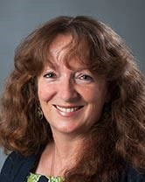
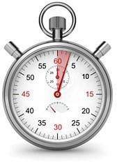
3 Minute Presentation competition
Guest Speaker:
Professor Miranda Rose
La Trobe University
From clinical experience to research:
managing post-stroke aphasia
Miranda is the Director of the Aphasia Lab and a Principal Research Fellow at La Trobe University. Miranda's research interests concern finding effective treatments and management strategies for aphasia. Miranda has had extensive clinical experience in
acute and rehabilitation hospitals in regional and metropolitan Victoria, and completed
a Graduate Diploma in Neurogenic Communication Disorders and Neuro- psychology before starting her academic career at La Trobe University in 1987.
Her PhD, completed in 2002, involved a cognitive neuropsychological study of the comparative efficacy of gesture and verbal treatments for post stroke aphasia. Miranda was the senior research fellow in the NHMRC funded Centre for Clinical Research Excellence in Aphasia Rehabilitation
(2010-14), an Australian Research Council Future Fellow (2012-15) and now directs the NHMRC funded COMPARE trial.
Miranda has over 100 peer-reviewed publications, 37 invited key note workshops and presentations and has received over $4.5 million of competitive research grant income as Chief Investigator.
Miranda collaborates with aphasia researchers internationally, and is committed to helping to develop the next generation of excellent aphasia researchers. We are fortunate to welcome Miranda to Eastern Health for our 2018 Allied Health Research Forum.
3MP competition entrants are asked to present a project (proposed or completed) in strictly 3 minutes, with no props and a single power point slide.
Allied Health clinicians at Eastern Health are eligible to enter the competition.
Our esteemed panel of judges will be awarding a prize for the best presentation, and the audience will also be voting for a “People’s Choice” award.

Still not sure? Search for “3 minute thesis” on YouTube and you’ll find plenty of examples of three minute presentations to get an idea of what the format looks like.
Entry forms are available either from allied health managers, or by contacting Katherine Harding or Nick Taylor in the Allied Health Clinical Research Office. Entries close 27th April, 2018.

Poster Display

Have you presented a printed poster at a conference in the last 12 months?
Why not give it another airing?
We are inviting allied health clinicians who have pre- sented posters in printed format at conferences over the last year to display them for their colleagues at the Allied Health Research Forum.
If you have a poster that you would like to display, please:
    - Send an email to: annie.lewis@easternhealth.org.au to let us know of your intention, and so that we can ensure that space is made available for you
    - Bring your poster anytime from 1.30pm on the day of the forum.

Refreshments will be served, so please RSVP by 30th April to annie.lewis@easternhealth.org.au

ALLIED HEALTH RESEARCH NEWS MARCH 2018

Early Supported Discharge after stroke— does it improve outcomes for
patients with upper limb impairments?
Early Supported Discharge (ESD) Programs aim to provide early, intensive therapy in people’s homes as an alternative to inpatient rehabilitation. For stroke survivors, they offer similar services to specialised stroke units in that they use a multi- disciplinary and coordinated approach. However, the ESD Program enables practice in a familiar, contextual environment. Evidence from systematic reviews provide evidence that stroke survivors with mild to moderate impairments benefit from this model of care, but few studies have specifically looked at the
RESEARCH AS A COMMODITY
I was recently listening to a podcast because I am too cool to read or watch mainstream media. Usually my podcasts involve; sci fi, gaming, Star Wars, comics, and, Game of Thrones. Hence I have just proven my earlier statement about being cool. Discussion over.
However, on this occasion I was listening to a ‘behind the media’ type of podcast and one of the regulars is a business person. One day they said, “Everything is a commodity” and
“everything can be monetized”. Which is great news for my David Prowse (look him up) autographed photo framed in my office.
But, as with everything it seems, the podcast got me thinking about the commodity of re- search. Now I’m not referring to Journals who charge thousands for subscription or open access, but began to think about how re- search can be measured as a commodity. I realized I had no clue, so I googled it. Then I realized google had no clue either. Then I realized that as a person near the end of his PhD, my first instinct for research on this mat- ter was to go to google for an answer. Then I thought about taking up drinking. But I have settled on a hot chocolate. I then realized that I tend to go on a tangent.
Where was I? Ah, commodity. Well, commod- ity is essentially an object for trade. Now I know all of the economists who regularly read my musings will scoff at the simplicity.
If you are upset, go and write your own musings.
As for me, research as a commodity is all about sharing. Not just with fellow research- ers, but our consumers, and the communi- ty. If they engage with what we are research- ing, and they feel it improves their lives, then we are research rich.
I’m sure there are far more sophisticated dis- cussions on this topic. But I decided to write about this as I hope it makes you think about what the value of your research is, and to whom.
Off to listen to my next podcast, “The Weekly Planet” and see if they will give me royalties for mentioning their name.
impact of this model of care on upper limb function.
ESD Occupational Therapist Sara Whittaker conducted an observational study to compare the patient characteristics and upper limb functional outcomes for patients who received post stroke care as part of an ESD program with those who received traditional bed based rehabilitation. Thirty-six people participated in this study, with thirty completing assessments both at baseline and at four week follow up. The Action Research Arm Test (ARAT) was the primary outcome measure for the study; the Motor Activity Log (a measure of
activity participation) and grip strength were also measured as secondary outcomes.
As an observational study, participants were not randomly allo- cated to groups and findings reflect clinical allocation to ESD or inpatient models of care. Participants in the ESD population had FIM scores indicating a moderate to mild level of disability, whereas those in inpatient rehabilitation had a range of FIM scores indicating severe to moderate level of disability. Similar findings were observed in the ARAT at baseline.
“We hypothesised that the ESD population would have better functional outcomes as they are in their own familiar environment and have greater opportunities for incidental
upper limb activity.” said Sara. “However, patients in both the inpatient and ESD group made similar improvements in upper limb function as measured by the ARAT.” However, the
researchers did report differences on the MAL, which measures how much people use their arm, and their satisfaction with that movement. “The ESD population had almost double the improvements compared to the inpatient group, suggesting that they were both using their arm more and they had increased satisfaction with the improvements that were made.”
Sara completed this study as part of a Masters in Clinical Rehabilitation with Flinders University.
Page 4

Euan’s Musings
Euan works with the Psychiatric and Emergency Response Team. He does not have a podcast but if he did he would call it, “Why are you listening to me and not watching
Star Wars?”
Key Findings
- Stroke survivors referred to Early Supported Discharge generally have more moderate impairments than those in inpatient rehabilitation
- Improvement in upper limb function is similar for patients in ESD and inpatient rehabilitation
- Patient in ESD report using their arm more, and are more satisfied with the movement.

ALLIED HEALTH RESEARCH NEWS MARCH 2018 Page 5

Clinical Research Opportunities
Project Officer Required for Metabolic Syndrome Research Project

An opportunity is currently available for an allied health professional (Gr 1 or 2) or registered nurse (Gr 2 or 3) to work with a research team investigating the prevalence of metabolic syndrome among patients attending community rehabilitation at Eastern Health.
The work will involve:
- Recruiting participants to the project
- Measuring health indicators such as waist circumference and blood pressure
- Taking measures of physical activity (10 metre walk test and applying an accelerometer)
- Administering health related questionnaires
Physiotherapists needed for supervised walking intervention

An opportunity is available for one or more physiotherapists interested in conducting supervised walking sessions in the community for patients participating an RCT evaluating the benefits of prescribed physical activity for people recovering from hip fracture.
Participants in the intervention group will be prescribed a set amount of walking for 12 weeks, including one session per week supervised by a physiotherapist. The sessions will be scheduled at a mutually convenient time for the participant and therapist, and will require the physio- therapist to meet the participant either at their home or an appropriate location in the community.

Hours for both of these projects are flexible and will depend on the rate of recruitment. The Meta- bolic Syndrome project is expected to require about 2 days work per week, for about 6 months. The hip fracture project will likely total around 250 hours over 6 months fitting in with participants’ schedules. Work on each project can also be shared by more than one clinician. This work would ideally suit people who are currently employed part time at Eastern Health and are interested in additional hours. To express your interest in either of these positions, please contact: Katherine.harding@easternhealth.org.au by 6th April 2018.

Need some advice on a research idea?
Come and have a chat to an experienced researcher at one of our allied health research clinics.

Site | Date | Contact
Peter James Centre | 19th April, 8.30-10.30 | Katherine.Harding@easternhealth.org.au
Maroondah Hospital | 26th April, 8.30-10.30 | Katherine.Harding@easternhealth.org.au
Wantirna Health | 3rd May, 9.30-11.30 | Katherine.Harding@easternhealth.org.au
Yarra Ranges Health | 31st May, 8.30-10.30 | Judi.porter@easternhealth.org.au
Box Hill Hospital | Make an appointment any time | Katherine.Harding@easternhealth.org.au or  Nicholas.taylor@easternhealth.org.au
Angliss Hospital |  | Judi.porter@easternhealth.org.au

Page 6

ALLIED HEALTH RESEARCH NEWS MARCH 2018

Allied Health Research Achievements

Publications:

Allied Health Research Committee

Taylor NF, Harding KE, Lynch L, Wallis J, Kerridge G, Wilby A, et al. Evaluating the introduction of an allied health research office on research participation, interest and experience of allied health professionals. J Allied Health. 2018;(in press).
Kellie Emmerson, Occupational Therapy
Emmerson KB, Harding KE, Lockwood KL, Taylor NF. Home exercise programs supported by video and automat- ed reminders for patients with stroke: A qualitative analysis. Australian occupational therapy journal. 2018;(in press).
Kylee Lockwood, Occupational Therapy
Lockwood KJ, Taylor NF, Boyd JN, Harding KE. (in press). Reasons for readmission to hospital after hip fracture: Implications for occupational therapy. British Journal of Occupational Therapy. 2018 (in press)
Nick Taylor, Allied Health Clinical Research Office
Peiris CL, Shields N, Brusco NK, Watts JJ, Taylor NF. Additional physical therapy services reduce length of stay and improve health outcomes in people with acute and sub-acute conditions: an updated systematic review and meta-analysis Archives of Physical Medicine and Rehabilitation . 2018 (in press)
Judi Porter, Dietetics/Allied Health Clinical Research Office

Porter J, Nguo K, Gibson S, Huggins CE, Collins J, Kellow N, Truby H. Total energy expenditure in adults aged 65 years and over measured using doubly-labelled water: International data availability and opportunities for data sharing. Nutrition Journal, in press.

Judi Porter and Ella Ottrey, Dietetics
Porter J, Ottrey E. Process evaluation of implementing Protected Mealtimes under clinical trial conditions. Journal of Advanced Nursing, in press.

Ella Ottrey, Dietetics
Ottrey E, Huggins CE, Palermo C, Porter J. Exploring staff perceptions and experiences of volunteers and visitors on the hospital ward at mealtimes using an ethnographic approach. Journal of Clinical Nursing, in press.
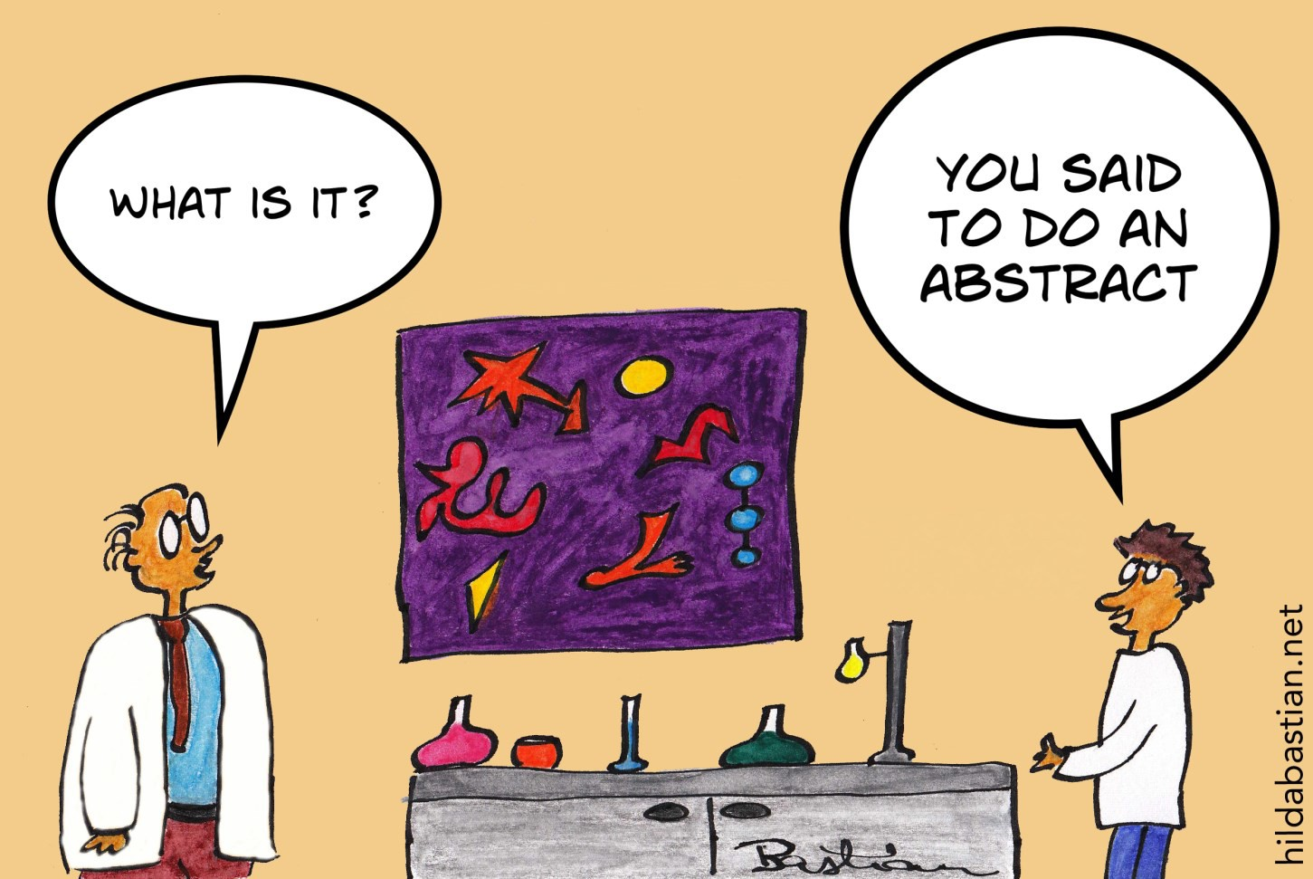

Follow us on Twitter! @EH_Research

Allied Health Research Committee

Nick Taylor Katherine Harding Anne Thompson Jason Wallis (PT) Alison Wilby (Psych)
Sarah Dallimore (Pod) Judi Porter (Dietetics)
Euan Donley (Mental Health) Lauren Lynch (SP)
Sara Whittaker (OT) Glenda Kerridge (SW) Judy Bottrell (PT)

Allied Health Clinical Research Office Telephone: 9091 8880 or 9091 8874 nicholas.taylor@easternhealth.org.au katherine.harding@easternhealth.org.au

