ALLIED HEALTH
RESEARCH NEWS Reflections from the

Allied Health Research News

September 2017

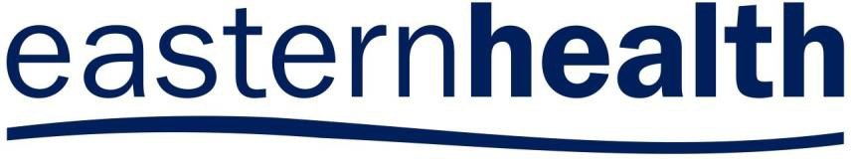ISSUE 40 SEPTEMBER
2017

A Research Newsletter _{for} Allied Health Clinicians
Inside this issue:

“Meal realities” on the sub-acute ward | 2
New York study tours | 3
EH Occupational Therapy shines! | 4
Professional identity study outcomes | 5
Euan’s Musings | 6
Allied Health Research Achievements | 7

12th National Allied Health Conference
Anita Wilton, Director of Allied Health

The 12th National Allied Health Conference was held this year at the brand new International Convention Centre Sydney, alongside the annual Bridal and Honeymoon Showcase. A number of bridal delegates seemed to find their way into the trade display at the NAHC and appeared a little disap- pointed to find only mini hand sanitiser and pens to be collected. However for those of us genuinely there for the NAHC there was plenty to get excited about.
Conference MC Adam Spencer tied together the keynote with the support of an Auslan interpreter. Her interpretation of Luke Escombe’s comedic presenta- tion on his personal experiences with Crohn’s disease was a performance in its own right. Have a look at Luke’s nov- el advocacy approach here: www.youtube.com/watch?v=sDBjI_Rqqm4.
The keynote presentation from
Dr Jacqui Lunday- Johnstone, Chief Health Professions Officer for the National Health Service in Scotland was a highlight for me. Jacqui presented on the Scottish Allied Health National Delivery plan, aimed at aligning the allied health professional workforce with health and social care. This has led to a focus on high profile areas where Allied Health could contribute to the agenda, including healthy eating, aging well, and supporting early years. Consumer engagement has been integral to the strategy along with the intent that allied health professionals work in partnership with people to enable them to live healthy and independent lives. One resulting initiative has been the Active and Independent Living program, based partly on the idea that the impact of allied health could be increased if interventions could be delivered earlier in the patient’s health care jouney.
Through this work they have developed
a national falls program working across agencies, with an intent to disrupt current processes. For example, working to provide alternatives to

automatic conveyance of people who have fallen to hospital.
Another initiative of the Scotland NHS has been the Up and About Pathway, focusing on balance and activity. This preventative, value-based musculo- skeletal service is leading a whole change in the system. Dr Lunday- Johnstone reported that 25% of GP consults were related to musculoskele- tal issues, and this work has led to a reduction in ED attendances. I would recommend reading the paper, or seeking out further information about these fantastic strategies online.
It was also a proud moment to hear Chris Bruce present the work that she has led with Eastern Health Speech Pathology on the experiences of care of consumers with communication difficulties. Sobering figures indeed.
By the number of people taking photos of her slides, I would have to say her impact factor was huge!
Another highlight was to see Kathleen Philip, Chief Allied Health Advisor Victoria and Michael Butler (a previous Eastern Health Director of Allied Health who is known to many) being listed as two of the six finalists from over 180 nominees for the inaugural National Allied Health Inspiration Award. Both were excellent nominees and would have been worthy recipients. The winner was Dr Rosalie Boyce, who is well known for her work on the management and organisation of Allied Health professions. Her research findings have contributed to the implementation of the Allied Health Assessment at Eastern Health.
If you get a chance in the future to attend a National Allied Health Conference, I would highly recommend it. Start planning now for the next one– its never too early to start thinking about that presentation or poster that you would like to share.

ALLIED HEALTH RESEARCH NEWS SEPTEMBER 2017
“Meal realities” on the subacute ward
Ella Ottrey—Dietitian and PhD candidate
Page 2

Ella Ottrey was the winner of the ‘Best Presentation’ prize awarded by the judging panel at the 3 minute presentation competition at the 2017 Allied Health Research Forum. As well as having a great project, Ella’s presentation is an excellent example of the “3 minute” style for anyone thinking of being a part of next year’s forum. Well done Ella!

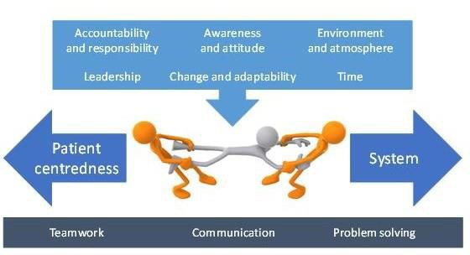“Imagine you’re a patient on a rehab ward. It’s just on 8 o’clock; breakfast time. The dietitian’s ordered you scrambled eggs, and for the first time in weeks, you’re excited at the prospect of eating. But before you can get started, you’ve got to finish your medica- tions. You manage to get the last one down, and you turn your attention back to breakfast. You pick up your fork, and just as you’re about to dig in, the blood nurse arrives. They only take a couple of minutes, but it’s long enough for your eggs to go cold, and you just can’t bring yourself to
eat them.
You search your meal tray for
. another option. Fruit yoghurt; that
might be nice! You reach for the tub and try to open it, but the foil lid keeps slipping through your fingers. You look around for some- one to ask for help, but there’s no one. You know time’s running out when a wheelchair is parked
beside you, ready to take you down to therapy. You give up. Half a piece of toast will just have to do.
We know that many of our patients don’t eat enough in hospital. We also know that simply giving them more food won’t necessarily fix the problem. So what I wanted to do, was to take a look at what’s going on around patients at mealtimes, to learn more about the mealtime environ- ment and the practices of staff,
volunteers and visitors.
I spent three months on two wards watching what happened at breakfast, lunch and dinner. I spoke to more than 60 staff, volunteers and visitors to under- stand what mealtimes were like for them.
And the verdict? I found that staff, volunteers and visitors strive for patient centredness at mealtimes, but they’re constantly challenged
by the routine and structured nature of the food and health- care systems. This tension between patient centredness and system was impacted by things like accountability, awareness and time. Team- work, communication and problem solving underscored the actions and interactions of
staff, volunteers and visitors.
Understanding these meal realities helps us to appreciate why poor food intake is so difficult to address in hospital. Medications, bloods and therapy are all vital parts of rehab, but so is food. We need to work out better ways to approach mealtimes in hospi- tal, to work with the system, so that all patients can eat and enjoy their meals, for better healing and recovery, and a
better healthcare experience”.

ALLIED HEALTH RESEARCH NEWS SEPTEMBER 2017
“I want to be a part of it,
New York, New York…”
Page 3
EH Allied Health expanding horizons with USA study tours

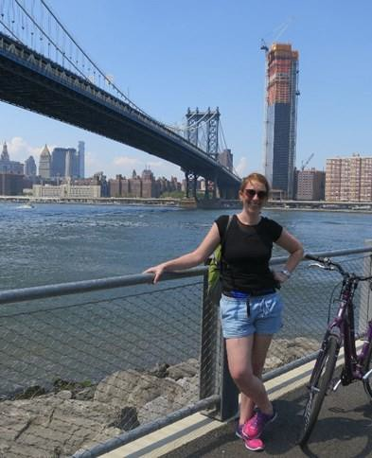In the words of Frank Sinatra, physiotherapist Amy Dennett and social work manager Glenda Kerridge have indeed “been a part of it” with study tours taking in the sights of New York alongside some incredible learning experiences.

Amy Dennett—Physiotherapy
This year I was lucky enough to be awarded a Felice Rosemary Lloyd Scholarship which allows for Victorian physiotherapists to travel overseas to help aid the development of the profession through education and research. I set off in late July to the United States to learn about all things oncology rehabilitation.
My first week saw me off to the picturesque Rocky Mountains where I completed the week long intensive Cancer Exercise Specialist Certification at The University of Northern Colorado. This was a multidisciplinary course primarily of other physical therapists and exercise physiologists from across the United States. We learnt detailed exercise prescription protocols for patients with cancer and had the opportunity to shadow patient appointments in their top of the range gym facility. The course was also a great opportunity to share our triumphs and challenges of implementing oncology rehab into standard practice. I also enjoyed seeing the similar patient/ therapist dynamic and ‘fun’ this program bought to patients, (like ours at home) despite being on the other side of the world.
Next stop was New York, where I had the opportunity to visit the world’s leading oncology rehabilitation physician –
Dr Michael Stubblefield. I was able to receive a different perspective of oncology rehabilitation outside the exercise sphere and the importance of how the two professions can work together. Also in New York, I visited the Lee Jones Exercise Physiology Lab at
Memorial Sloan Kettering where I was exposed to cutting edge research evalu- ating the dose response effect of exercise on cardio- pulmonary function which included a very intense post treadmill echocardiogram!
This whirlwind trip was such a great learning opportunity and I hope to implement some of my findings back here at Eastern Health. Stay tuned for part 2 of this tour
where next month I depart again for the States and Canada to present findings from our own research at the American Congress of Rehabilitation Medicine, Yale, University of British Columbia and University of Alberta.
Glenda Kerridge—Social Work Manager
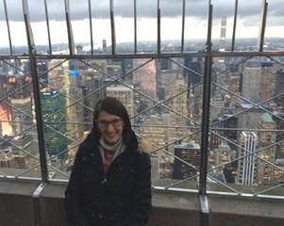In 2016 I was privileged to be selected as the Australian representative for the Mt Sinai Department of Social Work International Enhancement of Leadership Program in New York. I have known several previous scholars and waited many years for the right time for this “once in-a- lifetime” career experience.
This Program aims to provide a pathway for social work leadership. The 2016 program included myself and an Isreali Colleague. It included meetings with a broad range of social workers and managers from Mt Sinai, an accredited leadership course with Dr Garry Rosenberg and a practice research course with Professor Irwin Epstein. We also had personal meetings with the Deans of Social Work at Fordham and Columbia Universities.
I was particularly interested in examining the Mt Sinai responses to family violence and elder abuse. I learned that these issues are complex across the world, and achieving truly coordinated care is a universal challenge. The use of validated screening tools at Mt Sinai resonated with initiatives emerging in Victoria, and the sophistication of data collection was impressive. I also observed the successful use of volunteers in support and advocacy roles in a range of other areas – a highly transferable and sustainable model.
The leadership message from Mt Sinai was very clear – that being agile and innovative in adapting to the inevita- ble and rolling political and economic changes in the health systems in which we work, is vital to the future of health social work. This is equally true in our own context.
The 8 weeks I spent at Mt Sinai provided a unique oppor- tunity to step away from operational responsibilities and to immerse myself in a different health and social work culture. I had time to reflect and engage with insightful and generous mentors to challenge my thinking, and to remind me of my responsibility to make the most of this great opportunity by becoming an agent of change myself. My New York colleagues created a truly remarkable experience, and the political backdrop of the presidential election shone a light on the values and issues which are important to us all. The backdrop of
Central Park, Broadway shows, galleries, museums and the best smoked salmon bagels in the world was, indeed, a fabulous bonus.

ALLIED HEALTH RESEARCH NEWS SEPTEMBER 2017 Page 4
Eastern Health Occupational Therapists shine at the Occupational Therapy Australia Conference!
Eastern Health Occupational Therapy continues to lead the way with an exceptional amount of quality and research projects undertaken by these dynamic clinicians. The recent 27th National Conference of Occupational Therapy Australia, held in Perth in July was a fantastic opportunity to showcase this work to a National audience.

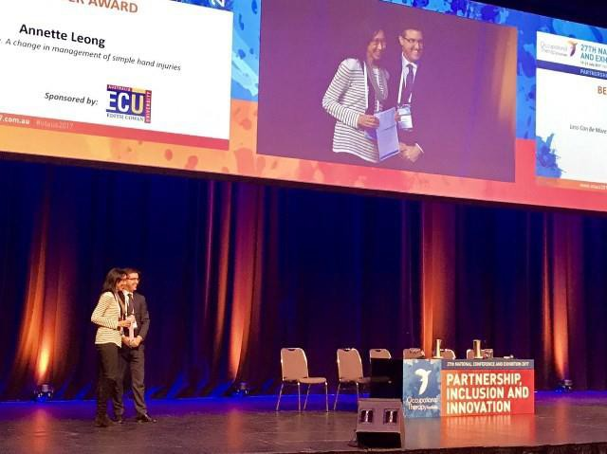Oral Presentations:

Congratulations Annette Leong! BEST ePOSTER AWARD
Sara Whittaker
Does upper limb therapy through an Early Supported Discharge Program, compared to Inpatient Rehabilitation, improve functional upper limb outcomes for stroke clients? An observational study.
Phoebe Williamson
Youth and family experiences of sensory modulation in community mental health settings.
Alicia Morris
Implementation of tailored, multi-component knowledge translation interventions to increase the use of functional electrical stimulation in sub acute rehabilitation to manage shoulder subluxation, post stroke.
Annette Leong , Jude Boyd, Sue Giles, Lisa Vale, Kim Mestroni, Alison Lunt, Ted Brown, Claire Lynch and Janice McKeever
Advancing scope of practice through innovation, inclusion and partnerships.
Anuschka Toal
Implementing a standardised approach in the assessment and management of the stroke affected upper limb through competency based learning and practice guidelines
Anna Joy, Leeanne Carey, Kate D’Cruz
Clinical Supervision as a platform from knowledge translation
Kellie Emmerson, Katherine Harding and Nick Taylor
Home exercise programs supported by electronic tablets compared with standard paper-based home exercise programs in patients with stroke.
Allison Farley, Matilda Patterson
Using multimodal video education to support implementation of an Occupational Therapy Cognitive Assessment Clinical Practice Guideline.
Cathryn Baldwin, Lynda Power, Kat Pope, Amy Harry, Katherine Harding
The feasibility and effectiveness of constraint induced movement therapy in a community rehabilitation setting: A pilot randomized control trial
Janelle Arnold, Cassandra Doyle, Sarah Watterson and Katherine Harding
Improving access for community health and sub-acute outpatient services: The STAT Project

ePoster Presentations:

Becca Allchin, Cate Bourke, Bronwyn Sanders and Primrose Lentin
Are family and carer roles as everyday occupations overlooked by mental health Occupational Therapists?
Rebecca Reed and Jessica Tuck
Occupational Therapy leading the way in delirium assessment and intervention - An evaluation of a newly implemented Occupational Therapy clinical practice guideline.
Annette Leong and Yvonne Fellner
Less can be more. A change in management of simple hand injuries

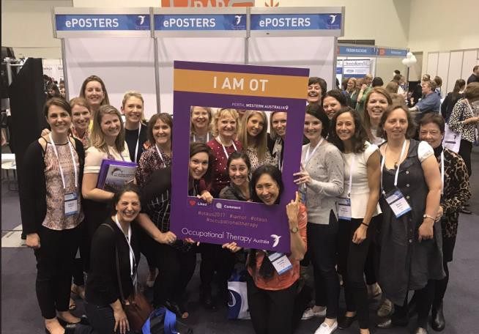

ALLIED HEALTH RESEARCH NEWS SEPTEMBER 2017 _{Page} ₅

Eastern Health Allied Health show a high level of professional identity: Initial findings from the Eastern Health Professional Identity Study
Judi Porter

Professional identity, or “one’s professional self-concept based on attributes, beliefs, values, motives, and experiences”1(p85), has not previously been explored in a large cohort of allied health staff. It has been reported that professional identity across multiple health professions is high on entry to university, but declines throughout
pre-registration training2.
Recently all staff employed in allied health roles at Eastern Health were invited to partici- pate in a survey to describe the professional identity of allied health staff. A professional identity scale developed by Brown et al3 was embedded in the survey, along with additional questions relating to the demographics of respondents, and aspects of the allied health workforce structure. A maximum score of 50 on the scale indicates a very strong sense of professional identity. Preliminary analysis has been completed and the he profile of respondents is shown in Figure 1.
Professional identity was very high and similar across each of the three allied health program structures, with some small variations across individual professions (Table 1).
The study will be repeated following the implementation of recommendations in the Allied Health Assessment conducted last year. This will enable us to observe any changes in professional identity that may be associated with the new inter-professional program structures.
Thanks to the many allied health staff across each profession and program area who contributed.
Table 1: Professional Identity ratings by professional group

Program area (No. of respondents) | Professional identity rating
Allied health bed-based services (114) | 45.6
Ambulatory and community allied health services (81) | 43.2
Allied health mental health services (32) | 45.6
Allied Health Profession (No of respondents) | Professional identity rating
Allied health administration (7) | 39.9
Allied health assistant (5) | 42.0
Community development worker (2) | 43.5
Dietitian (29) | 45.3
Occupational therapist (31) | 44.1
Physiotherapist (83) | 45.3
Podiatrist (3) | 46.3
Psychologist (19) | 45.2
Social worker (31) | 44.3
Speech pathologist (12) | 44.8
Spiritual care practitioner (3) | 46.7

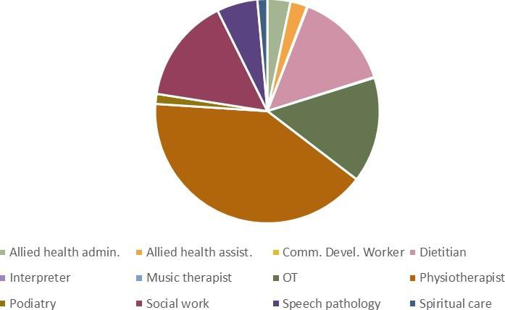
Figure 1: Proportion of respondents from each allied health discipline

References:
- Slay HS, Smith DA. Professional identity construction: using narrative to understand the negotiation of professional and stig- matized cultural identities. Hum Rel. 2011; 64(1):85-107.
- Coster S et al. Interprofessional attitudes amongst undergraduate students in the health professions: A longitudinal questionnaire survey. Int J Nurs Stud. 2008; 45:1667-1681.
- Brown R et al. Explaining intergroup differentiation in an industrial organization. J Occup Psych. 1986; 59: 273-286.

ALLIED HEALTH RESEARCH NEWS SEPTEMBER 2017
Page 6
Need some advice on a research idea?
Nick Taylor, Katherine Harding (both based at Box Hill) and Judi Porter (based at the Angliss) are available to meet with Allied Health Clinicians anytime to provide advice on research ideas.
Meetings can be arranged face to face, by phone or video conference.

Nick: Phone: 9091 8874
Nicholas.taylor@easternhealth.org.au

Katherine: Phone: 9091 8880;
Katherine.harding@easternhealth.org.au

Judi:
Phone: 0466538172
judi.porter@easternhealth.org.au
2017 Eastern Health
Research Forum
Thursday 7 December 2017, 8.30am, Box Hill Institute (TAFE) Lecture Theatre

Featuring:
Guest speaker Professor Rachelle Buchbinder,
Director of Monash University Department of Clinical Epidemiology.
Oral and poster presentations showcasing Eastern Health Research

Euan’s Musings
Euan is close to the end of his PhD (and sanity) and works in Emergency with the psychiatric team. He is not a plagiarist because he acknowledged the original source of the quotes. He had an awesome time at Comic Con.

WORDS OF WISDOM, NOT FROM EUAN
Sometimes research is just wonderful. It all comes together, our results reflect our research question, and we have too many participants wanting to be involved in our research. For the other 99.99% of the time, it can be a test in resilience. I was asked, in these times, to come up with some words of wisdom. Rather than do that, I figured I would just phone this article in and let more impressive people do the talking for me:
“Research is what I’m doing when I don’t know what I’m doing.” - Wernher von Braun
“As always in life, people want a simple answer . . . and it’s always wrong.” - Susan Greenfield
“Research is to see what everybody else has seen, and to think what nobody else has thought” - Al- bert Szent-Gyorgyi
“If we knew what it was we were doing, it would not be called research, would it?” - Albert Einstein
“We must have perseverance and above all confidence in ourselves. We must believe that we are gift- ed for something and that this thing must be attained.” - Marie Curie
“Progress is made by trial and failure; the failures are generally a hundred times more numerous than the successes; yet they are usually left unchronicled.” – William Ramsay
“Valid criticism does you a favour.” Carl Sagan

“Kids, you tried your best and failed. The lesson is, never try.” – Homer Simpson
“One ticket to Comic-con please” Euan Donley

Page 7 ALLIED HEALTH RESEARCH NEWS SEPTEMBER

Allied Health Research Achievements

Publications:

Dietetics:
Ottrey E, Porter J. (2017) A qualitative exploration of patients’ experiences with three different menu ordering systems in hospital: Implications for practice. Nursing Standard, 31(50):41-51.
Leipold C E, Bertino S B, L'Huillier H M, Howell P M, & Rosenkotter M. (2017). Validation of the Malnutrition Screening Tool for use in a Community Rehabilitation Program. Nutrition & Dietetics (early online).

Social work:
Donley, E. Evaluation and Implementation of a tele-psychiatry Trial in the Emergency Department of a Metropolitan Public Hospital. Journal of Technology in Human Services. (in press)

Conference Presentations:

Dietetics
Wilton A, Porter J, Sharp M, Smith G. Study protocol: professional identity amongst allied health staff in three workforce structures. National Allied Health Conference, August 2017, Sydney.

Speech Pathology
Chris Bruce. In our own words. What do consumers with communication difficulties say about their healthcare? National Allied Health Conference, August 2017, Sydney.

Social Work:
Euan Donley: The NEAT awakens: A Mental Health Social Work risk assessment regarding the Impact of National Emergency Access Targets on family work in ED. Victorian Mental Health Social Work Conference, Melbourne, October 2017. (Keynote Speaker)
Euan Donley: Evaluation and Implementation of a tele-psychiatry Trial in the Emergency Department of a Metropolitan Public Hospital National Emergency Access Targets: Implications for involving family and carers in the Emergency Department during mental health risk assessment. TheMHS Conference, August 2017, Sydney.

Conference Presentations continued...

“Momentum 2017” National Physiotherapy
Conference, October 19-21, Sydney

Nick Taylor: Motivational interviewing can increase physical activity through increasing selfefficacy in community-dwelling people after hip fracture.
Sue Parslow: Our graduate workforce - promoting adaptability, confidence and responsiveness to clinical demand.
Amy Dennett: Cancer survivors awaiting rehabilitation rarely meet recommended physical activity levels: an observational study.
Amy Dennett: A good stepping stone to normality…’ experiences of an oncology rehabilitation program.
Jason Wallis: “My knee is buggered and needs replac- ing:” the perceptions of people with severe knee osteo- arthritis following a walking program.
Jason Wallis: A walking program for people with se- vere knee osteoarthritis did not reduce pain but may have benefits for cardiovascular health.
Andrea Bruder & Nick Taylor: Exercise may not be effective in improving activity and reducing ipairments during upper limb fracture rehabilitation.
Andrew Bruder & Nick Taylor: Activity monitors are valid and reliable tools to measure gross arm move- ment in Adults following distal radius fracture.
Casey Peiris & Nick Taylor: The maximum tolerated amount of walking for community-dwelling adults after hip fracture.

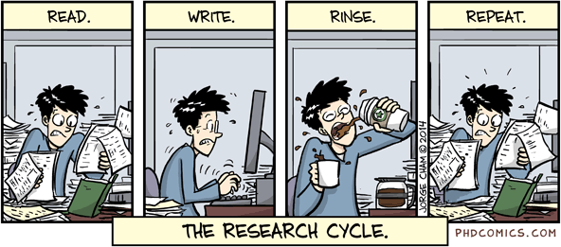
Follow us on Twitter!

@EH_Research

“Piled higher and deeper” by Jorge Cham.—PHDCOMICS.com

Allied Health Research Committee Do you have anything of interest to report in this newsletter? Please forward your articles

Nick Taylor
Katherine Harding Jason Wallis (PT) Alison Wilby (Psych) Anne Thompson (ACS) Sarah Dallimore (Pod)
Judi Porter (Dietetics)
Euan Donley (Mental Health) Lauren Lynch (SP)
Anna Joy (OT)
Glenda Kerridge (SW) Judy Bottrell (PT)
and achievements to:

Allied Health Clinical Research Office Telephone: 9091 8880 or 9091 8874 nicholas.taylor@easternhealth.org.au katherine.harding@easternhealth.org.au

