ALLIED HEALTH RESEARCH NEWS

ISSUE 39
JUNE 2017
Allied Health Research News JUNE

2017 Allied Health Research Forum

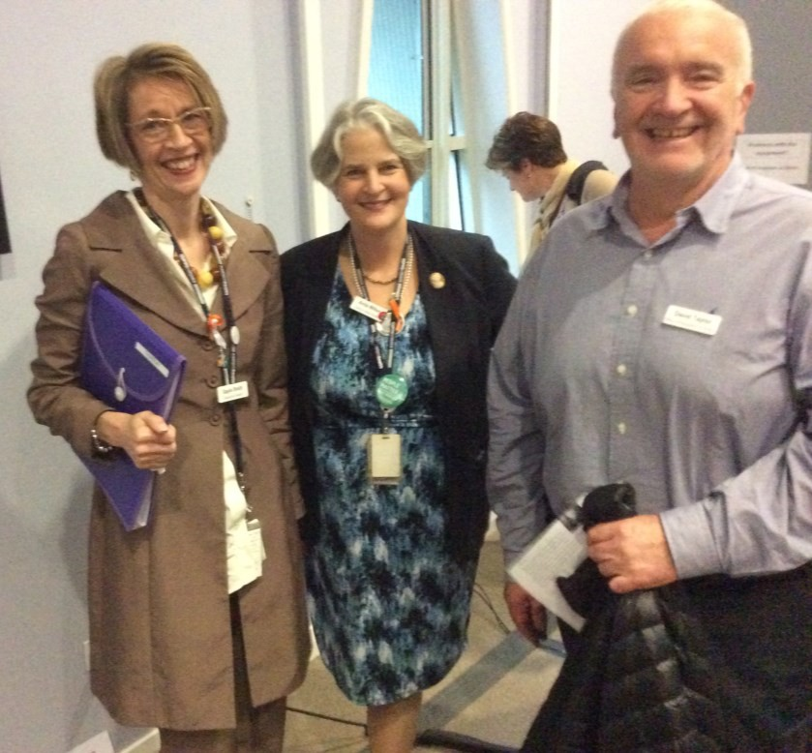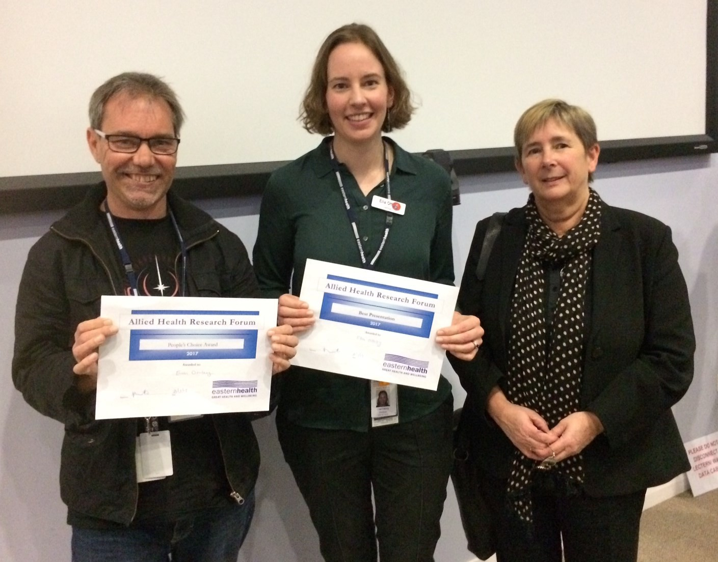A Research Newsletter _{for} Allied Health Clinicians

Inside this issue:

Professional identity of allied health staff research | 2
Winning work from the AH Research Forum | 3
Protected mealtimes: The evidence | 4
Stepping into research participants 2017 | 5
Euan’s musings: Avoiding predatory journals | 6
Allied Health research achievements | 7

Chief Allied Health Officer Gayle Smith with Allied Health Director Anita Wilton and Eastern Health Director of Research David Taylor
This was followed by the 3 minute presentation competition, which continues to be a fantastic initiative well received by audiences. The presentations this year were of an extremely high standard. The ‘Best Presentation’ prize was awarded by the judging panel to Ella Ottrey (Dietetics) for her presentation “Meal realities on the sub-acute ward” and the ‘People’s Choice’ award went to Euan Donley (Social work) for
“Tele-psychiatry in ED”.
Turn to page 3 for more information on the work behind these winning projects.

3 minute presentation winners Euan Donley and Ella Ottrey with Professor Christine Bigby

The Annual Allied Health Research Forum held on May 25th was an opportunity to celebrate the amazing work that the clinicians within our network produce.
The afternoon was launched with guest speaker Professor Christine Bigby, the Director of the Living with Disability Research Centre and Chair Academic Board, School of Allied Health at La Trobe University.
Professor Bigby shared her work on policy issues, program effectiveness and front line practice that supports quality of life outcomes for people with intellectual disability. Her current ARC and other grants are examining the effectiveness of supported accommodation services, the nature and meaning of social inclusion for people with intellectual disability, and supported decision making for people with
cognitive disability.

Page 2 ALLIED HEALTH RESEARCH NEWS JUNE 2017

Professional Identity of Allied Health staff research: Your help is needed!
Eastern Health employs over 900 allied health staff across bed-based services, ambulatory and community services, and mental health services. A study is currently under way exploring the professional identity of these staff across Eastern Health.
If you are employed as a social worker, OT, physiotherapist, psychologist, speech pathologist, dietitian, podiatrist, interpreter, spiritual care practitioner, welfare worker, music therapist, community development worker, allied health assistant or in allied health administration...

Can you take 5 minutes to complete a short survey?
Click here to
Start the survey

Or copy this link into your browser:

https://monash.az1.qualtrics.com/jfe/form/SV_ab2iYCYG73tB4qN
Please note, the survey contains references to Monash University as we are using survey software accessed through the university. The data will not be used for any Monash University purposes.

Results will be disseminated in an upcoming edition of the quarterly newsletter from
the Allied Health Clinical Research Office. If you have any questions relating to this research, please contact Judi Porter by email: judi.porter@easternhealth.org.au

2017 Eastern Health Research Forum
Thursday 7 December 2017, 8.30am, Box Hill Institute (TAFE) Lecture Theatre

Featuring guest speaker Professor Rachelle Buchbinder,
Director of Monash University Department of Clinical Epidemiology.

Research Abstract Submissions Now Open
We look forward to reviewing research across all of Eastern Health at the Forum and invite you to submit an abstract. Abstracts are to be submitted using the online form https://easternhealth.smartygrants.com.au/ResearchForum2017
All submissions will initially be considered for inclusion as poster presentations, with some abstracts invited to be presented as

oral presentations (3 min or 12 min).

David Taylor
Director of Research and University Relations, Eastern Health
Abstract submissions close Monday 28 August 2017. All authors will be notified by

6 October 2017.

ALLIED HEALTH RESEARCH NEWS JUNE 2017 Page 3

Winning work from the 2017 Allied Health Research Forum

Euan Donley: People’s choice award
Ella Ottrey: Judges Award
Ella presented her work on Meal time realities on sub-acute wards. We look forward to bringing you a full report of Ella’s work in an upcoming edition of Allied Health Research news.

- ED Mental Health patients increasing.
- TP effective
- Quicker, cost effective, collaboration, satisfaction

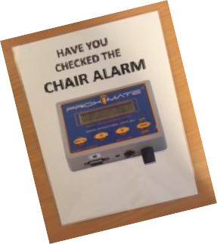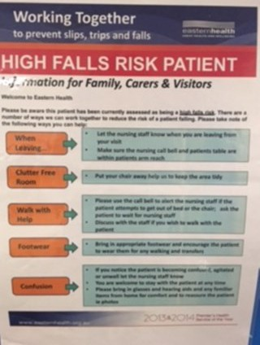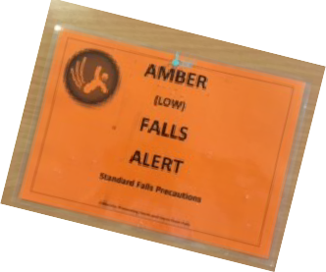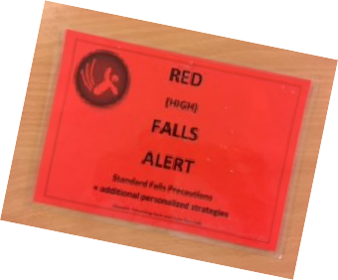

- Measured satisfaction & process (N = 44)
- Dependent on
technology
- Rather biased pool
- More research

Eastern Health treats many psychiatric patients in crisis across our three emergency departments. The demand is increasing, with assessments doubling from 4,000 in 2013 to 8,500 in 2015. Over the last 20 years, tele-psychiatry has been developing and shown to be effective at treating depression, PTSD, anxiety, eating disorders, and in reducing hospital admissions /relapse.
TELE-PSYCHIATRY IN ED
RESULTS FROM AUDIT
Donley, E., Goh, J., McClaren, A., Jones, R., Katz, P.
This project was conducted in the Angliss ED and is the first time tele-psychiatry has been officially trialled in an ED anywhere in the world. An off-site mental health clinician interviewed patients on live video-conference stream with an ED staff member present with the patient. Satisfaction / ED targets were measured after the assessment utilising approved Eastern Health tele-health satisfaction surveys (N = 44).
Patients and staff were happy with the service, with no adverse outcomes reported. Time spent in ED was significantly reduced from 615 to 382 mins with tele-psychiatry and the service was cost effective.
The trial also improved collaboration between clinicians, likely due to the fact that ED staff were present at the assessment. The technology proved to be a challenge at times, and it is important to note that strict inclusion and exclusion criteria limited the types of patients who received the tele- psychiatry service. The project has shown significant benefits that may be applicable to other emergency departments as well as community mental health clinics.
Euan would like to thank his fellow researchers; A McLaren, R Jones, P Katz and J Goh.

Rebecca Sullivan: Highly Commended
I set out to see if there was a link between communication difficulties and falls. Specifically, do stroke survivors with a communication difficulty fall more often on EH wards than those without a com- munication difficulty?
EUAN DONLEY
I audited medical records of 149 stroke survivors admitted over 2 years. Over 65% of the sample had a communication impairment, and half of that group had no functional communication. This means that they had no ability to communicate their basic needs.
So do these stroke survivors fall more often than those survivors without a communication difficulty? The answer is yes. My research shows that stroke survivors without a communication difficulty have
  - falls per 1000 bed days, and in those with a communication difficulty the rate is 46 falls per 1000 bed days.
Falls prevention is one of the top 10 national accreditation standards. However, communication difficulties are not identified as factor influencing high falls risk on any of our Eastern Health assessment tools. Conversely, other factors identi- fied as risk factors, including the score on the Falls Risk Assessment Tool, were significant predictors of
falls in this population.
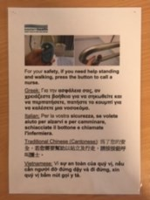We need to recognise communication difficulties as an independent risk factor for falls in our rehab wards. I’m challenging us to start doing that now.
Cognition

History of falls

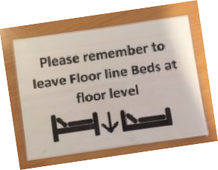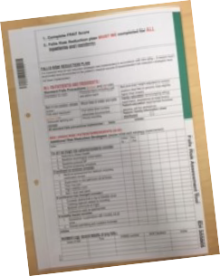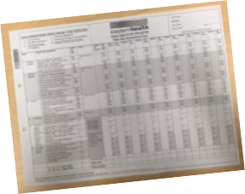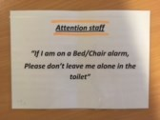
Medications
Co-morbidities

ALLIED HEALTH RESEARCH NEWS JUNE 2017

Page 4

Protected Mealtimes are not the answer to resolving hospital malnutrition

Judi Porter

Thanks to many of you who may have contributed to this clinical trial, a key part of my NHMRC Translating Research into Practice Fellowship (2015-16). This was the first trial internationally to use high quality study design (a stepped wedge design) to test whether the implementation of Protected Mealtimes improved nutritional intake of patients. Protected Mealtimes aims to address the problem of malnutrition in hospital- ised patients through increasing positive interruptions (such as feeding assistance) whilst minimising unnecessary interruptions (including ward rounds and diagnostic procedures) during mealtimes. The study was powered to determine whether the intervention closed the daily energy deficit 1900kJ/day between estimated intake and energy requirements measured in the pilot
study for this trial.
Twenty students from the Monash University Bachelor of Nutrition and Dietetics program collected outcome
data; students were blinded to the intervention being implemented. In total, 416 observations of 24 hour food intake were obtained across the three sites. Energy intake was not significantly different between the intervention [(mean±SD) 6479±2486kJ/day] and control [6532±2328kJ/day] conditions (p=0.88). Daily protein intake was not significantly different between the intervention (68.6±26.0g/ day) and control (67.0±25.2) conditions (p=0.86). The difference between estimated energy/protein requirements and estimated energy/protein intakes were also not different between groups. The adjusted analysis yielded significant findings for energy deficit: [coefficient (robust 95% CI), p value] of -1405 (-2354
to -457), p=0.004. Variability in implementation across some aspects of Protected Mealtime policy components was noted.
The findings of this trial mirror the findings of other observational studies of Protected Mealtimes implementation. We recommend that approaches with a greater level of evidence for improving nutritional outcomes such as mealtime assistance, other food based approaches and the use of oral nutrition support products to supplement oral diet, should instead be considered in the quest to reduce hospital
malnutrition.
Again, my sincere thanks to everyone at Eastern Health who participated in this trial: All patients and clinical staff in October-November 2015 working on North Ward at Wantirna Health, 1 West at the Angliss Hospital, and East Ward at PJC contributed, as well as the ISS staff and Dietetics teams, and the Nutrition EAC who provided
governance and oversight.

Dr Judi Porter
Outstanding Contribution Award
from the Dietetic Association of
Australia
This award recognises the outstanding contribution of members to the Association and/or the profession given at a National level
over a three year period.

Kylee Lockwood Relevance to Allied Health Award

Post graduate student category
at the Victorian Allied Health Research Conference in Melbourne, March 2017

Jason Wallis, Jason Wallis,

Best Poster Presentation
Best Pfoor AsltlieedrHPearlteh sReesneatrachtion
at thefroercAenlltieNdeHweZaelathlanRdesRehaerucmhatology Aasst othceiatrieocnenatnNdeAwuZsterallaianndRRhheeuummaattoolologgyy AsAssoscoiactiaiotnionJoiannt dAnAnuusatrlaSlicainenRthifeicuMmeaetotilnoggy Associatioin AJouicnktlAandnuMalaSyc2ie0n1ti7fic Meeting
in Auckland May 2017

ALLIED HEALTH RESEARCH NEWS JUNE 2017
Page 5

Our next cohort to
‘Step into Research’

Stepping into Research Training Scheme, 2017

Congratulations to our group of successful applicants who have stepped forward for this year’s ‘Stepping into Research’ training scheme. We continue to be impressed by the high standard of applications received for this program. Good luck to all our participants!

Over the last few years we have had very strong representation in the Stepping into Research Program from some of our smaller professional groups, such as dietetics and speech pathology, with a high level of participation relative to the size of the workforce in these professions.
This year the balance seems to have been restored with a large proportion of this year’s cohort being physiotherapists, along with two OTs and one podiatrist.

2017 Participants and their areas of interest:
Bernadette Sexton (Physiotherapy) Medication versus mobilisation for the treatment of deep vein thrombosis
Daniel Kim (Podiatry) AFOs versus foot orthotics for the management of forefoot amputation

Jess Anderson (Physiotherapy) Physical activity of patients on Early Supported Discharge Programs compared to those treated in inpatient rehabilitation settings
Jess Tuck (Occupational Therapy) Family interventions in the treatment of delirium Kate Gamble (Physiotherapy) Aquatic therapy for the treatment of patients after stroke Mel Haley (Physiotherapy) Physical activity interventions in the management of delirium
Richard Hession (Physiotherapy) Self management and education interventions in the management

of bronchiectasis
Vicky Stewart (Occupational Therapy) Do occupational therapy interventions reduce hospital admissions?

Thanks to our mentors for this year’s program: Nick Taylor, Katherine Harding, David Snowdon,
Amy Dennett, Casey Peiris, Anna Joy, Judi Porter, Kate Lawler, Kylee Lockwood

ALLIED HEALTH RESEARCH NEWS JUNE 2017

Euan’s Musings
Page 6

Euan is a PhD student, and works in ED psych triage. He is close to finishing his PhD, and is fortunate to have about 8 publications. He also has a habit of talking about himself in the third person.

special about my research skills. However, I perse- vered, and my article was accepted into a better journal, at no cost. The journal initially tore the arti- cle to shreds, but after a few tears, further self- questioning, and chocolates we got there.
Avoiding the jaws of predatory journals
All those years ago when I started my PhD, along with Moses and Nebuchadnezzar, the idea of my research being published in an international journal were in the same category as by beloved Western Bulldogs winning a Grand Final. Sure, it would be nice, but it is never going to happen. Skip to now, and I am fortunate enough to have experienced the joys of both.
I won’t pretend I was not desperate to be published. My first publication was accepted into a great journal with a good impact factor, but it nearly was not. Would you like to know more? Well keep reading. If not fine, no doubt there is an article in this newsletter about some award ceremony that has pretty pictures.
I received an e-mail seeking my input in a mental health special issue. Now let’s be brutally honest for a moment. Any journal asking someone for an article needs to be met with caution. And if they are asking me? Well it is a no brainer that it is a phishing scam and they will publish me as soon as I send them my bank and insurance details, blood type and the health of my kidneys. However, at the time I was desperate so sent an article in. Lo and behold a few days later my article was accepted,
and please pay $1,000.
I was quite tempted. At this time this type of publication (now called a predatory journal) was fair- ly new, and I was desperate to have my first article published. However, in the words of my wise super- visor, ”persevere”. (She has also told me “write more clearly”, “use verbs more appropriately”, “articles are not supposed to have jokes”, “be more professional” and “here’s the name of a good thera-
pist”).
If you are a regular reader of this article (what is wrong with you?) you will note that I am not the most formal of writers, and there is really nothing
Thus I have learned a few tips for choosing journals that are worth passing on.
    - If acceptance was too easy or quick, chances are you should not go with the journal, unless you are Jason Wallis who is a natural genius.
    - If they ask for money, be wary. There are many high quality open access journals who charge publi- cations fees. Ask yourself if the cost seems reasona- ble and what you are getting for your money.
    - Does the journal have an impact factor? Impact factors are a measure of how often articles from the journal get cited by other authors. The impact factor it is usually published on the journal’s home page, and the mere presence of one is an indication that the journal is legitimate. No impact factor is another cause for caution.
    - Look at their other journal articles. Are they any good? Are they related to the topic of the journal?
    - Do a search — Is the journal is on a predatory journal list? (eg. Check http://beallslist.weebly.com)
    - What doe their peer review process look like? Quick with minimal comment, or rigorous?
    - See if the journal appears in reputable databases, such
as PubMed or Cinahl
    - If in doubt, ask someone who knows. We have
plenty of good minds on the allied health

research committee (see all the names at the end of the newsletter, except mine).

PREDITORY JOURNAL AHEAD

Need some advice on a research idea? Attend an Allied Health Research Clinic
Allied Health Research Clinics are a place to sit down with some experienced researchers in an informal setting to discuss any research related questions or ideas.

July 20th, 10.00am-12.00 | Yarra Ranges | For bookings contact Judi.porter@easternhealth.org.au
Aug 10th, 8.30-10.30am | Maroondah | For bookings contact katherine.harding@easternhealth.org.au

Page 7
ALLIED HEALTH RESEARCH NEWS JUNE 2017

Allied Health Research Achievements
Publications
Judi Porter (Dietetics/Allied Health Clinical Research Office)
- Porter J. 2017. The perspectives of patients and their families remain largely unheard in mealtime assistance research. Evidence Based Nursing. DOI: 10.1136/eb-2017-102682.

- Doyle E, Simmance N, Wilding H and Porter J. Systematic review and meta-analyses of food service interventions and their effect on nutritional outcomes and satisfaction of adult oncology patients. Nutrition and Dietetics 74:2, 116-128.
Anna Gillman (Dietetics—Stepping into Research participant)
Gillman A, Winkler, R, Taylor NF. 2017. Implementing the Free Water Protocol does not result in aspiration pneumonia in carefully selected patients with dysphagia: A Systematic Review. Dysphagia 32:345-361
Jimmy Liapis (Occupational Therapy—Stepping into Research participant)
Liapis J, Harding KE. Meaningful use of computers has a potential therapeutic and preventative role in dementia care: A systematic review. Australasian Journal on Ageing (in press 2017).
Claire Leopold (Dietetics)
Leipold CE, Bertino SB, L’Huillier HM, Howell PM, Rosenkotter M. Validation of the Malnutrition Screening Tool for use in a Community Rehabilitation Program. Nutrition & Dietetics (in press 2017).
Dana Gunning (Speech Pathology)
Wenke, R., Cardell, E., Lawrie, M., & Gunning, D. (2017). Communication and well-being outcomes of a hybrid service delivery model of intensive impairment-based treatment for aphasia in the hospital setting: a pilot study. Disability and Rehabilitation, 1-10.

Conference Presentations:
Congratulations to the following allied health staff on recent conference presentations:
- Victorian Allied Health Research Conference
Kate Lawler, Nick Taylor, Katherine Harding, Yvonne Fellner and Kylee Lockwood.
- Australian and NZ Rheumatology Associations Joint Annual Meeting, Auckland, May 20-23.
Jason Wallis
- Dietitians Association of Australia conference, Hobart, May 2017. Melanie McGrice, Judi Porter, and Ella Ottrey.
- National Podiatry Conference, Melbourne, May 2017 Katrina Richards, Michelle Kaminski and Danielle Griffiths

26th-29th August 2017, ICC Sydney
RESPONSIVE SERVICES RELIABLE SYSTEMS RESILIENT WORKFORCE
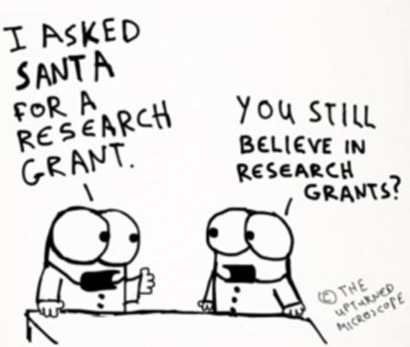

@EH_Research

Allied Health Research Committee
Do you have anything of interest to report in

Nick Taylor Katherine Harding Jason Wallis (PT) Alison Wilby (Psych)
Anne Thompson (ACS) Sarah Dallimore (Pod)
Judi Porter (Dietetics)
Euan Donley (Mental Health) Lauren Lynch (SP)
Anna Joy (OT)
Glenda Kerridge (SW) Judy Bottrell (PT)
this newsletter? Please forward your articles and achievements to:

Allied Health Clinical Research Office Telephone: 9091 8880 or 9091 8874 nicholas.taylor@easternhealth.org.au katherine.harding@easternhealth.org.au

