Case Study - Healthy Choices 2016-18

Benjamin Brewin- Health Promotion

Introduction:

Eastern Health (EH) Executive committed to the Healthy Eating Benchmark of the State Government Achievement Program in late 2014 (Achievement Program, 2018). This commitment has led to the development of the Healthy Choices Project Group and the ongoing Implementation of the Victorian Healthy Choices (HC) framework (Healthy Choices Guidelines, 2018) across all EH sites. EH has 7 retail sites that provide food and drinks across 5 campuses. This includes 5 privately facilitated cafeterias operated by Zouki and 2 auxiliary kiosks run internally by Eastern Health. EH has been part of the Healthy Choices journey for over 5 years to 2018. As part of the journey EH staff have worked closely with our retail and vending suppliers, aiming to increase the availability of healthy foods and drinks to staff and the general public accessing the facilities. This work at EH is led by the Healthy Choices Project Group which consists of: EH staff from multiple backgrounds and leadership positions and representation from Zouki.

Health Promotion instigated the alignment of healthy choices to the internal EH organisational improvement process known as Re-design in 2017. This ensured for the first time a high level of accountability and governance to be provided by an Executive sponsor for the initiative. At the time when the Redesign plan was designed it was found that over 50% of food and drink offered at EH was in the red category. Since then the Healthy Choices project group has been involved in a number of strategic interventions to reduce the availability of red foods and drinks and to increase the availability of green foods and drinks.

Goal: By January 2020 less than 20% of the food items available for purchase at EH sites will be ‘red’ items.

Actions:
Staff and visitor retail outlets – Zouki, as our major retail provider, is a member of the Healthy Choices Project Group. As part of their representation they implemented a number of changes in four of their EH sites: the large café at Box Hill Hospital, the smaller café at 5 Arnold Street Box Hill, the café at Peter James Centre and the cafe at Wantirna Health. The changes that Zouki made included the following: Modifications to hot food recipes to increase the amount of vegetables and decrease the amount of added sugars, fats and salt, increases to the amount of cold food green and amber options available including sandwiches and sushi, a reduction of red sweets and snack options and a similar increase to the amount of green and amber sweets and snack foods, this included trialling new green and amber snack options and the introduction of healthy choices marketing material at these four sites. These changes lead to a decrease in the availability of red food and drink products as well as an increase in the availability of green items.

June 2018 spot audit results
BHH Zouki Café – 44% Green, 24% Amber, 32% Red.
Arnold Street Zouki Café – 45% Green, 22% Amber, 32% Red.
Peter James Centre – 51% Green, 20% Amber, 29% Red.
Wantirna Health – 50% Green, 26% Amber, 24% Red.

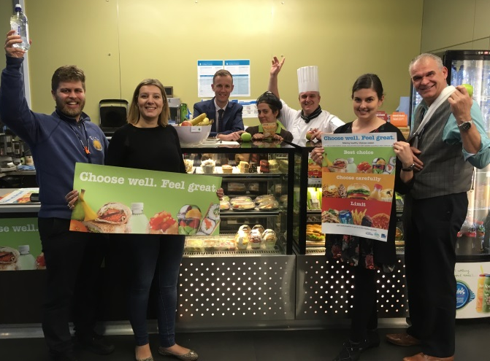
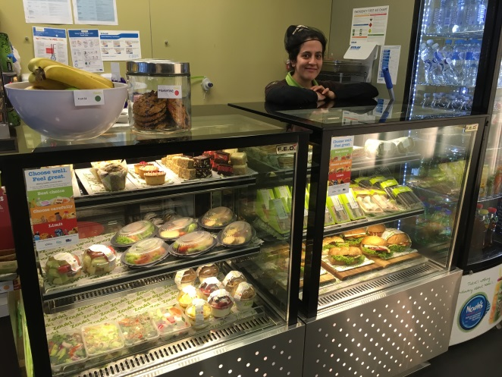

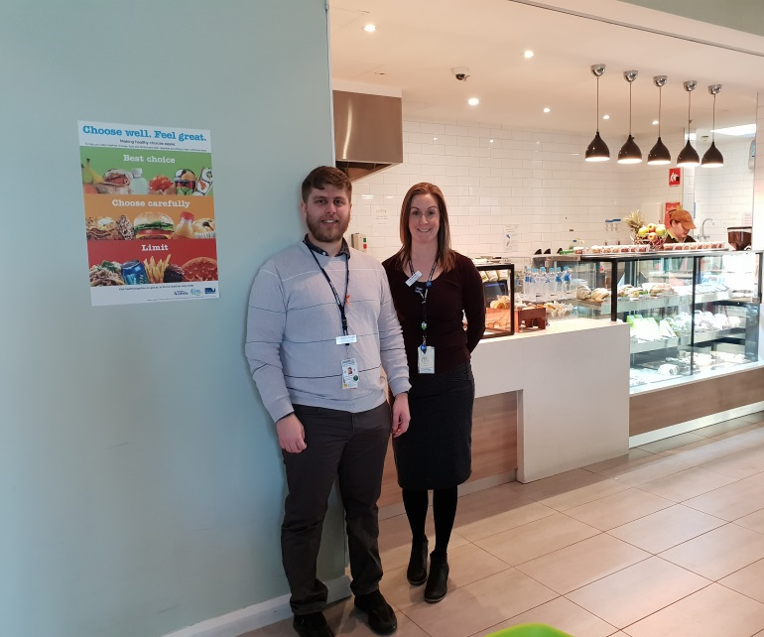

Vending Machines - The most visible increase was the change in supplier and subsequent rollover of vending machines to match the Healthy Choices guidelines in June and July 2017. In March 2016, EH Health Promotion identified the opportunity to introduce the Healthy Choices guidelines into the vending machine contract which was under review by facilities management. EH had 38 vending machines at this time and they were managed by a range of different suppliers. At least 10 were managed by the EH Foundation. EH negotiated management of all vending machines with supplier Zouki over a six month period. EH Health Promotion asked the Nutrition Expert Advisory Committee (EAC) to provide assistance to the new vending contract. This was an opportunistic adjustment that has resulted in a significant increase in the number of green and amber items available in our vending machines. The result of this change was measured in the October/November 2017 organization wide audit. The Healthy Choices Guidelines were embedded as an essential requirement into the vending contract in 2017.

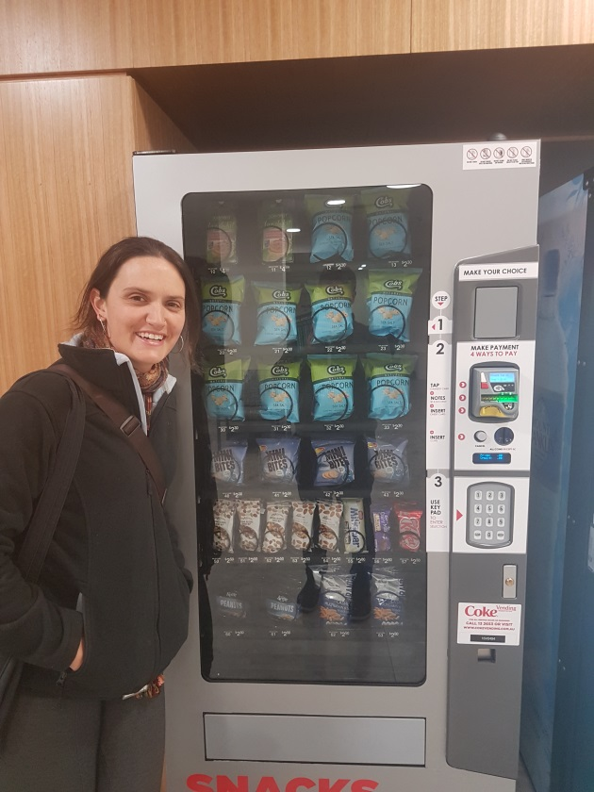

Auxiliary Kiosks – EH Health Promotion and Dietetics met with key staff and volunteers at the Box Hill Kiosk and members of the Maroondah Auxiliary Committee in 2016. Health Promotion gave an introductory presentation on the Healthy Choices Project. In November 2016 a training workshop was held with 10 volunteers to plan the way forward. The kiosks showed a willingness and keenness to work towards implementing the guidelines. Some initial changes with the kiosks have been undertaken including the rearranging of drinks in both Maroondah and Box Hill. Both kiosks have now reduced the amount of red sugary drinks and increased their varieties of green alternatives. More detailed focus on both kiosks is planned in 2019 to match the changes that have already occurred in the 3 Zouki sites.

Eastern Health, healthy food and drink guideline – Health Promotion obtained approval by the Nutrition EACH to develop a new practice guideline to implement healthy choices in 2016. The final guideline was developed utilising best practice examples from the field nationally and was endorsed in 2018. The guideline covers the Victorian state recommendations for retail sites, vending machines and catering practices. It also includes considerations regarding fundraising and sponsorship agreements It is now an endorsed EH organisational guideline and is scheduled to undergo its first review in February 2021.

To coincide with the implementation of this guideline EH Health Promotion and EH Communications team, with the aid of Public Health Nutrition students developed and delivered a detailed communications initiative. This was to inform staff members of the changes that had occurred at the 3 retail sites and the vending machines. Training was also delivered to staff members who regularly order catering.

Discussion

The HC Project Group at EH has achieved significant outcomes throughout the project’s journey to date. The endorsement and introduction of the Healthy Choices, food and drink guideline signifies the continued efforts and resources EH are placing into this project. It also aligns the HC initiative with EH leadership and has established a system of reporting and accountability. Another highlight has been the significant changes made to the physical environment across EH sites. All vending machines at EH are now offering a range of drinks and snacks which comply with the 50:30:20 recommendations. As part of the changeover of the vending machines the HC guidelines were embedded into the contract. This will ensure the sustainability of these changes into the future.

Similar progress has been made by Zouki in their two Box Hill cafes, Peter James Centre cafe and the Wantirna Health café. This change stemmed from a strong partnership between Zouki, Nutrition Australia and EH. Alongside these changes Nutrition Australia installed HC collateral obtained from HEAS at both Box Hill sites and the Wantirna site. This collateral was funded by Zouki through their partnership with Nutrition Australia. A large increase in the amount of green options and a large decrease in the amount of red options has been the result of these changes. These changes were found to be just shy of the state recommendations of 50:30:20, meaning there is still work to be done. The intention of the HC Project Group and Zouki is to roll out these changes across all sites moving into 2019. To coincide with this roll out the Health Promotion team will continue to work with the two auxiliary kiosks to implement the HC changes and move them closer towards the state government recommendations.

Moving forward EH still has some work to do to ensure that the positive changes made throughout the HC initiative are sustained. The project team will continue to work with Zouki to ensure the roll out across all sites. Annual auditing of all retail and vending sites will be undertaken over the next few years for compliance purposes. Planning for sustained change and integration of the Healthy Choices project into an existing EH structure also must take place. EH are working towards applying for recognition from the state government for the Healthy Choices work as part of their commitment to the Achievement Program. Eastern Health are committed to promoting healthy eating as part of their overall commitment to staff wellbeing at Eastern Health.

References:

Chronic Disease. Australian Institute of Health and Welfare. 18/01/2018. Available at: https://www.aihw.gov.au/reports-statistics/health-conditions-disability-deaths/chronic-disease/overview

Health and Wellbeing status of Victoria. Victorian public health and wellbeing plan 2015-2019 companion document. 2015.

A picture of overweight and obesity in Australia. Australian Institute of Health and Welfare. 2017. Available at: https://www.aihw.gov.au/getmedia/172fba28-785e-4a08-ab37-2da3bbae40b8/aihw-phe-216.pdf.aspx?inline=true

Healthy Workplaces. Achievement Program. 2018. Available at: https://www.achievementprogram.health.vic.gov.au/healthy-places/workplaces

Healthy Choices Guidelines. Healthy Eating Advisory Service. 2018. Available at: https://heas.health.vic.gov.au/healthy-choices/guidelines

