|  |  |  |
| --- | --- | --- |
| Shared Care Protocol Survey Report | April 5  2019 | |
| The EMHSCA Shared care protocol is a key support for Mental Health Service Coordination activities in the Inner and Outer Eastern Areas of Melbourne. Periodically members are surveyed about the adequacy of support for implementation of the protocol within their organisation. This report outlines the results of the survey conducted in February/March 2019. | | Eastern Mental Health Service Coordination Alliance |

Creating opportunities to work strategically across the region with multi-sectoral partners





**Eastern Mental Health Service Coordination Alliance**

**Shared Care Protocol Survey report**

**April 2019**

# Background

The EMHSCA Shared Care protocol has been in place in the Eastern Metropolitan Region of Melbourne since 2007 and describes expectations, requirements and processes for shared care by 27 EMHSCA member agencies, with the objective of improving outcomes for consumers, their carers, impacted families and children. The EMHSCA Shared Care protocol includes guidelines on the collaborative practices:

1. For service providers when working together with shared consumers;

2. For the development of Shared Care Plans;

3. For appropriate and effective sharing of information between parties to the Shared Care Plan.

The protocol was revised by the Collaborative Pathways subcommittee of EMHSCA in 2013 to be more inclusive of a range of health and community sectors and supported by EMHSCA Collaborative Care Planning Workshops for staff and separately for leaders. An implementation strategy was developed in 2014 and endorsed by EMHSCA members <https://www.easternhealth.org.au/images/services/emhsca/Shared_Care_Implementation_Strategy.pdf>.

The success of this initiative has been measured in a variety of ways including

* the EMHSCA Shared Care Audit <https://www.easternhealth.org.au/services/mental-health-services/eastern-mental-health-service-coordination-alliance#reports> and,
* administration of a questionnaire in 2015 that aimed to assess the extent to which the elements of the protocol had been embedded across EMHSCA services. The original survey was completed by 11 members and revealed that there was a good awareness of the protocol, however very few members had managed to introduce the protocol to staff across their services.

The survey delivered in 2019 was a short version of the original, the results of which are outlined and discussed here.

# Method and Aims

A quantative survey was developed by the EMHSCA project officer in consultation with the EMHSCA Implementation committee. EMHSCA members were invited to complete the survey online, via Survey Monkey.

Objective To collect information from EMHSCA members regarding their progress with embedding the EMHSCA Shared Care Protocol at their services.

Target group surveyedEMHSCA members.

Participating membersN=14; Completion rate: 100%; Average time for completion: 3 minutes

Participants identified that they represented the following organisations for the purposes of the survey: Uniting Wesley, Neami National, Anglicare AOD, EMPHN, Dual Diagnosis Consumer and Carer Advisory Council, EACH Mental Health, Wellways, Campbell Page, Whitehorse City Council, EACH Community Health, Salvocare Eastern, NEXTT, Eastern Health Adult Mental Health, Eastern Health CYMHS.

## Elements of the survey

The survey was intentionally compact with the aim of improving completion rates. The survey was comprised of the following questions.

In relation to the EMHSCA Shared care protocol

* Have you read the protocol?
* Is it included in your organisation’s orientation for new staff?
* Are the elements of the protocol included in your service audits?
* What do you think works about having this protocol?
* Are there any key elements missing from the protocol?

# Results

The results of the survey are detailed in the following graphs and summarised comments taken from the Survey Monkey account.

Fig a) Have you read the EMHSCA Shared Care protocol?

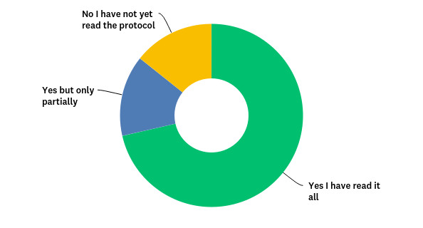

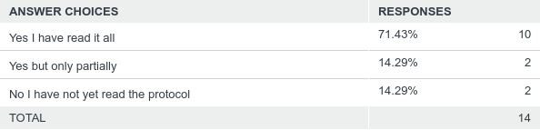

Comments: Appears to be a comprehensive document

Fig b) Is the EMHSCA Shared Care protocol part of orientation for new staff at your organisation?

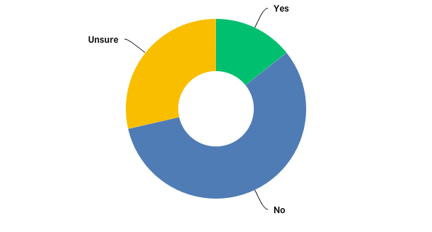

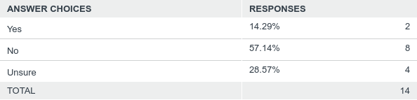

Comments:

* I have only recently joined EMSCHA and will need to discuss the role of the Shared Care Protocol within the service delivery streams of Council
* Primarily for Mental Health staff but we are in the process of updating orientation for Integrated Service Teams and the protocol will be included
* We are not involved in direct service delivery
* It is something that is discussed with staff entering roles that pertain to the EMHSCA framework.
* As an entire agency, it would not be relevant
* I believe on an ad hoc basis- only for staff in the eastern region

Fig c) Are elements of the Shared Care protocol included in your service audits? e.g. questions about shared care planning and working with other providers.

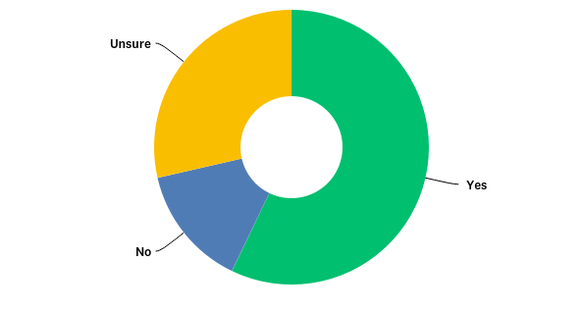

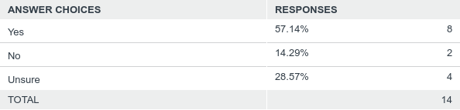

Comments:

* It was previously - I am not sure if it is currently
* Yes, and evidence of a collaborative care plan
* I believe that our involvement in EMHSCA is mentioned in audits as evidence of collaboration with other services in the sector

## Open questions

*What do you think works about having the EMHSCA Shared care protocol in the inner and outer eastern regions?*

The EMHSCA Shared Care protocol provides a shared language and good guidelines regarding standards of practice for a structured approach to collaboration between services. It promotes a consistent approach to shared care with everyone being on the same page. The protocol ensures consistent communication between organisations and co-ordinated delivery of care, which leads to better outcomes for consumers. The protocol acts to prevent the client having to start from scratch each time, and it gives the consumer increased control of their treatment

“It has been a fantastic shared language and understanding to support best practice and outcomes for our clients across multiple services”.

*In your opinion are there any key elements missing from the EMHSCA Shared care protocol?*

Of the 13 respondents to this question, five answered that there was nothing missing. More information on documentation and information sharing to support confidence of staff in communicating effectively was useful. It should be noted that 2 pages of the protocol are dedicated to this subject and an information sharing flow chart is provided as an attachment. Simplification of the protocol and improving access at all levels may improve compliance. There was an interest in finding out how the shared care protocol will be impacted by NDIS, with the tightening of funding for collaboration between workers.

“As many MH clients transition to the NDIS, managing shared care plans is becoming a complex challenge and unless a client sees the value in the shared care plan, they will not utilise funds from their NDIS package to develop and/or review the plan. Not sure how we expand the protocol to help address this issue. Clients of the NDIS are not specifically identified as a MH client and this can be a challenge of itself”.

There was a suggestion to ensure that other pieces of work link into the protocol. This would be the responsibility of EMHSCA member agencies.

A desire for greater sector influence and decision-making power was expressed in the comments for this question, accompanied by a recognition that these may not be in the scope of the protocol.

# Conclusion

Results of this survey would indicate that the EMHSCA Shared Care protocol provides a clear apparatus for supporting coordinated care practices across health and community services in the region. There appears to be a lack of knowledge of the protocol for some EMHSCA members and there are likely to be many more staff in services who have not had an opportunity to be introduced to the Shared Care Practices.

The EMHSCA Implementation committee will need to consider ways in which to make the protocol more accessible to both staff and service users. The aim would be for every health and community services staff member to be aware of the five key Shared care practices contained in the protocol and every EMHSCA member service to have consumer and carer focussed material in their waiting areas to promote the idea of a coordinated approach to their care.

# Future work

The EMHSCA Implementation committee is currently reviewing the EMHSCA Shared Care Protocol implementation strategy and will work with consumer and carer advisors to develop suitable promotional material to support consumer and carer awareness of the need for shared care. Examples of Shared Care will be added to the protocol and Aboriginal advisors will be asked for their view on the protocol to improve accessibility for all.