**NDIS Unpacked – Making it work together in the east!**

**17th May 2018**

**Event report**

Report provided by Bronwyn Williams – EMHSCA Project Officer & Eastern Health Mental Health NDIS Program Lead

On Thursday 17th May 2018, the EMHSCA Workforce development subcommittee provided an up to date event that built upon the introduction to NDIS held in August 2017. The idea that this event would “unpack” the NDIS pathway emerged from discussions with Mental Health Community Service partners. Collaboration with NDIA and our Local Area Coordinators, Latrobe Community Health Service, was considered a key component of the event. Held at the Box Hill Lower Town Hall, the event catered for 140 staff from 24 services.

# The Aim

To provide a psychosocial disability focussed NDIS event to meet the needs of a range of health and community service sector and peer workforce staff who are often involved in providing services to people experiencing mental ill health and psychosocial disability with the key aims of:

1. Unpacking the participant pathway for people with psychosocial disabilities and outlining support needs;
2. identifying the new marketplace and exploring marketplace issues with a solutions focus;
3. learning about what exists and is coming for people who are not NDIS participants;
4. Discussing the impact of NDIS on local service partnerships and collaborative practices.

This forum is a follow on to the “Mental Health, Partnerships and NDIS – Making it work together in the East! “ forum EMHSCA held in August 2017, as we aimed to prepare our region for the introduction of NDIS. Now that our service providers have some knowledge of the scheme, we aimed to build upon this with an event that clarified their various roles as they support people on the NDIS pathway, and help them to navigate the changing marketplace of supports.

.

# The Program

This full day forum was provided in 3 parts as follows:

Unpacking the NDIS Pathway

The morning provided participants with a walk through of the key elements of the NDIS pathway for psychosocial disability. This was headed up with a presentation by Melissa Young who is the Director of Stakeholder Engagement for NDIA in the east. The morning provided participants with a breakdown of the support work required to assist consumers and their carers to access and navigate the various aspects of the NDIS pathway. Presentations included the ROAR project (Peter McGrath and Michelle Egan), NDIS Consumer and Carer presentations (David Neef and Robyn Callaghan), Local Area Coordinators (Maya Djordic and Rose Juan), Partners in Recovery (Sarah Boyes), and Eastern Health Clinical Mental Health (Gareth Maloney). Midway through the pathway, Jenny Bretnall of VMIAC provided a reflective and engaging presentation on Recovery and NDIS.

## Marketplace

At Morning tea and lunch time an NDIS focussed Market Place gave opportunity for participants to meet and interact with fourteen services representing EMHSCA partners, NDIS providers and peak bodies.

## L:\EHMentalHealth\Mental Health Program\Service Coordination Project\Eastern Mental Health Service Coordination Alliance\Workforce Development\NDIS\2018\NDIS 2018 pics\IMG_5684.JPG

## Afternoon sessions

Following lunch, a presentation about the Clinical Mental Health Interface project (Julie Skilbeck - DHHS) enlightened attendees regarding the Department’s work in supporting the transition to NDIS. As a starting point for exploring potential psychosocial supports for people who are not NDIS participants, a presentation about Information, Linkages and Capacity Building was provided by Christiaan Bramblebee (Latrobe CHS) and Liz Wrigley (EACH). Larissa Taylor and Jackson Reynolds of Mental Health Victoria (previously VicServ) provided information on the changing role of the mental health workforce and some alarming statistics to put the situation in Victoria in context.

## Panel Discussions

Two panel discussions were facilitated by Kieran Halloran of the Eastern Melbourne PHN which explored the effects of NDIS on collaborative practices. Responses emphasised the importance of working together to support people during this transition period as NDIS is establishing itself in the east.

Jenny and Robyn (VMIAC) outlined what was important for consumers about collaboration and NDIS. They encouraged providers to be “respectful, dignified, curious and interested” with the people they work to support. Honesty and openness along with intentional power sharing were mentioned as important aspects of the worker and participant relationship. Jenny informed us that it is difficult to prove you have a psychosocial disability when you are living with a psychosocial disability. Robyn let us know that “A clipboard and 27 questions” is intimidating and can inhibit engagement in NDIS planning. Tandem’s Simon Jones reminded us to provide family inclusive supports to people and alerted us to the fact that Mental Health carers are faring worse in an NDIS environment than other carer groups. The importance of ‘face to face’ relationships and networking were highlighted by other panel members and an appetite for continuing collaboration was evident. The threat of the NDIS provider business model drivers impeding collaborative work was rejected by many present.

## The Venue

The event was held in the Lower Town Hall at the Box Hill Town Hall with the marketplace around the perimeter. This was spacious and well lit. The Town hall staff provided the room set up and sound and we provided the visual display equipment. The projection area in this space is small and can be difficult for rear seats to view the screen. Acoustics are poor and presenters are encouraged to utilise the microphone. The roving microphone provided does not consistently work.

## Event facilitation

This event was developed, organised and provided by the EMHSCA Workforce Development subcommittee and EMPHN PIR, along with the various presenters from a range of services.

# EMHSCA Workforce Development Subcommittee members

|  |  |
| --- | --- |
| **Anna Makris** (chair) | **Federal Dept. Human Services** |
| **Bronwyn Williams** (Project Officer) | **Eastern Health Adult MH Program** |
| **Jacqui Turnbull** | **Wellways** |
| **Josie Tremain** | **Neami National** |
| **Maria Yap** | **Eastern Melbourne PHN** |
| **Sandro Madrigale** | **Eastern Health Aged Persons MH Service** |

It is important to acknowledge the substantial contribution of these members and their teams to the success of the EMHSCA Workforce Development events each year. Thanks goes to EMHSCA member organisations for contributing in this way to improving Service Coordination across the EMR for the benefit of people who experience mental ill-health and co-occurring issues.

I would also like to acknowledge the City of Whitehorse who provided grant funding to support this event and also to Waverley Industries for their reliable and delicious catering.

We are grateful to event participants for their contributions via registration. EMHSCA thanks Mental Health Victoria and the Eastern Melbourne PHN for sponsoring this event and enabling the participation of the peer workforce, NDIA and our Local Area Coordinators.

# Attendance by sector

# Overall Attendance

|  |  |
| --- | --- |
| Registered | 143 |
| Did not register and attended | 16 |
| Apologies | 19 |
| **Total attendance** | **140** |

# Budget

Catering $2,694.99

Venue $1,381.00

Total: $4,075.99

Plus in-kind support from EMHSCA organisations for printing and staffing.

The NDIS Unpacked event piloted a new way of supporting EMHSCA events by charging each participant $20 via Eventbrite. $2,124 was raised from this process and contributed to the catering costs as listed below. Additionally sponsorship of $500 from Mental Health Victoria and $500 from the Eastern Melbourne PHN was received. Therefore, of the $4,075.99 required to fund the event, only $951.99 was drawn from EMHSCA Workforce development funds.

|  |  |
| --- | --- |
| Access Community Health | 1 |
| Anglicare | 8 |
| Aus gov DHS | 5 |
| Austin Health | 1 |
| Campbell Page | 2 |
| Capability | 1 |
| Dept Health & Human Services | 3 |
| EACH | 14 |
| Eastern Community Legal Centre | 1 |
| Eastern Health | 21 |
| Eastern Melbourne PH Collaborative | 1 |
| Eastern Melbourne PHN | 3 |
| EDVOS | 1 |
| ERMHA/Deakin | 1 |
| Forensicare | 1 |
| Healthcare Australia | 4 |
| Inspiro | 1 |
| Integra | 1 |
| JobCo. | 4 |
| Knox City Council | 1 |
| Latrobe Community Health | 3 |
| Live | 1 |
| Maroondah City Council | 1 |
| MeWell | 2 |
| Mentis Assist | 2 |
| MH Victoria | 2 |
| MIND Australia | 10 |
| NDIA | 4 |
| Neami National | 18 |
| NEXTT | 1 |
| Outcome Health | 2 |
| Progress Occupational Therapy | 1 |
| Salvocare Eastern | 6 |
| State Trustees | 1 |
| Tandem | 3 |
| Uniting Prahran | 2 |
| Villa Maria Catholic Homes | 1 |
| VMIAC | 2 |
| Wellways | 6 |

# Feedback

“Excellent forum! Well done”

“Great content and presenters”

“Very informative and well balanced”

“It is heartening that there appears to be a willingness amongst providers to collaborate”

“Jenny’s presentation was fantastic. Practical and useful”

“Great questions and discussion”

“Love the recognition of service survival in the transition to NDIS”

“Catering was excellent”

“Adding consumers personal point of view creates better understanding”

“Great to hear consumer prespectives”

“I really liked the marketplace and panel”

“I attended last year and this year – thoroughly enjoyed both and would support that these continue every year as the NDIS and mental health service system evolves”

The event participants were provided with feedback forms in hard copy at the event. Just 48 of the 140 participants provided feedback. Of this cohort the following results were collected.

The morning presentations received a range of reviews, with the majority of participants finding them useful. The ROAR presentation on accessing the scheme and the presentation on Activating Supports were most popular. It is noted that both had a strong case presentation focus.

Afternoon presentations rated more highly than those in the morning program. Mental Health Victoria was found to provide the most useful content.

The overall view of respondents was that the forum provided a good level of improvement in knowledge of the elements of the NDIS pathway, and available NDIS supports. Most respondents felt the forum allowed them to express their concerns about NDIS and that these concerns were somewhat addressed. Comments revealed that some people would have liked the panel discussion to be more focussed on Question and Answer opportunities and some said they were not interested in talking about collaboration.

The forum aimed to strike a balance between exploring issues and supporting a positive view of the NDIS. In comments participants varied with some wanting more focus on the issues and at least one person wanting to hear more success stories. Some attendees voiced that they wondered if the access process was worth the trouble and if consumers would be better off without NDIS after attending the forum.

Some participants indicated that the NDIS pathway was still confusing for them. A simple flow chart may have assisted with assimilation of the information. Examples of NDIS plans and services received, and some rationale for NDIS applicant ineligibility were requested. Some respondents would have liked more networking time and potentially some group work to explore the challenges in relation to NDIS.

# Discussion

The forum informed participants regarding the NDIS pathway and at the same time raised a variety of issues and challenges.

Key points that we can take from this forum are:

* There is a clear commitment from our Local Area Coordinators and NDIA reps to collaborate with our service providers and peer workforce;
* We are developing a better understanding of the NDIS pathway however this is made more difficult by the inconsistencies encountered in access, planning and review;
* The NDIS pathway for psychosocial disability requires some skill to navigate and people who experience mental ill-health may need support from their local service providers to access the scheme;
* Where people lack support to access NDIS it may be best to link in with advocacy services;
* The NDIS can offer around 10% of people who experience mental ill-health more choice regarding how their money will be spent to support them in managing their psychosocial disability;
* Almost all community mental health supports in Victoria are affected by NDIS which may create a significant gap in service provision to as many as 90% of consumers who are found ineligible or are unwilling to test their eligibility for the scheme;
* Information, Linkages and Capacity Building funds are assigned to support people who are non-NDIS participants. Funds will be made available again in 2019 and services may engage in a tender process to provide supports to non-NDIS participants;
* There is a general concern that NDIS is disrupting our collaborative work of the past 10 years and there was strong expression from many participants of wanting to preserve it. The will of NDIS providers (ex MHCSS) to work collaboratively remains, however the service capacity for this is diminishing;
* Clinical Mental Health staff require more targeted training and resourcing in order to support consumers and carers and this is in development via DHHS;
* Service providers are frustrated by the difficulties they experience in expressing their concerns and following up on issues for the people they support along the NDIS pathway. Better mechanisms to address issues and escalate them as necessary require development.

cid:_1_0ACE30DC0ACE025C00282B8DCA257D02 *EMHSCA acknowledges the traditional Aboriginal owners of country throughout Victoria and respects them, their culture and their Elders past, present and future.*

# Conclusion

“NDIS unpacked” provided a timely opportunity for EMHSCA partners to develop relationships with NDIS providers, the NDIA and Latrobe Community Health Service. This targeted forum supported staff across the region to develop a good level of knowledge regarding how to support consumers and carers along the NDIS psychosocial pathway. Additionally this forum provided an environment for staff to discuss the various challenges of working in an NDIS environment and reinforced the good will of all concerned to work collaboratively.

This event received a mixed response from attendees. The vast majority of people found the event beneficial; however there were a small number of attendees who expressed desire for something quite different. On reflection, it is always challenging to meet the needs of a broad cross-sectoral audience. It would appear that the inner and outer eastern regions have reached a point of need regarding NDIS that is increasingly difficult to meet with the available information. One survey respondent summed it up by criticising the forum for not outlining “what to expect next” from NDIS.

The NDIS environment is unpredictable, inconsistent and constantly developing, especially in relation to psychosocial disability. New learnings come to light on an almost daily basis. There is little doubt that we will need to provide future EMHSCA NDIS forums. Consideration of the full range of feedback received from participants of NDIS Unpacked will inform the development of our next annual NDIS event.

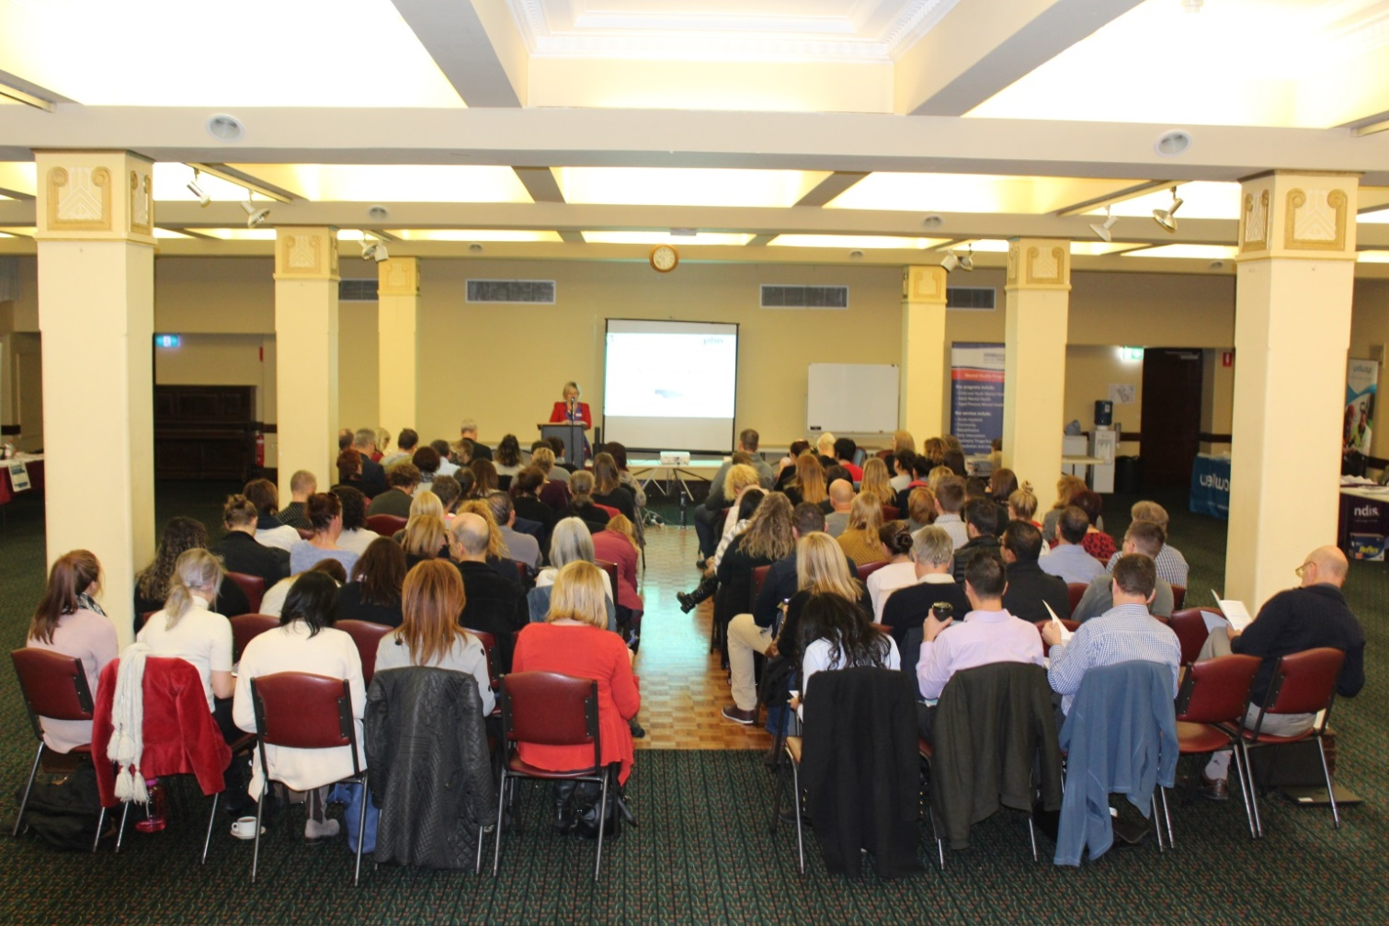

# Appendix A NDIS Unpacked Event Program

|  |  |  |
| --- | --- | --- |
| ***Thursday 17th May 2018*** | | |
| 9am  30 | **Registrations** | *EMHSCA Workforce Development Sub committee* |
| 9.30am  10 | **Introduction** | *Bronwyn Williams – Mental Health NDIS Program Lead/ EMHSCA Project Officer* |
| 9.40 am  20 | **NDIS pathway for Psychosocial Disability** | *Melissa Young – Director Stakeholder Engagement - NDIA Vic East* |
| 10 am  45 | 1. **Accessing the scheme** | *Peter McGrath Manager - Homelessness and Support Services - SalvoCare Eastern*  *Michelle Egan - Manager Strategic Development Disabilities Participation and Choice - EACH*  *David Neef - Senior Carer Peer Worker - Eastern Health* |
| 10.45am  15 | 1. **Maintaining a Recovery focus** | *Jenny Bretnall – NDIS educator - VMIAC* |
| 11am  30 | **Morning Tea Break** | *Marketplace* |
| 11.30am | 1. **Planning** | *Maya Djordjic Community Development and Capacity Building Coordinator  - Latrobe Community Health Box Hill*  *Gareth Maloney – Occupational Therapist - Eastern Health* |
| 12MD  25 | 1. **Activating supports** | *Robyn Callaghan – Peer presenter - VMIAC*  *David Neef – Senior Carer Peer Worker - Eastern Health*  *Sarah Boyes – Support Facilitator - Partners In Recovery* |
| 12.25pm  20 | 1. **Plan reviews** | *Rose Juan - Community Development and Capacity Building Coordinator*  *Local Area Coordination Service Outer East Melbourne* |
| 12.45 pm  45 | **Lunch time** | *Marketplace* |
| 1.30pm  20 | **NDIS Clinical Mental Health interface** | *Julie Skilbeck - Manager, Program Design and Strategy System Policy and Integration, Mental Health Branch DHHS* |
| 1.50pm  20 | **Information, Linkages & Capacity Building** | *Christiaan Bramblebee – Community Engagement, Latrobe CHS,*  *Liz Wrigley - SKIPS & Consumer Engagement Coordinator*  *Mental Health Recovery, EACH* |
| 2.10pm  15 | **Workforce and Marketplace update** | *Larissa Taylor – Manager of NDIS Engagement- Mental Health Victoria*  *Jackson Reynolds – Campaign Manager NDIS Policy and Projects Officer– Mental Health Victoria* |
| 2.25pm  20 | **Afternoon tea break** |  |
| 2.45pm  40 | **Panel discussion** | *VMIAC (Jenny Bretnall & Robyn Callaghan), Tandem (Simon Jones), Mental Health Victoria (Larissa Taylor), NDIA(Melissa Young & Chris Cahill), Latrobe CHS (Maya Djordjic)*  *Facilitated by Kieran Halloran* |
| 3.25 pm  20 | **NDIS provider expert panel** | *Glen Tobias (Neami National/MeWell); Justin McKenzie (Wellways); Sue Fowles (EACH); Neil Grunn (MIND Australia)*  *Facilitated by Kieran Halloran - Mental Health Manager Severe & Enduring (PIR/Suicide Prevention)* |
| 3.45pm  15 | **Wrap** | *Kieran Halloran*  *Bronwyn Williams* |
| 4pm | **Event close** |  |

# Appendix B

## Marketplace Stalls Website

Access Health and Community (**03) 9810 3000** [www.accesshc.org.au](http://www.accesshc.org.au)

Campbell Page **(03) 9046 5940** [www.campbellpage.com.au](http://www.campbellpage.com.au)

Carrington Health **(03) 9890 2220** [www.carringtonhealth.org.au](http://www.carringtonhealth.org.au)  
Eastern Community Legal Centre **(03) 9285 4822** [www.eclc.org.au](http://www.eclc.org.au)

EACH **1300 00 3224** [www.each.com.au](http://www.each.com.au)

Healthcare Australia **1300 422 247** [www.healthcareaustralia.com.au](http://www.healthcareaustralia.com.au)

Latrobe Community Health **1800 242 696**  [www.lchs.com.au](http://www.lchs.com.au)

Link Health and Community **1300 552 509** [www.linkhc.org.au](http://www.linkhc.org.au)

Me Well **1800 258 258** www.me-well.org.au

MIND Australia **1300 286 463** [www.mindaustralia.org.au](http://www.mindaustralia.org.au)

NDIA **1800 800 110**  [www.ndis.gov.au](http://www.ndis.gov.au)

Tandem (**03) 8803 5555** [www.tandemcarers.org.au](http://www.tandemcarers.org.au)

Uniting Life Assist **(03) 9239 2500** [www.lifeassist.org.au](http://www.lifeassist.org.au)

Uniting Prahran **9692 9500** [www.unitingcare.org.au](http://www.unitingcare.org.au)

VMIAC **(03) 9380 3900** [www.vmiac.org.au](http://www.vmiac.org.au)

Wellways **1300 111 400**  [www.wellways.org](http://www.wellways.org)