Mental Health, Partnerships and NDIS – Making it work together in the east! August 31st 2017
Event report
Report provided by Bronwyn Williams – EMHSCA Project Officer
The EMHSCA Workforce development and Strategic Planning subcommittees identified the need to prepare the Eastern Metro Region Health and Community services for the roll-out of the National Disability Insurance Scheme (NDIS) that is planned to commence in November 2017. Held at the Box Hill Town Hall, the event catered for 250 staff from more than 40 services.

The Aim

To provide a mental health focussed NDIS forum tailored to the needs of a range of health and community service sectors who are often involved in working with people experiencing mental ill-health and psychosocial disability and are EMHSCA partners. The key aims were to 1. provide clarity regarding the various roles of staff, and 2. explore the issues around maintaining the EMHSCA partnerships.

The Program
This full day forum was provided in 3 parts as follows:
NDIS and Mental health focussed overview presentations
The morning provided participants with an overview of the peak body and lead agency perspectives on NDIS and how it will affect health and community service provision in relation to people experiencing mental ill-health and their supports. Presenters included Sasha James (NDIA); Neil Turton-Lane (VMIAC); Robbert Roos and Simon Jones (Tandem); Donna Hayes (DHHS) and Larissa Taylor (Vicserv).
Kieran Halloran (EMPHN) facilitated a panel discussion which included all morning presenters. A range of topics were addressed and audience participation was encouraged.
Dr. Tamsin Short reminded us all about International overdose awareness day as this event coincided with this important calendar item. Dr. Short emphasised the importance of humanising those who experience substance use issues with the aim of addressing the associated stigma and shame.

Marketplace
At Morning tea and lunch time an NDIS focussed Market Place gave opportunity for participants to meet and interact with NDIS providers and peak body representatives.

Afternoon Break-out sessions
Four break-out sessions were conducted to provide practical advice to Clinical Mental Health Staff, AOD/Homelessness and other health and community service staff, non-clinical community mental health staff and, by invitation, an EMHSCA Leaders forum that aimed to support the ongoing partnerships in this region. The MHCSS room experienced presentation from VMIAC and Vicserv and concluded with a panel of partners from the North east region. The Clinical Mental Health room provided improved understanding and practical advice from North eastern clinical services, MHCSS and DHHS. Case examples were used to walk staff through the access form and evidence gathering. The Non-NDIS, non-clinical room commenced with a presentation regarding overdose awareness and mental health by Dr. Tamsin Short. This was followed by local leaders providing a panel discussion to begin to explore the potential impact of NDIS on their sectors. This session concluded at 2.45pm and the participants were invited to join the Clinical Mental Health room for some practical advice on working with people who may or may not be eligible for NDIS funded supports.

“Great speakers, very helpful and relevant resources”.

“Experienced NEMA rollout. Would have been very useful to have had this prior”.

“Spoke to all the current questions I had about the role of clinical staff”.

“Senior leaders in the room with focussed discussion were very useful – a great step forward for EMHSCA”.

“It was very real, honest & transparent. Some great advice”.

“Excellent networking opportunities”.

“Good pace and well organised”.

“Fabulous day! Thanks”.

“This was a fantastic day. One of the better NDIS forums”.

Feedback
Of the 103 responses received to the post event survey approximately 40 % had attended the MHCSS presentations, 24% were in the Clinical Mental Health room, 30% engaged in the non-NDIS, non-clinical health and community services forum and 12% were part of the EMHSCA leaders’ forum. Satisfaction with the event was rated highly and a moderate improvement in knowledge in the following domains was achieved: Clarity about the role of staff in an NDIS environment; Understanding how NDIS may affect people attending services; understanding the effect on service partnerships. All but one respondent found the tailored approach to the subject useful and 46% of people found it very useful.
The utility of the event was in the practical information provided with specific advice on how to support people with access and evidence; the leaders’ forum with frank discussions at a senior level; panel discussions; resources and tools; great speakers; meeting other service providers; hearing that services in the east plan to collaborate; consideration of challenges; developing creative ideas about how to work with NDIS; hearing different perspectives; hearing from the north-east region; and mental health focussed case examples.
What people would like to know more about included: CALD and carer engagement under NDIS; How it impacts EMHSCA in future; Physical disability; relationship to family violence; more info on clinical roles and NDIS; more case studies; impacts on services; specific referral pathways for NDIS; plans for non-MHCSS consumers and the phasing into NDIS; later impacts of NDIS as it evolves; how family services can work with people on NDIS; how can we maintain an experienced workforce for mental health services; how NDIS will work with Dual Diagnosis.

The Venue
The first part of the event was held in the Main Ball room at the Box Hill Town Hall with the marketplace around the perimeter. The afternoon was held across the Whitehorse, Matsudo and Gawler rooms and the EMHSCA leaders’ forum was held in the Council Chambers.

Event facilitation
This event was developed, organised and provided by the EMHSCA Workforce Development subcommittee in collaboration with the Strategic Planning subcommittee with funding via annual contributions from EMHSCA member organisations and substantial financial contributions from the Eastern Melbourne Primary Health Network.
Workforce Development subcommittee | Strategic Planning subcommittee
Aaron Jones - Neami National | Anne Dooley - MIND Service manager Maroondah PARC
Anna Makris (co-chair) - Federal Dept. Human Services | Bronwyn Williams - EMH SC Alliance Project Officer
Bronwyn Williams - EMH SC Alliance Project Officer | Hang Vo - General Manager  Planning, Strategy & Development/EACH
Sandro Madrigale - Community Programs Manager, APMHS | Jacky Close - Executive officer | Outer East Health and Community Support Alliance
Sue Leen Ng - Wellways | Joddie Pappas - Team leader/ Prahran Mission Mt Waverly
Pembrooke Werden - PHAMS Monash Team Leader, Prahran Mission | Joel Robins - Eastern Melbourne PHN Mental Health Manager Youth MH & AOD
Corey Eastwood - MIND PARC programs | Michelle Clark - Senior Program Advisor | Outer East Team, East Division. Department of Health and Human Services.
Jose Abalo (co-chair) - Federal Dept. Human Services | Tracey Blythe - Inner East PCP A/Executive Officer
Maria Yap –Eastern Melbourne PHN
Nell Dickinson - Anglicare

It is important to acknowledge the substantial contribution of these members and their teams to the success of the EMHSCA Workforce Development events each year. Thanks goes to EMHSCA member organisations for contributing in this way to improving Service Coordination across the EMR for the benefit of people who experience mental ill-health and co-occurring issues.
I would also like to acknowledge the City of Whitehorse who provided grant funding to support this event and also to Waverley Industries for their reliable and delicious catering.

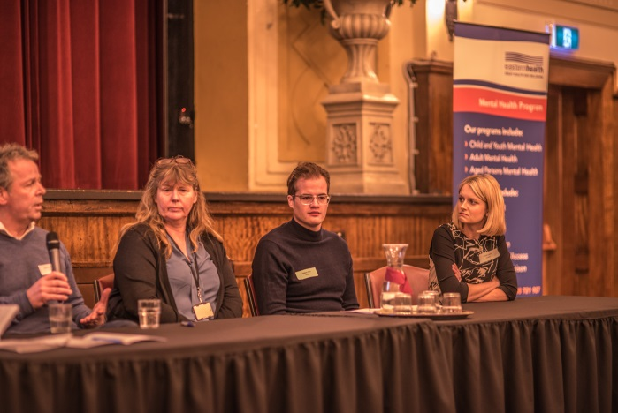
Attendance
Registered | 240
Did not register and attended | 43
Apologies | 21
Total attendance | 237
Uncertain attendance | 25
There was a substantial waitlist for this event.
Budget
Catering $2,859
Venue $1,634.50
Total: $4,554
Plus in-kind support from EMHSCA organisations for printing and staffing.
The City of Whitehorse provided a grant that reduced the venue hire by half.
This event would have been well outside the EMHSCA budget. We are grateful to the Eastern Melbourne phn for meeting the full cost of catering and half of the venue hire.

Attendance by sector
AOD | 31
Aus gov DHS | 3
Clinical Mental Health | 40
Community Health | 1
Dept Health & Human Services | 7
Dept Social Services | 1
Eastern Community Legal Centre | 1
Eastern Melbourne phn | 7
Family Services | 9
Homelessness/Housing | 8
Local council | 5
MHCSS, Vicserv, Tandem & NDIS | 128
Primary Care Partnerships | 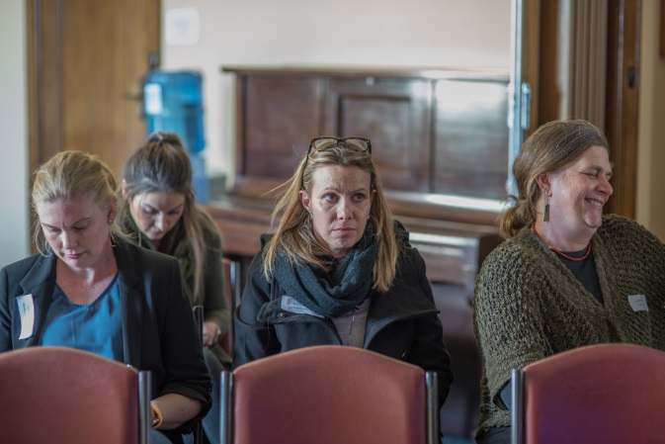  2
State Trustees | 1
Universities | 2
Unknown | 5
VACCA | 5
VMIAC | 1

Discussion
With the ever changing nature of the scheme, this tailored forum provided something for everyone. Information from North eastern services was perceived by all as valuable and served to clarify some issues whilst raising others. The importance of Clinical Mental Health services, G.P’s and other evidence providers was highlighted along with the essential supportive role that all health and community service providers will play as the NDIS landscape unfolds.
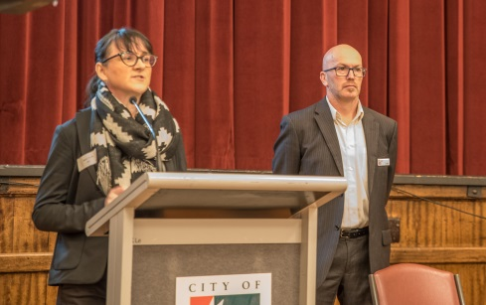
Key points that we can take from this forum are:
- The NDIS can offer a small cohort of people more choice regarding how their money will be spent to support them in managing their psychosocial disability;
- Existing Mental Health Community Services will transition into the NDIS on 1st November 2017;
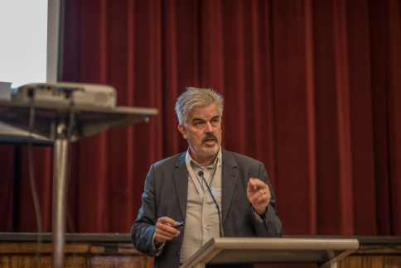
- There will be a lot of staff changes in this sector with changing pay rates and business parameters;
- Services will need to be creative to ensure their staff are able to attend training, and also to enable them to engage in collaborative conversations;
- All health and community services will need to collaborate to ensure people are not left without important resources;
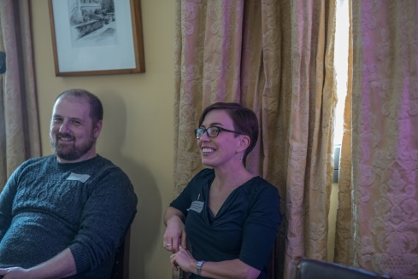
- People will need significant support prior to engaging in planning conversations with the NDIA to ensure they are well prepared;
- People need to know that a face to face planning meeting is recommended and they may ask to have a worker or family member present;
- Clinical Mental Health staff require targeted training and resourcing in order to support consumers and carers effectively in relation to access and evidence provision for NDIS;
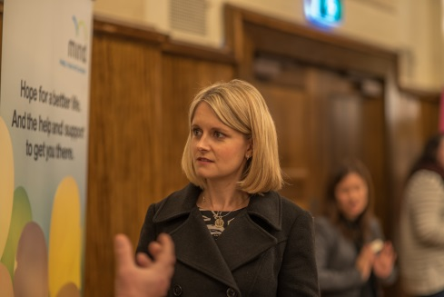
- Service providers will need to speak two languages - Recovery and NDIS - and they will need to help their consumers and carers do the same;
- It is concerning that substance use issues have been identified as a “wrong door” criteria for the NDIS at the point of access given the work of the Dual Diagnosis initiative over the past 15 years to have services address these co-occurring issues together;
- There is a lot of good will in the health and community service sectors and everyone wants to ensure the NDIS works for as many people as possible;
- Everyone expressed their desire to continue their strong local partnerships and develop creative solutions to the challenges raised by the NDIS.
Conclusion
This event has demonstrated the importance of a collaborative and tailored cross-sector approach to information provision to service providers regarding NDIS for people who experience mental ill-health and associated psychosocial disabilities. Subsequent and similar forums are indicated to ensure targeted information is provided to staff and collaborative relationships are strengthened and promoted. EMHSCA may use this forum as a springboard to have a collective impact on the way in which NDIS rolls out in the Eastern Metro Region of Melbourne. All EMHSCA committees will use the information gathered here to inform their strategy go ing forward and to preserve their collaborative relationships into the future.
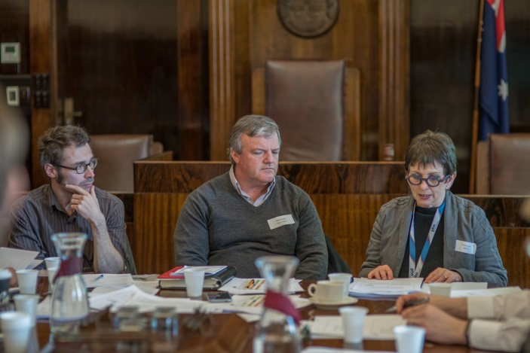
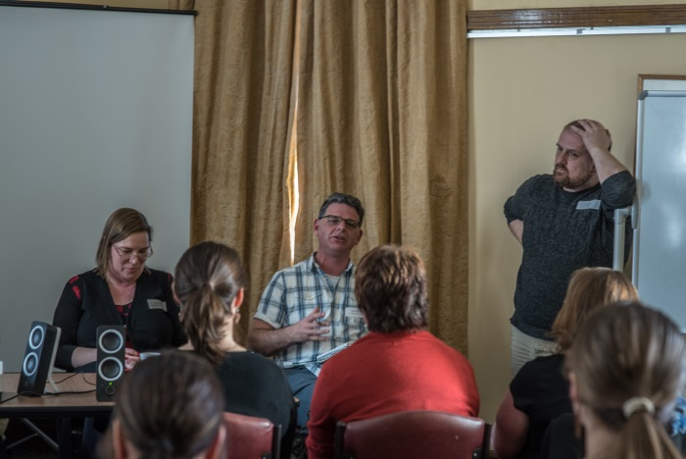

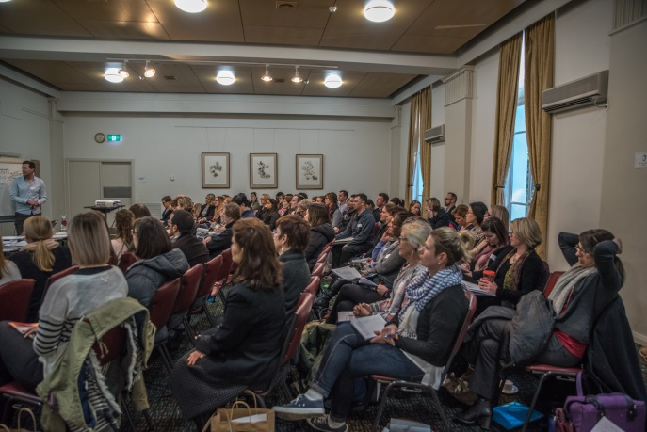
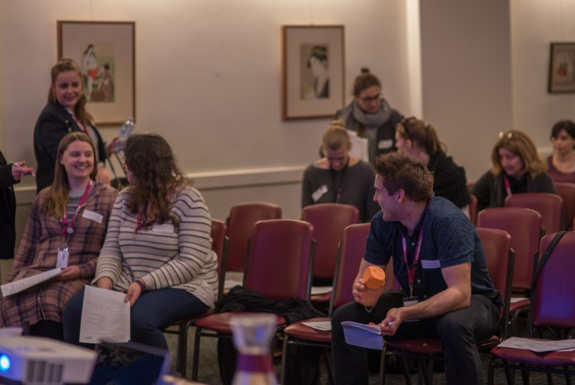

Appendix A Event Program
Time | AGENDA ITEM | Presenter
9.15am | Welcome to Country | Aunty Joy Murphy
9.30am | Intro to day and house keeping | Bronwyn Williams - EMHSCA project officer  Overview of the day and intro to Eastern MH SC Alliance
9.40 am | Setting the scene for the future | Sasha James- Director Stakeholder Engagement –Victoria East, National Disability Insurance Agency  Sasha.james@ndis.gov.au
10 am | Consumers, Mental Health and NDIS | Neil Turton-Lane - Consumer Liaison Manager - VMIAC  neil.turton-lane@vmiac.org.au
10.15am | Carers, Mental Health and NDIS | Robbert Roos - Carer Advocate – Tandem  Simon Jones - NDIS transition - Tandem  robbert.roos@tandemcarers.org.au
10.35am | Transitioning the region to NDIS | Donna Hayes- East Division NDIS Transition Manager – Department of Health & Human Services  donna.hayes@dhhs.vic.gov.au
10.50am | Morning Tea Break | Networking time and Marketplace
11.20am | NDIS: Considerations for Community Mental Health Providers | Larissa Taylor - Manager, NDIS engagement - VICSERV  l.taylor@vicserv.org.au
11.40pm | Mental Health and Partnerships in a new world  Panel Discussion and Q & A | Kieran Halloran - Mental Health Manager Severe & Enduring (PIR/Suicide Prevention)  Eastern Melbourne Primary Health Network  Kieran.halloran@emphn.org.au
12.25pm | International Overdose Awareness Day | Dr. Tamsin Short - Executive Director of Alcohol and Other Drug Services Connect4Health consortium  Tamsin.short@accesshc.org.au

Room  Facilitator | Council Chambers  Jacky Close  & Anne Lyon  EMHSCA Partners Leader’s forum | Gawler Room  Tom Stylli  & Maria Yap  Non-NDIS Health and Community Services |  | Whitehorse Room  Bronwyn Williams  & Roseda Campbell  Clinical Mental Health |  | Matsudo Room  Kim Johnson  & Kerry Boyd  Community Mental Health (MHCSS)
1.40pm | Introduction | Introduction |  | Introduction |  | Introduction
1.45pm | Reflections on the morning sessions – Facilitated by Anne Lyon | Mental Health and Overdose: A New Approach to Prevention & Treatment – Dr. Tamsin Short - Access Health & Community Services |  | Where are we at with the integration of NDIS and clinical mental health? Wendy Davis Program Design & Strategy DHHS  Practice Advice for Mental Health Clinicians - Christine Hodge Business and Service Development Manager Northern Area Mental Health Service |  | Psychosocial Disability and the NDIS: “Supporting consumers with NDIS access requests” – Neil Turton-Lane VMIAC
 | Celebrating EMHSCA – Where we are today – Cathy Keenan DHHS
2.05pm | Learnings - what we know about NDIS and partnerships – Jacky Close | Non-NDIS health and community services panel discussion – What NDIS means for our work.  Angela Geylswyk (Anglicare family services)  Junelle Rhodes (Link Health & Community)  Jane Moreton (VAADA) |  |  |  | Providing evidence to support NDIS applications - Larissa Taylor –VICSERV
EMHSCA’s future vision
Facilitated discussion with Anne Lyon
2.25pm | The challenges and the opportunities  Facilitated group activity |  |  |  |  | The role of the MHCSS worker to prepare people for planning meetings - Larissa Taylor –VICSERV
2.45pm Afternoon Tea
3pm | Planning for the sustainability of EMHSCA – practical steps | No session. All participants are invited to join session in the Whitehorse room for practical advice regarding working with people who may or may not be eligible for NDIS. | Supporting applications, meeting evidence requests and preparing for planning meetings – Phil Watson NEAMI |  | How NDIS has worked in the North - MHCSS panel - Andrea Lally(EACH) Farshid Zamen (NEAMI) ; Neil Turton-Lane (VMIAC); Larissa Taylor (Vicserv);

