2018
EMHSCA End of year Report
“Creating opportunities to work strategically across the region with Multi- Sectoral partners”

Report provided By EMHSCA Project Officer
Bronwyn Williams
Contents
EMHSCA background 2
EMHSCA Strategy 3
EMHSCA Co-chairs: 3
Membership 3
Highlights 5
Analysis 6
EMHSCA Work plan elements 7
Mental Health & AOD System Reform 7
NDIS 7
Safe and Quality Care 8
October 8
December 8
February 2019 8
Collaborative Care Planning 9
Workforce Development 9
Steering group work 7
Budget 10
Costs for 2018 Annual year 11
Projected Costs for 2019/2020 12
EMHSCA research project 12
Conclusion 12
Appendix A 2018 Leaders’ Collaborative Care Planning Workshop Report 14
Appendix B NDIS Unpacked – Making it work together in the east! Event report 17
Appendix C EMR Orientation 2018 Sector Overviews Event Report 25
Appendix D EMHSCA Open House Service Showcase Event Report 30

EMHSCA background
Mental Health Alliance activity in the Eastern Metropolitan Region dates back to 2007. Even prior to this some efforts were being made to connect community and clinical Mental Health leaders. In 2009 the inner and outer eastern Mental Health alliance groups joined to form the Eastern Mental Health Alliance which aimed to support the delivery of more accessible, appropriate and coordinated mental health services to improve the experiences of mental health consumers, carers and practitioners. The Alliance has expanded to include a wide range of regional partners to support a broader focus on mental health service coordination across the service system. This Alliance has been called the Eastern Mental Health Service Coordination Alliance since 2012 in order to reflect the inclusion of the broader membership. This Alliance serves all parts of the inner and outer east and is now known as EMHSCA. The range of sectors includes Mental Health, Alcohol & Other Drugs (AOD), Homelessness & Housing, Family Services, Family Violence services, Aboriginal services, Primary and Community health services, Employment supports, NDIS providers, Consumer advocacy and Community Legal services, and is supported by the Department of Health and Human Services (DHHS).
The Alliance was originally funded by DHHS; however since 2012 EMHSCA has been funded in partnership by various members. For the period 2018 to June 2020 EMHSCA is co-funded by DHHS, the Eastern Melbourne PHN and Eastern Health. Member organisations contribute financially to the Workforce Development activities and provide their time and resources in-kind to the functioning of EMHSCA.
EMHSCA initiatives have included the following: the EMHSCA MOU (25 signatories); Service Coordination focussed workforce development activities (34 events provided for 2844 staff since 2010); EMHSCA Shared Care Audit (6940 files across 6 orgs. over 4 years) and consumer survey; EMHSCA Shared Care Protocol; Eastern Peer Support Network; EMHSCA service mapping; EMHSCA Colocation guide; EMHSCA Shared care plan guide; and a range of EMHSCA tip sheets.
The EMHSCA shared repository can be located here https://www.easternhealth.org.au/services/mental-health-services/eastern-mental-health-service-coordination-alliance.
In 2018 a review of the EMHSCA strategy resulted in a new work plan. The EMHSCA structure was simplified and Alliance meeting agenda was revised to enable more collaborative discussions, consultations, and solution seeking. This revision of EMHSCA was in response to the multiple and significant sector reforms taking place, particularly in relation to mental health supports.

EMHSCA Strategy
This partnership aims to strengthen Mental Health and AOD service collaboration, coordination and system integration across Inner and Outer Eastern Melbourne for improved consumer outcomes.

EMHSCA Priority Areas
1. Mental health and AOD service and system reform
2. NDIS
EMHSCA Vision: To ensure that people who experience mental ill-health and co-occurring concerns have access to responsive, appropriate and collaborative services to assist with the multiple facets of their individual recovery journey.

EMHSCA Function
EMHSCA provides a key local platform for health and community service consultation and collaborative decision making in the Eastern Metropolitan Region and is centrally focussed on Mental ill-health and Alcohol and other Drug related service coordination.

Partnership
A Memorandum of Understanding exists between 25 member services of the EMHSCA. This is due for review and re-signing in 2019.
EMHSCA Co-chairs: Dr. Tamsin Short (Connect 4 Health) and Brad Wynne (Eastern Health Mental Health Program).

Membership
New members that joined EMHSCA in the 2nd half of 2018 are Maroondah City Council. This has led to EMHSCA inviting all relevant local councils to join EMHSCA in 2019. The EMHSCA MOU is due for resigning in 2019 and this task is to be completed by December. The EMHSCA Steering group will attend to this early in the year to ensure enough time is allowed for any potential delays.
A membership review was conducted in September with only minor alterations to EMHSCA membership occurring. Notably, this review has provided additional members for the EMHSCA Implementation committee.
The Alliance membership changes are listed as follows:
Tom Stylli has moved out of this region and is now working at Thorn Harbour Health. Tom will be replaced by Toni Williams (Area Manager for Maroondah) as the AOD representative from EACH in 2019. Mandy Mercuri has taken on the role of Principle Strategic Advisor for the Regional Family Violence Partnership and joins EMHSCA as the representative for Family Violence. Ellisa Scott replaces Sepi Nessari as the representative for Independent Mental Health Advocacy. Rod Donald (Acting Manager Community Programs) is replacing Aaron McKee to represent YSAS; Phil Dunn (General Manager Partnerships) and Sandra Natale (Service Operations Manager Mind Centres Victoria) will both represent MIND in 2019. Heather Burns (Coordinator Care Planning and Assessment) is representing our new partner, Maroondah City Council. Chris Walsh (Director Partnerships and Community development) is representing Eastern Community Legal Centre. Carly Gibson is Acting Regional Operations Manager for Inner and South East Uniting Prahran. Jasmine Corbo is the Acting Regional Manager for Inner East Wellways and replaces Justin McKenzie for EMHSCA.
At this time the local NDIA is still considering their availability to join EMHSCA. Chris Cahill (Director Stakeholder Engagement Eastern Victoria) is the key contact in relation to this development. It is expected that this may occur when the NDIS is at full scheme.

Consumer and Carer Engagement and Representation
EMHSCA established a working relationship with the Dual Diagnosis Consumer and Carer Advisory Council (DDCCAC) in 2013 and continues to consult with this key regional advisory group in relation to mental health, AOD and service coordination. Members of the DDCCAC sit with the Alliance and provide timely and targeted input to topical discussions. Current members who attend Alliance meetings are Fred Murray and Belle Groves who actively provide advice and support discussion regarding Dual Diagnosis consumer and carer matters.
The Eastern Peer Support Network (EPSN) was initiated in 2015 as an EMHSCA project. This network exists to support connection between ‘Lived experience’ workers from inner and outer Eastern area services. The EPSN coordinator attends EMHSCA meetings. Sam Ryan has taken on this role and is a new EMHSCA member in 2019. Kathy Collet is a carer consultant for the Adult Mental Health Program at Eastern Health and she returns to EMHSCA in the new year.

EMHSCA Strategic Priorities

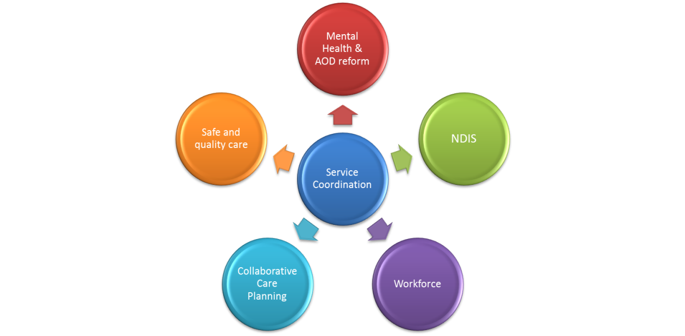

Highlights
- The EMHSCA restructure is complete and the committees are established in their new roles.
- Consultations have occurred in relation to the Regional Integrated MH and suicide prevention plan at the December Alliance meeting.
- VAADA’s guide “USING COLLABORATIONS AS A CAPACITY BUILDING TOOL”, and released in November, featured EMHSCA as a case study.
- A brief members’ survey was conducted in November and further consultation with EMHSCA Implementation committee and the EMHSCA Steering group has led to the development of the EMHSCA events calendar 2019.
- The EMHSCA Members guide was reviewed and revised to reflect changes to the EMHSCA structure.
- A review of the EMHSCA membership was conducted to align with the EMHSCA restructure.
- The EMHSCA Orientation event and the Open House service showcase was provided to health and community services staff on 11th October at the Box Hill Town Hall for Mental Health week.
- Presentations were provided by the EMHSCA project officer at the BUDDY’s Youth Dual Diagnosis forum in August, the Whitehorse council Mental Health Forum in October, and the Dual Diagnosis Linkage meeting in December. The aim was to support greater awareness of available Mental Health, AOD services and NDIS.
- Mapping of Non-NDIS EMHSCA services was completed in October to support appropriate referrals. This resource is located on the EMHSCA webpage.
- Safe and quality care discussions have been added to standing agenda at Alliance meetings since October. Topical de-identified cases are presented and discussion regarding issues of collaboration are facilitated.
- The EMHSCA webpage was updated following the EMHSCA restructure.
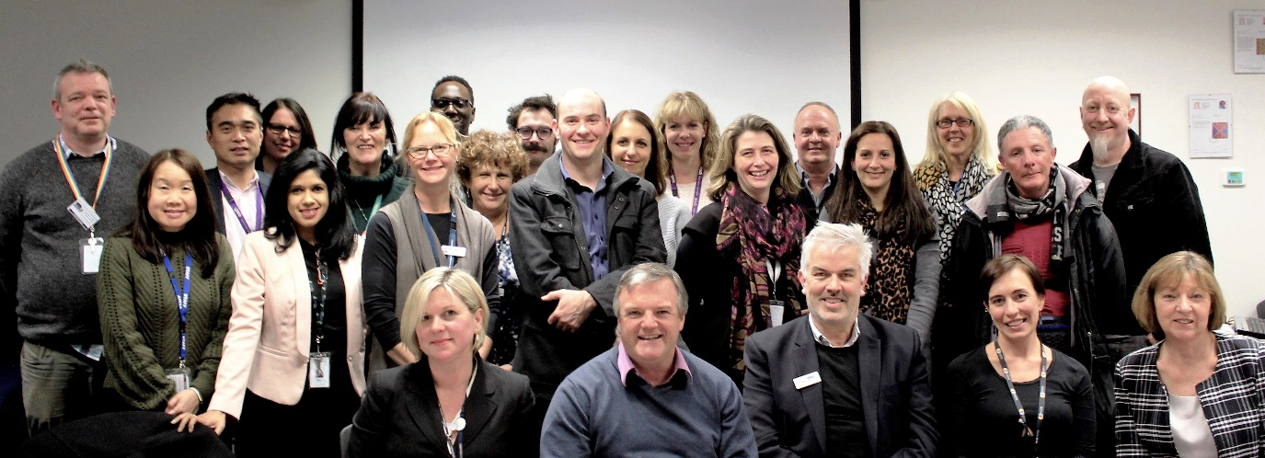

Analysis

EMHSCA Work plan elements

Steering group work
The EMHSCA Steering group oversees the EMHSCA Strategic direction and associated work plan. The Steering group is responsible to take account of the issues raised by the broader membership in the setting of the direction for EMHSCA. Their tasks are as follows:
- Maintain the EMHSCA MOU to support linkages and collaboration during the roll-out of NDIS in this region and adjust as required.
- Develop Program theory to align with the EMHSCA work plan 2018.
- Consider useful links and improvements to the EMHSCA structure to promote collaborative work with Aboriginal Services.
- Monitor EMHSCA membership and support strategic expansion.

Mental Health & AOD System Reform
Support development of a project examining strategies to address physical health and wellbeing needs of Mental Health and AOD consumers, ensuring linkages to their treating GP in the context of multi-sector collaborative care planning.
Continue to provide a forum in Alliance meetings to identify local themes and raise issues for discussion and action as required.
Continue to provide a mechanism to communicate about events, funding opportunities, initiatives and workforce capacity opportunities occurring in the region
Contributing to the co-design of EMPHN’s AOD model of care
Continue consideration of better integration with the broader service system including family services, education, employment and social functioning.
Continue to work collaboratively with the EMR Dual Diagnosis response to aide integration, extend resources and ensure reduced duplication of effort.

NDIS
Continue to provide NDIS updates at Alliance meetings and also via EMHSCA forums to ensure EMHSCA partners are aware of developments as the NDIS is embedded across the region.
Continue to seek clear and effective communication mechanisms, and establish collaborative partnerships with the NDIA, LAC and NDIS service providers.
Maintain the local-issues register and communicate key concerns to DHHS.
Update mapping of local NDIS and non-NDIS service provision in August 2019

Safe and Quality Care
A dedicated section of the Alliance meeting agenda has been allocated for case based discussions regarding safe and quality care and collaborative practice issues.

October
At the October Alliance meeting a case was presented by Tamsin Short and Emma Newton. The issues raised by this case were as follows:
The G.P. is often perceived as the care coordinator but lacks capacity for this role.
Sharing discharge summaries is useful and should involve the whole care team (as per EMHSCA Shared care protocol).
An incident reporting matrix could be useful for EMHSCA as a shared activity.
Cross organisational reviews and analysis could be more effective.
Work is needed on ensuring staff can know when information that is sent has been received by the intended recipient.
There is confusion for staff about reporting when some services are state-funded and some are federally funded.

December
Mandy Mercuri and Jess from EDVOS attended to present a family violence related case and explore potential for collaboration with Alliance members. The Royal Commission into Family Violence report was delivered in March 2016 and found that legal, administrative and policy barriers prevent information from being shared as effectively as it could be and found that the failure to share crucial information with frontline workers can have catastrophic consequences. The case study was prepared specifically for Mental Health and Alcohol and Other Drug workers. The purpose of the case study:
• Give a specific and relatable example of how the Family Violence Information Sharing Scheme (FVISS) might be used and highlight potential risks/opportunities for sharing information
• Provide an opportunity to reflect on necessary procedures for dealing with the FVISS at an organisation level.
• Highlight possible risks or mis-use of the scheme for its intended purpose.

February 2019
Merilyn Duff is now working at HICSA Partners In Recovery and has kindly agreed to present at the February meeting of the Alliance to support improved knowledge and facilitate discussion regarding the engagement of Indigenous people with EMHSCA partner services.
Other topics for future discussion include community legal, disability employment, Centrelink, and Local council amongst others.

Collaborative Care Planning
A review of the Shared Care protocol and the associated implementation strategy is to commence in February 2019 with the EMHSCA Implementation Committee and in consultation with Alliance members.
Case examples and more detailed information sharing guidance will be included. One-page handouts for consumers, carers and staff are to be reviewed and revised.
A brief survey will be conducted in February 2019 of EMHSCA partners to find out:
- How well embedded is the SCP in your org?
- Do you audit for the elements?
- Are there any elements missing in your opinion?
4. In relation to the SCP, what do you think works?
Preliminary information gathered at the December Alliance meeting identified the following:
  - The EMHSCA Shared care protocol brings the MOU some substance for members.
  - AOD services may bring other services back to the protocol to remind them of the need to share info and work collaboratively.
  - Principles are useful and are in policy in EMHSCA organisations.
  - NDIS has necessitated a change in language for consumers’ plans.
  - Plan elements may vary from org to org but principles are stable across services.
  - The practices are useful and could be supported by a poster for consumers and carers to be displayed in EMHSCA organisations’ waiting rooms.
  - For staff a one page exists and needs review as it is not being utilised.
  - Aligning Recovery plans to NDIS language.
  - G.Ps need to be included. Broadening protocol to better speak to other services.
Consideration is to be given to suitable methods of ongoing monitoring of the uptake of the protocol by EMHSCA partners. This will necessitate a review of the EMHSCA Shared Care Audit tool and associated partner surveys.
Develop and agree on ‘Safe and smooth transitions of care’ for MH & AOD consumers in Eastern Melbourne region’.

Workforce Development
EMHSCA events are now managed and delivered by the new EMHSCA Implementation Committee. EMHSCA Members Survey
The survey was conducted in November and December 2018 with 18 respondents completing four questions via Survey Monkey. Results indicate that EMHSCA partners value all EMHSCA workforce development events. The Mental Health and Co-occurring Issues Explored workshop was rated as the highest priority (94.12% rated it as a priority) followed by the Eastern Metropolitan Region Orientation event (88.9%). The NDIS forum was next with 76.5% rating this as a priority. The service showcase was rated by 70.59% as a priority and the Collaborative Care Planning workshops were rated by 66.66% of respondents as a priority. The workforce development contribution is likely to be provided by 40% of EMHSCA partners, enabling the ongoing provision of events at no cost to participants.
Responding to the EMHSCA Members survey 2018, a new calendar of events is to be delivered in 2019.
- A Psychosocial supports forum is to be held on the 29th August 2019 from 9am-1pm in the Box Hill Town Hall Ballroom.
- The Mental Health and Co-occurring Issues Explored workshops will be held over 2 half days in late November with a series of 8 case based and interactive mini workshops provided on key co-occurring issues for people who experience mental ill health.
Planning for Collaborative Care Planning Workshops to recommence in late 2019, with the next workshop scheduled for March 2020.

Budget
EMHSCA partners were consulted in relation to the EMHSCA workforce Development contribution in December 2017. The EMHSCA committee decided to collect the usual annual contributions to support EMHSCA events for the 2018 annual year. Eastern Health has been administrating the EMHSCA Workforce development funds for 5 years and has agreed to continue this as long as it is required by the partnership. Invoices were distributed to EMHSCA partners in March 2018 and it is anticipated that $8,126 has been received to cover the costs for EMHSCA events for the 2018/2019 financial year.
The NDIS Unpacked event piloted a new way of supporting EMHSCA events by charging each participant $20 via Eventbrite. $2,124 was raised from this process and contributed to the catering costs as listed below. Additionally, sponsorship of $500 from Mental Health Victoria and $500 from the Eastern Melbourne PHN was received. Therefore, of the $4,075.99 required to fund the event, only $951.99 was drawn from EMHSCA Workforce development funds.

Costs for 2018 Annual year
Event | LCCPW | NDIS Unpacked | Orientation event | Service showcase | Total costs
Venue costs | Nil | $1381 minus $500 MH Vic sponsored EMHSCA paid $881 | $522.18 | $441 | $1,844.18
Catering costs | EMPHN paid | $2694.99 Mostly covered by participants and EMPHN EMHSCSA paid $70.99 | $409.09 |  | $480.08
Welcome |  |  | $500
Total overall costs | Unknown | $4075.99 | $1,431.27 | $441 | $5,948.26
Total event costs to EMHSCA | Nil | $951.99 | $1,431.27 | $441 | $2,824.26
Attendance | 21 | 140 | 138 | 116 | 415

Additional in-kind support from EMHSCA organisations has been provided for printing and staffing.
EMHSCA acknowledges the City of Whitehorse who provided grant funding to support these events. Sponsorship was received from Mental Health Victoria and EMPHN for the NDIS Unpacked event. We are grateful to event participants for their contributions via registration.

The actual cost of the events without sponsorship is approximately $15 per participant. It has been found to be less useful to charge participants a fee to attend EMHSCA forums and workshops. A reduction in the number of participants, increased administration responsibilities, and the dissatisfaction of participants with events that leave them out-of-pocket contribute to the decision to provide EMHSCA events at no cost to participants in future. It is no longer necessary to provide lunch as events conclude at lunch time.
Half of EMHSCA members have indicated in the Members survey conducted in November 2018 that they remain prepared to pay the annual workforce development contribution of just less than $500 per year. Reconciliation of EMHSCA workforce development funds will be made prior to 30th June 2019 and a suitable figure per organisation will be invoiced and based on projected costs.

Projected Costs for 2019/2020
July 2019-June 2020 | Psychosocial Forum | MHACIE | CCPW | Total costs
Venue costs | $752.50 | $243.50 | $156 | $1,152
Catering costs | $850 | $960 | $580 | $2,390
Welcome | $500 |  |  | $500
Total costs | $2,102.50 | $1,203.50 | $736 | $4,042
Anticipated Attendance | 150 | 60 | 60 | 270 = $15 per participant on average

EMHSCA research project
An evaluation of the EMHSCA project has been desired since 2013 however no suitable method has been identified to complete this task. Data has been gathered in multiple forms: Four years of Shared Care Audit results; Partnership survey; Consumer survey; Members surveys; Workforce development event summaries, feedback and solutions focussed consultations.
This year the EMHSCA project officer is undertaking a major project to complete her Masters of Public Health studies at Deakin University. Bronwyn is investigating the enablers and barriers to collaborative and coordinated care for people who experience mental ill-health and co-occurring issues in Melbourne’s east. EMHSCA partners are being interviewed (both leaders and other staff groups including peer workers) along with consumers and carers who attend mental health and AOD services. The project concludes by the end of May 2019. A research paper will be submitted for publication later in 2019 and EMHSCA will be the subject of the research. A full report will be provided to EMHSCA partners.

Conclusion
As 2018 draws to a close, it is apparent that the EMHSCA restructure has been timely and welcomed by partners. The activity of the restructure has provided a much-needed opportunity to refresh the EMHSCA priorities and renew member’s commitment to the work of mental health focussed service coordination into the future. With the project being funded until at least the end of June 2020, forward planning is made possible and momentum can be achieved. There remains a clear mandate to continue to support health and community services staff and build their capacity to provide collaborative and coordinated care to people who experience mental ill-health and co-occurring concerns. An evidence base is emerging to validate and affirm the work of this unique and productive Alliance and support the replication of efforts in other areas of Victoria. As we remain responsive to the people we aim to serve as well as our EMHSCA partners we can adapt and grow to meet the ongoing challenges of sector reform.

Appendix A 2018 Leaders’ Collaborative Care Planning Workshop Report
Report provided by Bronwyn Williams – EMHSCA Project Officer
The Eastern Metropolitan Region (EMR) Leaders’ Collaborative Care Planning Workshop (LCCPW) was held on Thursday the 29th March in the Banksia Room at the Eastern Melbourne PHN and catered for 21 attendees in total. This event is provided annually by the EMHSCA Workforce Development sub-committee which consists of 6 representatives from a variety of EMHSCA services. The event was sponsored entirely by the Eastern Melbourne PHN.

The Aim

The workshop aim was to equip leaders to support their organisations to engage in collaborative relationships in a changing health and community service landscape.
The purpose of the event was to orient leaders from health & community services across the EMR to the EMHSCA Shared Care Protocol and provide opportunity to explore the challenges of collaborative practices, with an emphasis on generating solutions.

The Program
A new program was developed this year in an effort to explore issues raised from critical incidents in the recent past. The idea of strengthening transitions between services was highlighted in planning discussions. This year the following topics were presented and discussed:

- The Collaborative Care policy journey
- Shared Care Practices
- Consumer case presentations and discussions
- The role of leaders/managers in supporting collaboration

Maria Yap of the EMPHN led the event. A Snakes and Ladders exercise was used to open the discussions in groups regarding
Bronwyn Williams described the EMHSCA Shared Care Protocol and participants workshopped the Shared Care Practices contained within it.
Peer presenters provided case presentations that raised some key issues regarding collaborative practices. Participants were asked to decide on the top 3 things they would do to support the consumer in the scenario. This led to cross sectoral learnings and collaborative decision making. The peer presenters then provided feedback to the groups with their perspective on the work. Table facilitators were utilised to support discussions. These facilitators were briefed and provided with a guide to support their role. The EMHSCA Shared care protocol was introduced by the project officer followed by a discussion of the principles and the challenges to collaboration. All were encouraged to connect with others after the workshop by sharing details.

Feedback
The small group provided a more intimate environment for solutions focussed discussions and was well received by participants. Formal feedback was sought and entered manually into survey monkey by the event crew supports at Eastern Melbourne PHN. A group discussion on the role of managers in supporting collaboration was found to be the most useful. The consumer case discussions and the Shared care protocol introduction were very well received by all. The policy journey with ‘snakes and ladders’ was somewhat less useful overall however the group found the activity engaging.
Comments included “Very good and meaningful components”; “Lots of new learning about mental health services and the breadth of support now available”; “The snakes and ladders activity allowed very good discussion by different sectors. Always very good to highlight and identify strengths and weaknesses – highlighting positive risk-taking, respect, dignity and self-determination”. “Smaller groups worked really well for more in-depth discussions and opportunities to explore challenges and pathways”.
Advice for next year included having more time for the leaders discussion and more opportunity to develop ideas and solutions. A survey of ground staff to inform the gaps in collaobration at a management level would be useful. Opportunity to change tables during the event would have been good to foster networking.
All participants rated the workshop as effective at fostering collaboration in order to better support the client’s recovery journey. 83% of respondents would recommend the workshop to others, and 17% may recommend it.

EMHSCA Workforce development committee
The LCCPW event is developed, organised and provided by the EMHSCA Workforce Development subcommittee with funding via annual contributions from EMHSCA member organisations.
It is important to acknowledge the substantial contribution of these members and their teams to the success of the EMHSCA Workforce Development events each year. Thanks goes to EMHSCA member organisations for contributing in this way to improving Service Coordination across the EMR for the benefit of people with mental ill health and co-occurring issues.

Budget
All costs for this event were generously met by the Eastern Melbourne PHN. The event was held at the EMPHN Box Hill site due to its suitability for hosting a smaller event.

Conclusion
The significant changes experienced by health and community services staff over the past 5 years and the impact of the NDIS on networks in the east highlight the importance of keeping “collaboration” on the table. The Leaders’ Collaborative Care Planning Workshop provided an opportunity for local leaders to consider the journey so far and begin conversations to plan a way forward in an effort to preserve and support collaborative care planning.

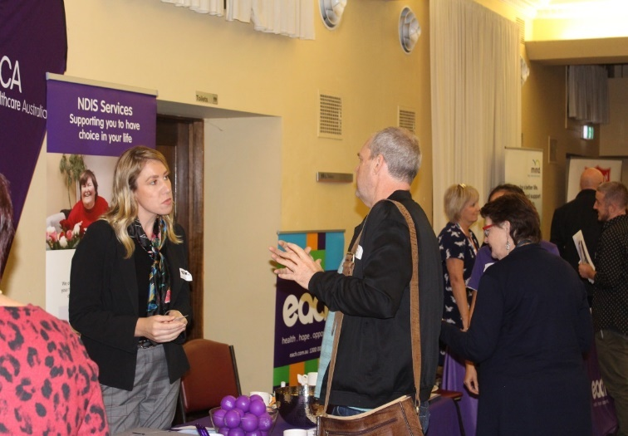
Appendix B NDIS Unpacked – Making it work together in the east! Event report
Report provided by Bronwyn Williams – EMHSCA Project Officer & Eastern Health Mental Health NDIS Program Lead. On Thursday 17th May 2018, the EMHSCA Workforce development subcommittee provided an up to date event that built upon the introduction to NDIS held in August 2017. The idea that this event would “unpack” the NDIS pathway emerged from discussions with Mental Health Community Service partners. Collaboration with NDIA and our Local Area Coordinators, Latrobe Community Health Service, was considered a key component of the event. Held at the Box Hill Lower Town Hall, the event catered for 140 staff from 24 services.

The Aim
To provide a psychosocial disability focussed NDIS event to meet the needs of a range of health and community service sector and peer workforce staff who are often involved in providing services to people experiencing mental ill health and psychosocial disability with the key aims of:
- Unpacking the participant pathway for people with psychosocial disabilities and outlining support needs;
- identifying the new marketplace and exploring marketplace issues with a solutions focus;
- learning about what exists and is coming for people who are not NDIS participants;
- Discussing the impact of NDIS on local service partnerships and collaborative practices.
This forum was a follow on to the “Mental Health, Partnerships and NDIS – Making it work together in the East! “Forum EMHSCA held in August 2017, as we aimed to prepare our region for the introduction of NDIS. Now that our service providers have some knowledge of the scheme, we aimed to build upon this with an event that clarified their various roles as they support people on the NDIS pathway and help them to navigate the changing marketplace of supports.
.

The Program
This full day forum was provided in 3 parts as follows:

Unpacking the NDIS Pathway
The morning provided participants with a walk through of the key elements of the NDIS pathway for psychosocial disability. This was headed up with a presentation by Melissa Young who is the Director of Stakeholder Engagement for NDIA in the east. The morning provided participants with a breakdown of the support work required to assist consumers and their carers to access and navigate the various aspects of the NDIS pathway. Presentations included the ROAR project (Peter McGrath and Michelle Egan), NDIS Consumer and Carer presentations (David Neef and Robyn Callaghan), Local Area Coordinators (Maya Djordic and Rose Juan), Partners in Recovery (Sarah Boyes), and Eastern Health Clinical Mental Health (Gareth Maloney). Midway through the pathway, Jenny Bretnall of VMIAC provided a reflective and engaging presentation on Recovery and NDIS.

Marketplace
At Morning tea and lunch time an NDIS focussed Market Place gave opportunity for participants to meet and interact with fourteen services representing EMHSCA partners, NDIS providers and peak bodies.

Afternoon sessions
Following lunch, a presentation about the Clinical Mental Health Interface project (Julie Skilbeck - DHHS) enlightened attendees regarding the Department’s work in supporting the transition to NDIS. As a starting point for exploring potential psychosocial supports for people who are not NDIS participants, a presentation about Information, Linkages and Capacity Building was provided by Christiaan Bramblebee (Latrobe CHS) and Liz Wrigley (EACH). Larissa Taylor and Jackson Reynolds of Mental Health Victoria (previously VicServ) provided information on the changing role of the mental health workforce and some alarming statistics to put the situation in Victoria in context.

Panel Discussions
Two panel discussions were facilitated by Kieran Halloran of the Eastern Melbourne PHN which explored the effects of NDIS on collaborative practices. Responses emphasised the importance of working together to support people during this transition period as NDIS is establishing itself in the east.
Jenny and Robyn (VMIAC) outlined what was important for consumers about collaboration and NDIS. They encouraged providers to be “respectful, dignified, curious and interested” with the people they work to support. Honesty and openness along with intentional power sharing were mentioned as important aspects of the worker and participant relationship. Jenny informed us that it is difficult to prove you have a psychosocial disability when you are living with a psychosocial disability. Robyn let us know that “A clipboard and 27 questions” is intimidating and can inhibit engagement in NDIS planning. Tandem’s Simon Jones reminded us to provide family inclusive supports to people and alerted us to the fact that Mental Health carers are faring worse in an NDIS environment than other carer groups. The importance of ‘face to face’ relationships and networking were highlighted by other panel members and an appetite for continuing collaboration was evident. The threat of the NDIS provider business model drivers impeding collaborative work was rejected by many present.

The Venue
The event was held in the Lower Town Hall at the Box Hill Town Hall with the marketplace around the perimeter. This was spacious and well lit. The Town hall staff provided the room set up and sound and we provided the visual display equipment. The projection area in this space is small and can be difficult for rear seats to view the screen. Acoustics are poor and presenters are encouraged to utilise the microphone. The roving microphone provided does not consistently work.

Event facilitation
This event was developed, organised and provided by the EMHSCA Workforce Development subcommittee and EMPHN PIR, along with the various presenters from a range of services. Kieran Halloran arranged and facilitated the afternoon panel discussions with providers.
I would also like to acknowledge the City of Whitehorse who provided grant funding to support this event and also to Waverley Industries for their reliable and delicious catering.
We are grateful to event participants for their contributions via registration. EMHSCA thanks Mental Health Victoria and the Eastern Melbourne PHN for sponsoring this event and enabling the participation of the peer workforce, NDIA and our Local Area Coordinators.

Overall Attendance
Registered | 143
Did not register and attended | 16
Apologies | 19
Total attendance | 140

Attendance by sector
Access Community Health | 1
Anglicare | 8
Aus gov DHS | 5
Austin Health | 1
Campbell Page | 2
Capability | 1
Dept Health & Human Services | 3
EACH | 14
Eastern Community Legal Centre | 1
Eastern Health | 21
Eastern Melbourne PH Collaborative | 1
Eastern Melbourne PHN | 3
EDVOS | 1
ERMHA/Deakin | 1
Forensicare | 1
Healthcare Australia | 4
Inspiro | 1
Integra | 1
JobCo. | 4
Knox City Council | 1
Latrobe Community Health | 3
Live | 1
Maroondah City Council | 1
MeWell | 2
Mentis Assist | 2
MH Victoria | 2
MIND Australia | 10
NDIA | 4
Neami National | 18
NEXTT | 1
Outcome Health | 2
Progress Occupational Therapy | 1
Salvocare Eastern | 6
State Trustees | 1
Tandem | 3
Uniting Prahran | 2
Villa Maria Catholic Homes | 1
VMIAC | 2
Wellways | 6

Budget
Catering $2,694.99
Venue $1,381.00
Total: $4,075.99
Plus in-kind support from EMHSCA organisations for printing and staffing.

The NDIS Unpacked event piloted a new way of supporting EMHSCA events by charging each participant $20 via Eventbrite. $2,124 was raised from this process and contributed to the catering costs as listed below. Additionally sponsorship of $500 from Mental Health Victoria and $500 from the Eastern Melbourne PHN was received. Therefore, of the $4,075.99 required to fund the event, only $951.99 was drawn from EMHSCA Workforce development funds.

Feedback
“Excellent forum! Well done”
“Great content and presenters”
“Very informative and well balanced”
“It is heartening that there appears to be a willingness amongst providers to collaborate”
“Jenny’s presentation was fantastic. Practical and useful”
“Great questions and discussion”
“Love the recognition of service survival in the transition to NDIS”
“Catering was excellent”
“Adding consumers personal point of view creates better understanding”
“Great to hear consumer perspectives”
“I really liked the marketplace and panel”
“I attended last year and this year – thoroughly enjoyed both and would support that these continue every year as the NDIS and mental health service system evolves”
The event participants were provided with feedback forms in hard copy at the event. Just 48 of the 140 participants provided feedback. Of this cohort the following results were collected.
The morning presentations received a range of reviews, with the majority of participants finding them useful. The ROAR presentation on accessing the scheme and the presentation on Activating Supports were most popular. It is noted that both had a strong case presentation focus.
Afternoon presentations rated more highly than those in the morning program. Mental Health Victoria was found to provide the most useful content.
The overall view of respondents was that the forum provided a good level of improvement in knowledge of the elements of the NDIS pathway, and available NDIS supports. Most respondents felt the forum allowed them to express their concerns about NDIS and that these concerns were somewhat addressed. Comments revealed that some people would have liked the panel discussion to be more focussed on Question and Answer opportunities and some said they were not interested in talking about collaboration.
The forum aimed to strike a balance between exploring issues and supporting a positive view of the NDIS. In comments participants varied with some wanting more focus on the issues and at least one person wanting to hear more success stories. Some attendees voiced that they wondered if the access process was worth the trouble and if consumers would be better off without NDIS after attending the forum.
Some participants indicated that the NDIS pathway was still confusing for them. A simple flow chart may have assisted with assimilation of the information. Examples of NDIS plans and services received, and some rationale for NDIS applicant ineligibility were requested. Some respondents would have liked more networking time and potentially some group work to explore the challenges in relation to NDIS.

Discussion
The forum informed participants regarding the NDIS pathway and at the same time raised a variety of issues and challenges. Key points that we can take from this forum are:
- There is a clear commitment from our Local Area Coordinators and NDIA reps to collaborate with our service providers and peer workforce;
- We are developing a better understanding of the NDIS pathway however this is made more difficult by the inconsistencies encountered in access, planning and review;
- The NDIS pathway for psychosocial disability requires some skill to navigate and people who experience mental ill-health may need support from their local service providers to access the scheme;
- Where people lack support to access NDIS it may be best to link in with advocacy services;
- The NDIS can offer around 10% of people who experience mental ill-health more choice regarding how their money will be spent to support them in managing their psychosocial disability;
- Almost all community mental health supports in Victoria are affected by NDIS which may create a significant gap in service provision to as many as 90% of consumers who are found ineligible or are unwilling to test their eligibility for the scheme;
- Information, Linkages and Capacity Building funds are assigned to support people who are non-NDIS participants. Funds will be made available again in 2019 and services may engage in a tender process to provide supports to non-NDIS participants;
- There is a general concern that NDIS is disrupting our collaborative work of the past 10 years and there was strong expression from many participants of wanting to preserve it. The will of NDIS providers (ex MHCSS) to work collaboratively remains, however the service capacity for this is diminishing;
- Clinical Mental Health staff require more targeted training and resourcing in order to support consumers and carers and this is in development via DHHS;
- Service providers are frustrated by the difficulties they experience in expressing their concerns and following up on issues for the people they support along the NDIS pathway. Better mechanisms to address issues and escalate them as necessary require development.

Conclusion
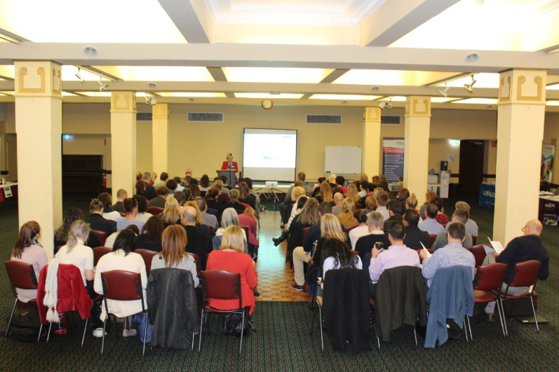
“NDIS unpacked” provided a timely opportunity for EMHSCA partners to develop relationships with NDIS providers, the NDIA and Latrobe Community Health Service. This targeted forum supported staff across the region to develop a good level of knowledge regarding how to support consumers and carers along the NDIS psychosocial pathway. Additionally this forum provided an environment for staff to discuss the various challenges of working in an NDIS environment and reinforced the good will of all concerned to work collaboratively.
This event received a mixed response from attendees. The vast majority of people found the event beneficial; however there were a small number of attendees who expressed desire for something quite different. On reflection, it is always challenging to meet the needs of a broad cross-sectoral audience. It would appear that the inner and outer eastern regions have reached a point of need regarding NDIS that is increasingly difficult to meet with the available information. One survey respondent summed it up by criticising the forum for not outlining “what to expect next” from NDIS.
The NDIS environment is unpredictable, inconsistent and constantly developing, especially in relation to psychosocial disability. New learnings come to light on an almost daily basis. There is little doubt that we will need to provide future EMHSCA NDIS forums. Consideration of the full range of feedback received from participants of NDIS Unpacked will inform the development of our next annual NDIS event.

Appendix C EMR Orientation 2018 Sector Overviews Event Report
The 11th Annual Eastern Metropolitan Region (EMR) Orientation event was held on the 11th October 2018 in the Ballroom at the Box Hill Town Hall and attracted 138 attendees in total. Locally known as EMRO, this event is provided annually by EMHSCA, and in 2018 the newly formed EMHSCA Implementation committee were responsible for the event’s delivery. This group has eight members from a variety of EMHSCA services. A number of additional staff also assists the committee on the day of the event. The purpose of this event is to provide a forum for new and interested staff from the EMR to learn about a range of health and community support services and meet other local staff.
A range of sectors were represented on the day including Aboriginal services, Aged care, DHS Centrelink, DHHS, Mental Health (community and clinical), Family services, Family violence services, Homelessness/Housing, Primary Health Network, Disability employment services, Dual Diagnosis service, Gamblers’ Help, Carer and Consumer groups, Partners in Recovery, Local council and legal services.

On the day
Aunty Joy provided a Welcome to Country and reminded participants of the traditional owners of the land and their customs and language. The EMHSCA project officer’s introduction encouraged participants to broaden their perspective on referral pathways and recognise their role in creating them. This was followed by consumer perspectives provided by Paula Kelly. Sectoral overviews were provided from a range of local service leaders (Primary care, Homelessness, Family services, Alcohol & Other Drug, Clinical & Community Mental Health). These overviews aimed to help orient people to the various sectors (not services specifically) and highlight the sectoral differences. A game of acronym bingo was played by all and aimed to highlight the importance of breaking acronyms down when communicating with other service providers and, most importantly, with service users!
At morning tea and lunch time a marketplace which featured more than 30 service stalls was provided.

Feedback
The marketplace surrounded the event participants in the main ballroom allowing for service promotion throughout the morning. The colourful banners and resources provided a visual representation of the diversity of services across this region. A larger screen for projection was provided this year.
“I thought the format; breadth of information, pacing and venue set up was spot on”
“Fantastic set up with Marketplace in main room”
“A good chance to meet and gather resources from different providers”
“Good to share current information including current referral pathways”
“I liked the consumer perspective – hearing from someone with a lived experience”
“Stories were a great way of relating information”
“The event booklet is a very helpful resource”
“It was short and precise to capture the history, needs analysis, service and referral pathways”
“The market stalls provided an opportunity to ask direct questions about service provision”
“Great pace, wonderful info and having services give out their brochures…fantastic”
“Location was great and the pizza out the front great”
Almost 40% of attendees (53 participants) completed feedback for this event. 38% of participants were new to their sector and 43% were new to their organisation. 28% of respondents to the survey were from the Homelessness/Housing sector.
Overall the feedback from the event was encouraging with all activities being rated by the vast majority of participants as useful to very useful. No presentation was considered by anyone as ‘not useful’. They enjoyed the sector overviews, networking opportunities, and service information provided in the marketplace. Paula Kelly’s presentation of the consumer perspective was most popular, followed by the Homelessness/Housing sector overview and the Clinical Mental Health overview. The lived experience speaker, homelessness sector case scenarios and the AOD sector presentation were popular in the comments received. Quite a number of comments affirmed the format of the event. Many suggested that presenters weave case discussions through their presentations to improve engagement.
When asked what they liked: The sharing of up to date information about service sectors and the ability to engage in the marketplace were most often mentioned. All presentations were mentioned at some point in the ‘most useful’ part of the feedback.
When asked what people wanted more of in future: LGBTIQ+ supports; Family Violence; More lived experience speakers; Homelessness supports; Aboriginal services; Youth specific programs; Dual Diagnosis; CALD; Legal services. Most of these are routinely covered in the Service Showcase event.
When asked what we could improve for next time: Provide opportunities for group activities; Invite the local council to provide a stall in the marketplace; have presenters on the stage; encourage a case-based format for presenters; more speakers to acknowledge the traditional owners; simpler slide shows; speakers to time their presentations so not rushing.

EMHSCA Implementation committee
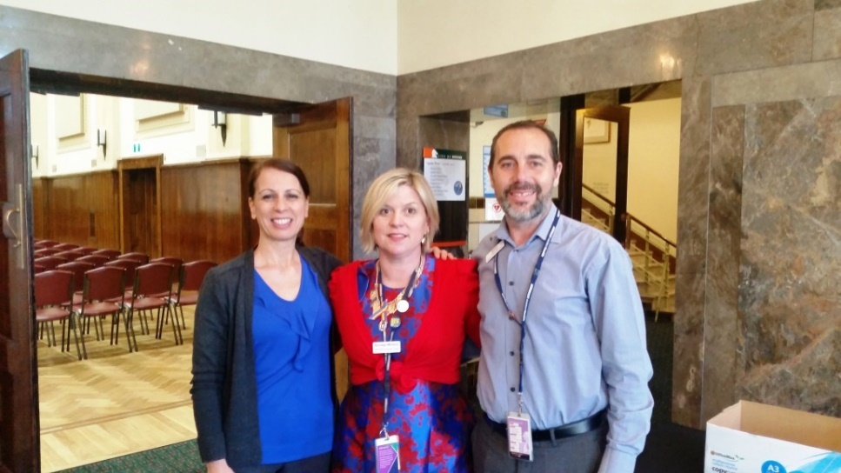
The Eastern Metro Region Orientation event was developed, organised and provided by the EMHSCA Implementation committee with funding via annual contributions from EMHSCA member organisations. The committee consists of eight members as follows:
Anna Makris (Chair) | Federal Dept. Human Services
Bronwyn Williams (Project Officer) | EMHSCA Project Officer
Georgia Hiscock | Campbell Page
Jacqui Turnbull | Wellways
Rachel Pritchard/ Maria Yap | Eastern Melbourne phn
Rose Juan/ Christiaan Bramblebee | Latrobe Community Health Service
Sandro Madrigale | Eastern Health Aged Persons MH
Shilpa Ullagaddi | Neami National

Attendance by service
Access Health and community | 3 | EMPHN | 5
Anchor Inc. | 1 | Fapmi | 2
Anglicare | 3 | Inspiro | 1
Camcare | 2 | JobCo | 3
Campbell Page | 3 | Latrobe Uni | 1
CHL | 1 | LCHS | 3
CVGT | 2 | Maroondah Council | 4
DDCCAC | 1 | Eastern Dual Diagnosis Service | 4
DHS | 9 | EH Hope | 1
DHHS | 4 | EMPHN | 5
EACH | 5 | Mentis Assist | 2
EACH Gambler’s Help | 2 | MIND | 5
EACH Sure | 1 | Mullum Mullum | 1
EACH Thrive | 2 | Neami | 4
Eastern Homelessness network | 1 | NEXTT | 2
ECASA | 1 | Salvocare Eastern | 12
ECLC | 2 | Turning Point Eastern | 1
EDVOS | 2 | Uniting (Family services; Homelessness) | 16
e-focus | 1 | VAACA | 1
Eastern Health | 12 | VMCH | 1
Eastern Dual Diagnosis Service | 4 | Wellways | 9
EH Hope | 1 | Unknown | 1

Budget
Catering $409.09
Venue $522.18
Welcome to Country $500
Total: $1,431.27
Plus in-kind support from Eastern Health for printing and administration, and other EMHSCA organisations for staffing. Costs for this event came within budget.

Conclusion
From all accounts this event remains relevant as an orientation for local staff to the Eastern Metro Region health and community services. A move to more case-based presentations in 2019 would be a welcome innovation. Support for the event was lacking this year and appeared to be related to the decline in available staff in the transition to NDIS. All administration tasks fell to the project officer. The EMHSCA Work force development contribution was funded by a smaller group of partners and as a result catering was not supplied. Only tea, coffee and biscuits were provided. A pizza van was a useful addition to the event this year and well attended at lunch time. As we observed for the NDIS event in May, the management of payments for events is time consuming and dissuades some staff from attending, even if the fee is small. It is therefore the aim of the Implementation committee to keep this as a free event for staff in order to maximise participation. Inclusion of an overview of the occupational support sector is to be considered for future EMRO events.

Appendix D EMHSCA Open House Service Showcase Event Report
“Very informative and engaging”
“Provided a lot of info about the services” “Very useful in terms of referral process” “Helped with resource building and becoming aware of non-NDIS services”
“Enjoyed collaboration and networking”
” The range of information was good and the event was well set up”
The EMHSCA Open House Service show case event was held on the 11th October 2018 across the Whitehorse, Gawler, Padgham and Boyland rooms at the Box Hill Town Hall and attracted 116 attendees in total. This event is provided annually by the EMHSCA, and in 2018 the newly formed EMHSCA Implementation committee were responsible for the event’s delivery.
The purpose of this event is to provide a forum for new and interested staff from the EMR to learn about a range of health and community support services and meet other local staff. In 2018 this event was provided as a separate half-day to the EMR Orientation. Both events were held on the same day to maximise committee resources. Separate registrations allowed for staff to choose the amount of time they could allocate to the events.
A range of sectors were represented on the day including Mental Health (community and clinical), Alcohol and Other Drugs (AOD), NDIS providers, Homelessness/Housing, Aboriginal services, Youth services, DHHS, DHS Centrelink, Primary Health Network, Family services, Specialist Family Violence services, Carer and Consumer groups, Partners in Recovery, education services and legal services
On the day
Participants were provided with a hard copy guide to the afternoon sessions held across four rooms and a map to navigate the event. EMHSCA Implementation committee members were on hand to guide participants to the rooms and make choices about the program as required. All sessions commenced and concluded at the same time to allow participants to change rooms if desired. Each participant had the opportunity to attend a maximum of 5 presentations of the available 20 on offer. See appendix for session details. Unfortunately, the Aboriginal health and well-being workshop was cancelled. All other sessions ran to schedule. Later afternoon sessions were poorly attended. In particular, the Family Services presentations had very low numbers of attendees.

Feedback
There were 28 responses to feedback for this event. This represents only 24% of attendees. Both hard copy and online survey feedback was sought. Overall the feedback from the event was encouraging with all activities being rated by the vast majority of participants as useful to very useful. Most respondents were from the Homelessness/Housing sector (42.86%); Partners In recovery (10.71%); Local council (10.71%); and Community Mental Health (10.71 %.). When asked what they liked respondents listed a full range of the presentations offered. One person summed it up saying they liked “All variety of sessions”. Most popular sessions by rating scales were the Eastern Community Legal Centre enhanced entry project; Clinical Mental Health Triage; Mental Health and the prison system; Eastern Centre Against Sexual Assault; and Hoarding and Squalor. When asked what people wanted more of in future: Non-NDIS services for mental health consumers; Mental health recovery programs; Homelessness; Hoarding; Managing complex mental health; NDIS – bridging gaps and referral pathways; and prison seminars were suggested. When asked what we could improve for next time: Case based longer sessions with longer breaks between sessions were suggested. One person would have liked to attend all sessions on offer, and another found the registration process for the events confusing. One third of respondents found that 60% of the event provided new learnings; a quarter found 80% of the content new; and a quarter found 40% of the content new. All but one respondent would recommend the event to others.

Conclusion
This event was a pilot of a new way of providing the latter part of the long-standing Eastern Metro Region Orientation event. The registration numbers reflected a keen interest in this type of event. On the day it was noted that attendance at the workshops held after 3pm declined and that attendees appeared fatigued. This may be due to many attendees choosing to also attend the EMR Orientation event in the morning. In future this event should be held on a separate date to support full attendance throughout the program. All presenters will be encouraged to centre their presentation on case scenarios to improve understanding. It was undoubtedly a valuable event for those that responded to the invitation to provide feedback.

Attendance by service
Access Health and community | 3 | EMPHN | 2
Anchor Inc. | 1 | Fapmi | 2
Anglicare | 3 | Inspiro | 0
Camcare | 2 | JobCo | 2
Campbell Page | 3 | Latrobe Uni | 1
CHL | 1 | LCHS | 3
CVGT | 2 | Maroondah Council | 5
DDCCAC | 1 | Eastern Dual Diagnosis Service | 4
DHS | 6 | EH Hope | 1
DHHS | 3 | EMPHN | 5
EACH | 4 | Mentis Assist | 2
EACH Gambler’s Help | 2 | MIND | 5
EACH Sure | 1 | Mullum Mullum | 1
EACH Thrive | 2 | Neami | 2
Eastern Homelessness network | 1 | NEXTT | 2
ECASA | 1 | Salvocare Eastern | 9
ECLC | 2 | Turning Point Eastern | 2
EDVOS | 2 | Uniting (Family services; Homelessness) | 13
e-focus | 1 | VAACA | 1
Eastern Health | 12 | VMCH | 1
Eastern Dual Diagnosis Service | 4 | Wellways | 5
EH Hope | 1 | Flourish | 1
 |  | MIC | 1

Budget
Venue hire cost $441. Catering for tea and coffee was carried over from the morning event and not costed to the afternoon event.
Plus in-kind support from Eastern Health for printing and administration, and other EMHSCA organisations for staffing.

