Eastern Mental Health Service Coordination Alliance (EMHSCA)
Consumer Shared Care Survey Results, 2015

Introduction/ Background
Vision
“All participating agencies offer opportunities for people to participate in a person centered, integrated, shared care planning process with a recovery focus.”
Purpose
The purpose of the 2015 consumer survey is to contribute to EMHSCA member knowledge of consumer experience when finding, accessing and using AOD and/ or mental health services in the EMR. In order to complement the understanding gained through service audits, a small-scale round of direct and indirect interviews with consumers was conducted during October and November 2015. Specifically, it aimed to gather consumer perspectives on what it is like to find and access services for AOD or mental health-related concerns, with particular focus on physical health need identification and service support and service provider shared care behaviour and practice.
Survey Execution/ Methodology
Sample
- Consumer target group: N=165
Sampling aimed to purposively target and select a cross-section of consumers from multiple services who were currently using mental health or AOD service in the EMR (EMHSCA cohort).
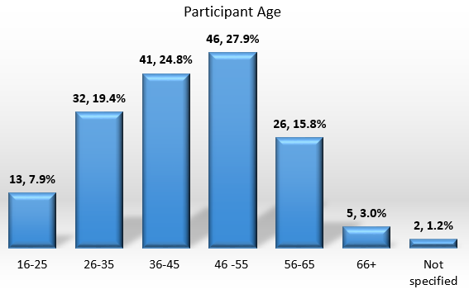
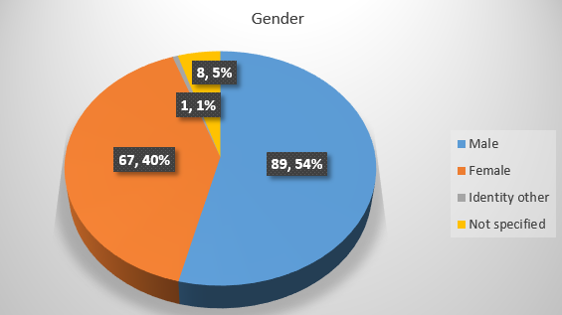
- Participating EMHSCA member organisations: N= 10. Eight Mental Health and two AOD organisations participated in the survey activity.

Survey collection method and procedure

Trained Peer workers and providers conducted 165 consumer surveys between October to November 2015. A mixed employment of face-face and telephone interviews was conducted.
A standardised survey interview tool and procedure was developed for interviews with consumers. The survey instrument had 13 nominal questions, three quantitative likert scale-type and five open ended questions. With only a small cross section of participants across 10 participating organisations, there is an opportunity to broaden this activity significantly or select/ employ another complimentary method (e.g. focus groups) to gain a richer understanding of consumer perspectives. There is also an opportunity for increased particpation from AOD services.

Data collected from the survey (interviews) were aggregated and synthesised into descriptive themes and statistics.

See ‘Key data issues, limitations and considerations’ section of this report.
Key Findings-Consumer Insights
Access to services
Out of 165 consumers who participated in this survey:
- 88.5% (146) consumers had a regular GP;
- 58% found it “very easy” or “easy” and 24% found it “difficult” and “very difficult” when finding services to meet their needs (M=2.5, SD=1.2, N=165);
- 42% of consumers reported being referred to the service by another mental health or AOD health professional/ service and 21% by a specialist (psychiatrist, psychologist).
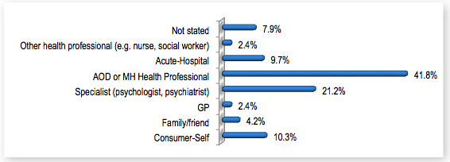

Figure 1: Mental Health/AOD Referral sources

- 42% consumers had accessed the service before, with 48% responding their period of support with the service being greater than 23 months (59% reported ‘one to two years’).
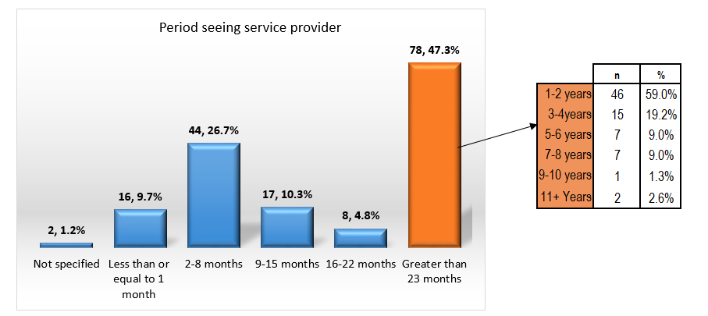
Figure 2: Consumer period of service support

- 67% consumers reported assistance from more than one service, with 43% accessing two services; 45% three to four services and 12% five to seven services (Figure 3).
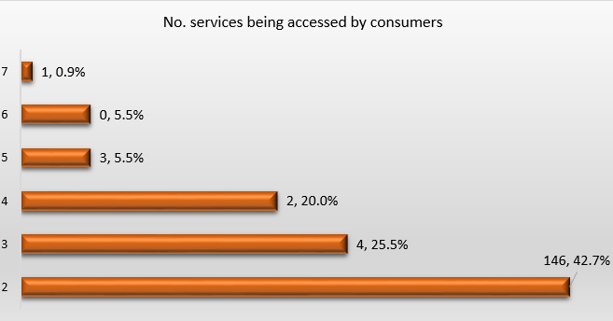
Figure 3: No. Services being accessed by consumers

- 89% consumers responded that ‘In person one-to-one’ as the preferred way of seeking support (Figure 4).
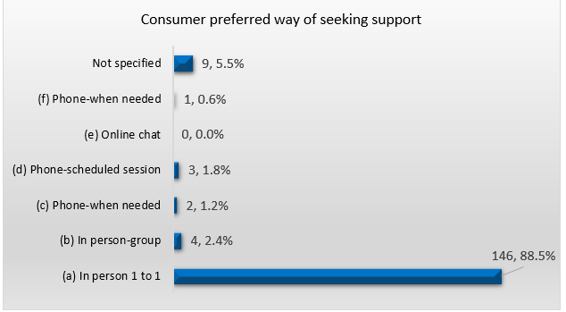
Figure 4: Consumer preferred way of seeing support

Consumers were asked to report ‘things’ that have helped them access mental health and/or AOD services. Consumers reported the following aspects being contributing factors:
- Their own knowledge about appropriate and affordable services to meet their needs;
- Family and friend support to connect them with services;
- Service and program location and proximity to where they live;
- Public transport availability;
- Professional, friendly and approachable service providers;
- Different service model options e.g. Individual, group, outreach programs;
- Available information about mental health/ AOD and other services;
- Service provider knowledge of other services and facilitated referral to needed services.

Some suggestions were made by consumers to improve access to mental health and/or AOD services and other needed services (things that would have made access easier), these being:
- Increase consumer and carer awareness and knowledge about services;
- Better support for family unit;
- Improve communication and marketing about available services;
- More affordable and available services;
- Improve proximity to available services or increase access to transport;
- Reduce long waiting periods, earlier service response and entry to needed services and programs;
- Clarity of service provision being offered right from the beginning;
- Increase number of drop in social programs and groups, phone and on-line contact and support;
- Better collaboration and communication between service providers;
- Facilitated assistance to make connections with other needed services (referral pathways);
- Increase GP and other provider knowledge about services;

Service provider holistic approach
Out of 165 consumers who participated in this survey:
- 83% consumers were asked about their physical health needs, with 70% reporting an identified physical health need;
- 79% who reported a physical health issue were receiving assistance, treatment or service for their identified needs;
- 158 consumers were accessing a mental health service, with 82% (126) reporting they were asked about their substance use issues/concerns;
- Seven consumers were accessing an alcohol and other drug service, with 100% reporting they were asked about their mental health issues/ concerns;
- 50% were asked about how their substance use and mental health affected each other.

Planning and Shared care processes/practice
In relation to consumers experience with planning and shared care processes:
- 81% reported their service providers were talking to each other, with 68% consumers responding their services were working together;
- 69% reported that the service provider talked with them about how to keep safe, with
74% stating they had a plan to keep them and others safe. Of those consumers, 73% reported they had documented Safety plan;
- 64% consumers reported they had a plan to help them keep well and manage things when they are not well, with 99% stating they had a documented Wellness Plan;
- 82% (135) consumers stated they had a recovery plan, with 28% reporting they had more than one plan;
- Consumers that had a recovery plan, 37% reported that other providers were not mentioned on their recovery plan and 45% stated their carer/ significant other were not involved in the development of their recovery plan;
- Consumers who reported they had physical health needs (116), 69% had their needs included as a goal in their recovery plan.

Consumers who had a documented recovery plan were asked perception- based, Likert scale type questions regarding their level of agreement and importance rating with key recovery-planning processes. Key insights include:
- Overall consumers ‘agreed’ and ‘strongly agreed’ that service providers were involving them and other relevant participants in the planning process, goal setting and ‘giving them ownership of the plan’. There was also consumer agreement that key recovery plan elements (aligned with best practice) were documented and actioned and that the plan was easy to read and information recorded in the plan was useful (see Table 1).
- Consumers responded that their and carer/significant other involvement in the development of the plan that documents goals and strategies about their physical health was ‘extremely important’. Consumers also rated ‘who is involved and who is doing what’, ‘having clear and agreed time lines’ and having a copy of the recovery plan as ‘extremely important’ (Table 2).
Development of a Recovery Plan
Level of Agreement
Likert Scale: 1=Strongly disagree; 2=Disagree; 3=Neutral; 4=Agree; 5=Strongly agree
Descriptive Statistics | Person involved in planning | Person in charge of plan | Relevant people involved in the development of the plan | Plan identifies person's strengths | Plan identifies goals | Plan identifies how person is going to achieve their goals | Plan identifies who is involved in person's care | Plan identifies when the plan is to be reviewed | Plan identifies someone who is responsible for making sure the plan happens | Plan is easy to read | Information in the plan is useful | Person understood the information in the plan | Plan was shared with other people who were involved in person's care | Plan is regularly reviewed
N | 135 | 135 | 135 | 133 | 135 | 135 | 135 | 134 | 130 | 135 | 134 | 134 | 134 | 132
Mean (Average) | 4.40 | 4.22 | 3.92 | 3.87 | 4.27 | 4.00 | 3.96 | 3.82 | 3.85 | 4.21 | 4.26 | 4.33 | 3.52 | 4.02
Median | 5.00 | 4.00 | 4.00 | 4.00 | 4.00 | 4.00 | 4.00 | 4.00 | 4.00 | 4.00 | 4.00 | 4.00 | 4.00 | 4.00
Mode | 5.00 | 5.00 | 4.00 | 4.00 | 5.00 | 4.00 | 5.00 | 4.00 | 4.00 | 4.00 | 4.00 | 4.00 | 4.00 | 4.00
Standard Deviation | 0.78 | 0.92 | 1.00 | 1.07 | 0.78 | 0.91 | 1.05 | 0.94 | 0.98 | 0.85 | 0.76 | 0.68 | 1.22 | 0.89
Table 1: Consumer level of agreement with key aspects of recovery plan development
Recovery Plan development process
Level of Importance
Likert scale: 1=Not at all Important; 2=Slightly Important; 3= Moderately Important; 4=Important; 5=Extremely Important
Descriptive Statistics | Person involved in the development of the plan | Plan includes goals about physical health needs  (if applic.) | Carer/ significant other/ support person involved in the development of plan  (if applic.) | Person provided with a copy of the plan | Person knows who is involved and who is doing what | Review plan at agreed times with the service provider
N | 133 | 131 | 121 | 132 | 133 | 133
Mean (Average) | 4.56 | 4.31 | 3.47 | 4.14 | 4.56 | 4.16
Median | 5.00 | 5.00 | 4.00 | 5.00 | 5.00 | 4.00
Mode | 5.00 | 5.00 | 5.00 | 5.00 | 5.00 | 5.00
Standard Deviation | 0.78 | 0.91 | 1.54 | 1.15 | 0.62 | 1.03
Table 2: Consumer importance rating for key elements of the recovery plan development process

Key Data Issues, Limitations and considerations
- Unless specifically stated, frequencies and percentages are calculated based on valid data and therefore exclude missing/unknown data.
- The data contained in this report is based on raw data submitted by participating EMHSCA agencies. Due to occasional missing or incomplete data, data quality had the potential to be compromised.
- Participating organisations self-selection of consumers for the survey can unintentionally introduce bias to the procedure.
- Sample sizes for data collection are often a compromise between the validity of results and pragmatical issues around data collection. In an ideal situation, data should be representative and valid. Majority of organisational data would not have been representative due to low sample sizes.
- Surveys take time and resource for effective implementation. Some trained agency peer workers conducted the survey and it was acknowledged there was limited mentoring and support for some workers, which could have unintentionally compromised the procedure and in turn data quality.
- The survey instrument was designed for face- to- face interviews. Some participating organisations used the survey tool over the phone and some questions, in particular the Likert scale type questions were difficult to ask in this format.

EACH Social & Community Health; Eastern health; Eastern Health-Wellington House; Linwood PARC; Mental Illness Fellowship (MIF); MIND; NEAMI; PIR; Prahran Mission; Turning Point Eastern Treatment Services -Carrington
Please note one organisation’s data set was not included in the findings due to limited survey responses.
Likert/ rating Scale: 1=Very Easy; 2=Easy; 3=Not sure; 4=Difficult; 5=Very Difficult
Caveat: Data quality is questioned

