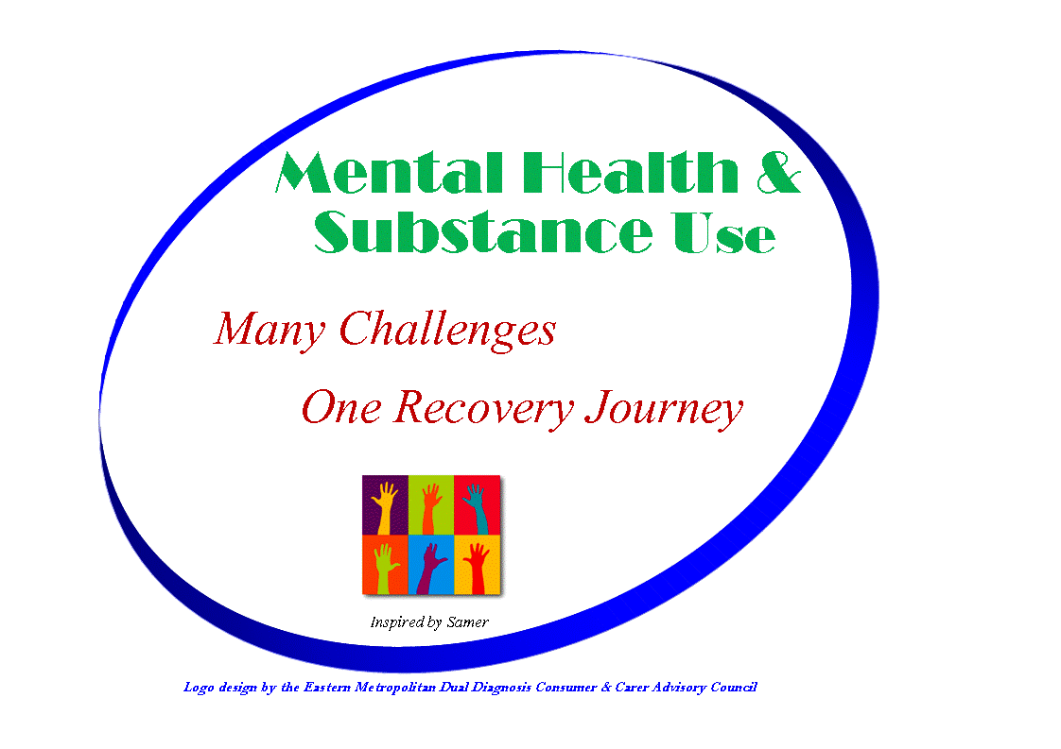 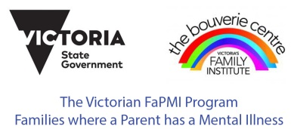

**“Carers Can Ask”**

**Advice for Carers on**

**Treatment, Discharge Planning and On-going Support**

**The Purpose of this Resource**

This resource is intended to help you, as a carer, have an informed conversation with service providers about treatment, discharge planning and ongoing support for your loved one after discharge. It aims to assist you (the carer) to maximise your understanding of the person’s condition and ongoing care. It provides questions that may help you to find out about treatment and discharge planning. The questions are suggestions only and not intended as an exhaustive or prescriptive list.

This resource includes a list of some of the services available to further assist carers in better understanding treatment, discharge planning and ongoing support of those they care for.

This resource is also useful to services as a guide to carer’s needs.

**Definition of Carer**

Carers provide personal care, support and assistance for someone due to frail age, ongoing disability, medical conditions, including terminal or chronic illness, mental illness, or dementia. The person they care for may have difficulty managing at home or in the community without support. Carers may be family or friends, and can include young people caring for a parent, or extended family such as grandparents or other relatives.

**Talking with Service Providers About Your Loved One**

It’s in everyone's best interests for all parties to have clear, respectful lines of communication and good relationships. Good, open communication between carers and the various services involved in the care of the person can assist in achieving better treatment and discharge outcomes.

Questions should always be asked and responded to in a sensitive and respectful manner.

Some of these questions can take time to answer due to the often complex nature of mental health and alcohol or other drug issues. The questions are suggestions only and not intended as an exhaustive or prescriptive list. Don’t be afraid to add your own as you see them.

**Feedback**

If you don’t get the service you expect, you have the right to ask to speak with another person at the service or to provide feedback to the agency involved. It is often best to seek resolution first at the local level.

If you still do not feel satisfied, complaints about public sector mental health services can be made to the Mental Health Complaints Commissioner. For alcohol and drug services complaints, you can contact the Health Complaints Commissioner. Contact details are found at the end of this document.

Providing feedback (positive or negative) to the local service assists that service to identify ways to provide the best care possible.

**I want to ask a question about…**

**Consent/Information Sharing**

Consider asking these questions:

* Has the client told you that I’m their carer?
* Are there any privacy or consent issues I need to be aware of?
* Have they agreed to sharing information with me?
* What are my rights if they don’t provide consent to share information with me?
* Have they been asked how they would like me to be involved?
* What information am I entitled to?
* How do I share information that I believe is relevant with the treating team?
* Will information I share with the treating team be shared with others? Who?

**Strengths**

Understanding the strengths of the client is most important. All people have strengths and an inherent capacity to learn, grow and change even when they present with vulnerabilities. Their strengths are in their passions, in their skills, in their interests, their relationships and their environments. The focus of the relationship between the mental health clinician and the client is on personal goals, based on these strengths, and finding niches in the community where these strengths can be used and valued. Through this, the client develops their skills and a greater sense of hope and control.” (Source P.5 St Vincent’s Hospital Melbourne publication: Adult Mental Health Information for Consumers, Families and Carers)

Consider asking these questions:

* Can we talk about the client’s strengths? I’d like to support these.
* I have some additional knowledge of the client’s interests that I would like to talk about?
* What decisions and choices have they made about their illness?
* Can we talk about their understanding and feelings about the experiences that have led them to being in this situation?
* What goals have they been pursuing through this service?

**Treatment**

Consider asking these questions:

* How can I be involved in treatment planning?
* What is this illness called and how long is it expected to last? What can be done about it? What is the “diagnosis” and “prognosis”?
* How might that affect their behaviour?
* Has a dual diagnosis assessment been done? Assessing both mental health and drug or alcohol use?
* What treatment have they received? How does it work?
* How do we know if the treatment is working?
* Have they agreed to the treatment plan?
* Is this treatment compulsory? If yes, what is the process and review date?
* Will treatment be in the public or private system? How much will it cost? (eg. medications, services etc).

**Medications**

Consider asking these questions:

* Can you explain how the medication works, any side effects and any interactions it may have with alcohol or other drugs?
* What should I do if they seem to be having a bad reaction?
* What should I do if they don’t take their medication?
* Is there a record of what medications have been tried? Has this been shared to avoid any mistakes?
* Is there a record of his/her reactions to past medications?

**Discharge Planning**

Consider asking these questions:

* Has the client been asked if they are ready to be discharged?
* Can I be included in the discharge planning?
* Can you explain why they are being discharged?
* Who has been involved in making the decision?
* Are both mental illness and drug and alcohol issues being followed up?
* Has their culture and background been taken into consideration?

**Discharge**

Consider asking these questions:

* Is it possible to attend a family meeting before discharge so I can have further input if needed?
* Is there a written discharge summary or instructions for carers and others?
* Who will receive it? (eg. GP, other services)? Will I get a copy?
* Does everyone know what they need to do next?
* What am I expected to do? (eg. attend to medication needs, prevent relapse, co-ordinate transport, make appointments etc).
* Can we talk about it?
* Have they agreed to me doing those things?
* What happens if I can’t do those things?
* Can I have help to support them? What sort of help can I get?

**Relapse**

Consider asking these questions:

* How will I know if they are relapsing?
* What might the early warning signs be?
* Do they know what they are?
* What do I do if I notice these early warning signs?
* Who should I contact?
* Is there a written relapse plan?
* Have they made a written plan about what they want to happen if they become unwell? (eg. Advance Statements).

**Referrals**

Consider asking these questions:

* Who else is involved in supporting my loved one?
* Who have you made referrals to? Have they been accepted?
* How long will the referral last? Do they need to go to a GP for another referral?
* Does everyone know what they are meant to be doing?
* Have they agreed to this?
* Have they met the new clinician/GP/support worker?
* Are there any other supports that might be useful?
* Is there anything I need to do to support my loved one? How do I provide support?
* What happens if they don’t go?

**Returning to the Service Again**

Consider asking these questions:

* Can they use this service again?
* When?
* Who do we contact?
* What is the process if they need to come back?
* How will they access further treatment after being discharged?

**After Discharge**

Consider asking these questions:

* If they don’t follow the plan, what will I do?
* If they don’t follow the plan, what will you do?
* Will I be able to contact you or ask for advice after they’re discharged?
* If not you, who or what service should I speak with?
* What psycho social supports are available? e.g. education, employment, recreation, community managed mental health services, housing, legal, financial etc.
* Has an application been made to NDIS for support?

**Risk**

Consider asking these questions:

* Is the client aware of possible risk issues?
* Is there a risk of them overdosing?
* What is the likelihood that their mental health condition will relapse?
* What is the likelihood that they will relapse in relation to alcohol or other drug use?
* Has a risk assessment been recently completed? What were the results?
* Do any self-harm or suicide risks exist?
* Who can I contact if I see these risks happening and feel I can’t manage them?
* Are there any potential risks to my safety or general well-being? If so how can I protect myself?

**Relevant Emergency Contacts**

Consider asking these questions:

* Can you give me emergency contact numbers for my area?
* How do I know which one to call?
* When is it the right time to call?
* What do I do if an emergency happens when I am not at home?

**Carer Supports**

Consider asking these questions:

* Who can I contact if I need help myself?
* Who do I contact if things go wrong?
* What sort of support can I have? (eg. respite, counselling, peer support, advocacy)
* Do I need a referral?
* Am I able to speak with a carer consultant/peer worker?
* Am I able to access any financial support?

**Anything Else?**

Consider asking these questions:

* Is there anything else I need to know?
* Can you tell me where to get more information about the illness?
* How else can I help once they leave here?
* Where can I find out more?

**Your Notes:**

**OTHER SUPPORT SERVICES**

**Mental Health Services  
Eastern Health Mental Health Access Triage Telephone 1300 721 927**

Eastern Health Mental Health Program has a central Triage number. During business hours you can choose the options for Adult, Child & Youth, or Aged Person’s Mental Health Program. After hours, the Triage service is managed by the Mental Health Program. Further information can be found at: www.easternhealth.org.au/services/mental-health-services

**Alcohol or Drug Services**

**Outer East Intake Telephone 1300 007 873**  
**Sure Consortium**  
Yarra Ranges, Knox and Maroondah

**Inner East Intake Telephone 1800 778 278**  
**Eastern Consortium of Alcohol and Drug Services**  
Boroondara, Manningham, Whitehorse and Monash

**DIRECTLINE** **Telephone 1800 888 236**  
Statewide 24/7 alcohol and drug counselling, information and referral

**Carer Services/Supports**

**Carer Gateway**

Advice, support, financial assistance, respite

<https://www.carergateway.gov.au/>

**Eastern Health Mental Health:**

Adult Mental Health Carer Consultant **Telephone (03) 9843 5800**

CYMHS Family Carer Consultant **Telephone 0400 810 165**

Aged Person’s Mental Health Carer Consultant **Telephone (03) 8804 9908**

Dual Diagnosis Carer Consultant **Telephone (03) 9194 7544**

**Tandem Telephone 1800 314 325**(Previously Victorian Mental Health Carers Network)   
[http://tandemcarers.org.au**/**](http://tandemcarers.org.au/)

**VMCH** **Telephone 1300 971 720**

(previously Villa Maria Catholic Homes)

Boroondara, Knox, Manningham, Maroondah, Monash, Whitehorse and Yarra Ranges

<https://vmch.com.au/services/>

**Carers Victoria**

Carers Victoria Advisory Line **Telephone 1800 242 636**The Victorian Support for Carers Program provides person centred respite and other support to carers:

* One-off or short term support for carers including goods and equipment, that can add to other services or fill service gaps
* Supporting carer's wellbeing – quality of life, physical and mental wellbeing, social activity and/or social connections.

<http://www.carersvictoria.org.au/advice>

**Carer Helplines**

**Family Drug Helpline** **Telephone 1300 660 068**  
9.00am to 9.00pm Monday-Friday

www.familydrughelp.com.au  
  
**Mind Carer Helpline Telephone 1300 554 660**Monday – Friday 9.00am-9.00pm

**Wellways Helpline** **Telephone 1300 111 500**Monday - Friday 9.00am-9.00pm

**Family Supports**

**FaPMI Families where a Parent has a Mental Illness Telephone** (03) 9871 3988  
FaPMI can provide information and support for families and young carers where parents have a mental illness or AOD concerns – includes peer support groups for children, young people and parents including CHAMPS and Space 4 Us.

Monday – Friday 9.00am-5.00pm

https://www.easternhealth.org.au/fapmi.aspx

**Young People**

**Headspace** **Telephone 1800 650 890**  
For young people aged 12-25 years

**YoDDA**  **Telephone 1800 458 685**(formerly YSAS Line)

**Aboriginal and Torres Strait Islander Services**

**Eastern Health Aboriginal Health Team Telephone (03) 5957-1100**377 Maroondah Hwy , Healesville

Intake: AHTintake@easternhealth.org.au

**Oonah Belonging Place**

**(Formerly HICSA)** **Telephone (03) 5962-2940**1A Badger Creek Road, Healesville  
Monday - Friday 9.00am–5.00pm  
admin@hicsaorg.au  
Community Engagement Worker: engagementworker@hicsa.org.au

**Mullum Mullum Indigenous Gathering Place Telephone (03) 9725-2166**

3 Croydon Way, Croydon

**The National Disability Insurance Scheme (NDIS)**

The National Disability Insurance Scheme (NDIS) is designed to provide support to people with disabilities, including people who experience psychosocial disabilities.

Not everyone living with a severe mental illness will be eligible for the NDIS. To meet the NDIS disability requirement the person’s mental illness must significantly affect their ability to undertake everyday activities and/or cause barriers to their participation in life and the community i.e. they have a psychosocial disability. In addition, they must experience a psychosocial disability that is likely to be enduring and lifelong.

There are a number of services providing support to test eligibility for NDIS:

**Latrobe Community Health Services**  **Telephone** **1800 242 696**

Call to be directed to your nearest service location.

https://www.lchs.com.au/aged-disability-carers/national-disability-insurance-scheme-ndis

**Mental Health NDIS Access Project**

For the Eastern Region contact **EACH** **Telephone 1300 003 224**

Email: [NDISAccess@each.com.au](mailto:NDISAccess@each.com.au)

**NDIS website**

http://www.ndis.gov.au  **Telephone 1800 800 110**  
  
**Tandem Carer NDIS Warmline**                                   **Telephone 1800 314 325**http://www.tandemcarers.org.au/access-the-ndis.php

Note: If the person has a **Clinical Mental Health case manager**, they can help them test their eligibility for the NDIS and offer support along the NDIS pathway.

**Multicultural Resources**

**Eastern Health - Language Services Office Telephone (03) 9981 2736 or (03) 9981 2753**

Interpreter bookings Monday - Friday: 8:30am – 4:00pm

Email: interpretingservices@easternhealth.org.au

**After-Hours Interpreter Access Telephone (03) 9605 3056**

For on-site (face-to-face) interpreter bookings and telephone interpreters 24/7

**Auslan sign language Telephone 1300 287 526**

In less common languages in which there are a limited number of certified interpreters, telephone interpreting may be the only option available.

**Translating and Telephone Interpreting Service Telephone 131 450**24hrs/7 days a week

**Mental Health Patient Rights Telephone Information Line**

24 hours, 7 days a week – recorded information about the Mental Health Act, treatment orders, electroconvulsive therapy and the Mental Health Review Board - Redirects callers to Victoria Legal Aid

Monday - Friday 8.45am–5.15pm **Telephone 1300 792 387**

**In community languages:**Arabic Telephone (03) 9679 9825  
Cambodian Telephone (03) 9679 9826  
Cantonese Telephone (03) 9679 9827  
Croatian Telephone (03) 9679 9828  
English Telephone (03) 9679 9838  
Greek Telephone (03) 9679 9829  
Italian Telephone (03) 9679 9830  
Macedonian Telephone (03) 9679 9831  
Mandarin Telephone (03) 9679 9837Serbian Telephone (03) 9679 9834  
Somali Telephone (03) 9679 9832  
Spanish Telephone (03) 9679 9833  
Turkish Telephone (03) 9679 9835  
Vietnamese Telephone (03) 9679 9836

**Action on Disabilities in Ethnic Communities Telephone (03) 9480 1666**http://www.adec.org.au

**LGBTIQA+**

**Switchboard Victoria - LGBTIQA+ Resource**

**Gay and Lesbian Switchboard Victoria**Provides a peer-driven support services for the lesbian, gay, bisexual, transgender and gender diverse, intersex, queer and asexual (LGBTIQA+) people, their families, allies and communities.  
 **Melbourne Telephone (03) 9663 2939  
Regional Victoria Telephone 1800 184 527**Monday - Thursday 6.00-10.00pm  
Wednesday – 2.00-10.00pm  
Friday, Saturday, Sunday& Public Holidays 6.00-9.00pm  
http://www.switchboard.org.au/

**Other Resources that Might Help**

Self Care for Carers: The importance of taking great care of yourself when looking after others. Occupational Therapy Australia E-Book <https://pub.lucidpress.com/selfcare_for_carers/#_0>

Privacy, Confidentiality & Information Sharing – Consumers, Carers & Clinicians: A position statement and issues paper by the National Mental Health Consumer & Carer Forum 2011. Download from: https://nmhccf.org.au/Publications-info

Adversity to Advocacy: The lives and hopes of mental health carers – Mental Health Council of Australia, Oct 2009. http://www.mhca.org.au/index.php/component/rsfiles/download?path=Publications/MHCA%20CEP%20webLR.pdf&Itemid=539

Communicating with carers and families: Information sharing for better outcomes (2007). http://www.chiefpsychiatrist.health.wa.gov.au/publications/

Carers guide to information sharing with mental health clinicians: communicating for better outcomes (2007). http://www.chiefpsychiatrist.health.wa.gov.au/publications

Carers Recognition Act 2012 http://www.dhs.vic.gov.au/about-the-department/documents-and-resources/policies,-guidelines-and-legislation/carers-recognition-act-2012

Working together with Families and Carers. Office of Chief Psychiatrist Guideline

https://www2.health.vic.gov.au/about/key-staff/chief-psychiatrist/chief-psychiatrist-guidelines/working-together-with-families-and-carers

**Feedback and Complaints**

**Mental Health Complaints Commissioner**

The Mental Health Complaints Commissioner is an independent, specialist body established under the Mental Health Act 2014 (the Act) to safeguard rights, resolve complaints about Victorian public mental health services and recommend improvements.

<https://www.mhcc.vic.gov.au/>  **Telephone 1800 246 054**

**Health Complaints Commissioner**

The Health Complaints Commissioner (HCC) resolves complaints about healthcare and the handling of health information in Victoria, including drug and alcohol services.

<https://hcc.vic.gov.au/> **Telephone 1300 582 113**

**NDIS National Quality and Safeguards Commission (NQSC) and the Commonwealth Ombudsman**

Where resolution with the NDIS provider has been unsuccessful, the person may make contact with the NQSC

<https://www.ndiscommission.gov.au/participants/complaints>

**Telephone** **1300 362 072**

**Creative Commons**



This resource was developed by members of the Eastern Region, Dual Diagnosis Consumer and Carer Advisory Council and Working Group (DDCCAC), based on content originally developed by the Discharge Planning Sub Committee of the North East Dual Diagnosis Youth network (NEDDY). It was initially based on the following source: Discharge Planning for Adult Community Mental Health Services - Office of Chief Psychiatrist 2002. We then updated the resource with information relevant to the eastern region, and consulted with consumers, carers and staff of mental health and drug and alcohol services. The questions are suggestions only and due to the number of people that provided input into the resource we make no claim to their originality. Thank you to all carers, staff and agencies (Eastern Health, FaPMI, Neami National, Wellways, Nexus and YSAS) involved. We thank all who have contributed to this resource and hope it is of use to carers.

**Creative Commons**

You are free to share and adapt the content as per the creative commons license provided that Nexus, the VDDI and NEDDY are acknowledged, under the following conditions:

Attribution - You must attribute the work to Nexus, the VDDI and NEDDY but not in any way that suggests that Nexus, the VDDI or NEDDY endorses you or your use of this work.

Non-commercial - You may not use this work for commercial purposes.

Share Alike - If you alter, transform, or build upon this work, you may distribute the resulting work only under the same or similar license to this one and with permission from Nexus.

See http: //creativecommons.org/licenses/by-nc-sa/3.0/

**Carers Can Ask**

**Treatment and Discharge Planning Resource**

**Brief Version:** (You can use this page to make notes when talking with services)

|  |
| --- |
| Consent/Information Sharing |
| Discharge Planning |
| Strengths |
| Discharge Summary |
| Carer’s Role in Discharge |
| Relapse |
| Treatment |
| Medications |
| Referrals |
| Carer Supports |
| Re Accessing the Service |
| Relevant Emergency Contacts |
| After Discharge |
| Risk |
| Anything Else |

**A note from other carers:**

***It can be helpful to start a diary or notebook in which new details are recorded including date, name and contact details of service providers and information.***