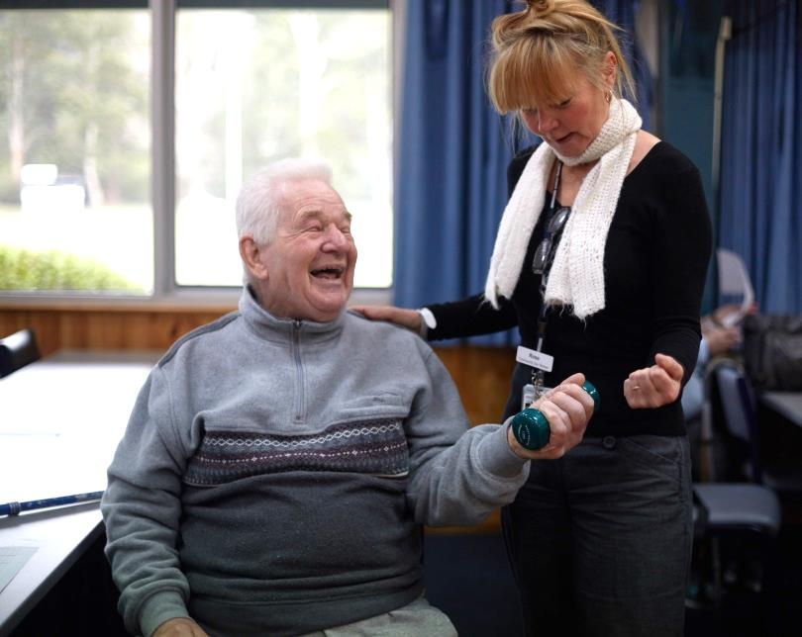

**Healesville Hospital and Yarra Valley Health**

This is a group exercise program for older adults. The program focuses on strength training to help strengthen your muscles and bones, improve your balance, coordination, flexibility and increase your overall health and fitness.

**When:**

Thursdays: 9am - 10am

**Where:**

Warburton & Millgrove Sports Complex

Warburton Hwy, Warburton

**Cost:** $5.00 per session

Please bring your own:

* water bottle
* hand towel
* wear comfortable, loose fitting clothing and supportive, non slip footwear
* any medication you may need, such as asthma puffers, anginine, jelly beans, etc.

**Please note:**

You will need to be assessed by a Physiotherapist before commencing this program.

**TO BOOK YOUR ASSESSMENT APPOINTMENT:**

P: **1300 130 381** (Mon to Fri)

E: **communityhealth@easternhealth.org.au**

This service is supported by funding from

the Commonwealth and Victorian Governments

**Strong and Steady - Warburton**

© Eastern Health 2018

**COMMUNITY  
HEALTH**

If you are unsure which services you require, we will be able to offer guidance. Our ‘No Wrong Door Policy’ ensures that if we cannot help you, we will direct you to a service better suited to your needs.

**For Further Information**

Phone: 1300 130 381

Fax: 5962 1458

Monday – Friday

9.00am – 5.00pm

[CommunityHealth@easternhealth.org.au](mailto:CommunityHealth@easternhealth.org.au)

Location details:

**377 Maroondah Hwy, HEALESVILLE 3777**

* Bus Stop (corner Eadie Avenue & Maroondah Hwy)
* Car parking onsite

**2475 Warburton Hwy, YARRA JUNCTION 3797**

* Bus Stop (in front of Eastern Health building)
* Car parking onsite

**What are the costs?**

The level of fees you will have to pay is dependent on your income and whether you have a concession card.

*Due to high demand, there may be a waiting time for this service.*

**What else do we offer at Healesville Hospital and Yarra Valley Health?**

* GP clinic, including After Hours service
* Renal Dialysis
* Pathology
* Radiology
* Surgery
* Specialist Outpatient clinics
* District Nursing
* Aboriginal Health team

Feedback

If you have any feedback or suggestions on how to improve this information sheet, please contact the Centre for Patient Experience at our email address: [**feedback@easternhealth.org.au**](mailto:feedback@easternhealth.org.au) or call 1800 327 837

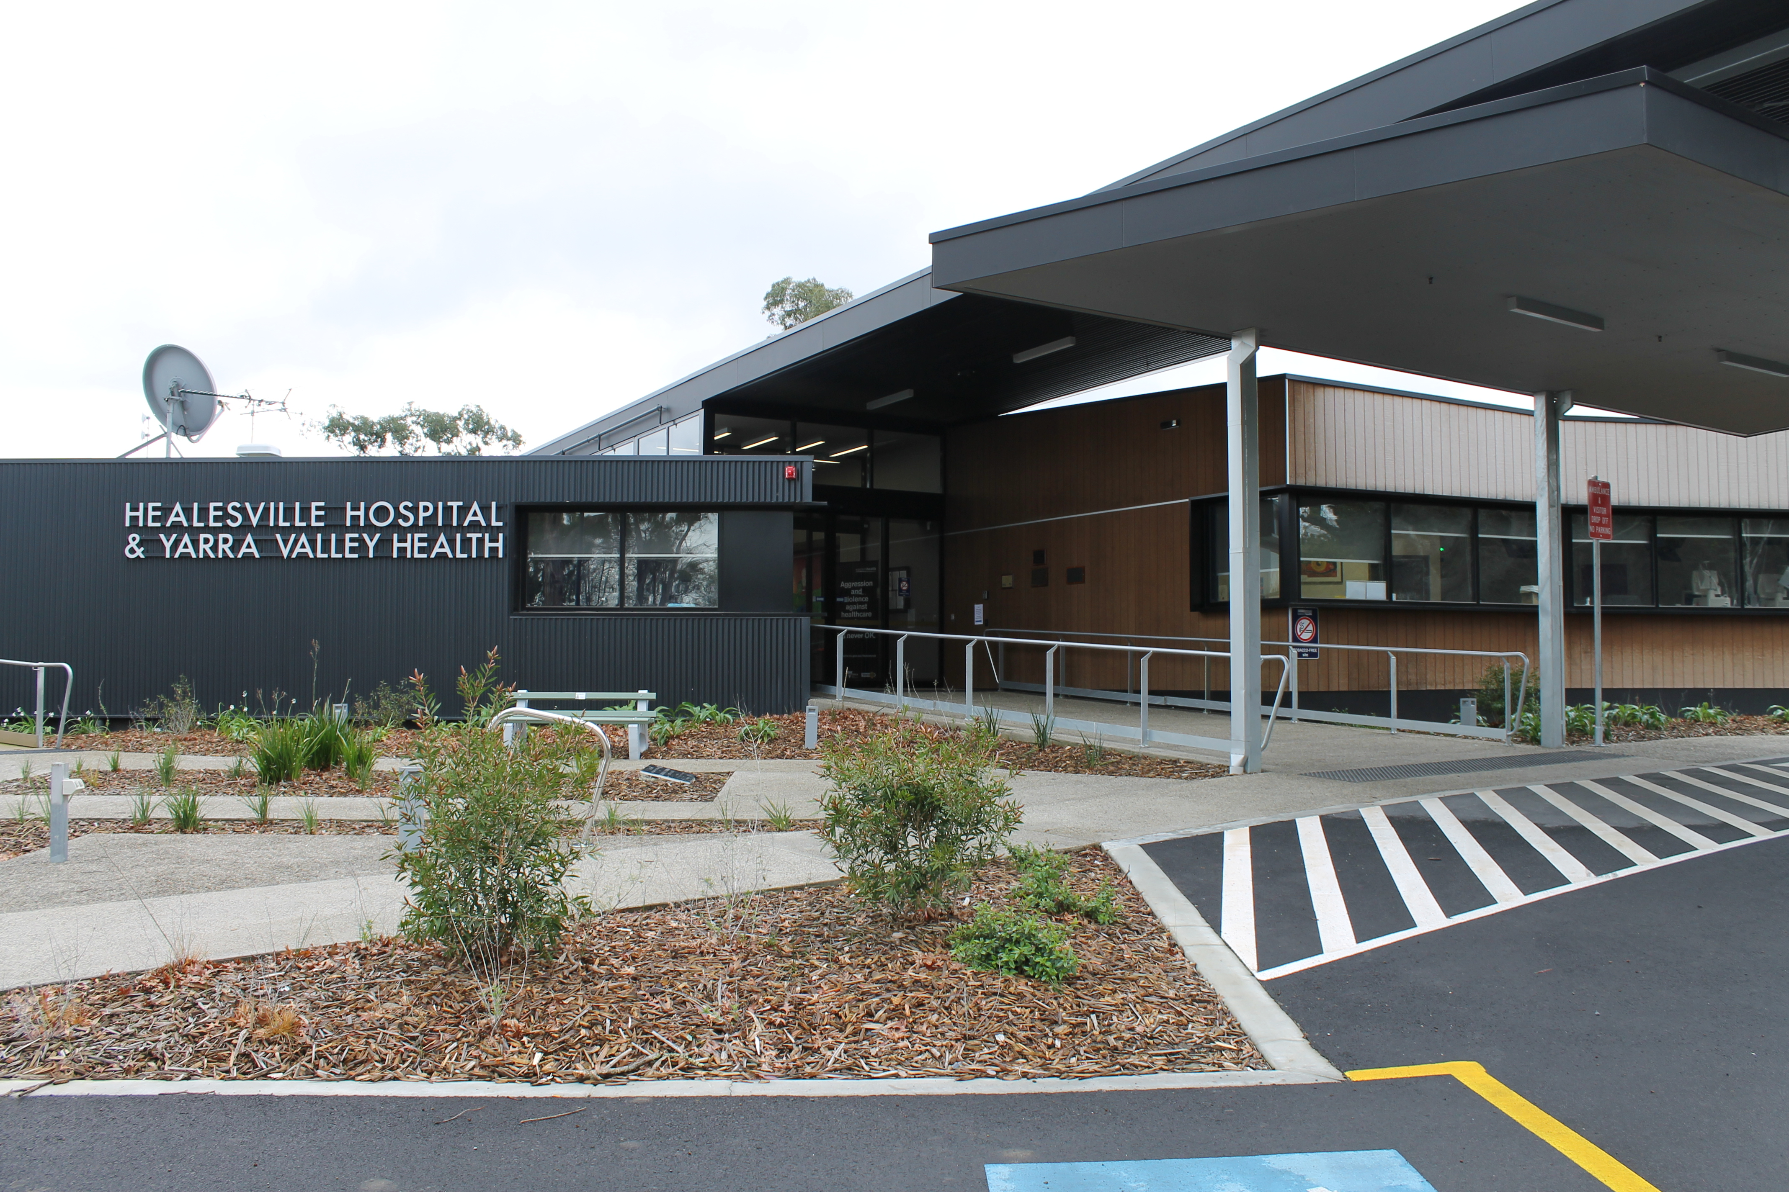

Website:

<https://www.easternhealth.org.au/locations/healesville-hospital-and-yarra-valley-health>

© Eastern Health 2018