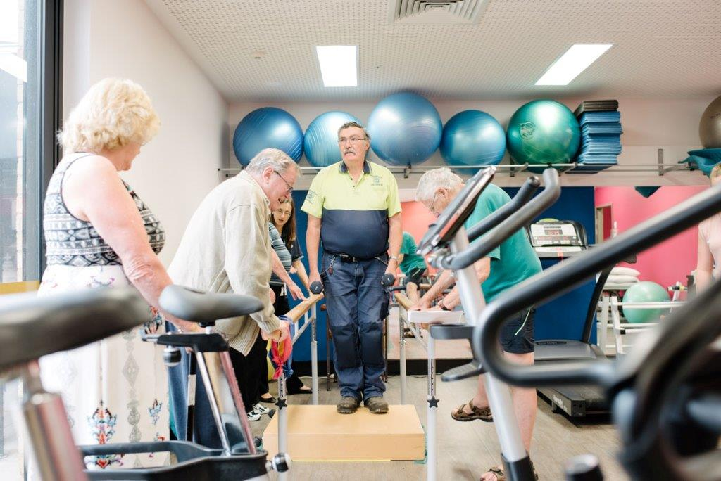

**Healesville Hospital and Yarra Valley Health**

This class is suitable for anyone who would benefit from strength training (e.g. diabetes, arthritis, chronic joint injury) and who is able to exercising without one to one assistance.

**When:**

Mondays: 11am - 12pm

Fridays: 12pm – 1pm

**Where:**

Physiotherapy Gym

Healesville Hospital and Yarra Valley Health

377 Maroondah Hwy, Healesville

**Cost:** $5.00 per session

Please bring your own:

* water bottle
* hand towel
* wear comfortable, loose fitting clothing and supportive, nonslip footwear
* any medication you may need, such as asthma puffers, anginine, jelly beans, etc.

**Please note:**

You will need to be assessed by a Physiotherapist before commencing this program.

**TO BOOK YOUR ASSESSMENT APPOINTMENT:**

P: **1300 130 381** (Mon to Fri)

E: **communityhealth@easternhealth.org.au**

This service is supported by funding from

the Commonwealth and Victorian Governments

**The Nutrition Circle -***Tailored Nutrition Advice*

p. 9720 0864 | f. 8677 2535 | e. [hello@thenutritioncircle.com.au](mailto:hello@thenutritioncircle.com.au)

w. [thenutritioncircle.com.au](http://thenutritioncircle.com.au/)

***CONFIDENTIAL*** The information in this message and in any attachments may be confidential. If you are not the intended recipient of this message, you must not read, forward, print, copy, disclose, or use in any way the information this message or any attachment it contains. If you are not the intended recipient, please notify the sender immediately and delete or destroy all copies of this message and any attachments. Any views expressed in this message are those of the individual sender, except where the sender specifically states them to be the views of The Nutrition Circle.

**Strong and Steady - Healesville**

**COMMUNITY  
HEALTH**

If you are unsure which services you require, we will be able to offer guidance. Our ‘No Wrong Door Policy’ ensures that if we cannot help you, we will direct you to a service better suited to your needs.

**For Further Information**

Phone: 1300 130 381

Fax: 5962 1458

Monday – Friday

9.00am – 5.00pm

CommunityHealth@easternhealth.org.au

Location details:

**377 Maroondah Hwy, HEALESVILLE 3777**

* Bus Stop (corner Eadie Avenue & Maroondah Hwy)
* Car parking onsite

**2475 Warburton Hwy, YARRA JUNCTION 3797**

* Bus Stop (in front of Eastern Health building)
* Car parking onsite

**What are the costs?**

The level of fees you will have to pay is dependent on your income and whether you have a concession card.

*Due to demand for services there may be a waiting time for some services.*

**What else do we offer at Healesville Hospital and Yarra Valley Health?**

* GP clinic, including After Hours service
* Renal Dialysis
* Pathology
* Radiology
* Surgery
* Specialist Outpatient clinics
* District Nursing
* Aboriginal Health team

Feedback

If you have any feedback or suggestions on how to improve this information sheet, please contact the Centre for Patient Experience at our email address: [**feedback@easternhealth.org.au**](mailto:feedback@easternhealth.org.au) or call 1800 327 837

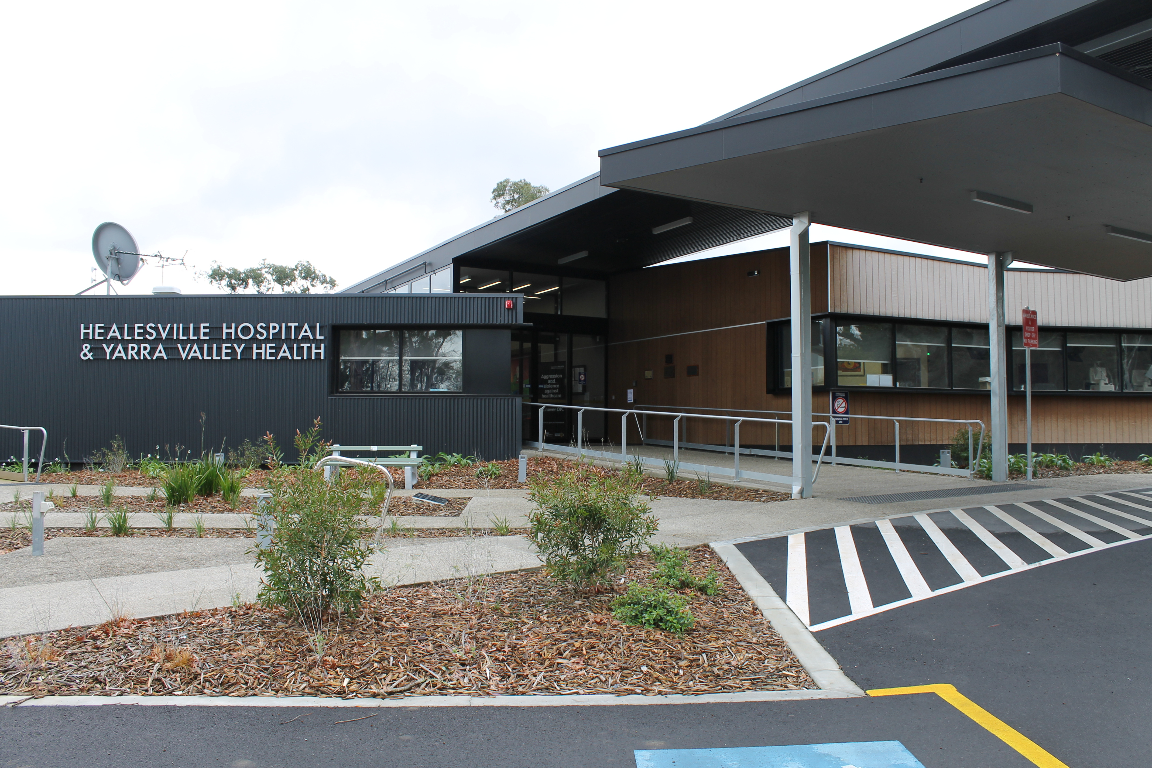

Website:

<https://www.easternhealth.org.au/locations/healesville-hospital-and-yarra-valley-health>

© Eastern Health 2018