2017 “Bridging The Divide” Event Report
Report provided by Bronwyn Williams – EMHSCA Project Officer
The Annual Eastern Metropolitan Region (EMR) Mental Health and Co-occurring Issues Explored (MHACIE) Workshop was held on Thursday the 30th November 2017 in the Matsudo Room at the Box Hill Town Hall and catered for 70 attendees in total. This event is provided annually by the EMHSCA Workforce Development sub committee which consists of 10 staff from a variety of EMHSCA services. A number of additional staff also assist the committee on the day of the event.

The Aim

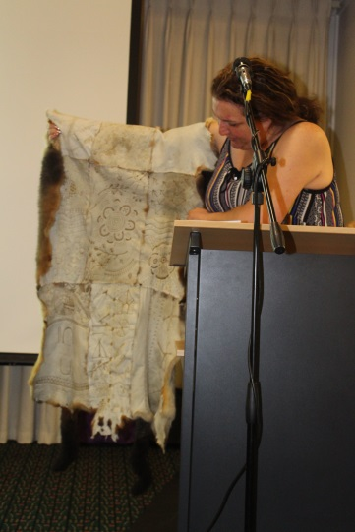
The purpose of this event is to provide increased understanding of a variety of issues that may co occur with mental ill health. Originally entitled “Complex Issues Explored”, it was renamed to more specifically address particular co occurring issues. The event aims to highlight the fact the it is the system that is complex and not the people we work with.

The Program
This year the following co-occurring issues were explored:

Physical Health : Petrina Hilton - Neami
Substance use: Gavin Foster – Eastern Health
Intellectual Disability: Dr. Chad Bennett - VDDS
Acquired Brain Injury: Alex Coopes and Edmund Tsang - CBDATS
Aboriginal health & well-being: Merilyn Duff - EACH
Family Violence: Diane Godfrey – Safe Futures

Presenters included staff from Eastern Health, Neami, Victorian Dual Disability Service, CBDATS, Eastern Dual Diagnosis Service, Safe Futures, and EACH.
The consumer perspective on approaching complexity was provided by Elinor Jack. There was a focus on creating safe environments, privacy and the importantance of a collaborative approach. The event concluded with a presentation from Aaron Jones (NEAMI) spoke to the issues around approaching complexity.
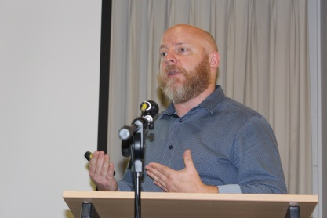
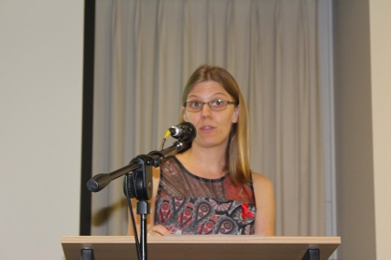
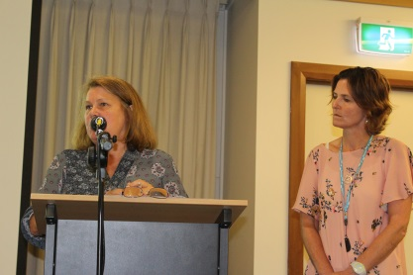
Table facilitators were utilised to ensure workshop exercises were well utlilised, even with large numbers of attendees. These facilitators were briefed and provided with a guide to support their role. 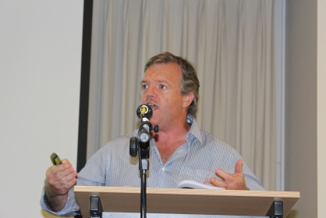

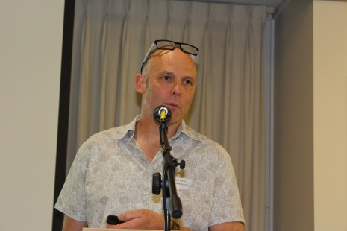
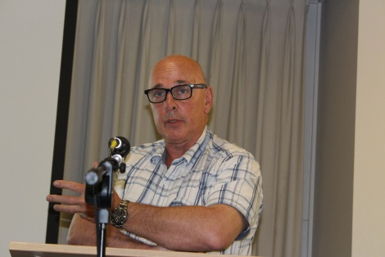
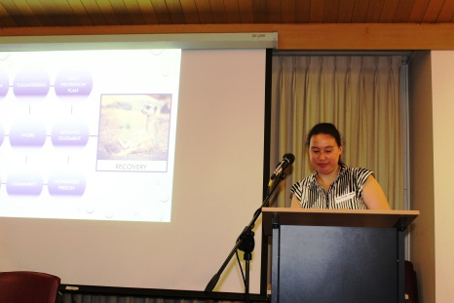
Feedback
Overall the feedback from the event was very positive. With all activities being rated by the vast majority of participants as useful to very useful. Feedback was received from 43 participants (61% of attendance). The most popular presentations were Intellectual Disability & MH, Aboriginal and Torres Strait Islander people and MH & Well-being, and Dual Diagnosis. There were opportunities provided for networking and table dicsussions were mentioned by participants as being a very useful aspect of the event. The venue and catering were well received and ensured participants remained in the venue for networking purposes.
EMHSCA Workforce development committee
The MHACIE event is developed, organised and provided by the EMHSCA Workforce Development subcommittee with funding via annual contributions from EMHSCA member organisations.
The committee consists of eleven members as follows:
Anna Makris (co-Chair) | Federal Dept. Human Services
Aaron Jones | Neami National
Bronwyn Williams (Project Officer) | Eastern Health Recovery Framework Implementation /EMHSCA/ Eastern Peer Support Network projects
Corey Eastwood | MIND PARC programs
Jose Abalo | Federal Dept. Human Services
Maria Yap | Eastern Melbourne Primary Health Network
Pembrooke Warden | Uniting Prahran
Sandro Madrigale | Eastern Health Aged Persons Program
Sue Leen Ng | Wellways
It is important to acknowledge the substantial contribution of these members and their teams to the success of the EMHSCA Workforce Development events each year. Thanks goes to EMHSCA member organisations for contributing in this way to improving Service Coordination across the EMR for the benefit of people who experience mental ill health and co occurring issues.
I would also like to acknowledge the City of Whitehorse who provided grant funding to support this event and also to Waverley Industries for their reliable and delicious catering.
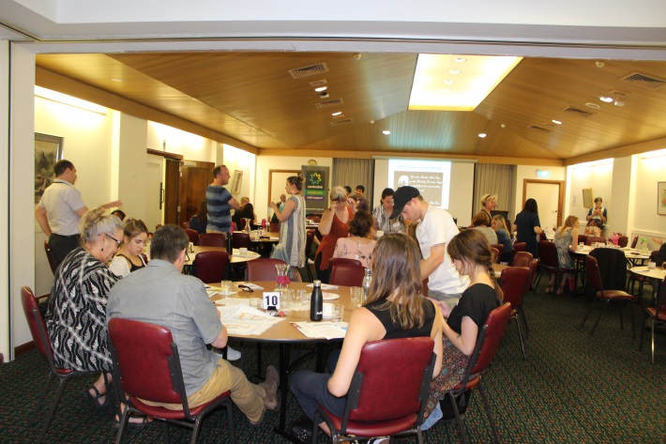
Attendance
Registered & attended | 60
Event crew | 10
Total attendance | 70
Non-attendance | 21
There was a substantial waitlist for this event.
Attendance by sector
AOD | 7
Clinical MH | 13
DHS | 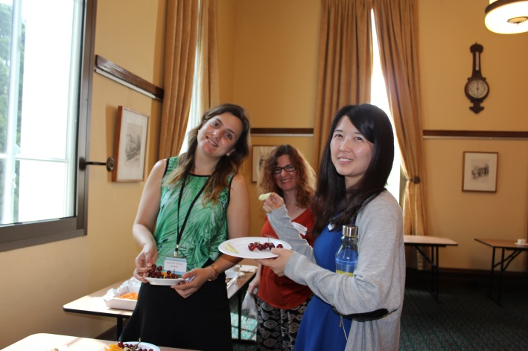  2
Family Services | 4
Forensic | 1
Local council | 2
MHCSS | 32
Other | 3
Budget
Catering $1,163
Venue $444
Total: $1,606
Plus in-kind support from EMHSCA organisations for printing and staffing.
The City of Whitehorse provided a grant that reduced the venue hire by half.
This event was within budget.
Conclusion
This event has developed over the past 7 years to provide a well-targetted program of mini-workshops that enhance knowledge and skills for a wide range of staff from across our region. A good blend of specialist information and case based activities is challenging to achieve. We will continue to work with this aim. This valuable and popular activity will be provided again in 2018.

