**e-Referrals to Acute Specialist Clinics (Eastern Health)**

**Oct 2022 Version 7.7**

From 1st December 2021, ***Acute Specialist Clinics (Eastern Health)*** transitioned to requiring e-referrals via ***HealthLink*** smart forms as the method for receiving referrals to ***Acute Specialist Clinics***. This approach is aimed towards “axing the fax” for better, safe transfer of care in ***Acute Specialist Clinics*** **only**. *This is not an organisation-wide change. All other departments will continue, as per their normal process.*

The move is designed to ensure your patients’ identifiable clinical information is transmitted from your ***Clinical Information System (CIS)*** directly to the ***Acute Specialist Clinics*** in a secure format, which will result in:

* receipt of referrals which are intact and complete,
* improved legibility,
* fewer declined referral and support adherence to the state-wide referral criteria released in 2019 - 2022,
* improved appointment advice response times for patients and GPs.

***HealthLink SmartForms*** are free to use and integrated with most GP clinical software including ***Medical Director***, ***Best*** ***Practice***, ***Genie***, and ***MedTech Evolution***. The ***SmartForms*** include a direct link to ***HealthPathways*** ***Melbourne*** which is up-to-date with ***State-wide Referral Criteria***, making it easier for GPs to include the required information in the referral to ensure that the referral meets these requirements and can be triaged efficiently and effectively. For further information and a list of clinics, please visit the ***Eastern Health Specialist Clinics*** [webpage](https://www.easternhealth.org.au/site/item/65-outpatients#making-a-referral).

Help is available

Additional information is available at ***Eastern Melbourne PHN’s*** [website](https://www.emphn.org.au/what-we-do/digital-health/electronic-referrals).

|  |  |  |  |  |
| --- | --- | --- | --- | --- |
| **Medical Director** | **Best Practice** | **Genie** | **MedTech Evolution** | **Portal** |
| * [Quick Start Guide – MD](https://www.easternhealth.org.au/images/QSG-VIC-eReferral-Medical_Director_MD-v_5.pdf) * [Tutorial Video – MD](https://vimeo.com/648824706) | * [Quick Start Guide – BP](https://www.easternhealth.org.au/images/QSG-VIC-eReferral-Best_Practice_BP-v_5.pdf) * [Tutorial Video – BP](https://vimeo.com/648824428) | * [Quick Start Guide – Genie](https://www.easternhealth.org.au/images/QSG-VIC-eReferral-Genie-v_5.pdf) * [Tutorial Video – Genie](https://vimeo.com/648824589) | * [Integration Guide-MedTech Evolution](https://www.easternhealth.org.au/images/Guide-Forms_Integration-MTE-v_1.0.pdf) | * [Quick Start Guide – Portal](https://www.easternhealth.org.au/images/QSG-VIC-eReferral-Portal.pdf) * [Tutorial Video – Portal](https://vimeo.com/652736316) |

For assistance with the ***HealthLink SmartForms*** in your software, contact ***HealthLink*** on **1800 125 036** or email [HelpdeskHL@healthlink.net](mailto:HelpdeskHL@healthlink.net)

For additional training, including demonstration, contacted ***Eastern Melbourne Primary Health Digital Health*** team on [digitalhealth@emphn.org.au](mailto:digitalhealth@emphn.org.au) or, if urgent, **(03) 9046 0300**.

For information on how to refer to ***Eastern Health Acute Specialist Clinics***, contact ***Specialist Clinics eReferral*** ***Management*** on [ereferralmanagement@easternhealth.org.au](mailto:ereferralmanagement@easternhealth.org.au).

***PLEASE NOTE:*** *As the COVID-19 pandemic continues to evolve, some Acute Specialist Clinics activity at Eastern Health has been reduced to ensure we can support the needs of the community and respond to COVID-19. This means our capacity has been reduced and wait times to offer Acute Specialist Clinics appointments will be longer than potentially expected.*

*Where possible, care will be continuing to be delivered via telehealth. For the latest information regarding Patients and Visitors during the Pandemic - please refer to* [*https://www.easternhealth.org.au/locations/patients-and-visitors*](https://www.easternhealth.org.au/locations/patients-and-visitors)

Frequently Asked Questions

**Does this apply to all Specialist / Outpatient Clinics at Eastern Health?**

No, e-referral only currently applies to **all acute specialist clinics and antenatal clinics.** A list of all acute specialist clinics can be found [here](https://www.easternhealth.org.au/site/item/65-outpatients#eastern-health-clinics).

It does not include referrals to the following services (click on each hyperlink for further referral information):

* Aged Care Assessment Service (ACAS) – referrals through the My Aged Care (MAC) website
* [Cardiology Investigations](https://www.easternhealth.org.au/services/item/775-cardiology-investigations-medicare-bulk-billed)
* [Community Health Services](https://www.easternhealth.org.au/a-z-service-directory)
* [Emergency Departments](https://www.easternhealth.org.au/services/item/610-emergency-department)
* [Geriatric Evaluation and Management at Home (GEM@Home)](https://www.easternhealth.org.au/services/item/555-geriatric-evaluation-and-management-at-home)
* [Hospital Admission Risk Prevention (HARP)](https://www.easternhealth.org.au/services/item/271-hospital-admission-risk-program-harp)
* [Hospital in the Home](https://www.easternhealth.org.au/services/item/683-eastern-home-hospital-in-the-home)
* [Mental Health Services](https://www.easternhealth.org.au/services/mental-health-services)
* Sub-Acute Ambulatory Clinics (SACS). These services include:
  + Continence Clinic
  + Falls and Balance
  + Cognitive Dementia and Memory Service (CDAMS)
  + Complex Care Clinic
  + Movement Disorders
  + Ambulatory Pain Management Service (APMS)
  + Rehabilitation Medicine
  + Focal Spasticity
  + Chronic rehabilitation – Cardiac, Heart Failure, Respiratory and Oncology

The referral form for ***Ambulatory Care*** and ***Community Services***, and ***Subacute*** is available [here](https://www.easternhealth.org.au/health-professionals/gp-referral-templates). Currently, referrals should be faxed to the ***Eastern Health Access Unit*** on **(03) 9881 1102.** Further information on these services is available [here](https://www.easternhealth.org.au/images/ACCS_Ref_Form_Instructions_12.2020.pdf).

Maternity Services has transitioned to exclusively using electronic referrals since March 2022. Hence, they are no longer utilising their patient online maternity booking form. Further information on this service is available [here](https://www.easternhealth.org.au/health-professionals/maternity-resources-for-gps).

**\*\*\* Please note that we are moving towards including several of the above services in e-referral. Information will be provided as it becomes available\*\*\***

Which medical software is compatible with e-referral?

***Medical Director (***Version 3.17 and above), ***Best Practice*** (***Lava*** and above), ***Genie***, and ***MedTech Evolution***.

Is Helix compatible with e-referral?

No, ***Helix*** is not currently compatible software. However, you can still submit forms electronically via the ***HealthLink*** Portal.

Are you going to accept faxed referrals after December 1st 2021?

All GP clinics with compatible software will be required to send all acute specialist clinics referrals via e-referral.

Practices with non-compliant software will be required to send referrals electronically via the ***HealthLink Portal***. If you are having issues and are unable to use e-referral or the portal, you can call the ***Specialist Clinics Referral Management*** on**1300 342 255** or email [ereferralmanagement@easternhealth.org.au](mailto:ereferralmanagement@easternhealth.org.au).

What happens if I don’t have conformant software to send an e-referral?

Please register for a ‘free’ ***HealthLink Portal*** licence by completing the [online registration form](https://au.healthlink.net/au_registration/) and notate in the comments/message field that you would like to use the ***SmartForms***, as well as selecting the two checkbox, as shown below:

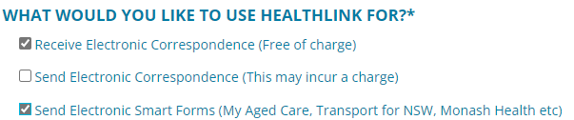

Once ***HealthLink*** will process the completed registration application form, and portal details will be forwarded to you.

**Do not email any referrals to email addresses as they are not encrypted**. Referrals sent by post will also be declined and will be requested to be re-sent via ***HealthLink SmartForms***.

What is the MyHealthLink Portal?

***MyHealthLink Portal*** is a stand-alone, web based system designed to enable medical practices and individual healthcare providers, who do not have conformance software (i.e. ***Medical Director***, ***Best Practice***, ***Genie***, or ***MedTech Evolution***), an alternative solution to electronically refer and submit patient referrals via ***HealthLink SmartForms*** to ***Eastern Health***.

Quick Start Guides for the ***HealthLink Portal*** is available [here](https://www.easternhealth.org.au/services/specialist-outpatients-clinics#making-a-referral).

Does e-referral auto- populate patient information?

Patient demographics, active medications, past history and practice details all auto populate for conformance software users.

Please note: This is different to the ***Portal***, and unfortunately all patient information will be required to be entered manually.

Can I refer to 2 specialists/ specialities on one referral?

No, you will need a separate e-referral for each clinical referral.

How do I attach investigation results?

You can attach results, reports etc. in the format which is highlighted on the ***SmartForm***.

* Attaching files from ***Clinical Information System (CIS)*** support: ***gif, html, jpeg, doc, docx,pdf, txt, rft*** and ***tiff***.
* Attaching file from computer (desktop) supports files that end in types: ***doc, docx, gif, htm, html, jpeg, jpg, pdf, rtf, tif, tiff*** and ***text***.

For ***Best Practice*** and ***Medical Director*** users, please ensure all plain text investigation includes the header.

Include Header in ***Best Practice***:

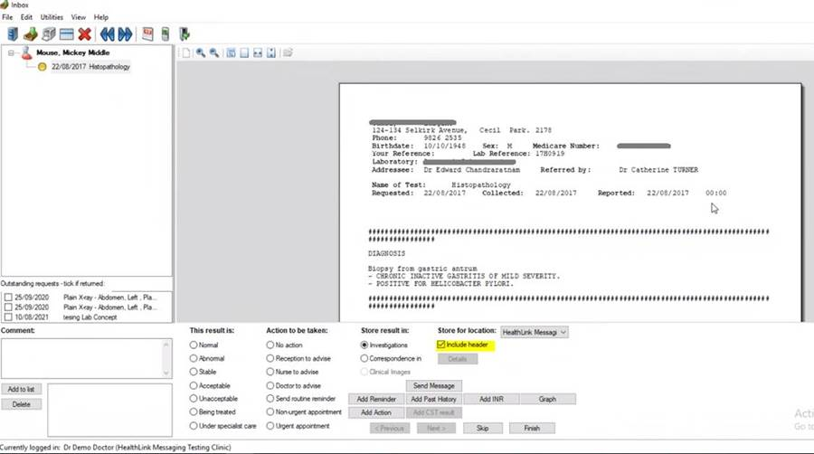

Include/Exclude Header in ***Medical Director*** (via Tools -> Options -> Investigations):

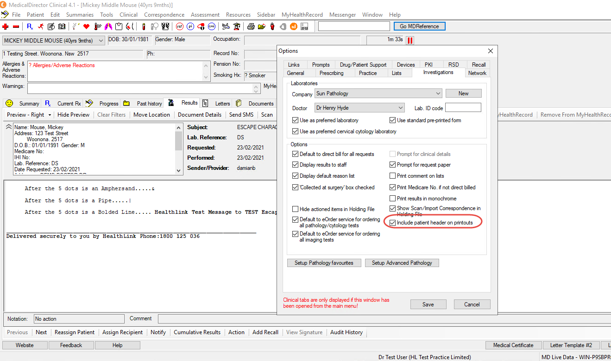

What do I do if I cannot attach documents?

Contact ***HealthLink*** on **1800 125 036** or email [HelpdeskHL@healthlink.net](mailto:HelpdeskHL@healthlink.net).

I can see this message at the bottom of my referral when previewing and it says there is “no attachments”. How do I know if my referral has been received with all the attachments included?

The below message relates to file attached ‘from your desktop’ not the patient’s clinical file.



If you have attached documents/reports from your patient’s clinical file, you will see the following example message:

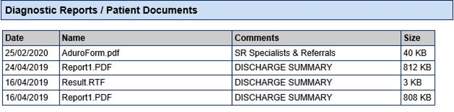

How long does it take to confirm receipt of the referral and method of confirmation?

You will be notified that the referral has been received within seconds.

Please note that this does not mean the referral has been accepted; only that it has been received.

What happens if the HealthLink referral fails to send?

You will be notified if the submission fails. The e-referral will be parked and available to re-open and resubmit later. When delivered, it will generate and send back an acknowledgement to you.

For any issues relating to this, contact ***HealthLink*** directly on [HelpdeskHL@healthlink.net](mailto:HelpdeskHL@healthlink.net) or **1800 125 036**.

How do I access HealthPathways Melbourne?

Send a request to [info@healthpathwaysmelbourne.org.au](mailto:info@healthpathwaysmelbourne.org.au) or complete this [access form](https://melbourne.healthpathways.org.au/LoginFiles/RequestLogin.aspx?topic=Request%20Access).