**Welcome to EMHSCA**

The members of the Eastern Mental Health Service Coordination Alliance welcome you, and look forward to a long and productive relationship as we collectively consider, strategise and act regarding service coordination issues in this region.

In order to achieve these aims EMHSCA committee members are required to be of a leadership level that allows for decision making on behalf of their organisation at EMHSCA meetings.

Membership of the EMHSCA sub committees is required from each EMHSCA member organisation and these members may or may not hold a leadership capacity in their organisation, but rather capacity for and an interest in planning and promoting service coordination activities in the region.

**Responsibilities of EMHSCA members**

* Attend bi-monthly EMHSCA meetings (as per calendar provided by Project officer).
* Provide suitable members from their organisation for the various EMHSCA sub committees (see below).
* Provide clear leadership and strategic direction in their respective organisations to develop and promote an integrated multi sector mental health service coordination model for people who experience mental ill-health and co-occurring concerns, and their carers, families, dependants and significant others.
* Implement the agreed integrated multi sector mental health service coordination model by working in a coordinated and collaborative manner to identify common issues and solutions, and build and progress working alliances in the interests of people with mental health illness and co-occurring concerns, and their carers.
* Achieve sustainable outcomes by embedding the agreed protocols and functional arrangements into local work practice and providing ongoing support for the implementation of practice reforms, cost effective innovation in service system delivery and the structural changes necessary for the development and sustainability of an integrated multi sector mental health service coordination model for people with mental ill health and co-occurring concerns, and their carers.
* Monitor the success of the mental health service coordination model and EMHSCA Strategic plan and their ongoing adaptation in response to changing needs of people with mental ill-health and co-occurring concerns, and their carers in the evolving nature of the mental health and health service system reform.
* In general all discussions within the EMHSCA committee meetings should be disseminated within partner agencies and other aligned services to enhance the progress of the project unless otherwise stated during EMHSCA committee meetings. It is the responsibility of EMHSCA committee members to convey information regarding EMHSCA activities, including workforce development activities, to their organisations.

**Communication and reporting structures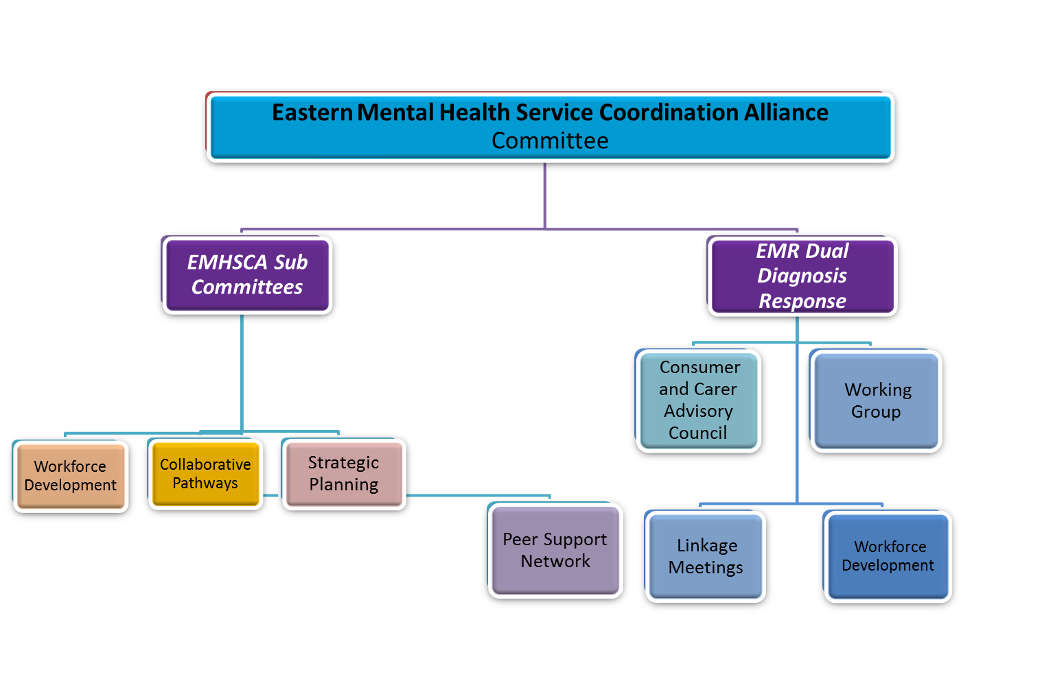**

EMR MH & AOD Catchment Planning Council

**Our Vision**

The EMHCSA vision is to ensure that people who experience mental ill-health and co-occurring concerns have access to responsive, appropriate and collaborative services to assist with the multiple facets of their individual recovery journey.

***At EMHSCA we value:***

* **A Strategic approach** by encouraging the expansion of organisational thinking and planning into a broader regional context.
* **A Respectful approach** by treating everyone with courtesy, acknowledging all viewpoints, respecting diversity, and considering everyone with fairness and ensuring constructive honesty.
* **Participation** from a diverse network of services, consumers and carers who commit to being actively involved in the sharing of information, practice wisdom, resources, and innovation.
* **Working collaboratively** to support each other to achieve common goals and enhance integrated practice across the region.
* **Capacity Building** to assist with continuous improvement of the services provided in this region, enhancing collaboration and coordinated care.

The EMHSCA vision is to ensure that people who experience mental ill-health and co-occurring concerns have access to responsive, appropriate and collaborative services to assist with the multiple facets of their individual recovery journey.

For further information about EMHSCA membership go to

<https://www.easternhealth.org.au/services/mental-health-services/eastern-mental-health-service-coordination-alliance>

Please refer to the

1. EMHSCA Strategic Plan
2. EMHSCA Memorandum of Understanding
3. EMHSCA Terms of Reference
4. Quarterly reports
5. Subcommittees’ Terms of Reference

cid:_1_0ACE30DC0ACE025C00282B8DCA257D02 We acknowledge the traditional Aboriginal owners of country throughout Victoria and respect them, their culture and their Elders past, present and future.